**ASSIGNMENT 24.3**

**PROBLEM STATEMENT:**

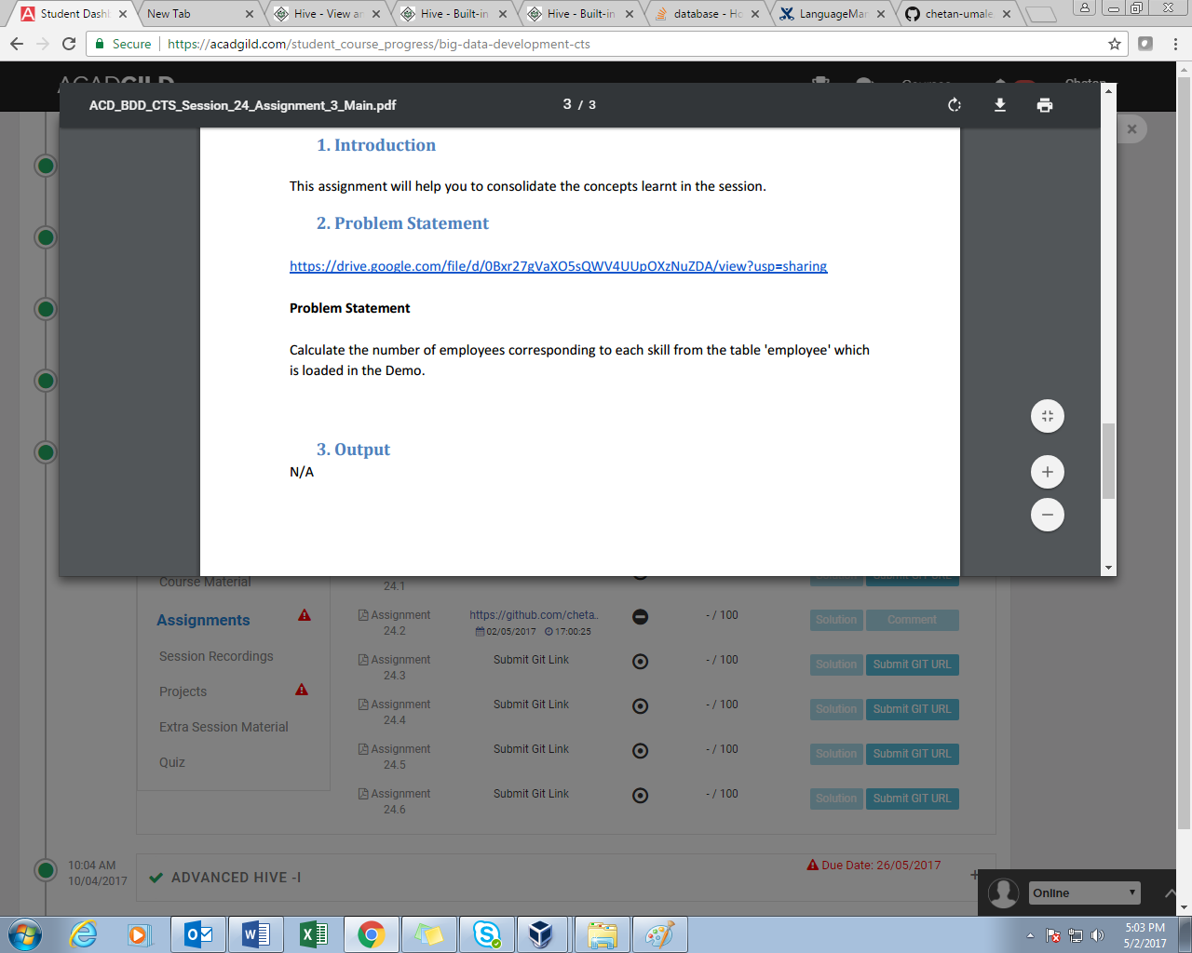

**SOLUTION:**

