**ASSIGNMENT 26.3**

**PROBLEM STATEMENT:**

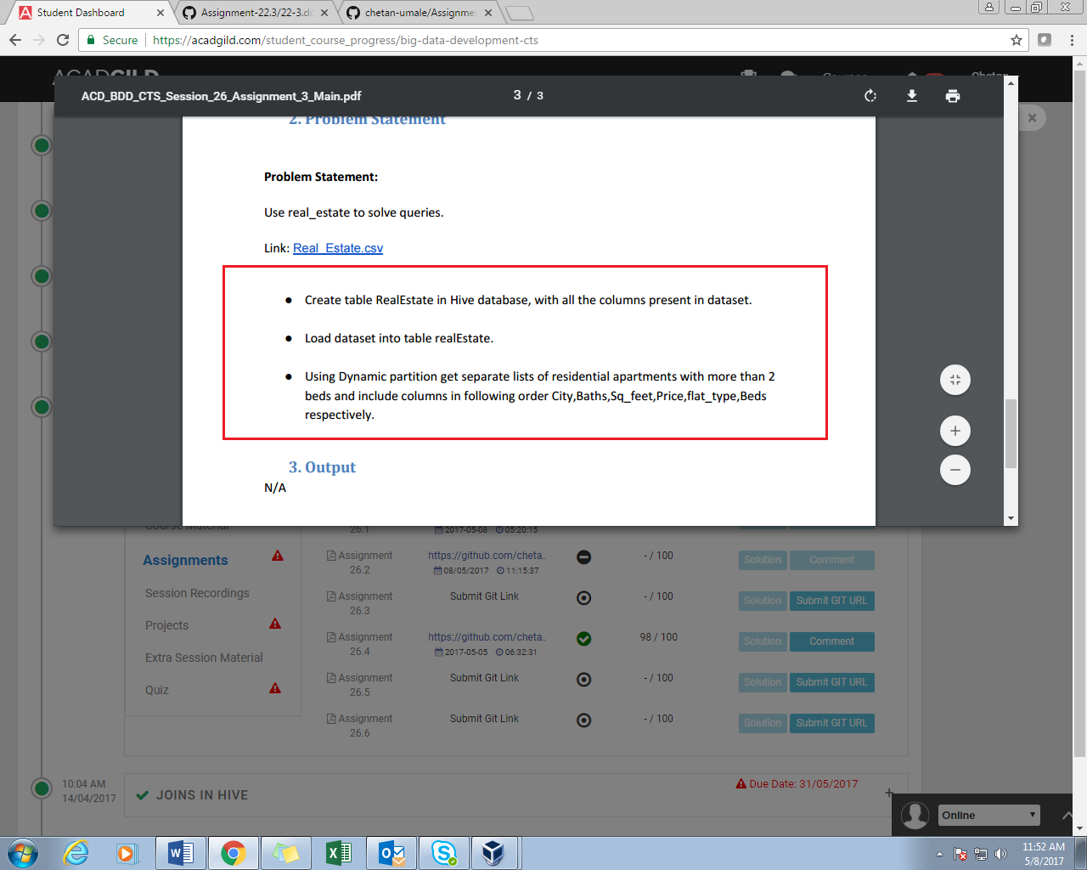

**SOLUTION:**

//CREATING TABLE AND LOAING DATA

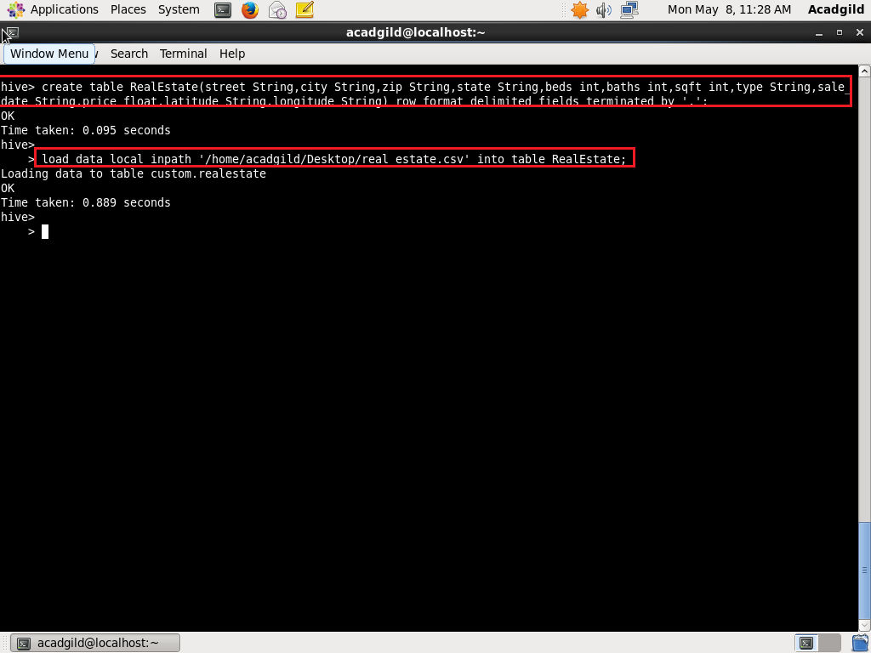

//CREATING MANAGED PARTITION TABLE

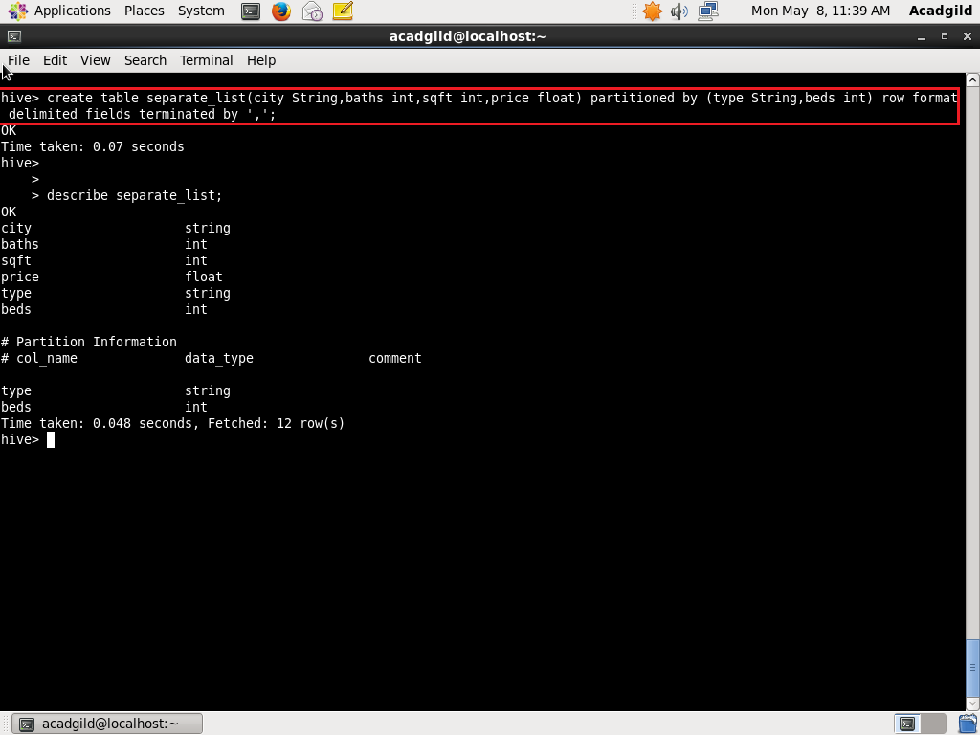

//INSERTING DATA INTO MANAGED PARTITION TABLE

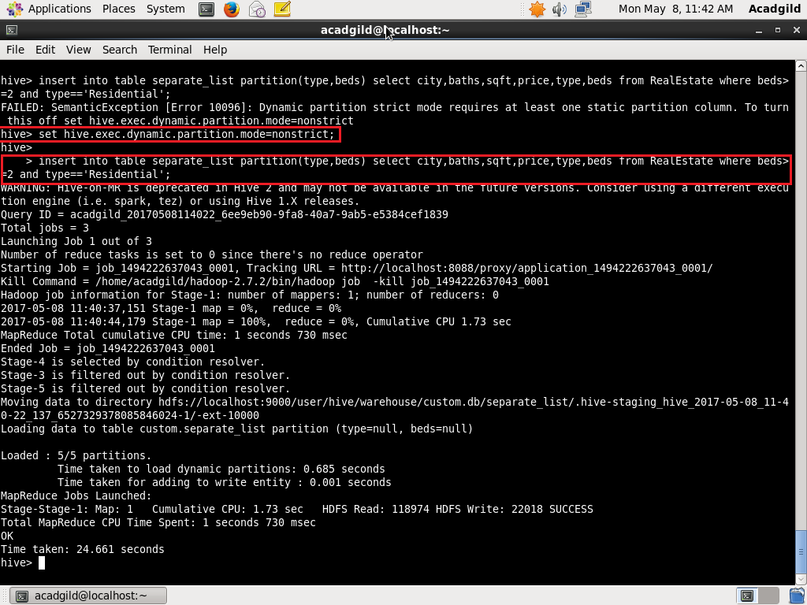

//DISPLAYING PARTITIONS

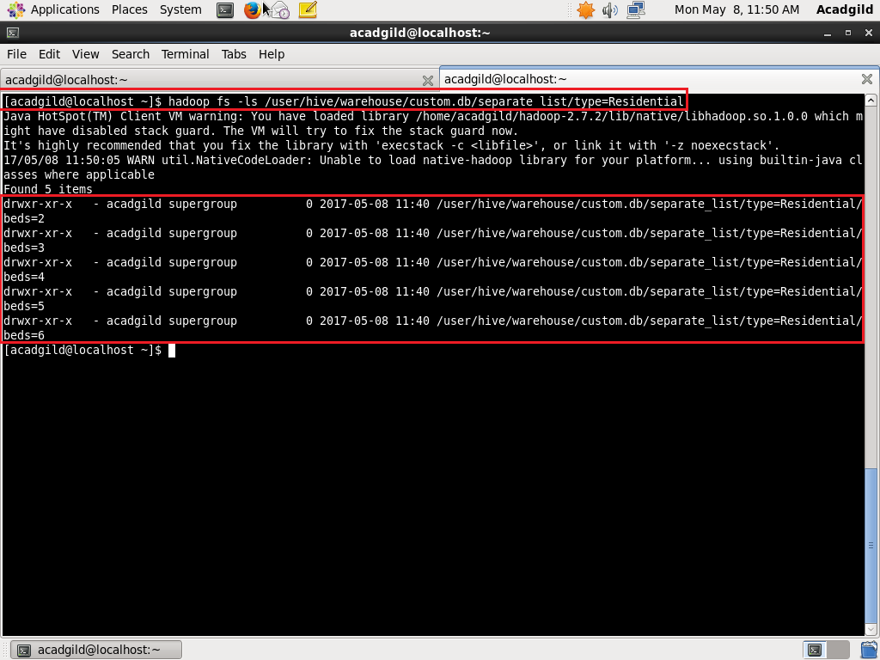

//DISPLAYING CONTENTS OF FILE

