**ASSIGNMENT 29.2**

**PROBLEM STATEMENT:**

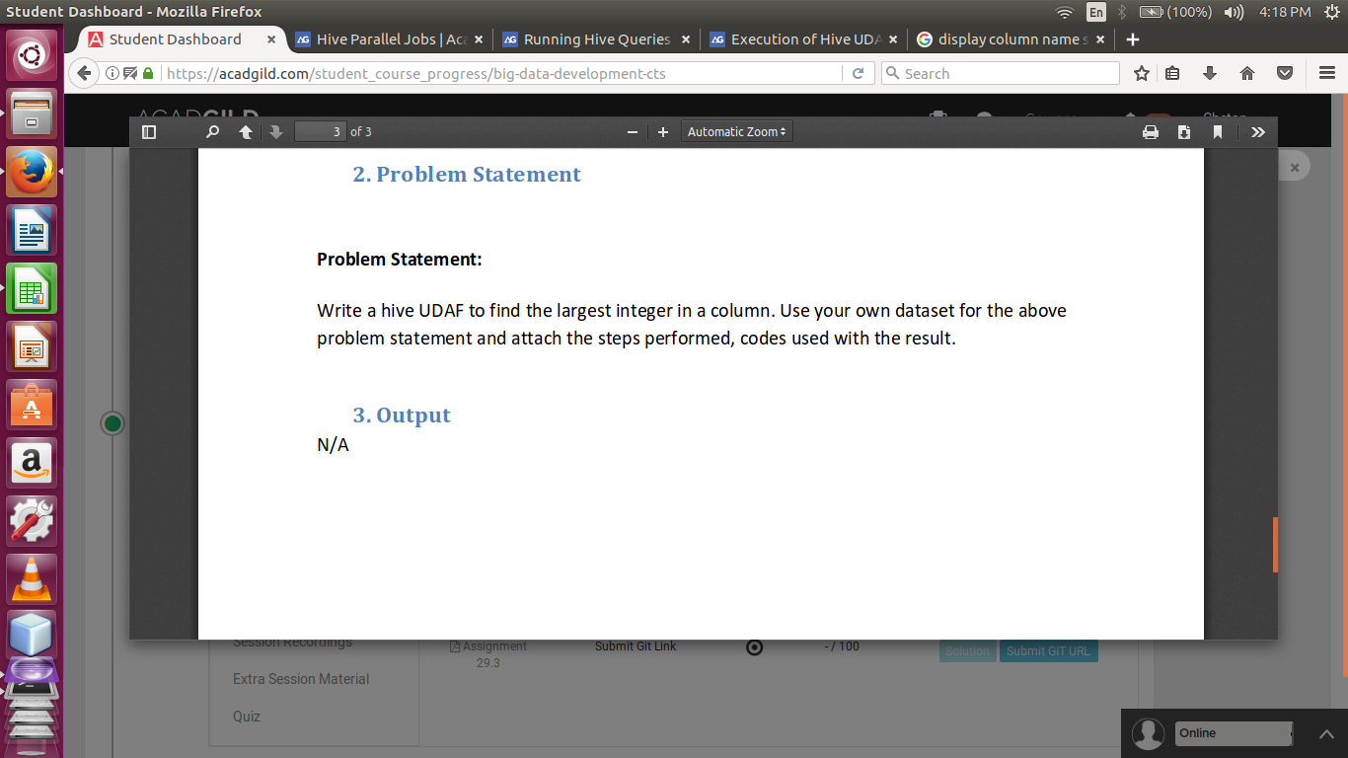

**SOLUTION:**

//JAVA CODE

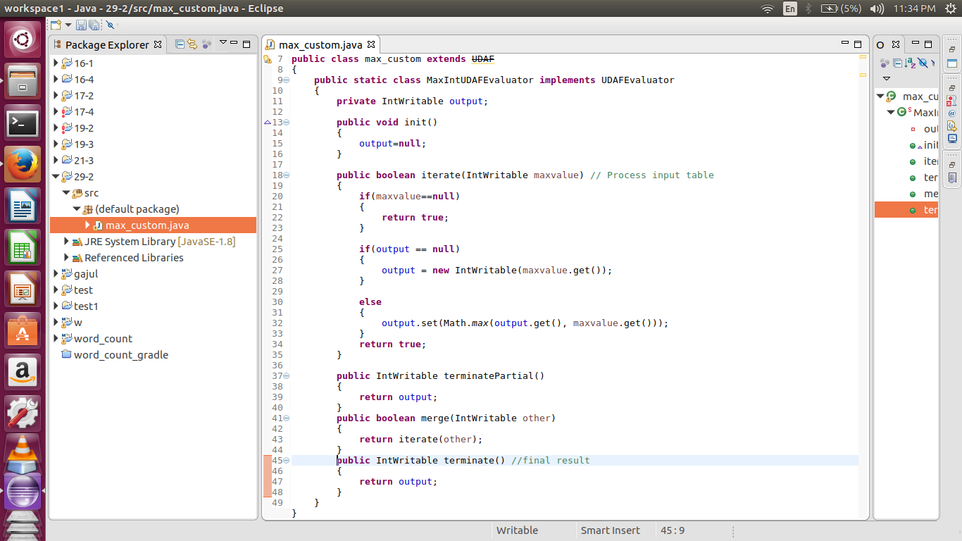

//DATASET

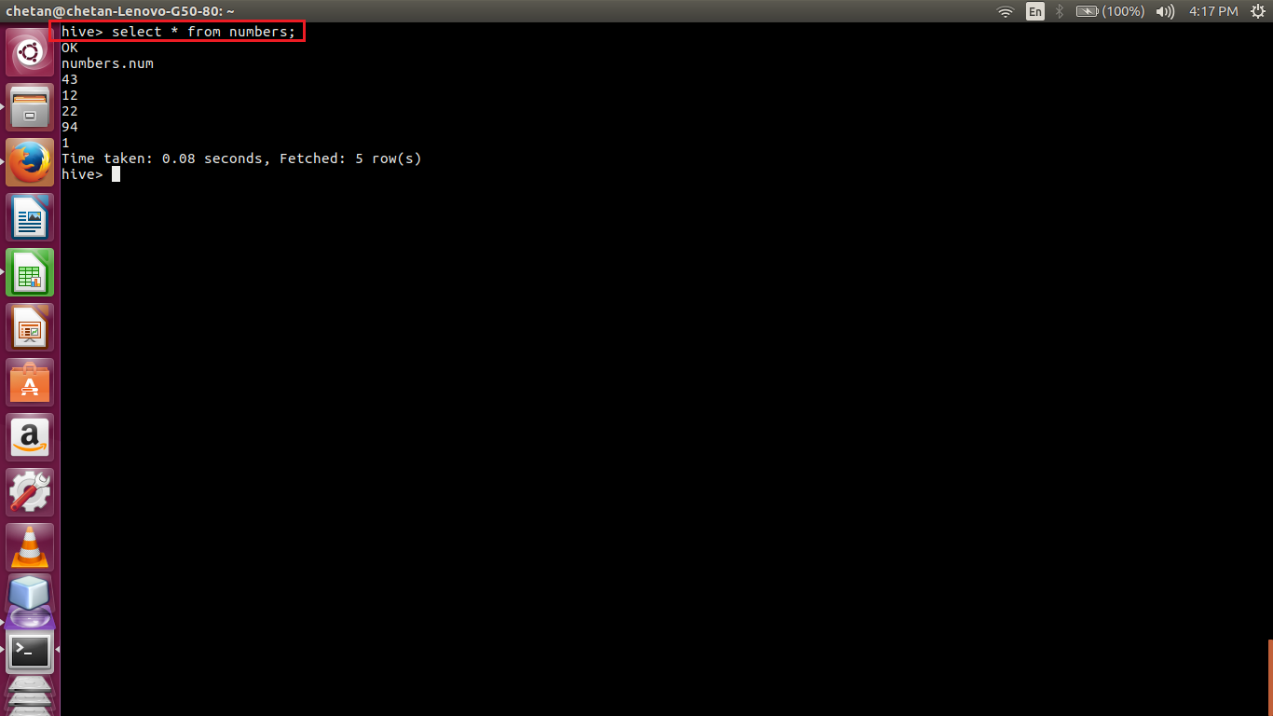

//ADDING JAR, CREATING TEMPORARY FUNCTION AND EXECUTION

