**ASSIGNMENT 35.3**

**PROBLEM STAEMENT:**

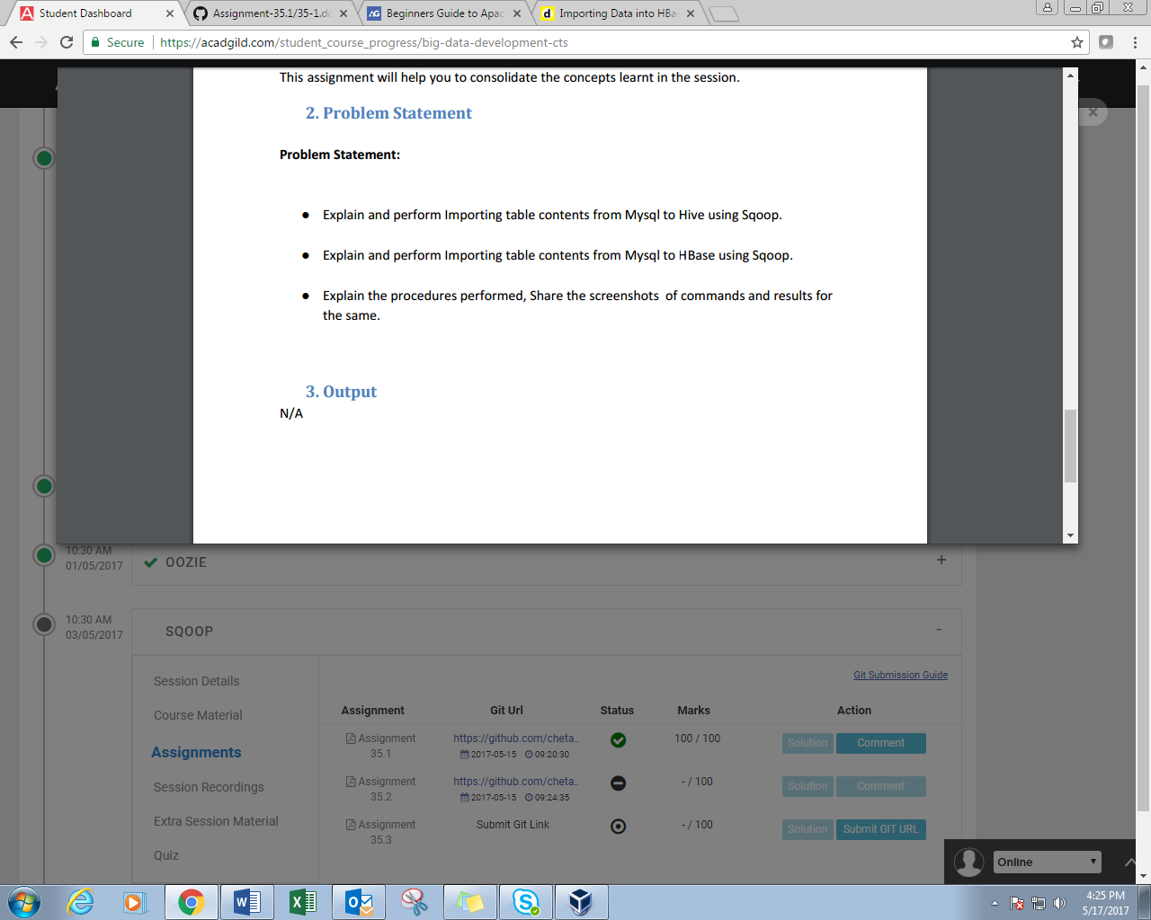

**Q1-**

//CREATING TABLE IN MYSQL, INSERTING DATA AND DISPLAYING RECORDS

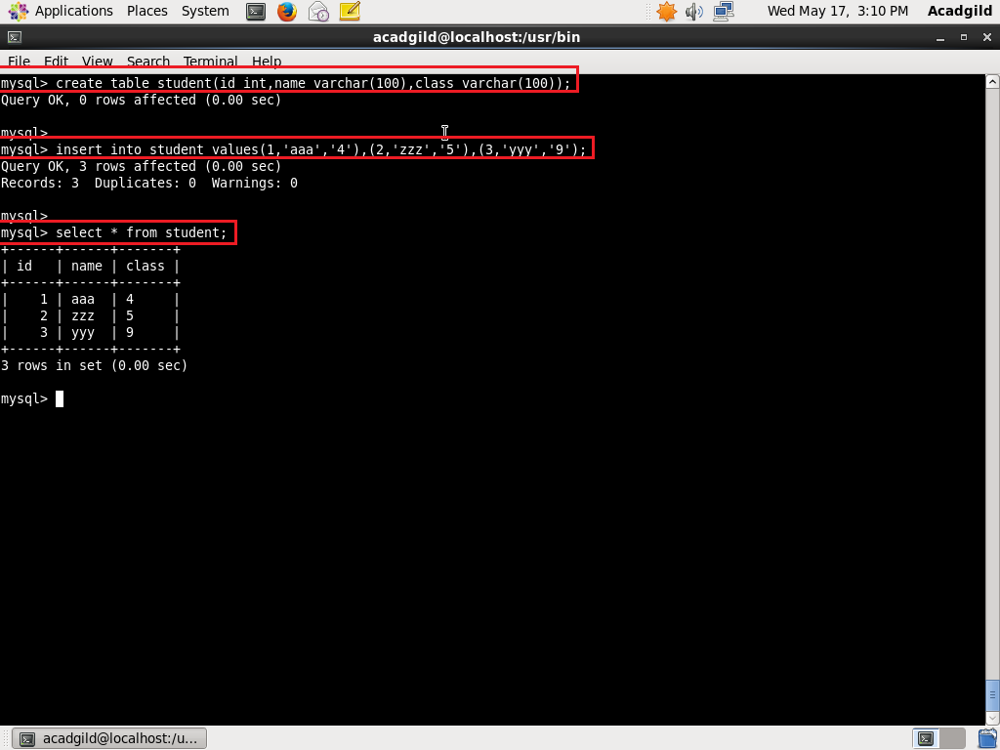

//SQOOP IMPORT COMMAND

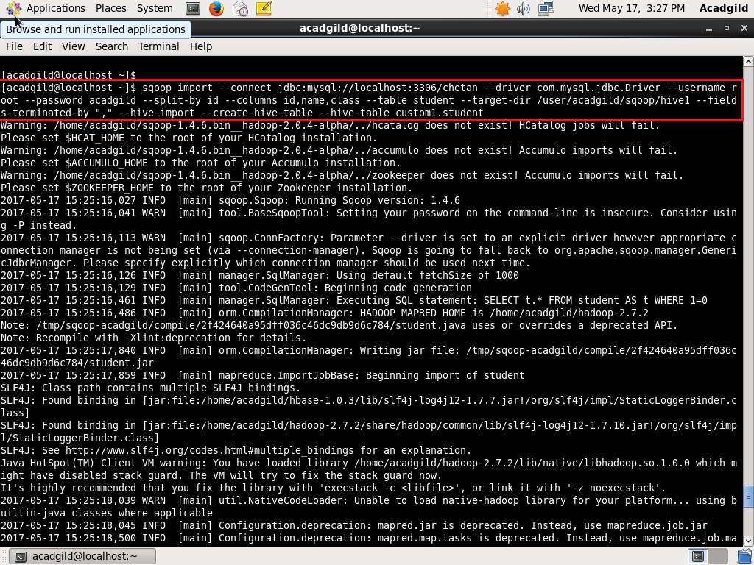

//HIVE IMPORT COMPLETE

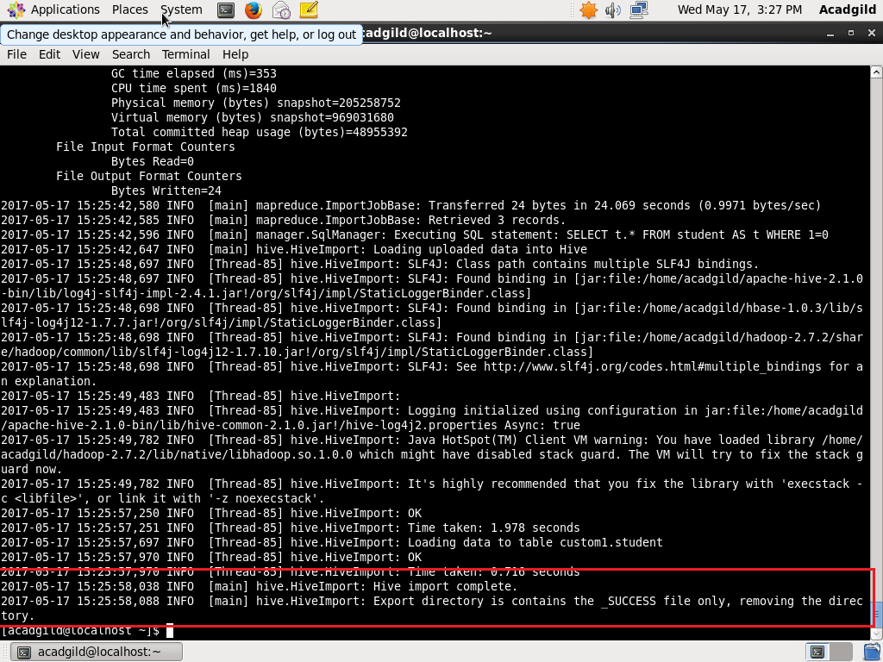

//DISPLAYING CONTENTS OF TABLE IN HIVE

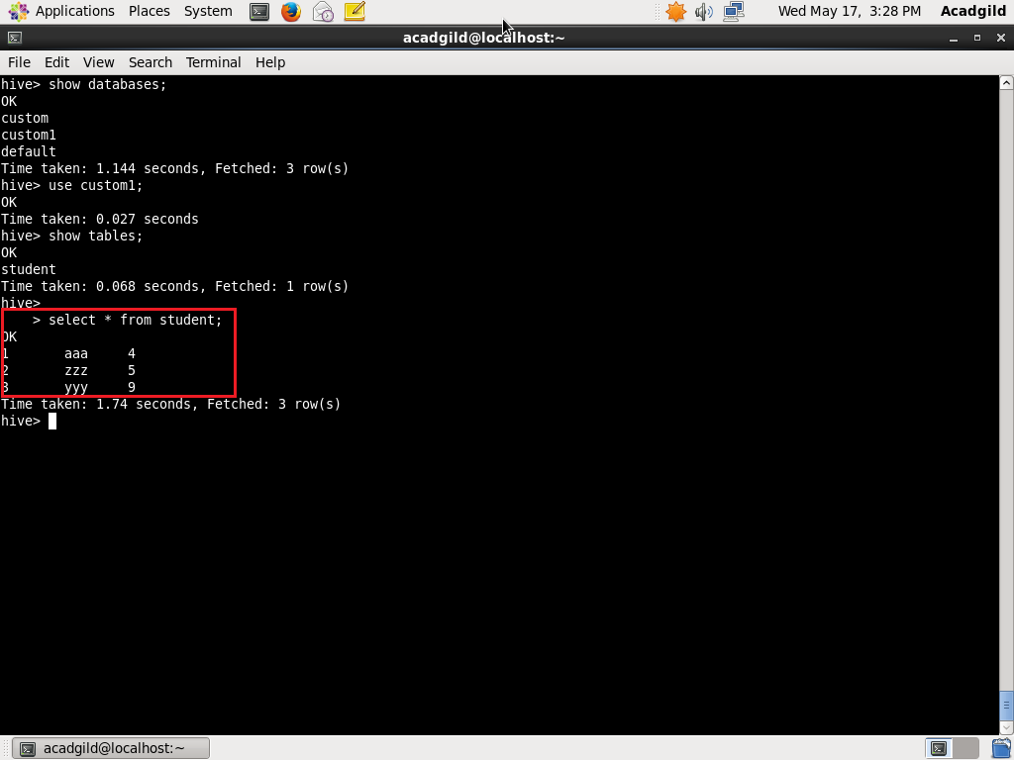

**Q2-**

//CREATING TABLE IN MYSQL, INSERTING DATA AND DISPLAYING RECORDS



//CREATING TABLE IN HBASE

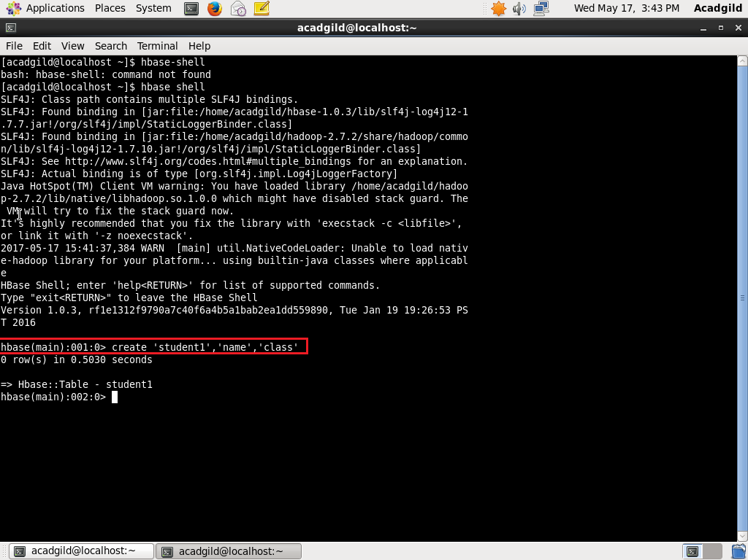

//SQOOP IMPORT FOR COLUMN FAMILY NAME

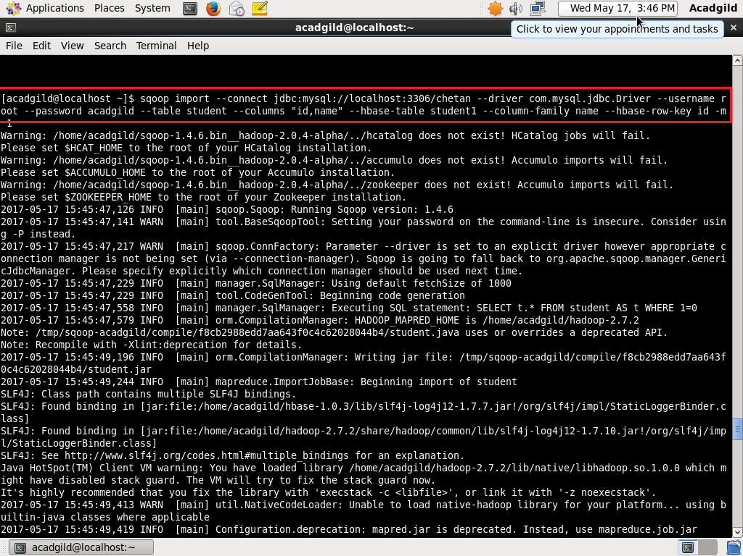

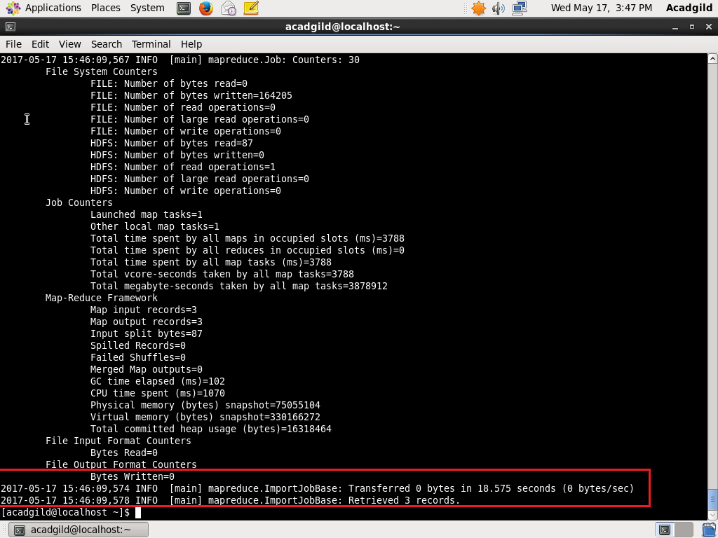

// SQOOP IMPORT FOR COLUMN FAMILY CLASS

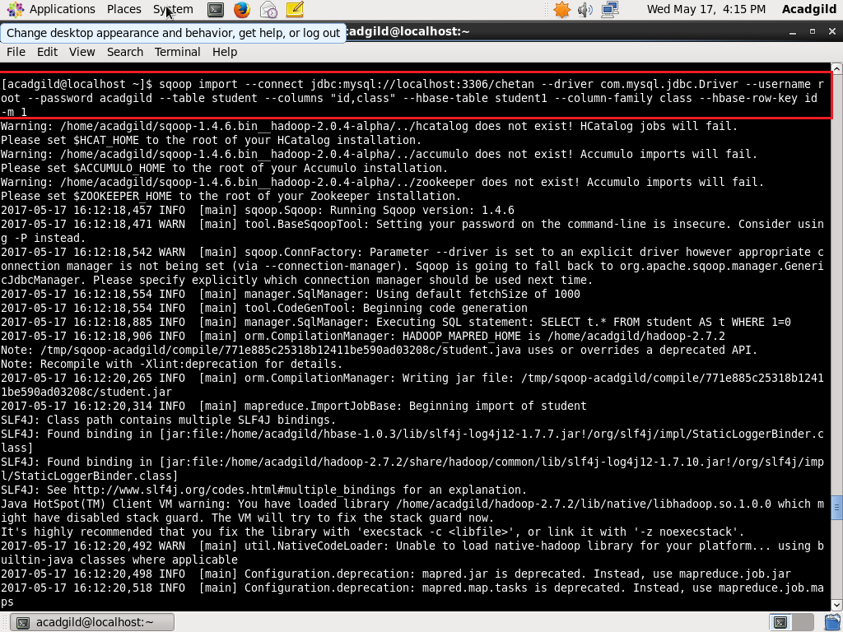

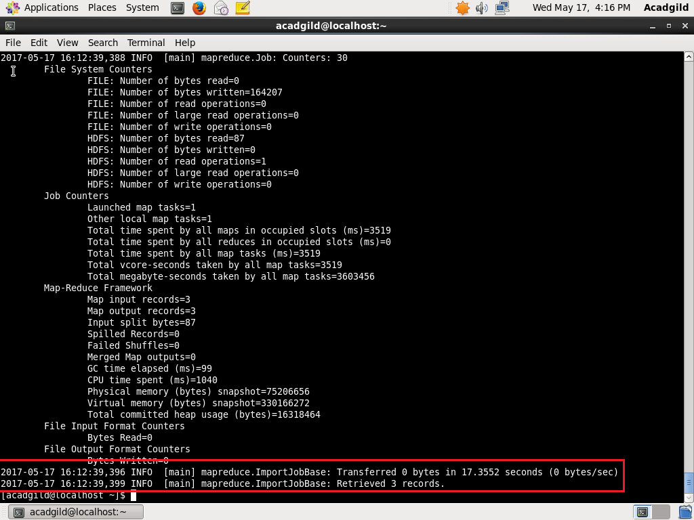

//DISPLAYING CONTENTS OF TABLE IN HBASE  
