**#Assignment5.3**

**Problem Statement:-**

**We are a dataset of movie data analysis Column Name: Column 1: User ID Column 2: Movie ID Column 3: Rating Column 4: Time stamp**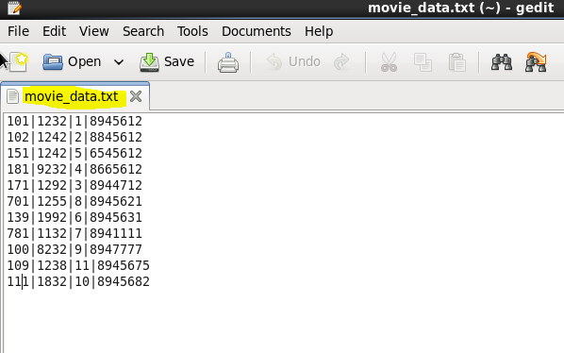

1. **Find the number of ratings given by each user:-**

**Driver:**

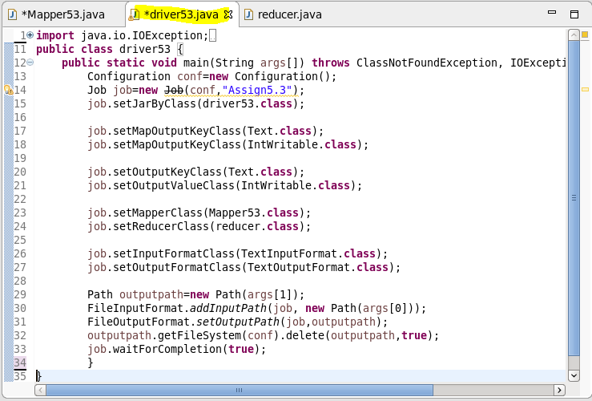

**Mapper:**

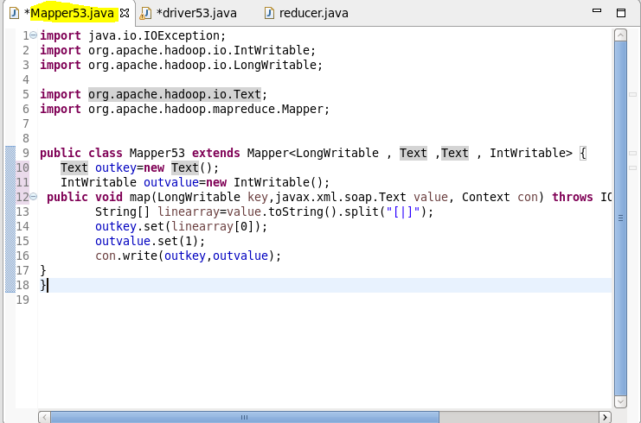

**Reducer:**

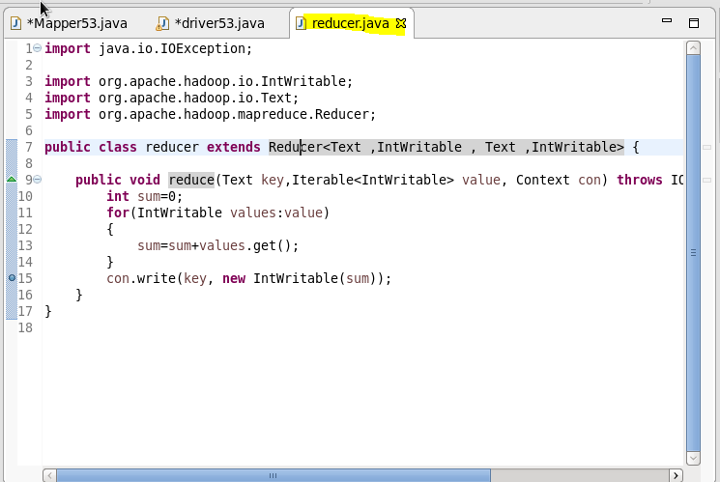

**Command:**

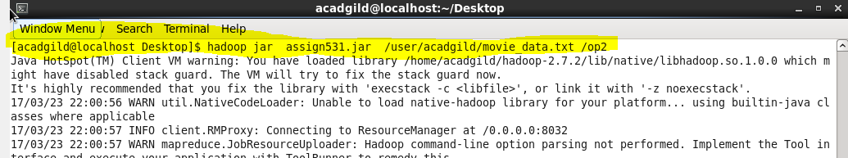

**Result:**

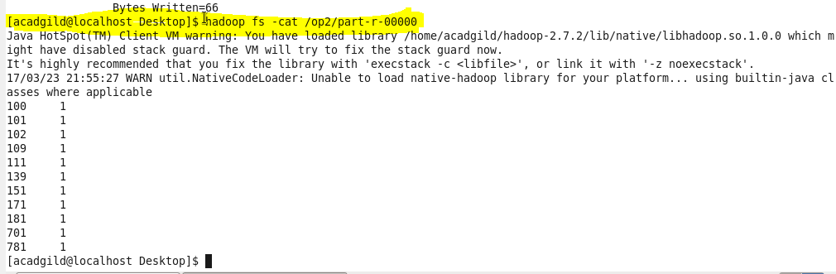

**2) Find the number of ratings received by each movie.**

**Driver:** 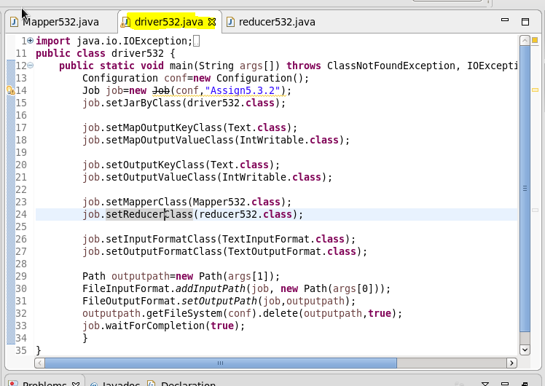

**Mapper:**

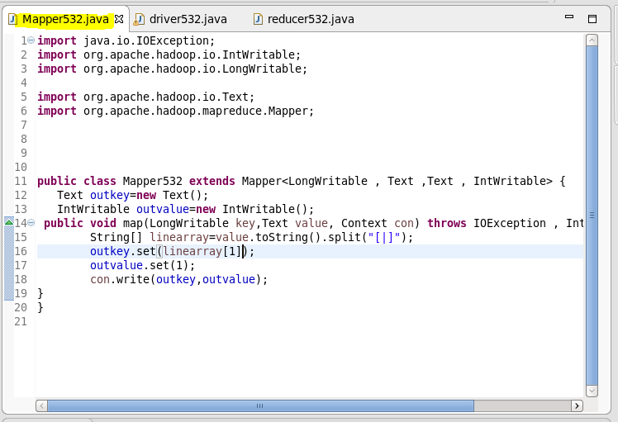

**Reducer:**

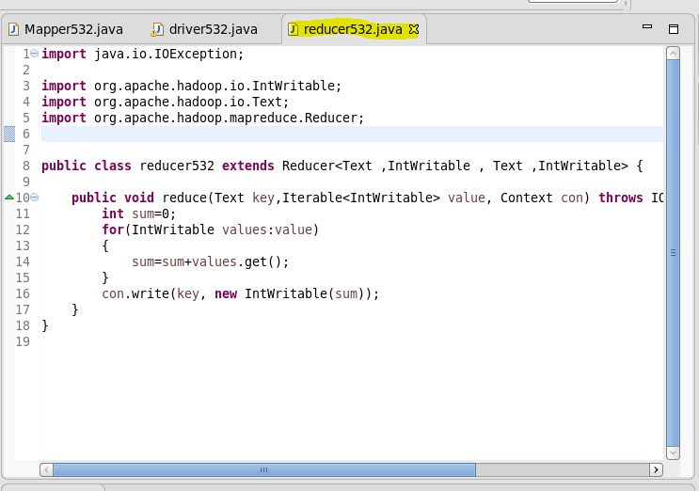

**Command:**

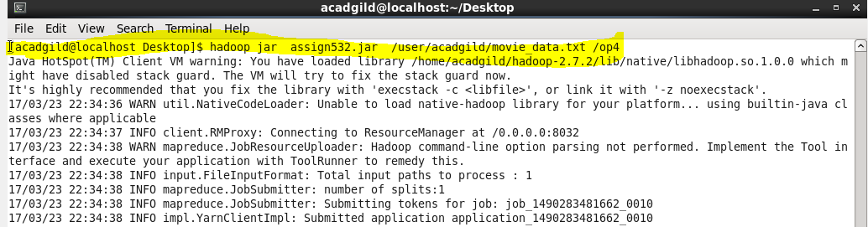

**Result:**

