**ASSIGNMENT 29.1**

**Problem Statement:**

Write a hive UDF that implements functionality of string concat_ws(string SEP, array). This UDF will accept two arguments, one string and one array of string. It will return a single string where all the elements of the array are separated by the SEP.

//dataset

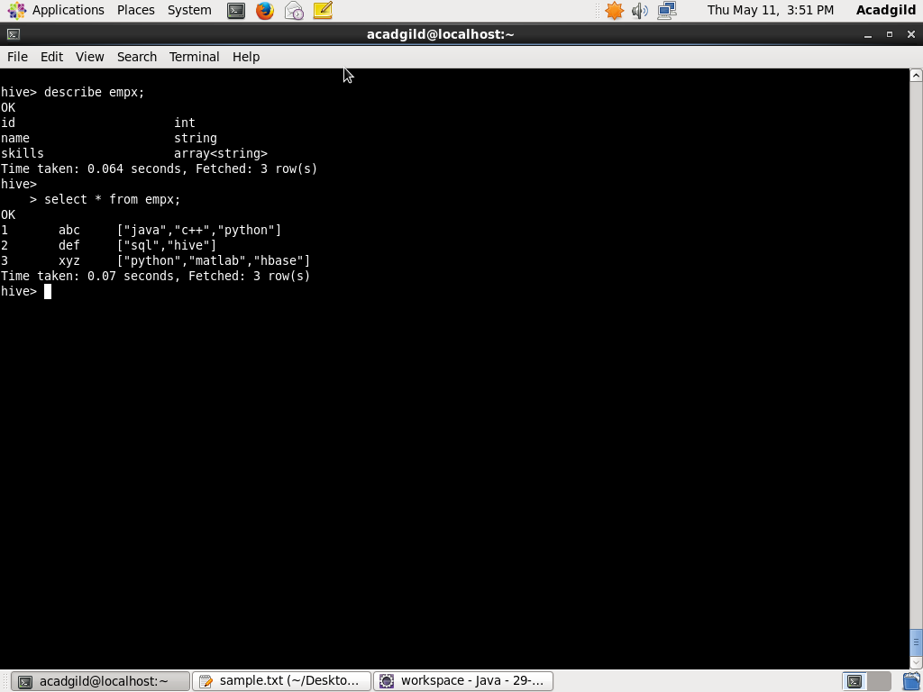

//java code

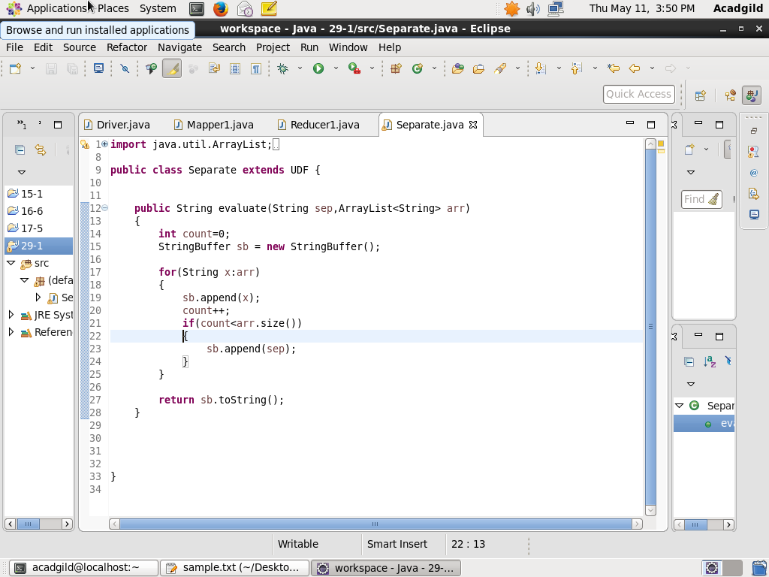

//adding jar, creating temp function and executing udf

