**ASSIGNMENT 16.5**

**PROBLEM STATEMENT:**

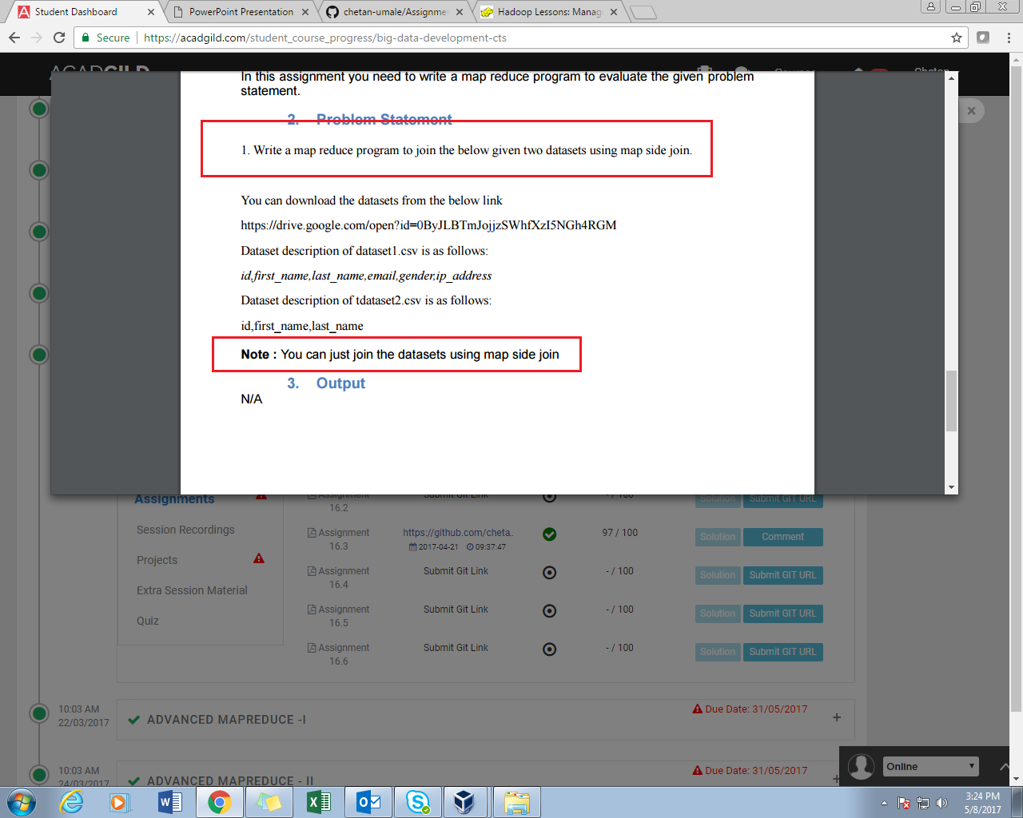

**PROGRAM:**

//DRIVER CLASS

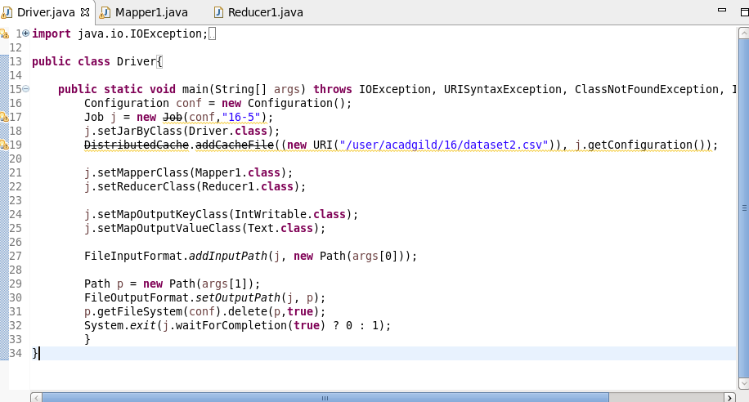

//MAPPER CLASS

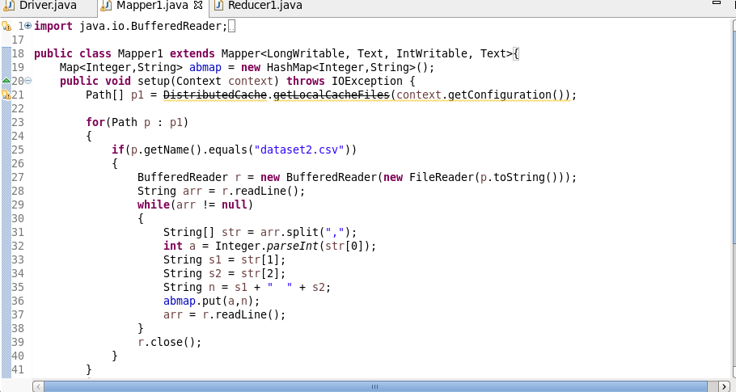

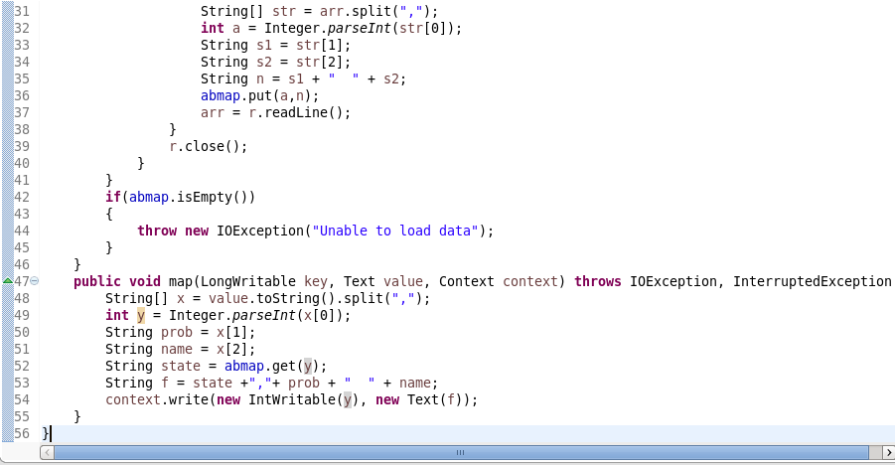

//REDUCER CLASS

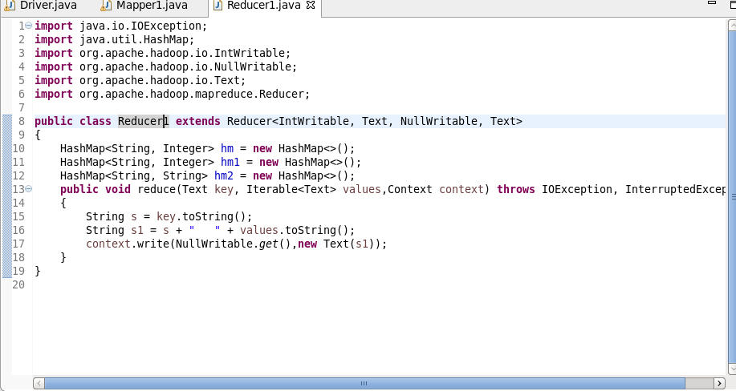

**EXECUTION COMMAND:**

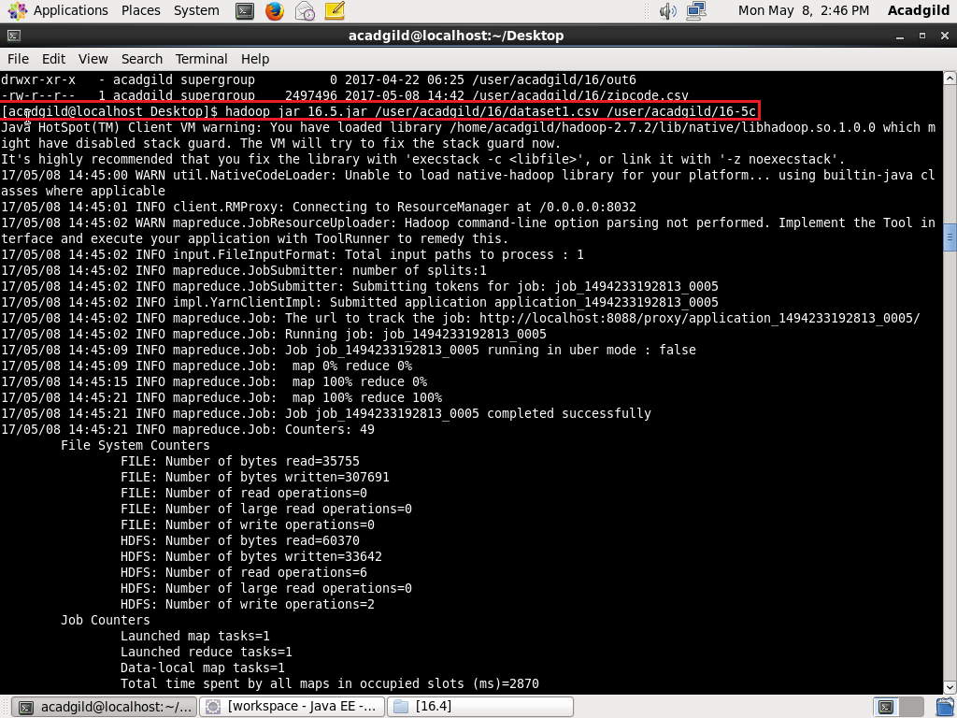

**OUTPUT:**

