**ITG US Business IT**



**ITG US Business IT**

**Applications Development**

**Electronic Death Match**

**Design Document**

|  |  |  |
| --- | --- | --- |
| Management: | Denise Murray | Project Manager |

**NOTICE**

**THIS DOCUMENT IS PROPRIETARY AND CONFIDENTIAL**

This document is the property of, and is proprietary to, MetLife, and it is protected under the copyright, trade secret and confidentiality laws of the United States and under international treaties. Please be aware that no part of this document may be reproduced in any form or by any means, electronic or mechanical, whether now known or later invented, including, without limitation by photocopying and recording, for any purpose without the express written consent of MetLife. In addition, due to the proprietary nature of MetLife methodologies and other information contained herein, this document and any derivative content may not be shown or otherwise disclosed to any third-party without the prior written consent of MetLife.

**© 2012 MetLife®**All Rights Reserved**.**

Contents

1. Revision history 5

2. Overview 5

3. In Scope: 6

4. Out of Scope: 8

5. Assumptions 9

6. Dependencies 11

7. High Level Architecture 12

8. Phase 1 Process: EXTRACT & RESPONSE 13

A. Extract Process: 13

**8.1 July, 2016 Release** 13

**8.2 September, 2016 Release** 13

**8.3 November, 2016 release** 13

**8.4 July, 2017 release** 14

**8.5 March, 2018 Release** 14

**8.6 November,2018 release** 17

**8.7 March,2019 release** 18

B. Response Process: 20

**8.9 July, 2017 release** 20

**8.10 November,2018 release** 27

9.PHASE 2 PROCESS: PIT and XML generation 28

A. PIT Process 28

**9.1 July,2016 Release** 28

**9.1** **September,2016 Release** 29

**9.2** **July,2017 release** 30

**9.3 November,2017 Release** 33

**9.4 July,2018 Release** 34

**9.5 November,2018 Release** 38

B. MDM XML Generation 38

**9.6 July, 2016 Release** 38

**9.7** **September,2016 Release** 39

**9.8 July,2017 release** 39

9.9 July,2018 Release 41

9.10 November,2018 Release 45

10.EDM INFA LAYER 45

**10.1 July,2016 Release** 46

**10.2 September,2016 Release** 48

**10.3 November,2016 Release** 51

**10.4 March,2017 Release** 52

**10.5 July,2017 Release** 53

**10.6 November,2017 Release** 57

**10.7 July,2018 Release** 61

**10.8 September,2018 Release** 61

**10.9 November,2018 Release** 61

**10.10 April,2019 Release** 62

11.Excessive Beneficiary address fix in Case Manager: 63

**EDM March 2018 Release- Group Life Strategic** 63

EDM Maestro Job Details 67

Appendix 71

# Revision history

| Version No. | Details of Change | Changed Sections |
| --- | --- | --- |
| 0.1 | Initial Version |  |
| 0.2 | Second version | Section 7 i.e. High Level Architecture added |
| 0.3 | Third version | Section 11 i.e. Excessive Beneficiary address fix in Case Manager added |
| 0.4 | Fourth version | Changes for BHF, KREBA, LTC and changes in filter condition added. |
| 0.5 | Fifth version | Extract Refine conditions added |
| 0.6 | Sixth Version | Extract Refine changes modification added. |
| 0.7 | Seventh Version | New filter conditions for Extract Refine changes added Section 8.8 modified. |
| 0.8 | Eighth Version | Filter conditions for Extract Refine changes removed as this is out of scope now. |

# Overview

The EDM Strategic platform will expand its capabilities to assess the death match results obtained from EDM contingency process and Lexis Nexis (as in EDM Phase 1) and establish a process to send and receive information/ inquired to and from EDM I&O interface.

# In Scope:

1. Extraction of global data from MDM Hub and send them to EDM Contingency Team.
2. ETL process will deliver the EDM death match results at a monthly frequency to the EDM I&O platform in XML File format based on INFA MDM XSD. This XML will contain the POINT IN TIME snapshot of the Global. POINT IN TIME denotes that time when the MATCH GRADE was associated with that global. One thing requires mention here that only Agreement related information will be captured in POINT IN TIME, other information like address, email, phone of the global, deceased contextual and beneficiaries is the current information.
3. Extract of Death confirmed records by DMBA to EDM I&O platform: DMBA will get suspect match results from GPM and return back the approved suspect match results which indicate Death confirmed records. These records will also be sent to EDM I&O platform.
4. A maximum of 20 contextual with the same role will be sent in the Extract to EIP in global.
5. A record will be loaded into C_L_EDM_RESULT table from the contingency file if any of FIRST_NM, LAST_NM, SSN, BIRTH_DT, D_FIRST_NM, D_LAST_NM, D_BIRTH_DT, SSN_FOR_MATCHED_NM or MATCH_GRADE changes for an already existing global in the C_L_EDM_RESULT table of Pre-Landing and Landing and in due course will be present in C_B_EDM_RESULT table of HUB.
6. Suppression of duplicate match results and suppression of lesser confidence match results from reaching the Business partners.
7. Sharing Best Matches with Case Manager.
8. Data Retention for Audit purposes.
9. Sending the unsuppressed XMLs to EIP via message queue.
10. WSTD Individual Customers from UIS admin system for Disability coverage is included in the EDM extract to EDM Contingency and suppression rule implementation in Informatica Layer.
11. UDA Inclusion to convert non suppressed death matches into XML format and sharing with Case Manager via EIP.
12. The in Scope Admin Systems for Extract Process are:

|  |  |  |
| --- | --- | --- |
| 1. IBDW_IDI | 1. IBDW_VNCH | 1. IBDW_PMF |
| 1. IBDW_SBR | 1. IBDW_VTG1 | 1. IBDW_SPVL |
| 1. TCA | 1. IBDW_VTRD | 1. IBDW_TVUL |
| 1. CRIL | 1. ATLS | 1. IBDW_ULS |
| 1. LTC | 1. GUL | 1. IBDW_VARI |
| 1. CYBR | 1. GVUL | 1. IBDW_VCS1 |
| 1. IBDW_COVA | 1. TERM | 1. IBDW_VENT |
| 1. IBDW_IDST | 1. IBDW_ANNH | 1. IBDW_PAS |
| 1. IBDW_LCDS | 1. IBDW_CV15 | 1. IBDW_MRPS |
| 1. IBDW_LCFS | 1. IBDW_EV15 | 1. IBDW_MPST |
| 1. IBDW_MCAM | 1. IBDW_LCMP | 1. IBDW_VCAP |
| 1. UIS_SEGO | 1. UIS_SEGD | 1. UIS_SEGE |
| 1. UIS_SEGA | 1. UIS_SEGB | 1. UIS_SEGC |
| 1. UIS_SEGF | 1. UIS_SEGH | 1. UIS_SEGI |
| 1. UIS_SEGJ | 1. UIS_SEGK | 1. UIS_SEGL |
| 1. UIS_SEGM | 1. UIS_SEGN | 1. UIS_SEGP |
| 1. UIS_SEGR | 1. UIS_SEGT | 1. UIS_SEGU |
| 1. UIS_SEGV | 1. UIS_SEGW | 1. UIS_SEGX |

1. The in Scope Admin Systems for MDM XML Generation and INFA Layer Processes are:

|  |  |  |
| --- | --- | --- |
| 1. IBDW_IDI | 1. IBDW_VNCH | 1. IBDW_PMF |
| 1. IBDW_SBR | 1. IBDW_VTG1 | 1. IBDW_SPVL |
| 1. TCA | 1. IBDW_VTRD | 1. IBDW_TVUL |
| 1. CRIL | 1. ATLS | 1. IBDW_ULS |
| 1. LTC | 1. GUL | 1. IBDW_VARI |
| 1. CYBR | 1. GVUL | 1. IBDW_VCS1 |
| 1. IBDW_COVA | 1. TERM | 1. IBDW_VENT |
| 1. IBDW_IDST | 1. IBDW_ANNH | 1. IBDW_PAS |
| 1. IBDW_LCDS | 1. IBDW_CV15 | 1. IBDW_MRPS |
| 1. IBDW_LCFS | 1. IBDW_EV15 | 1. IBDW_MPST |
| 1. IBDW_MCAM | 1. IBDW_LCMP | 1. IBDW_VCAP |
|  |  |  |

|  |  |  |
| --- | --- | --- |
| 1. IBDW_IDI | 1. IBDW_VNCH | 1. IBDW_PMF |
| 1. IBDW_SBR | 1. IBDW_VTG1 | 1. IBDW_SPVL |
| 1. TCA | 1. IBDW_VTRD | 1. IBDW_TVUL |
| 1. CRIL | 1. ATLS | 1. IBDW_ULS |
| 1. LTC | 1. GUL | 1. IBDW_VARI |
| 1. CYBR | 1. GVUL | 1. IBDW_VCS1 |
| 1. IBDW_COVA | 1. TERM | 1. IBDW_VENT |
| 1. IBDW_IDST | 1. IBDW_ANNH | 1. IBDW_PAS |
| 1. IBDW_LCDS | 1. IBDW_CV15 | 1. IBDW_MRPS |
| 1. IBDW_LCFS | 1. IBDW_EV15 | 1. IBDW_MPST |
| 1. IBDW_MCAM | 1. IBDW_LCMP | 1. IBDW_VCAP |
|  |  |  |

1. LOB wise Admin System

|  |  |
| --- | --- |
| LOB | Admin System |
| SBR | SBR |
| Group Benefits – CII/WSTD | CRIL |
| UIS (WSTD) |
| Non-Medical IDI | IDI |
| Non-Medical LTC | LTC |
| TCA | TCA |
| Retail Annuities | ANNH |
| CV15 |
| EV15 |
| LCMP |
| MRPS |
| VCAP |
| RIS | ACE |
| GPAY |
| PCTS |
| VRPS – RIS |
| Individual Life | CYBR |
| IDST |
| LCFS |
| MPST |
| PAS |
| PMF |
| TVUL |
| ULS |
| VARI |
| VCS1 |
| VENT |
| VNCH |
| VTG1 |
| VTRD |
| SPVL |
| LCDS |
| COVA |
| MCAM |
| Group Life | ATLS |
| GUL |
| GVUL |
| UIS |

# Out of Scope:

1. Admin systems other than the one mentioned in in scope section are out of scope.
2. Death matching process.
3. No Enrichment/Enhancement will be done on the extracted information.
4. LexisNexis:
   1. Secure transmission and receiving of files to/from LexisNexis
   2. Generation of file error reports (will be done by LexisNexis)
   3. TPAs, UDAs, spreadsheets and other data that is not in scope of EDM will not be matched by the vendor.
   4. Creating Cases and Tasks from LexisNexis sourced data for outreach and investigation.
   5. Creating additional or updating existing internal GPM reports with LexisNexis data.
   6. Existing production routing rule where a multi-match for a single global gets routed to the IDD work queue will be removed.
5. Display LexisNexis Best Customer Data and Deceased Middle Name in IDD.
6. ETL process will not be impacted by change in any of rules implemented by MDM process and implementing any of those is out of scope of GPM. Also changes to any Data Standardization logic in Trillium end which might affect the death matching process for first name and last name will not be in scope of ETL process.
7. Data quality of related party request coming from EDM I&O or related party appended from Acxiom is out of ETL scope.
8. Global death matches which hold only TPA records will be excluded from GPM EDM extract to EDM I & O regardless of match grade. Also the contextual for a global that belong to eDPM or UIS ELIGBLE is out of scope of GPM ETL and it will not be sent to EDM I&O.
9. Death Suppression Indicator and Related party data will be populated in GPM Strategic ETL process.
10. LOB suppression rule for TCA based on Registration lines is out of scope.
11. Changes to Match Patterns & Algorithms.
12. MDM data load is out of scope for ETL.
13. Population of records in MDM HUB
14. Routing of Suppressed XML to another location.
15. Any changes to EIP layer.
16. Sending the values to RIS is not in Scope for Informatica GPM.
17. Any conversion or enhancements on the attributes to the Case Manager other than mentioned in the BRD.
18. UDA input file validation and enrichment.
19. LOB derivation for UDA.
20. TPA inclusion.
21. Implementation of any suppression rules for UDA apart from LOB suppression
22. UDA data storage in GPM.
23. Splitting into multiple result and multiple suspect files as per LOB for UDA process. Sam will develop a separate process and design document.
24. Death Matching of Group Life Admin Systems not in GPM (TPA’s and other Group Life MetLife files (Except GUL/TERM, GVUL, ATLAS, UIS)).
25. Sending all the cases from Netview to CM for a one-time migration is not in scope for ETL.
26. File encryption/decryption and transmission using MFT is out of scope.

# Assumptions

1. The data in Extract file will contain only global data.
2. The response file will contain all the 9-point Match Grade.
3. GPM_PRE.C_L_EDM_ENRICH and GPM_ORS.C_B_EDM_ENRICH tables in the GPM database will store LN Best match attributes from Lexis Nexis for deceased records. It can also accommodate the non-deceased enriched data from Lexis Nexis for future release unless and until there is a requirement to store the enriched data from Lexis Nexis as separate contextual parties in GPM.
4. Business will identify the percentage of the identified populations on the basis of Admin System and Agreement status which is to be included within the next cycle.
5. There will be no impact in GPM DB for implementation of UDA.
6. For UDA, Death matches from Adhoc file will be filtered in Informatica EAD layer and will not be sent to CM.
7. GPM will receive UDA files on a weekly basis.
8. GPM Informatica EAD will share the XML files with EIP through the same Queue Manager which is used in GPM EDM strategic unsuppressed XML sending process.
9. Cases will be created in T_EDM_CASE table, for every unsuppressed Global sent to case manager.
10. ETL process will not insert, update or delete records from GPM ORS schema. Also audit table is loading is required.
11. Related Party information & Death Suppression Indicator should be present in the GPM database.
12. XML extract file creation will be executed on a monthly basis after EDM death match process which runs normally on 2nd Saturday of month.
13. GPM does not send notifications to Business when a match result is provided to I & O. There are no new business notifications being built for EDM Phase 2 coming out of GPM.
14. LexisNexis:
    1. LexisNexis Matching will perform the Death Match process against the best version of the customer (i.e. the Global Profile) and not the direct admin source version of the customer.
    2. With the addition of LexisNexis Matching, existing functionality of the EDM process will not change unless otherwise listed in this document. LexisNexis will act as additional source of match results and improve the I&O process with better matches.
    3. As per current existing process, Match results will be a point in time determination i.e. No updates or changes are made as records are merged or unmerged. Match results reflect the state of the global and contextual condition at the time of match creation, more specifically: at the point in time when the death match process ran.
    4. LexisNexis will not send match scores that is not agreed upon. Such matches if it comes will be routed to IDD.
    5. Only records for which LexisNexis found Death Match will be included in the response file. Parties for which no match found will not be included.
    6. LexisNexis will always send a response and a control file corresponding to each input file shared by MetLife, even if the response file is empty.
    7. LexisNexis will send an error file if any error encountered.
    8. LexisNexis will only send one match per global per cycle.
    9. The number of matches will increase by a measurable amount for all Lines of Business.
    10. Death match will continue to be performed and results will continue to be shared via Case Manager as early in the calendar month as is possible.
15. As confirmed by MDM Global GPM UUID will be the same for a particular global at any point of time.

# Dependencies

1. Informatica should be up and running.
2. Database should be up and running.
3. Mainframe Trillium should be providing the source Policy file.
4. Data in the source file (policy file) should be present in proper position.
5. EDM contingency process should provide the proper MATCH_GRADE information for global parties.
6. All environmental dependencies required for successfully running GPM ETL EDM jobs remains unchanged—Informatica Power Center up and running, EIP Queues are up and running and GPM DB up and running.
7. GPM Mainframe team will map Termination Reason Code from source system and will provide data to GPM ETL process.
8. Termination Reason Description for Corresponding Termination Reason Codes is being provided by the Business and any updates/addition to the same henceforth shall also be provided by the Business.
9. EDM contingency process should provide the proper MATCH_GRADE information for global parties.

# High Level Architecture

GPM HUB

EDM Extract for all In-scope Admin systems

MLDMF

Lexis Nexis

BIOS

EIP

RMT

Infa Layer

MDM XML

MLDMF Response File

Lexis Nexis Response File

Extract to be sent to BIOS to fetch suppression

Receive Suppression indicators from BIOS

CASE MANAGER

Netview

Unsuppressed XMLs

MDM HUB

Case and Task ID will be appended in the strategic intermediate file

Case Indicator and Task indicator for tactical BIOS will be fetched from Family Reunion Database and appended in tactical file

Load Death Match

All the actionable Global in T_PARTY_AGMT_STG table & Global in T_GLB_PARTY_STG table.

BIOS tactical file will send through DET

DET

Merge

Family Reunion Database

# Phase 1 Process: EXTRACT & RESPONSE

# Extract Process:

The in scope global records are fetched from MDM database. The extract for MLDMF contains First name, Last name, SSN, DOB etc. In the Lexis Nexis extract contains address field in addition to the fields sent to MLDMF. The Extract is then sent to EDM Contingency team(MLDMF) and Lexis Nexis team for the death matching.

## **8.1 July, 2016 Release**

**CR 55**

1. Global Records having at least one contextual belonging to one or more of the following Admin Systems:

CYBR, IBDW_COVA, IBDW_IDST, IBDW_LCDS, IBDW_LCFS, IBDW_MCAM, IBDW_ MPST, IBDW_PMF, IBDW_ PAS, IBDW_SPVL, IBDW_TVUL, IBDW_ULS, IBDW_VARI, IBDW_VCS1, IBDW_VENT, IBDW_VNCH, IBDW_VTG1, IBDW_VTRD, IBDW_SBR, IBDW_IDI, TCA, CPD, CRIL and Non-Medical LTC will be selected for extract process.

1. All the extracted records will be sent to EDM contingency for death match process.

## **8.2 September, 2016 Release**

**QC 43904(Change request)**

1. As per defect 43904 (CR), LOB filter for EDM extract process will be modified for “Hyatt Legal”, it will be replaced with “Legal services”.

## **8.3 November, 2016 release**

**CR 55 & CR 11**

1. As a part of the EDM 2016 November Release, Admin Systems belonging to **Retail Annuities** LOB are also being considered as in scope Admin Systems along with the existing list of In-scope Admin Systems.
2. As a part of this inclusion, global records which have at least one contextual belonging to the below mentioned Admin Systems will be sent to EDM Contingency for Death Matching Process.
   * IBDW_ANNH
   * IBDW_LCMP
   * IBDW_VCAP
   * IBDW_MRPS
   * IBDW_CV15
   * IBDW_EV15
   * IBDW_EV15
   * VRPS (All company code values will be sent to EDM Death Process—Discussed with Business and EDM Program Team on 9/29/2016)

## **8.4 July, 2017 release**

**WSTD: -**

WSTD individual customers from UIS admin system having coverage code as ‘WD’ and LOB as ‘DISABILITY’ will be included in the EDM Extract.

## **8.5 March, 2018 Release**

**ETL Process Changes: LexisNexis**

**LexisNexis Extract**

GPM ETL will send GPM Global Party data to LexisNexis for Death Matching on a monthly basis. These Parties are from EDM in-scope admin systems. This extract will be similar to EDM Strategic Death Match extract with some additional fields. For a monthly cycle both extract will have same set of global.

LexisNexis extract will have a file structure with pipe delimited. There will be one Control file containing LN extract file name, total records in the extract and date. Example: For June run, there are 12 million records. So, there will be 1 Data File and 1 Control File. Following is the data loading process for Lexis Nexis.

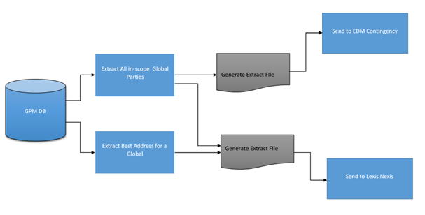

File Format to be followed for LexisNexis Extract:

|  |  |  |
| --- | --- | --- |
| **File Name** | **File Format** | **Example** |
| Input Data File | LEXISNEXIS_EXTRACT_<MMDDYYYYHHMMSS>_<Sequence #>.TXT | LEXISNEXIS_EXTRACT_12142017123035_1.TXT |
| Control File | CTRL_LEXISNEXIS_EXTRACT_<MMDDYYYYHHMMSS>.TXT | CTRL_LEXISNEXIS_EXTRACT_12142017123035.TXT |

The GPM data file shared with the vendor will include following fields:

|  |  |
| --- | --- |
| **Field** | **Field Description** |
| GPM_GLOBAL_ID | GPM ID for Global Party (Key) |
| PARTY_ID | Party Id |
| FIRST_NM | Global First Name |
| LAST_NM | Global Last Name |
| MIDDLE_NAME | Global Middle Name or Middle Initial (if available on the global record) |
| GENERATION | Global Suffix (Generation) (Jr., Sr., III, etc.) (if available on the global record) |
| DOB | Global Birthdate (if available on the global record) |
| SSN | Global SSN (if available on the global record) |
| ADDR_LINE_1 | Street Address Line 1 (if available on the global record) |
| ADDR_LINE_2 | Street Address Line 2 (if available on the global record) |
| ADDR_LINE_3 | Street Address Line 3 (if available on the global record) |
| ADDR_LINE_4 | Street Address Line 4 (if available on the global record) |
| CITY | City (if available on the global record) |
| STATE | State Code (if available on the global record) |
| POSTAL_CD | Zip 5 (if available on the global record) |
| POSTAL_EXTENSION_CD | Zip 4 (if available on the global record) |
| ADDR_ID | Address Id (if available on the global record) |

Control File will have following fields populated:

|  |  |
| --- | --- |
| **Field** | **Field Description** |
| MET_DATA_FILE_NM | This is the name of the data file to be sent. |
| MET_RECORD_COUNT | This is the date when the file is extracted. |
| MET_FILE_DT | This is the total number of records in the file. |
| LN_DATA_FILE_NM | To be populated by Lexis Nexis |
| LN_RECORD_COUNT | To be populated by Lexis Nexis |
| LN_FILE_DT | To be populated by Lexis Nexis |

**Best Address Logic**

For Best Address selection following algorithm will be implemented:

1. Select the most recent and complete address:
2. Where most recent means the address with the most recent MDM last update timestamp.
3. Where complete means the address having all the following fields populated
   * 1. Address Line 1
     2. City
     3. State
     4. Zip
4. If there are multiple complete addresses with the same last updated timestamp, then select the complete 'Acxiom best address'.
5. If there are multiple complete Acxiom best addresses, then
6. If all are same, then select one of them
7. If all are different then select the complete ‘Acxiom enriched address’
8. If there are multiple complete Acxiom enriched addresses, then
9. If all are same, then select one of them
10. If all are different then select the complete ‘MetLife address’
11. If there are multiple complete MetLife addresses, then
12. If all are same, select one of them
13. If they are different then select any one of them randomly
14. If there is no complete address i.e. all the addresses are incomplete, then repeat step 1 to 5 to select the best incomplete address.

## **8.6 November,2018 release**

**ETL Process Changes:**

* While generating LexisNexis Extract, the following attributes: Admin System, Policy Status and Role will be parameterized so that changes to include or exclude these values can be handled at the Script level for the Lexis Nexis Extract. Percentage calculation will be only based on Agreement Status and Admin System.
* Business will provide filter to select underlying arguments based on filter of Admin System and Agreement status field and the percentage of the identified populations to be included in the Extract for each phase.

**Approach for sharing data with Lexis-Nexis Phase wise:**

1. According to the phased approach, GPM will send global party data to LexisNexis to perform death matching. The data will be sent in four phases over 12 months. The phases will be 90 days apart. So, in total 4 phases of data will be shared with Lexis Nexis.
2. The LN Extract will be cumulative. Each phase will include the population shared in the previous phase. Hence, the Phase 4 will include full extract.
3. The percentage of population to be included for each extract prior to each phase will be shared by the business 3 weeks prior to the date when the extract has to be created (a percentage file will be created).
4. For throttling each population, business will have 5 options: 0%, 25%, 50%, 75% and All Remaining (“All Remaining” qualifier can and sometimes will be used to send an entire population all at once in a single cycle).
5. After generating the LN Full Extract for In-Scope Global, an Extract will be generated after joining the LN Full Extract with intermediate file to fetch Source system, Agreement status and Role.

|  |  |  |  |  |
| --- | --- | --- | --- | --- |
| **Global ID** | **LN EXTRACT INFO** | **Admin System** | **Policy Status** | **Role** |
| G1 | LN1 | PMF | ACTIVE | INSURED |
| G1 | LN1 | PMF | NOINPUT | INSURED |
| G1 | LN1 | IDST | ACTIVE | INSURED |

1. Global will be selected from the file generated above file on the basis of the Percentage file (containing admin system, percentage and status) and the selected global will be dumped into a semifinal LN extract.
2. The Semifinal LN Extract file is being sorted in ascending order based on Global Id. All the records for that combination will be included from the first line, so that Global which have been shared in previous phase will be include in the next phase.
3. After the LN extract file has been sorted on the basis of global id, Deduplication logic will be applied to get rid of duplicate Globals and the final LN extract will be generated.
4. Generated LN Extract file will be sent to LexisNexis via DET.

|  |  |  |
| --- | --- | --- |
| **Cycle 1 (Confirmed)** | | |
| Source | Target | Percentage |
| PIOS (PMF) | All Records | 100.00% |
| INDUSTRIAL | All Records | 100.00% |
| GROUP LIFE | ACTIVE customers | 25.00% |
| SBR (Vantage-One) | ACTIVE customers | 25.00% |
| UIS | All Records | 100.00% |

|  |  |  |
| --- | --- | --- |
| **Cycle 2 (Anticipated)** | | |
| Source | Target | Percentage |
| PIOS (PMF) | All Records | 100.00% |
| INDUSTRIAL | All Records | 100.00% |
| GROUP LIFE | ACTIVE customers | 50.00% |
| SBR (Vantage-One) | ACTIVE customers | 50.00% |
| UIS | All Records | 100.00% |
| Remaining Retail Life | ACTIVE customers | 33.30% |

**NOTE**: UIS will include all 4 Customers from Group Life & WSTD LOB.

## **8.7 March,2019 release**

* **CR008:** **BHF-Only Customers from LN Prod Extracts**

As a part of this release, EDM shall exclude only BHF Customers in the EDM monthly LN extract for March, June, September and beyond and produce match results as per the EDM Strategic design.

Global associated with only BHF customers will be excluded from LN extract.

* **UIS-KREBA Integration**

EDM shall include all KREBA Group UIS Customers in the EDM monthly extract and produce match results as per the EDM Strategic design. In scope are the following Group Customers and their respective customer number and coverage codes

**Coverage Codes:** SB

**Group Customer Number:** 7158484

GPM shall pass all the EDM results downstream to Case Manager and other supporting systems. Within the match result, the process shall pass all pertinent customer information downstream for the purpose of suppression, routing and producing cases and tasks on Case Manager.

The process shall provide the following to Case Manager and Cognos Reporting

* UIS Derived Person Status
* UIS Person Employee Number
* UIS Coverage Codes
* UIS Customer Name (KREBA)
* UIS Customer Number (7158484)
* UIS Coverage Start Date
* UIS Coverage Stop Date (a stop date will be used to derive Deceased status)

**Match Suppression Rules**

* The process shall suppress match results where a person is in a Deceased status
* The process shall suppress records in a Deceased Derived Status
* The process shall suppress match results if the account is in BIOS as an Open, Closed or Paid status.
* The process shall store suppressed matches as per current design for audit and traceability purposes.
* The process shall duplicate-suppress match results at the person/group ID level as per existing “9 points of data” duplicate suppression rules.
* **CR007c: Remove VRPS from Cycle 2**

In the cycle 2 extract, we send the cumulative of cycle 1(the conditions are attached in appendix) along with the cycle 2 conditions. In cycle 2 extract the following conditions are implemented.

* All remaining Retail Life
* All remaining SBR (approximately the remaining 75%)
* All of TCA
* All of IDI
* All of LTC
* All of Critical Illness
* Half (as close as reasonably possible) from each of RIS’s source systems ACE, PCTS, GPAY
* Half (as close as reasonably possible) of the remaining Group Life.

In cycle 3 extract, the full extract of GPM in scope customers is included, i.e. it includes the following conditions are implemented.

* All of MetLife Holdings Annuities (included are all retail VRPS company codes)
* The remaining Group Life records (approximately the other half of the 75% that remained after cycle 1
* All remaining RIS customers

# Response Process:

In the response process the response file from both MLDMF and Lexis Nexis is received. In these files we receive the matched records for the deceased parties only. Based on the 9 Point Match grade which consists of First Name, Last Name, SSN, DOB, Deceased First Name, Deceased Last Name Deceased SSN, Deceased DOB and match grade we load the data in response table. The MLDMF response file contains all the possible matches for the extract records. The Lexis Nexis file contains only 1 matched enriched record.

# 8.9 July, 2017 release

**LexisNexis Response**

LexisNexis will perform death match and send the response file back to GPM ETL. This

response file will contain details of all the MetLife customers who are deceased. LexisNexis will

return a response file for the data file sent by GPM even if the response is an empty file i.e. no

matches found for the customer’s information present in the data file. If an error is encountered

an error file will be returned with erroneous records. The response file will be pipe delimited.

**Example:** For June run, there are 12 million records. So, there will be 1 Data File and 1

Control File and 1 Error File (If any error encountered).

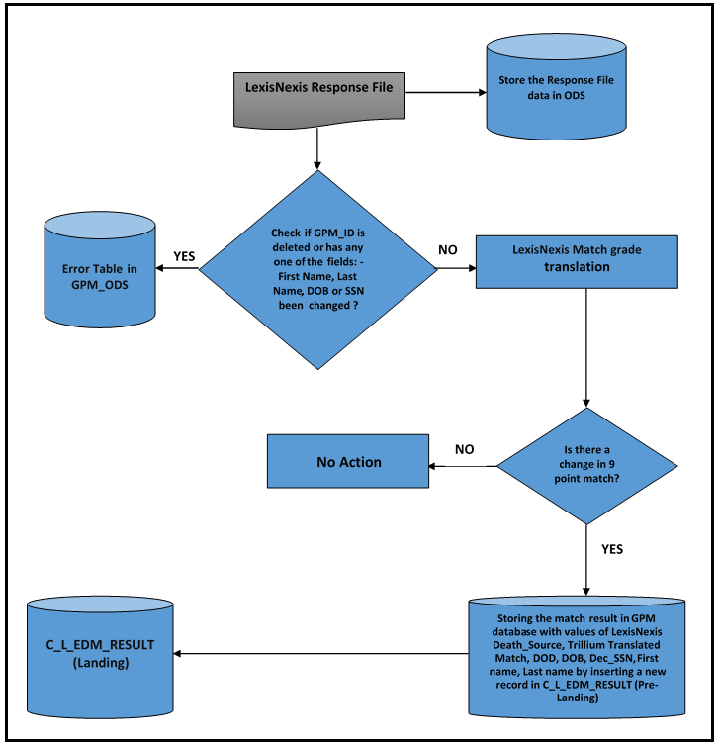

File format for Response from LexisNexis:

|  |  |  |
| --- | --- | --- |
| **File Name** | **File Format** | **Example** |
| Response Match File | LEXISNEXIS_RESPONSE_<MMDDYYYYHHMMSS>_<Sequence #>.TXT | LEXISNEXIS_RESPONSE_12142017123035_1.TXT |
| Error File | LEXISNEXIS_RESPONSE_<MMDDYYYYHHMMSS>.ERR | LEXISNEXIS_RESPONSE_12142017123035.ERR |
| Control File | CTRL_LEXISNEXIS_RESPONSE_<MMDDYYYYHHMMSS>.TXT | CTRL_LEXISNEXIS_RESPONSE_12142017123035.TXT |

The LexisNexis match results files shall be in the following format:

|  |  |  |
| --- | --- | --- |
| **Source** | **Current Layout** | **Description** |
| Input | Global ID | Input Data |
| Input | Party ID | Input Data |
| Input | FirstName | Input Data |
| Input | LastName | Input Data |
| Input | MiddleName | Input Data |
| Input | SUFFIX | Input Data |
| Input | DOB | Input Data |
| Input | SSN | Input Data |
| Input | AddressLine1 | Input Data |
| Input | AddressLine2 | Input Data |
| Input | AddressLine3 | Input Data |
| Input | AddressLine4 | Input Data |
| Input | CITY | Input Data |
| Input | State | Input Data |
| Input | ZIP | Input Data |
| Input | Zip4 | Input Data |
| Input | GPM Address ID | Input Data |
| Deceased | Death_Source | Identifies where the hit came from Two possible values: |
| SSA = social Security Adm DMF |
| SUP = Supplemental (everything else) |
| Deceased | DCD_Match | Applicable combinations of the below Lexis Match Codes |
| (LexisNexis Match Codes) | SE = SSN Exact |
|  | SF = SSN Fuzzy |
|  | FE = First Exact |
|  | FF = First Fuzzy |
|  | LE = Last Exact |
|  | LF = Last Fuzzy |
|  | D = DOB |
|  | A = Address match based on LN appended Address or input address if provided |
|  | C = City match based on LN appended City or input City if provided |
|  | Z = Zip batch based on LN appended Zip or input Zip if provided |
| Deceased | DOD | Date of Death as reported in LexisNexis deceased product |
| Deceased | DOB | Date of Birth as reported in LexisNexis deceased product |
| Deceased | V or P | Sourced from SSA Only in Deceased Product |
| Verified or Proof of deceased (i.e. codes V or P) |
| Deceased | dec_SSN | Reported SSN in deceased product |
| Deceased | fname | Reported First Name in deceased product |
| Deceased | mname | Reported Middle Name in deceased product |
| Deceased | lname | Reported Last Name in deceased product |
| Deceased | name_suffix | Reported Suffix in deceased product |
| Deceased | zip_lastres | Zip of last known residence |
| Deceased | zip_lastpayment | Zip of last known payment |
| Deceased | state | State of last known residence |
| ADL Best | score (overall LexID Match Score) | Identifies the overall confidence score for the best information. |
| ADL Best | best_ssn | best SSN based on LexID match |
| ADL Best | verify_best_ssn | The score of the best SSN based on LexID match vs Input: 100% = Exact match, 90% = 1 digit off, 80% 2 off, etc. 255 = Blank on one side or the other (could not compare). |
| ADL Best | best title | Most frequent reported Name in the last quarter based on LexID match |
| ADL Best | best_fname |
| ADL Best | best_mname |
| ADL Best | best_lname |
| ADL Best | best_name_suffix |
| ADL Best | verify_best_name | The score of the best name based on LexID match vs Input: 100% = Exact Match |
| ADL Best | best_dob | best Date of Birth based on LexID match |
| ADL Best | verify_best_dob | The score of the best DOB based on LexID match vs Input: 100% = Exact Match, 80% Month/Year Match or Month/Day, 40% - typically year only match. 255 = Blank on one side or the other (could not compare). |
| ADL Best | best_addr1 | Most frequent reported Address in the last quarter based on LexID match |
| ADL Best | best_city |
| ADL Best | best_state |
| ADL Best | best_zip |
| ADL Best | best_zip4 |
| ADL Best | best_addr_date | Identifies the date the individual was last seen at the address above |
| ADL Best | best_phone | best phone based on LexID match |

All matches will have at least one LexisNexis Match Code value. The codes will identify how

individual MetLife data elements matched to the LexisNexis decedent record. The combination

of letter codes will indicate the strength of the overall match per MetLife’s own interpretation.

ADL Best section will not be used in any kind of Processing by GPM ETL.

**Match Exclusion Due to GPM Data changes**

LexisNexis match results for global records that no longer exists (GPM ID not available)

in GPM or the global records that have changed with respect to following fields, from the

time extract for LexisNexis was created to the time the match response file is received

and processed, will not be considered for routing and sharing with I&O and IDD.

* + Party ID (Global)
  + GPM ID
  + First Name
  + Last Name
  + Date of Birth
  + SSN

The global records excluded in the above step will be stored in GPM ODS for auditing

purposes.

**LexisNexis Translation and Rankings**

LexisNexis source of decedent data will be translated into one of the following “Source_ID” values:

|  |  |
| --- | --- |
| **LexisNexis DECEASED: Death_Source** | **GPM Source_ID** |
| SSA | LNSSADMF |
| SUP | LNOTHER |

LexisNexis Match Code values will be translated to Trillium Match Grades before storing in GPM DB.

|  |  |  |  |  |  |  |
| --- | --- | --- | --- | --- | --- | --- |
| **LexisNexis Match Score** | **Match Score Meaning** | **Special Rule** | **Byte 1** | **Byte 2** | **Byte 3** | **Byte 4** |
| **LE** | Last Name Exact |  | A |  |  |  |
| **LF** | Last Name Fuzzy |  | B |  |  |  |
| **Neither LE nor LF** | No Last Name match |  | “-“ |  |  |  |
| **FE** | First Name Exact |  |  | A |  |  |
| **FF** | First Name Fuzzy |  |  | B |  |  |
| **Neither FE nor FF** | No First Name Match |  |  | “-“ |  |  |
| **D** | DOB Match | if "D" and Input DOB = Deceased DOB then "A" |  |  | A |  |
| **D** | DOB Match | if "D" and Input DOB <> Deceased DOB then "B" |  |  | B |  |
| **No D** | DOB did not match |  |  |  | “-“ |  |
| **SE** | SSN Exact Match |  |  |  |  | A |
| **SF** | SSN Fuzzy Match |  |  |  |  | B |
| **Neither SE nor SF** | SSN did not match |  |  |  |  | “-“ |

***Note:***LE & LF, FE & FF, SE & SF are all mutually exclusive pairs. We should never see both values in the same result.

Match Grades that are new to the process are highlighted below. LexisNexis Match Grades that correspond to an existing match grade does not need to be mapped.

|  |  |  |  |
| --- | --- | --- | --- |
| **Ranking** | **Match Grade (LastName, FirstName, DOB, SSN)** | **MetLife Sourced (SSN INCLUDED IN THE MATCH)** | **Special Rules** |
| 1 | **AAAA** | Send to Business I&O |  |
| 2 | **ABAA** | Send to Business I&O |  |
| 3 | **AABA** | Send to Business I&O |  |
| 4 | **AACA** | Send to Business I&O |  |
| 5 | **AAAB** | Send to Business I&O |  |
| 6 | **ABCA** | Send to Business I&O |  |
| 6.5 | **ABBA** | Send to Business I&O |  |
| 7 | **ABAB** | Send to Business I&O |  |
| 8 | **BAAA** | Send to Business I&O |  |
| 9 | **BBAA** | Send to Business I&O |  |
| 9.5 | **B-AA** | Send to Business I&O |  |
| 9.75 | **B-BA** | Send to Business I&O |  |
| 10 | **AAAC** | Send to Business I&O |  |
| 11 | **ABAC** | Send to Business I&O |  |
| 12 | **AA-A** | Send to Business I&O |  |
| 13 | **AB-A** | Send to Business I&O |  |
| 13.5 | **A--** | Send to Business I&O |  |
| 14 | **AAA-** | Send to GPM IDD UI | If GPM did not supply an SSN for internal or vendor matching and/or If a vendor match and vendor Deceased did not include an SSN as part of matching  Send to Business I&O |
| 15 | **ABA-** | Send to GPM IDD UI | If GPM did not supply an SSN for internal or vendor matching and/or If a vendor match and vendor Deceased did not include an SSN as part of matching   Send to Business I&O |
|
|
| 16 | **BACA** | Send to Business I&O |  |
| 16.5 | **BABA** | Send to Business I&O |  |
| 17 | **BBCA** | Send to Business I&O |  |
| 17.5 | **BBBA** | Send to Business I&O |  |
| 18 | **BA-A** | Send to Business I&O |  |
| 19 | **BB-A** | Send to Business I&O |  |
| 20 | **--AA** | Send to Business I&O |  |
| 20.25 | **--BA** | Send to Business I&O |  |
| 20.5 | **-A-A** | Send to GPM IDD UI |  |
| 20.75 | **-B-A** | Send to GPM IDD UI |  |
| 21 | **---A** | Send to GPM IDD UI |  |
| 21.5 | **AABB** | Send to Business I&O |  |
| 22 | **ABBB** | Send to Business I&O |  |
| 23 | **AACB** | Send to Business I&O |  |
| 24 | **AABC** | Send to Business I&O |  |
| 25 | **AA-B** | Send to Business I&O |  |
| 26 | **BAA-** | Send to GPM IDD UI | Send to GPM IDD UI |
| 27 | **AACC** | Reporting and Audit |  |
| 28 | **ABCB** | Reporting and Audit |  |
| 28 | **ABCC** | Reporting and Audit |  |
| 30 | **BBA-** | Reporting and Audit | Send to GPM IDD UI |
| 31 | **AAB-** | Reporting and Audit | Reporting and Audit |
| 32 | **ABB-** | Reporting and Audit | Reporting and Audit |
| 33 | **BACB** | Reporting and Audit |  |
| 34 | **BBCB** | Reporting and Audit |  |
| 35 | **BACC** | Reporting and Audit |  |
| 36 | **BBCC** | Reporting and Audit |  |
| 37 | **BAB-** | Reporting and Audit | Reporting and Audit |
| 38 | **BBB-** | Reporting and Audit | Reporting and Audit |
| 39 | **AAC-** | Reporting and Audit | Reporting and Audit |
| 40 | **--AB** | Reporting and Audit |  |
| 41 | **AB-B** | Reporting and Audit |  |
| 42 | **BA-B** | Reporting and Audit |  |
| 43 | **BB-B** | Reporting and Audit |  |
| 44 | **AB-C** | Reporting and Audit |  |
| 45 | **AB-C** | Reporting and Audit |  |
| 46 | **BA-C** | Reporting and Audit |  |
| 47 | **BB-C** | Reporting and Audit |  |
| XX | **Any unexpected pattern** | Send to GPM IDD UI |  |

Following Fields from LexisNexis match results will be stored in GPM:

* LexisNexis Death_Source (possible values are **LNSSADMF** and **LNOTHER**)
* Trillium Translated Match Grade (DCD_Match will be translated)
* LexisNexis DOD
* LexisNexis DOB
* LexisNexis Dec_SSN
* LexisNexis Fname
* LexisNexis Lname

ADL Best Fields will not be stored in GPM. Existing process to load MetLife MLDMF

matches will continue as it is.

**Audit**

GPM will maintain an audit trail of all data file interactions with LexisNexis in ODS (T_ETL_FILE_CTRL, T_ETL_PROC_CTRL). The audit trail will maintain following information:

* + Name of Extract
  + Number of records sent in Extract
  + Date of Extract file sent
  + Name of Response
  + Number of records sent in Response
  + Date of Response file sent

# 8.10 November,2018 release

**Response Process**

The response process will be modified to accommodate the additional best match fields shared by Lexis Nexis in MDM in addition to LexisNexis deceased fields which has already been implemented to be stored in March 2018 release.

**Store LN Best Match Data:**

Following best data fields will be stored in GPM.

* LexisNexis Best Last Name
* LexisNexis Best First Name
* LexisNexis Best Middle Name
* LexisNexis Best Title
* LexisNexis Best Suffix
* LexisNexis Best SSN
* LexisNexis Best DOB
* LexisNexis Best Address 1
* LexisNexis Best City
* LexisNexis Best State
* LexisNexis Best Zip Code
* LexisNexis Best ZIP4 code will be added as a separate field
* LexisNexis Best Address Date
* Lexis Nexis Best Telephone

To store the new additional best match data, a new table C_L_EDM_ENRICH table will be created in GPM Pre landing and corresponding tables C_L_EDM_ENRICH (Landing table) will be created under GPM_ORS Schema.

The response from Lexis Nexis will be initially loaded into GPM_PRE.C_L_EDM_ENRICH (Pre landing) table to store the enriched LN attributes from the Lexis Nexis response file and the same data will be loaded into GPM_ORS.C_L_EDM_ENRICH landing table.

**Store Deceased Middle Name field:**

* A new field Deceased Middle Name will be added in GPM_PRE.C_L_EDM_RESULT, GPM_ORS.C_B_EDM_RESULT tables.
* Code changes will be required in the existing Response process to load Deceased Middle Name field from the LN Response file.
* Deceased Middle name will be populated into the GPM_PRE.C_L_EDM_RESULT table from the Lexis Nexis response file and the same data will be loaded into GPM_ORS.C_L_EDM_RESULT landing table.

# 9.PHASE 2 PROCESS: PIT and XML generation

# PIT Process

In the PIT (Point In Time) Process the data from the response table acts as a source for the PIT table. In this table the global records which got confirmed after the last run are loaded in the new run. In this table the corresponding contextual records from XREF table are fetched for a particular global record. The PIT tables namely T_GLB_PARTY_STG, T_PARTY_AGMT_STG, T_AGMT_KEY_STG.

## **9.1 July,2016 Release**

* Point in Time information will be stored for these records in T_GLB_PARTY_STG and T_PARTY_AGMT_STG in ODS schema for Global and Contextual respectively.
* MDM XML will be generated for the records loaded in the PIT Process.

**CR 5B**

* + - 1. The additional attributes (ROC_CD, OWN_TYP_CD, EDM_MTCH_IND, and STOP_CD) will be stored in T_PARTY_AGRE and T_PARTY_AGMT_STG of ODS schema.
      2. Termination code will be fetched from the STATUS_RSN_CD column of C_B_AGMT table.
      3. “STOP CODE” will be a new Restriction Type stored in C_B_AGMT_RSTRCN_XREF table the corresponding value of which will be used in implementing in Suppression Logic.
      4. While loading the Point in Time information all these extra attributes (ROC_CD, OWN_TYP_CD, EDM_MTCH_IND) will be fetched from T_PARTY_AGRE table and will be stored in T_PARTY_AGMT_STG table.
      5. Restriction value having type “STOP CODE” fetched from C_B_AGMT_RSTRCN_XREF will be stored in “STOP_CD” column of T_PARTY_AGMT_STG table for TCA.

**CR 54**

1. Full Name of the Sponsor Party for a corresponding Agreement will be stored in the CUST_NM column of the T_PARTY_AGMT_STG table as a part of the PIT Load.
2. The FULL_NM column of the C_B_PARTY_XREF table will be used to fetch the Full Name of the Sponsor Party.
3. The Sponsor Party will not be loaded into the T_PARTY_AGMT_STG table as a part of the PIT Load process.
4. CUST_NM column of the T_PARTY_AGMT_STG table will only be populated for those agreements for which there is an existing Sponsor party in GPM DB.

## **September,2016 Release**

**CR 54 A**

1. Portfolio ID CRIL will be stored in GPM_ODS.T_PARTY_AGRE table.
2. Portfolio ID will be present in MDM XML, Unsuppressed XML and Suppressed XML. The XML element name is <PartyData><PartyLogical><Agreement><PortfolioId>
3. Portfolio Id will be populated from P-POLPT-PRTFLIO-ID (Source Policy file position 755-764) field of Policy File for Critical Illness.

Informatica Logic to get the data is SUBSTR (P_POLPT_AGREE_DSCR, 19, 10).

Policy File Layout is attached below:



1. Value of portfolio id will be stored in the column PORTFOL_ID of Point in time table (T_PARTY_AGMT_STG) for point in time data.

**CR 54 B**

1. Owner records for CRIL will be sent by Mainframe Source system and will be stored in GPM database.
2. EDM Rationalization for Owner records will be done and will be present in T_GPM_VAL_MAP table. The EDM rationalized value will be ‘OWNER’.
3. Business confirmed that Owner records for CR 54 B will be Organization records and these records will not participate in Death Match process.
4. Owner records will be sent to EDM I&O.

**CR 04: -**

1.CDF Customer number needs to be populated from C_B_PARTY_ALT_ID table

**CR 03- Termination Reason Code for CRIL**

1. Data from the STATUS_RSN_CD column of the C_B_AGMT_XREF table will be fetched and populated into the T_PARTY_AGMT_STG table as a part of the PIT Load Process.

## **July,2017 release**

**PIT Process: -**

* In the table GPM_ODS.T_PARTY_AGMT_STG two new fields (REC_START_DT & REC_END_DT) will be added to store point in time information of attributes on which Policy Status Code is derived.
* REC_START_DT & REC_END_DT columns will be fetched from C_B_PARTY_AGMT_XREF and populated in T_PARTY_AGMT_STG table.

**Defect #46217**

**QC Description: -**

Query needs to be modified to fetch Agreements from PIT table for Agreement Added Scenario.

**Root Cause: -**

For the Agreement Added Scenario, while fetching Agreements from T_PARTY_AGMT_STG table, in the Sql query there is a filter condition on CREATE_DATE of PIT table and on ETL_XTRCT_DT of T_EDM_AUDT table. Due to Timestamp part of Date field, new agreements which has been already sent in previous EDM run again got selected in the next run through Agreement Added scenario. Hence, no new tasks were present in the Update Case XML.

**Resolution: -**

There will be a change in the SQL query to fetch all existing Agreements from T_PARTY_AGMT_STG table for Agreement Added Scenario.

**Defect #46216**

**QC Description: -**

XML’s not having Case Folder ID but having Task ID

**Root Cause: -**

Since the same agreement may point to multiple tasks with different case folder ids, the correct task should be linked to the correct case.

According to the current design, the Tasks are getting selected based on the basis of Agreement ID to which they refer and not the cases to which they belong. For this Task id was also present for that global which has been selected for create case and associated to that agreement.

Thus not only Agreement ID but also 9 match points should be used to identify the cases to which these tasks belong.

**Resolution: -**

Same agreement may belong to multiple cases which are created from the same global but with different 9 match points. So while selecting the tasks it needs to be ensured that tasks are getting selected for that global with which the 9 match grade point matches.

**Defect #46215**

**QC Description: -**

There are some Update Case XML’s having no new tasks.

**Root Cause: -**

When a global is selected for update case scenario, check should be performed to see if all the identified new agreements selected in the process are suppressed in Informatica Layer. If suppressed, then the entire global should be suppressed and not resend to Case Manager. But according to the current design such check is not being performed, hence the global is getting selected for sending to case manager without any new agreement associated with it.

**Resolution: -**

According to current Design, for a Global if any of the deceased contextual remain unsuppressed then its global is treated as unsuppressed and reported to Case Manager whether it is a new global or selected through agreement added scenario.

1. In Informatica Layer, once all the suppression rules have been applied, count of unsuppressed agreements and TASK_ID will be taken.
2. Task Id will be present in Agreement intermediate flat file generated from MDM XML for previously reported agreement.

* Scenario 1: - Count is same

If count is same, it means that new identified agreement has been suppressed so global should be. (Based

|  |  |  |  |  |
| --- | --- | --- | --- | --- |
| Global Id | Party Id | Agmt Id | Task Id | Supp_ind |
| G1 | P1 | A1 | T1 | N |
| G1 | P2 | A2(NEW) |  | Y |

Suppressed on assumption that Task id will be present for previously reported agreement.

No of Unsuppressed agreement=1

No of Unsuppressed task=1

Count for both is same, it means global should suppress and its suppression Indicator will be set to ‘Y’ with suppression reason “All newly identified agreements has been suppressed”.

* Scenario 2: - Count is different

|  |  |  |  |  |
| --- | --- | --- | --- | --- |
| Global Id | Party Id | Agmt Id | Task Id | Supp_ind |
| G1 | P1 | A1 | T1 | Y |
| G1 | P2 | A2(NEW) |  | N |

No of Unsuppressed agreement=1

No of Unsuppressed task=0

Count of unsuppressed agreement is greater means that new identified agreement has not been suppressed so global should not be suppressed.

**Defect #** **46078**

**QC Description: -**

Currently Agreement key point in time is not being stored for EDM

**Root Cause: -**

Point in Time information for Agreement Key is not being stored. And for all the Agreements loaded in the PIT Process their active Agreement Key Information is fetched post the PIT Load during the MDM XML Generation process from the Database (C_B_AGMT_KEY_XREF table).

**Resolution: -**

1. **PIT Process: -**

A new stage table T_AGMT_KEY_STG will be created to store the PIT information for Agreement Key.

1. **XML Generation Process: -**

* Instead of fetching information from C_B_AGMT_KEY_XREF table, T_AGMT_KEY_STG table will be used to fetch Agreement Key Point in Time Data for the Agreements loaded in the PIT Process.
* For the newly identified Agreements selected for Update Case scenario, Agreement Key information will be fetched from C_B_AGMT_KEY_XREF and stored in T_AGMT_KEY_STG table as PIT load for **newly identified agreements performed later.**

## **9.3 November,2017 Release**

* **IDD Enrichment: -**

User places enrichment request for deceased person’s information through IDD UI and CCS UI. These requests go to Acxiom for enrichment. One consolidated response file will be received from Acxiom after enrichment, containing both IDD and CCS data. A new table will be created in GPM database to store Acxiom Enriched Information for IDD UI records from the response file. GPM ETL will check for availability of response file every 10 minutes as is done currently. If the file is available, it will be fetched and loaded in GPM.

* **Approach: -**

A new table needs to be created to store the Acxiom response for IDD UI records. Response feed from Acxiom will contain both CCS and IDD feed information. ETL is going to separate IDD UI data and will store in GPM Database.

* **Table Structure: -**



* **Flow Diagram: -**

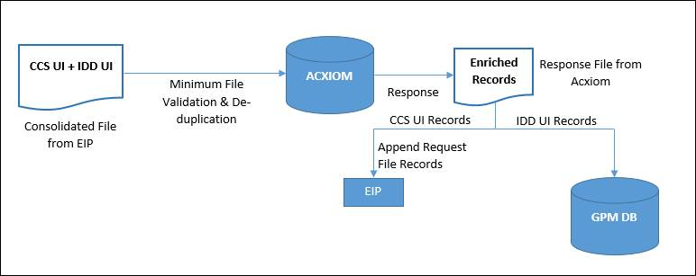

## **9.4 July,2018 Release**

**Point in Time**

No changes required for onboarding LexisNexis Match results.

**Pre Monthly XML Generation**

No changes required for onboarding LexisNexis Match results.

**MDM Monthly XML Generation**

**Multiple Match Selection**

Process will select and share the best (highest) match for a global in a cycle from mix of MetLife internal matches as well as LexisNexis matches.

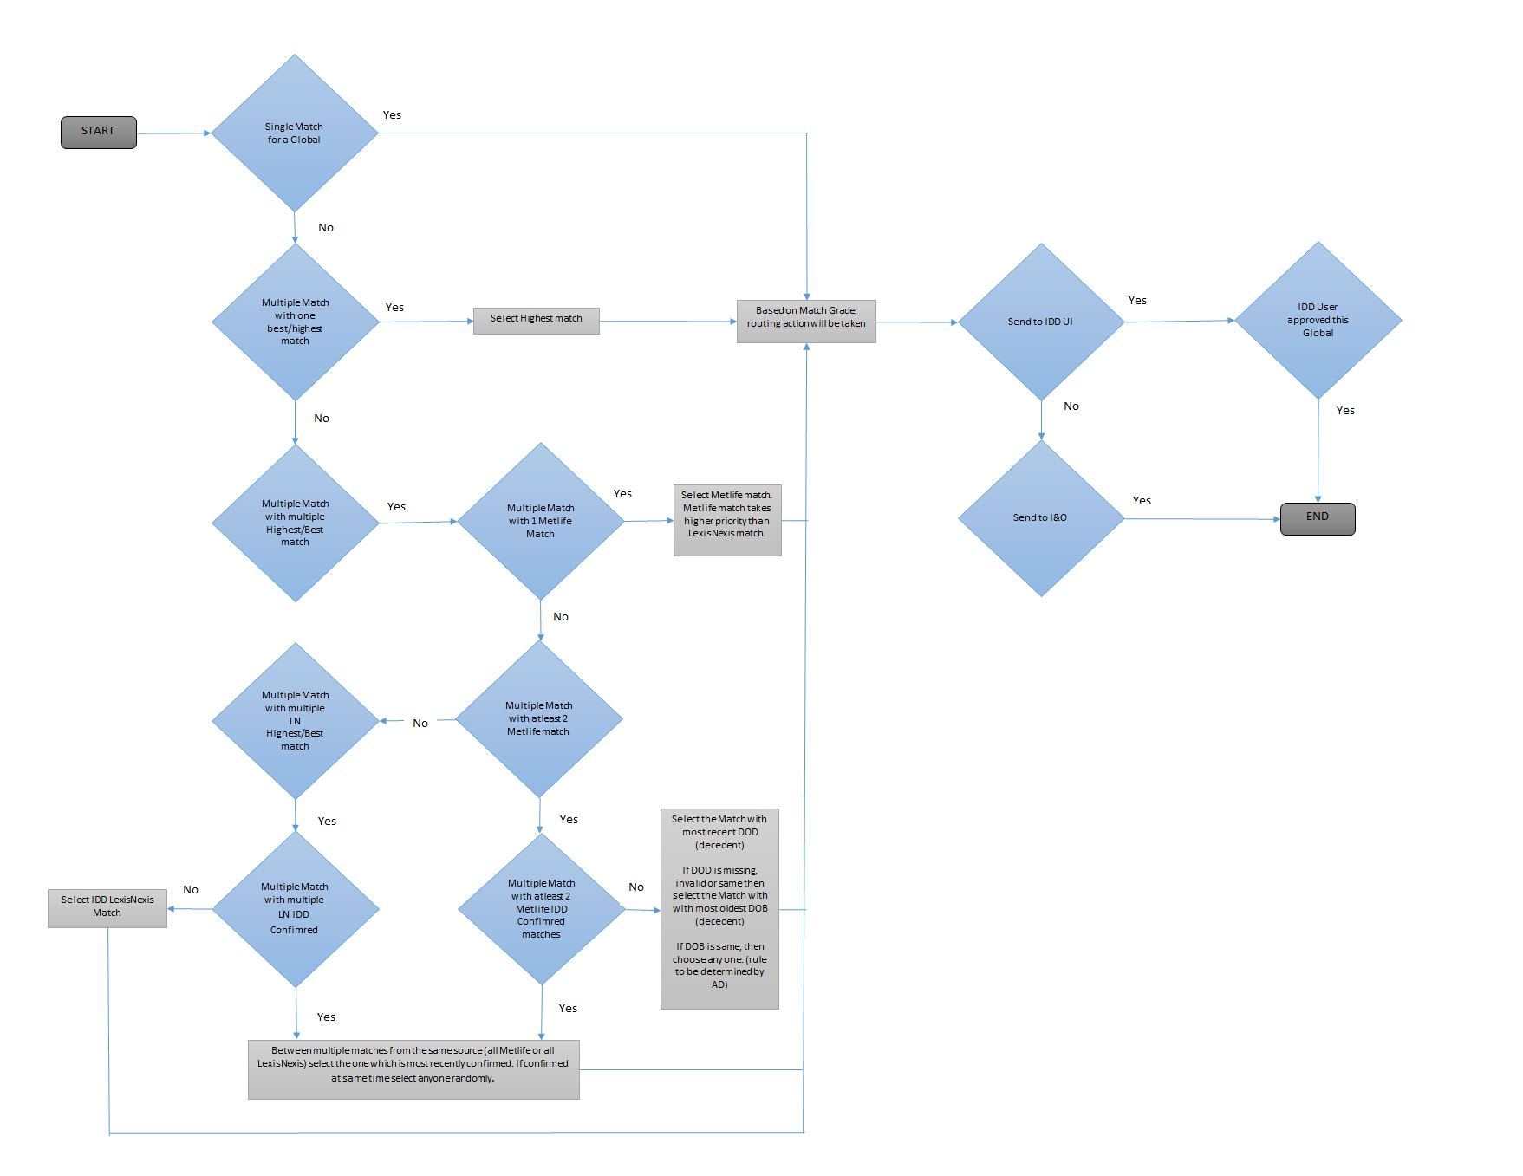

* + - If Global with multiple matches from different sources are having same highest match grade then,

MetLife match will get higher priority for sharing with Case Manager.

* + - If Global with multiple MetLife matches having same highest match grade then,

Select the MetLife match having most recent Date of Death (decedent).

* + - If Global with multiple MetLife matches with same highest match grade and having same or missing or invalid DOD then,

Select the MetLife match having oldest DOB (decedent).

* + - If Global with multiple MetLife matches with same highest match grade and same or missing or invalid DOB then, choose any one (this selection will be consistent based on rule determined by AD).
    - If matches are a mix of LexisNexis sourced matches, i.e. a mix of LexisNexis current match and a previously approved IDD LexisNexis match with same highest match grade, then select IDD LexisNexis Match and share with I&O.
    - If multiple IDD approved matches are received for the same Source (LN or ML) and with same highest match grade, then select the one which is most recently confirmed (this scenario can arise when independent IDD matches end up being associated with the same Global Party after GPM match and merge operation).

**Special Routing Override Rule**

Do not allow a best selected (based on match selection rules) match for a Global Party to be routed to IDD work Queue if the current cycle contains a recently approved IDD match for the Global Party ready to be shared with I&O. Reroute the best selected match to I&O.

**Change in 9-point Duplicate Match Suppression logic to suppress non-improved matches**

After selecting the best match to share, the process will compare new match for the current cycle against matches shared with I&O in prior cycles. The process will suppress match results (do not share with I&O) that do not offer an improvement in match information.

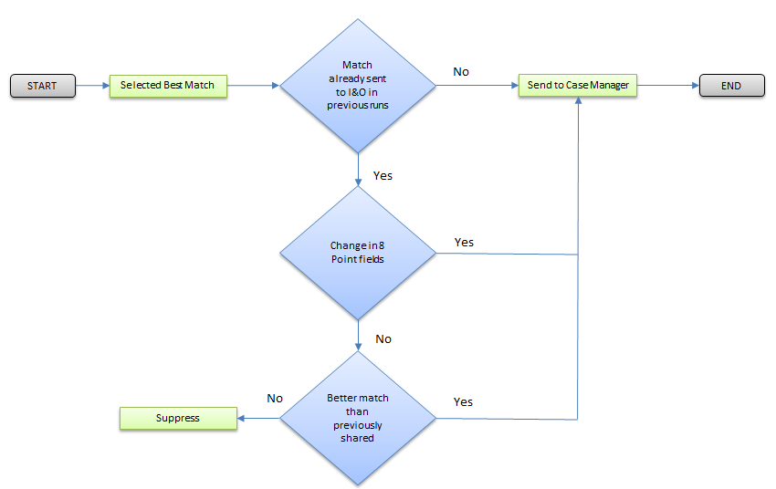

Here are the fields used to determine 9-point change.

* First Name
* Last Name
* SSN
* DOB
* Decedent First Name
* Decedent Last Name
* Decedent DOB
* Decedent SSN
* Match Grade

If there is change in Match Grade field alone on a match in current cycle and the match is lower or equal in rank than the match grade previously shared with I&O for the same Party, then the current match does not offer any improvement and will be suppressed. But if Match Grade in current cycle is higher than match grade shared previously for the same Party, then higher match grade from current cycle will be shared. However, a change to any of the other 8 point fields will still be reported to I&O as it does today. Below are a few scenarios.

|  |
| --- |
| **Scenario 1:** If the new Match grade received(M2) in the current cycle(D2) is higher in rank than the Previously sent Match grade(M1), then M2 will be eligible to be shared with Case Manager. |

C:\Users\613040\Desktop\Untitled.png

|  |
| --- |
| **Scenario 2:** If the new Match grade received(M4) in the current cycle(D2) is lower in rank than the Previously sent Match grade(M3), then M4 will not be shared with Case Manager. |



|  |
| --- |
| **Scenario 3:** If the new Match grade received(M5) in the current cycle(D2) is same as the Previously sent Match grade(M5), then M5 will not be shared with Case Manager. |



|  |
| --- |
| **Scenario 4:** If the new Match grade received(M6) in the current cycle(D2) is same as the Previously sent Match grade(M6), but if any of the 8 match point is changed then it will be shared with Case Manager. |

C:\Users\613040\Desktop\Untitled.png

**Retention**

All Input and Output files used in this process shall follow the retention guidelines asdefined by the EDM. Minimum period for retention for all files will be 16 years.

## **9.5 November,2018 Release**

**PIT & Pre Monthly Changes**

**PIT:** No changes are required in PIT Process.

**Pre Monthly:** Code changes will be implemented in the Pre monthly process to fetch Deceased middle name while fetching deceased information from GPM_ORS.C_B_EDM_RESULT Table.

# MDM XML Generation

In MDM XML generation the data from PIT table and C_B_EDM result table acts as a source. In MDM XML the processes that take place are Best Match Global Selection, Agreement Added Scenario

# 9.6 July, 2016 Release

**CR 5B**

* + - 1. All the information of these attributes (ROC_CD, OWN_TYP_CD, EDM_MTCH_IND, STATUS_RSN_CD, and STOP_CD) will be populated in agreement tag of MDM XML.

**CR 54**

1. XML generated from EDM phase will be having customer name information in agreement tag.

## **September,2016 Release**

**CR 54 A**

1. Portfolio ID will be present in MDM XML, Unsuppressed XML and Suppressed XML. The XML element name is <PartyData><PartyLogical><Agreement><PortfolioId>

**CR 54 B**

1. Values like Owner First Name, Owner Last Name for CRIL will be fetched from C_B_PARTY_XREF and SSN will be fetched from C_B_PARTY_ALT_ID_XREF table and will be present in MDM XML.

**CR 04: -**

1.In XML a new element will be added.

**CR 03- Termination Reason Code for CRIL**

1. MDM XML will contain the Termination Reason Code and corresponding Termination Reason Description Information in the Agreement tag. Termination Reason description will be available for LTC and CRIL in T_GPM_VAL_MAP table of ETDMDM1P database under GPM_ODS schema.

## **9.8 July,2017 release**

**MDM XML Generation: -**

1. REC_START_DT and REC_END_DT will be fetched from T_PARTY_AGMT_STG table and same will be populated in XML.
2. Admin source system filter will be modified to fetch records for UIS as well, data will be further more filtered on the basis of coverage code='WD' and LOB='DISABILITY'.

**Defect #46215**

**QC Description: -**

There are some Update Case XML’s having no new tasks.

**Root Cause: -**

When a global is selected for update case scenario, check should be performed to see if all the identified new agreements selected in the process are suppressed in Informatica Layer. If suppressed, then the entire global should be suppressed and not resend to Case Manager. But according to the current design such check is not being performed, hence the global is getting selected for sending to case manager without any new agreement associated with it.

**Resolution: -**

According to current Design, for a Global if any of the deceased contextual remain unsuppressed then its global is treated as unsuppressed and reported to Case Manager whether it is a new global or selected through agreement added scenario.

1. In Informatica Layer, once all the suppression rules have been applied, count of unsuppressed agreements and TASK_ID will be taken.
2. Task Id will be present in Agreement intermediate flat file generated from MDM XML for previously reported agreement.

* Scenario 1: - Count is same

If count is same, it means that new identified agreement has been suppressed so global should be suppressed. (Based on assumption that Task id will be present for previously reported agreement.)

|  |  |  |  |  |
| --- | --- | --- | --- | --- |
| Global Id | Party Id | Agmt Id | Task Id | Supp_ind |
| G1 | P1 | A1 | T1 | N |
| G1 | P2 | A2(NEW) |  | Y |

No of Unsuppressed agreement=1

No of Unsuppressed task=1

Count for both is same, it means global should suppress and its suppression Indicator will be set to ‘Y’ with suppression reason “All newly identified agreements has been suppressed”.

* Scenario 2: - Count is different

|  |  |  |  |  |
| --- | --- | --- | --- | --- |
| Global Id | Party Id | Agmt Id | Task Id | Supp_ind |
| G1 | P1 | A1 | T1 | Y |
| G1 | P2 | A2(NEW) |  | N |

No of Unsuppressed agreement=1

No of Unsuppressed task=0

Count of unsuppressed agreement is greater means that new identified agreement has not been suppressed so global should not be suppressed.

# 9.9 July,2018 Release

**Pre Monthly XML Generation**

No changes required for onboarding LexisNexis Match results.

**MDM Monthly XML Generation**

**Multiple Match Selection**

Process will select and share the best (highest) match for a global in a cycle from mix of MetLife internal matches as well as LexisNexis matches.



* + - If Global with multiple matches from different sources are having same highest match grade then,

MetLife match will get higher priority for sharing with Case Manager.

* + - If Global with multiple MetLife matches having same highest match grade then,

Select the MetLife match having most recent Date of Death (decedent).

* + - If Global with multiple MetLife matches with same highest match grade and having same or missing or invalid DOD then,

Select the MetLife match having oldest DOB (decedent).

* + - If Global with multiple MetLife matches with same highest match grade and same or missing or invalid DOB then, choose any one (this selection will be consistent based on rule determined by AD).
    - If matches are a mix of LexisNexis sourced matches, i.e. a mix of LexisNexis current match and a previously approved IDD LexisNexis match with same highest match grade, then select IDD LexisNexis Match and share with I&O.
    - If multiple IDD approved matches are received for the same Source (LN or ML) and with same highest match grade, then select the one which is most recently confirmed (this scenario can arise when independent IDD matches end up being associated with the same Global Party after GPM match and merge operation).

**Special Routing Override Rule**

Do not allow a best selected (based on match selection rules) match for a Global Party to be routed to IDD work Queue if the current cycle contains a recently approved IDD match for the Global Party ready to be shared with I&O. Reroute the best selected match to I&O.

**Change in 9-point Duplicate Match Suppression logic to suppress non-improved matches**

After selecting the best match to share, the process will compare new match for the current cycle against matches shared with I&O in prior cycles. The process will suppress match results (do not share with I&O) that do not offer an improvement in match information.



Here are the fields used to determine 9-point change.

* First Name
* Last Name
* SSN
* DOB
* Decedent First Name
* Decedent Last Name
* Decedent DOB
* Decedent SSN
* Match Grade

If there is change in Match Grade field alone on a match in current cycle and the match is lower or equal in rank than the match grade previously shared with I&O for the same Party, then the current match does not offer any improvement and will be suppressed. But if Match Grade in current cycle is higher than match grade shared previously for the same Party, then higher match grade from current cycle will be shared. However, a change to any of the other 8 point fields will still be reported to I&O as it does today. Below are a few scenarios.

|  |
| --- |
| **Scenario 1:** If the new Match grade received(M2) in the current cycle(D2) is higher in rank than the Previously sent Match grade(M1), then M2 will be eligible to be shared with Case Manager. |

C:\Users\613040\Desktop\Untitled.png

|  |
| --- |
| **Scenario 2:** If the new Match grade received(M4) in the current cycle(D2) is lower in rank than the Previously sent Match grade(M3), then M4 will not be shared with Case Manager. |



|  |
| --- |
| **Scenario 3:** If the new Match grade received(M5) in the current cycle(D2) is same as the Previously sent Match grade(M5), then M5 will not be shared with Case Manager. |



|  |
| --- |
| **Scenario 4:** If the new Match grade received(M6) in the current cycle(D2) is same as the Previously sent Match grade(M6), but if any of the 8 match point is changed then it will be shared with Case Manager. |

C:\Users\613040\Desktop\Untitled.png

**Retention**

All Input and Output files used in this process shall follow the retention guidelines asdefined by the EDM. Minimum period for retention for all files will be 16 years.

# 9.10 November,2018 Release

**MDM XML Generation Changes**

* Code changes will be implemented to fetch LN Enriched Data from GPM_ORS.C_B_EDM_ENRICH table and to populate the same into the MDM XML (for create case and Update case).
* LN Enriched Data will be populated into the MDM XML only if Lexis Nexis match is selected after best match selection process.
* Code changes will also be implemented to populate the Deceased Middle name into the MDM XML.
* XSD will be modified to include Deceased Middle name and LN Enriched Data.

The following LN Enriched fields will be populated in XML:

* LexisNexis Best Last Name
* LexisNexis Best First Name
* LexisNexis Best Middle Name
* LexisNexis Best Title
* LexisNexis Best Suffix
* LexisNexis Best SSN
* LexisNexis Best DOB
* LexisNexis Best Address 1
* LexisNexis Best City
* LexisNexis Best State
* LexisNexis Best Zip Code
* LexisNexis Best Zip4 Code
* LexisNexis Best Address Date
* LexisNexis Best Telephone

Additionally, a new field- Deceased Middle name will also be added to the XML.

# 10.EDM INFA LAYER

The Informatica Layer will serve Strategic EDM program and act as a liaison between EIP and GPM. It will be responsible for applying various business rules such as LOB suppression, Role Suppression, etc. on the data provided by GPM.

The Informatica layer will take XML as input from EDM Phase II and will apply certain Suppression logics. The unsuppressed records will be fed as XML to EIP via Message Queue. One Unsuppressed XML per Global record will be created. The Suppressed records will be stored in GPM server as XML files for future processing.

## **10.1 July,2016 Release**

**CR 35**

**INFA Layer**

* + - 1. LOB suppression rules will be applied for all the records having admin system for individual life i.e. (CYBR, IBDW_COVA, IBDW_IDST, IBDW_LCDS, IBDW_LCFS, IBDW_MCAM, IBDW_ MPST, IBDW_PMF, IBDW_ PAS, IBDW_SPVL, IBDW_TVUL, IBDW_ULS, IBDW_VARI, IBDW_VCS1, IBDW_VENT, IBDW_VNCH, IBDW_VTG1, IBDW_VTRD) and non-medical LTC while Informatica layer processing.
      2. After Informatica layer processing, Suppressed and Unsuppressed XMLs will be generated.
      3. Unsuppressed XML will be sent to EIP via message queue.

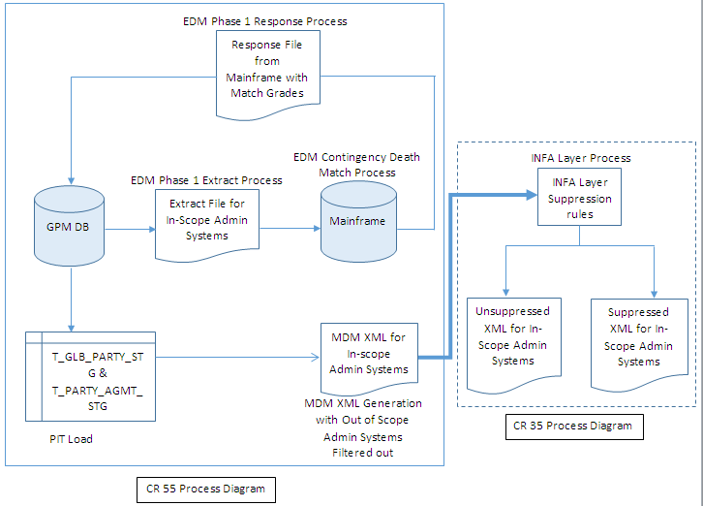

**CR 5B**

**INFA Layer: -**

* + - 1. MDM XML that has been generated from EDM Phase 2 containing all those attributes will undergo some suppression rules.
      2. Different suppression logic will be applied for different attributes (ROC_CD, OWN_TYP_CD, EDM_MTCH_IND, and STOP_CD).
      3. If all the contextual records belonging to a Golden record are suppressed, the corresponding Golden record will be suppressed too.
      4. The Unsuppressed/valid records and Suppressed records will be populated in two different XMLs.
      5. XML containing Unsuppressed/valid records will be sent to EIP through message queue in which the additional attributes will not be present.
      6. XML containing Suppressed records having the attributes added for TCA & LTC and suppression reason will be stored in GPM server

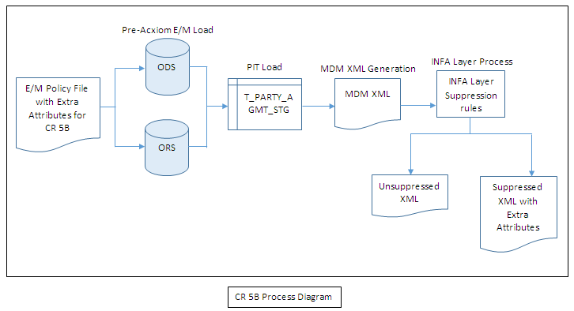The following table shows the position of the attributes in policy file that will be added for TCA and LTC as a part of CR 5B.

|  |  |  |  |  |  |  |
| --- | --- | --- | --- | --- | --- | --- |
| **Source System** | **Attribute** | **Mainframe Attribute Name** | **length** | **Position in Mainframe file** | **GPM Table Name** | **GPM Column Name** |
| **LTC** | Termination Date | P-POLPT-TERM-DT | 10 | 351 | GPM_ORS.C_B_AGMT_XREF,  GPM_ODS.T_PARTY_AGMT_STG | EFF_END_DT |
| Termination Code | P-POLPT-TERM-REASN-CD | 1 | 980 | GPM_ORS.C_B_AGMT_XREF,  GPM_ODS.T_PARTY_AGMT_STG | STATUS_RSN_CD |
| ROC Code | P-POLPT-RETRN-PREM-SCHED-ID | 5 | 981 | GPM_ODS.T_PARTY_AGRE,  GPM_ODS.T_PARTY_AGMT_STG | ROC_CD |
| **TCA** | Ownership Type | P-POLPT-OWN-TYP-CD | 2 | 752 | GPM_ODS.T_PARTY_AGRE,  GPM_ODS.T_PARTY_AGMT_STG | OWN_TYP_CD |
| Stop Code | P-POLPT-STOP-CD | 1 | 754 | GPM_ORS.C_B_AGMT_RSTRCN_XREF  GPM_ODS.T_PARTY_AGMT_STG | STOP_CD |
| EDM Match Indicator | P-POLPT-EDM-MTCH-IND | 1 | 986 | GPM_ODS.T_PARTY_AGRE, GPM_ODS.T_PARTY_AGMT_STG | EDM_MTCH_IND |

**CR 54**

**Informatica Layer: -**

1. MDM xml generated will be treated as source for Informatica layer processing.
2. Customer name will be present both in Suppressed and Unsuppressed XML.
3. Unsuppressed XML will be sent to EIP via message queue.

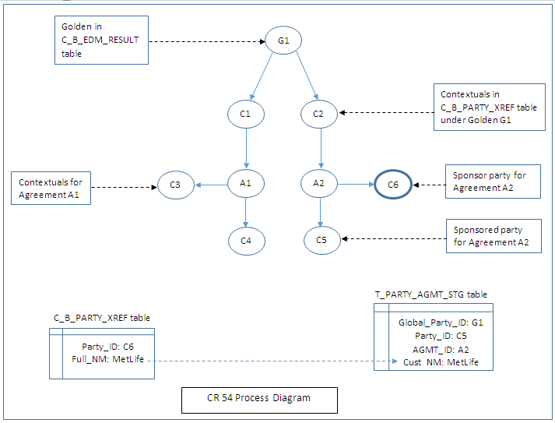

## **10.2 September,2016 Release**

**CR 5D (Informatica Layer)**

New suppression rules will be applied for Critical Illness admin system.

* GPM provided DOD. prior to effective date
* Effective Date- This is the effective start date of the contract.
* Rules will be implemented to suppress a record if the Date of Death (GPM provided DOD.) is prior to the Effective Start Date of the account

IIF (ADMIN_SYS_CRIL='Y' AND DATE_COMPARE (v_DOD, v_EFF_START_DT) =-1,'Y','N')

* Termination Date is prior or equal to GPM provided DOD.
* Rules will be implemented to suppress a record, if the Effective End Date (Termination Date) is prior or equal to the GPM provided DOD.
* IIF (ADMIN_SYS_CRIL='Y' AND DATE_COMPARE (v_EFF_END_DT, v_DOD) <=0,'Y','N')

**Note: -As per CR 39, suppression rules are applied on deceased records, where Deceased Contextual Indicator = ‘Y’.**

**DOD prior to effective date**

**Scenario 1: -** If all the deceased contextual for a global are not suppressed, then global will not be suppressed.



**Scenario 2: -** If all the deceased contextual for a global are suppressed, then global will be suppressed.



**Scenario 3: -** If the deceased contextual P1’ associated with the agreement A1 is suppressed then all other non-deceased records associated with this agreement will be suppressed.

In the below case, only agreement ‘A1’ will be suppressed not the global since all the deceased contextuals belonging to G1 are not suppressed.



**Termination Date is prior or equal to DOD**

**Scenario 1: -** If all the deceased contextual for a global are suppressed, then global will be suppressed.



**Scenario 2: -** If all the deceased contextual for a global are not suppressed, then global will not be suppressed.



**Scenario 3: -** If the deceased contextual P1’ associated with the agreement A1 is suppressed then all other non-deceased records associated with this agreement will be suppressed.

In the below case, only agreement ‘A1’ will be suppressed not the global since all the deceased contextual belonging to G1 are not suppressed.



1. After Informatica layer processing, Suppressed and Unsuppressed XMLs will be generated.
2. Unsuppressed XML will be sent to EIP via message queue.
3. Records which are suppressed the reason will be populated in following path of Suppressed XMl.
4. <PartyData><PartyLogical><Metadata><SuppressReasn>

|  |  |  |
| --- | --- | --- |
| **LOB** | **Condition** | **Suppression Rules** |
| CRIL | DOD prior to effective date | Suppress if the Date of Death (DOD) is prior to the Effective Date of the account. |
| Termination Date is prior or equal to DOD | Suppress if the Termination Date is prior or equal to the DOD |

**CR 04 (Informatica Layer)**

1. MDM XML generated from GPM EDM process will have Termination Date, Termination reason Code and ROC code populated for LTC.
2. The Unsuppressed XMLs will also have Termination Date, Termination reason Code and ROC code populated for LTC. Currently it is populated in only Suppressed XMLs.
3. CII will have only Termination Date populated in Unsuppressed XML.
4. All the attributes for Unsuppressed XML will be populated under Agreement hierarchy in MDM xml.
5. Termination Date for Critical Illness system should be already present in the unsuppressed XML.

Termination Date: - <PartyData><PartyLogical><Agreement><EffectiveEndDate>

Termination Reason Code: - <PartyData><PartyLogical><Agreement><TerminationCode>

ROC Code: - <PartyData><PartyLogical><Agreement><ROCCode>

## **10.3 November,2016 Release**

**CR 35 & CR 11**

**Informatica Layer: -**

1. As part of CR 35, Admin Systems belonging to **Retail Annuity** LOB will be included in the INFA Layer Process. Following are the Admin Systems that will be considered In-Scope:
2. IBDW_ANNH
3. IBDW_LCMP
4. IBDW_VCAP
5. IBDW_MRPS
6. IBDW_CV15
7. IBDW_EV15

Once INFA Layer Processing is complete, Suppressed and Unsuppressed XMLs will be generated Unsuppressed XMLs will be transmitted to EIP.

**CR 5B**

1. As part of CR 5B, a new suppression rule will be implemented in INFA Layer Process for Retail Annuity Admin Systems.
2. Records belonging to Retail Annuity Systems and contact status as Active would be suppressed in INFA LAYER Process.

**CR 08**

1. As part of CR 8, a new suppression rule needs to be implemented in INFA Layer Process for Individual Life Admin Systems
2. If the Policy status is **‘DEATH’** or **‘DTHPEND’,** then the corresponding agreement would be suppressed through INFA LAYER Process.

**CR 04: -**

**Informatica Layer: -**

* + - 1. MDM XML generated from EDM Phase 2 will be the source for Informatica Layer processing.
      2. CDF Customer Number will be populated in Unsuppressed XML and Suppressed XML.

**CR 03- Termination Reason Code for CRIL**

**Informatica Layer**

1. MDM XML generated from EDM Phase 2 will be the source for Informatica Layer processing.
2. Termination Reason Code and corresponding Termination Reason Description will be populated in Unsuppressed and Suppressed XML for CRIL and LTC agreements. For LTC Termination reason code is already populated.
3. New XML element Termination Reason Description will be added.

## **10.4 March,2017 Release**

**CR 7**

**Informatica Layer: -**

1. A new suppression rule needs to be implemented to suppress TCA Agreements having STOP_CD value 7. This information will fetch from the RSTRCN_VALUE & RSTRCN_TP of the C_B_AGMT_RSTRCN table.   
   All TCA Agreements where RSTRCN_VALUE= ‘7’ & RSTRCN_TP = ‘STOP_CD’ will be suppressed.
2. CRIL Agreements having Policy Status as ‘DECLINE’, ‘INELIGIBLE’, ‘NOT TAKEN’, ‘FNA’, ‘NOT TAKE’ or ‘INACTIVE’, should be suppressed.
3. A new suppression rule needs to be implemented to suppress Individual Life based on the below Admin-System and Policy Status combination:

|  |  |
| --- | --- |
| **ADMIN SYSTEM** | **POLICY STATUS** |
| IDST | FREELOOK,CANCELLED,EXCHNEWNUM,HOCANCEL,MATURED,NOTAKE,SURR |
| LCDS | DECISSUE,NOTAKE,TERMINATED |
| LCFS | INACTIVE,TERMINATED |
| MCAM | TERMINATED |
| MPST | HOCANCEL,INACTIVE,MATURED |
| PAS | CLOSEDOUT,EXCHNEWNUM,FREELOOK,NOTAKE,RESCNDED,SURR |
| PMF | CANCELLED,MATURED,NOTAKE,SURR |
| SPVL | CANCELLED,SURR |
| TVUL | INACTIVE |
| ULS | INACTIVE |
| VARI | FREELOOK,CANCELLED,INCOMPLETE,HOCANCEL,NOTAKE,SURR,TERMINATED |
| VCS1 | CANCELLED,MATURED,SURR |
| VNCH | FREELOOK,CANCELLED,HOCANCEL,LKRETCASH,NOTAKE,SURR |
| VTG1 | FREELOOK,CANCELLED,HOCANCEL,NOTAKE,SURR |
| VTRD | FREELOOK,CANCELLED,HOCANCEL,NOTAKE,SURR,INACTIVE,TERMINATED |

**CR for SBR Suppression (QC – 45907)**

**Informatica Layer: -**

1. A new suppression rule needs to be implemented to suppress SBR Agreements having Policy Status as ‘DEATH’.

**CR 10**

**Informatica Layer: -**

1. The suppression rule for records having LTC as admin system and TerminationCode='N' (Non-Voluntary), Termination Date is prior to DM DOD and POLICY STATUS = TERMINATED, will be suppressed if ROC Code is equal to R (ZERO) E (R0E), instead of ‘ROE’.

## **10.5 July,2017 Release**

**WSTD: -**

**INFA_LAYER:**

Only for WSTD, Policy status code would be generated on the below mentioned rules:

* Agreement Status will be considered as **ACTIVE** if any of the following condition is true.

1. If Party have a Start Date of the Current Date or earlier and does not have a Stop Date.
2. If Party have a Start Date of the Current Date or earlier and have a Stop Date of future.

* Agreement Status of Party (Individual Customer) will be considered as **LAPSED**.

1. If Party have a Start Date of the Current Date or earlier and a Stop Date of the Current Date or earlier and the Start Date is earlier than Stop Date.

|  |  |  |  |  |  |
| --- | --- | --- | --- | --- | --- |
| **S#** | **Condition No.** | **RULES** | | | **AGMT STATUS** |
| 1 | i | REC_START_DT | <= | CURRENT DATE | ACTIVE |
| ii | REC_END_DT IS NULL OR BLANK | | |
| 2 | i | REC_START_DT | <= | CURRENT DATE | ACTIVE |
| ii | REC_END_DT | > | CURRENT DATE |
| 3 | i | REC_START_DT | <= | CURRENT DATE | LAPSED |
| ii | REC_END_DT | <= | CURRENT DATE |
| iii | REC_START_DT | < | REC_END_DT |
| 4 | i | REC_START_DT | > | CURRENT DATE | INACTIVE |
| 5 | i | REC_START_DT | = | REC_END_DT | INACTIVE |
| 6 | i | REC_START_DT IS NULL, BLANK, INVALID | | | DATE ERROR |
| 7 | i | REC_START_DT | > | REC_END_DT | DATE ERROR |

* Agreement Status will be considered as **INACTIVE** if any of the following condition is true

1. If Party have a Start Date in the future (regardless of Stop Date)
2. If Party have a Start Date = Stop Date (regardless of dates being in the future or the past)

* Individual WSTD customer Death matches will be considered as **DATE ERROR** if any of the following condition is true.

Error Conditions are as follows:

1. A record not having a Start Date (Start Date is blank, an invalid value or otherwise unusable)
2. A Stop Date exists and is earlier than Start Date

Agreement Status will be derived as per below conditions:

* CURRENT DATE stands for derived Current Timestamp value
* Agreement status will be derived as ACTIVE if Rule 1 or Rule 2 holds true.
* Agreement status will be derived as LAPSED if Rule 3 holds true.
* Agreement status will be derived as INACTIVE if Rule 4 or Rule 5 holds true.
* Agreement status will be derived as DATE ERROR if Rule 6 or Rule 7 holds true.

The suppression Rules that will be implemented in Informatica Layer for WSTD policies are as follows:

1. Suppress if the agreement status is INACTIVE
2. Suppress if the matched Decedent Date of Death is in the prior calendar month or earlier as compared to the coverage Start Date

**CR 12 Implementation for New Suppression Rules: -**

**Informatica Layer: -**

* Existing suppression rules needs to be modified in Informatica Layer to remove explicit Policy Statuses (Policy status of Metadata File) from the Three Year Window condition check rule.
* New suppression rules need to be implemented in Informatica Layer to suppress corresponding Agreements:

1. All Individual Life Admin System Agreements if Policy (Contract) Status is

* Lapse no value
* Lift
* Lift pending
* Purchase Loan
* Unknown – Not In force
* Additional suppression rule - Three Year window check Condition 2 should also be considered along with above rule. Suppression will be based on source system policy values and not on Rationalized values and will be able to handle upper and lower case strings.

1. IBDW_VENT Agreements if Policy (Contract) Status is INACTIVE, CANCELED and SURRENDERED.

|  |  |  |
| --- | --- | --- |
| **LOB** | **Source System** | **Policy Status** |
| INDIV_LIFE | IBDW_VENT | INACTIVE |
| INDIV_LIFE | IBDW_VENT | CANCELED |
| INDIV_LIFE | IBDW_VENT | SURRENDERED |

1. IBDW_PMF Agreements if Policy (Contract) Status is INACTIVE.

|  |  |  |
| --- | --- | --- |
| **LOB** | **Source System** | **Policy Status** |
| INDIV_LIFE | IBDW_PMF | INACTIVE |

* Additional suppression rule - Three Year window check Condition 2 should also be considered along with above rule.

1. CYBR Agreements if Policy (Contract) Status is NOINPUT and 99.

|  |  |  |
| --- | --- | --- |
| **LOB** | **Source System** | **Policy Status** |
| INDIV_LIFE | CYBR | NOINPUT |
| INDIV_LIFE | CYBR | 99 |

* Additional suppression rule - Three Year window check Condition 2 should also be considered along with Policy Status 99.

1. IBDW_PAS Agreements if Policy (Contract) status is EXPNOTETI.

|  |  |  |
| --- | --- | --- |
| **LOB** | **Source System** | **Policy Status** |
| INDIV_LIFE | IBDW_PAS | EXPNOTETI |

* Additional suppression rule - Three Year window check Condition 2 should also be considered along with above rule.

1. All Individual Life Admin System Agreements if date of death of the policy owner is greater than policy status date having policy with status:

* LAPSED or Lapsed
* LAPSE PEND DCR
* LIFT

**NOTE:** - CR7 to implement new suppression rules for CYBR and IBDW_PAS admin system is incorporated with CR 12.

## **10.6 November,2017 Release**

**RIS ACE Automation and Integration: -**

As part of this, existing EDM mainframe process will be discontinued for in scope RIS admin systems (PCTS, VRPS, GPAY, ACE). Existing automation rules still needs to be continued and as part of this initiative, the in scope RIS admin systems is going to receive the matching output files from EDM strategic platform to continue trigger those automation rules.

**Informatica Layer: -**

* Suppression rules will be applied in this stage.
* For ACE admin system, below mentioned suppression rules will be applied.

Suppress if:

|  |  |
| --- | --- |
| Entity Type | ‘O’ Organization |
| Policy Status | ‘C’ Complete |
| ‘NOINPUT’ |
| Rule 1 | Decedent Date of death is in prior month or earlier than Contract Effective Date and decedent SSN is not an exact match to the ACE system SSN  Note:  In case one of the SSN’s is null then this rule is not going to be implemented. |
| Rule 2 | ACE Person Date of Death exists and is a valid date in the past |

1. For GPAY and PCTS admin systems, below mentioned suppression rules will be applied.

Suppress if:

|  |  |
| --- | --- |
| Policy Status | Is not 'ACTIVE' |
| Rule | Decedent Date of death is in the prior calendar month or earlier as compared to the contract effective date and decedent SSN is not an exact match to the RIS system SSN |

1. For VRPS admin systems, below mentioned suppression rules will be applied.

Suppress if:

|  |  |
| --- | --- |
| Policy Status | Is not 'INFORCE' |
| Rule | Decedent Date of death is in the prior calendar month or earlier as compared to the contract effective date and decedent SSN is not an exact match to the RIS system SSN |

**CR 17 Implementation for New Suppression Rules: -**

**Informatica Layer: -**

As part of CR17, a few suppression rules to be implemented for Individual life LOB in

Informatica Layer and Metadata file joining will be decommissioned for Individual life.

* All existing suppression rules dependent on Metadata File attributes needs to be removed.

Although the rule of Death and death pending that was implemented as part of CR7 is to be modified to restrict it for the below specific admin systems.

1. Suppress if Policy Status is 'Death' or 'Death Pending'.

* New suppression rules need to be implemented in Informatica Layer to suppress corresponding Agreements:

1. Suppress if Decedent DOD is after Contract Status date for the below mentioned Admin systems having corresponding Policy status

1. Suppress if Admin system belong to the below mentioned LOB having corresponding Policy status.

1. Suppress if Contract status date is less than Death Match Date by more than 18 months for the below mentioned Admin systems having corresponding Policy status.

**Note:**

**All versions of upper case and lower case for Status Code will be considered for this rule.**

|  |  |  |  |  |
| --- | --- | --- | --- | --- |
| LOB | ORIGIN_SRC_SYS | AGMT_STATUS | Suppress | Special Rules |
| INDIV_LIFE | IBDW_LCDS, IBDW_MPST, IBDW_SPVL | DEATH | Yes | CR7 POLICY STATUS (DEATH/ DTHPEND) |
| IBDW_PAS, IBDW_PMF, IBDW_VARI, IBDW_VCS1, IBDW_VENT, IBDW_VNCH, IBDW_VTG1, IBDW_VTRD, IBDW_IDST | DEATH, DTHPEND |
| IBDW_PAS | EXPIRED, Expired, EXPNOTETI, LAPSED, Lapsed | Decedent DOD is after Contract Status date. |
| IBDW_PMF | EXPIRED, Expired, TERM EXPIRY, LIFTPND, LAPSED, Lapsed |  |
| IBDW_IDST | EXPIRED, LIFTPND, LAPSED | **Note:** |
| IBDW_SPVL, IBDW_VARI, IBDW_VCS1, IBDW_VENT, | LAPSED, Lapsed | **Blank, null or 01/01/1900 Policy Expiry Date cannot be suppressed.** |
|  |
| CYBR | 98, 99 | Policy Status |
| IBDW_LCDS | DECISSUE, NOTAKE, Terminated |
| IBDW_MPST | HOCANCEL, INACTIVE, MATURED, Matured, PENDING |
| IBDW_PAS | CLOSEDOUT, EXCHNEWNUM, FREELOOK, NOTAKE, RESCNDED, SURR, FULLACCEL |
| IBDW_PMF | CANCELLED, MATURED, Matured, NOTAKE, SURR, REISSUE, Reissue |
| IBDW_VARI | FREELOOK, CANCELLED, INCOMPLETE, HOCANCEL, NOTAKE, SURR, TERMINATED, Terminated, DIACCL, FULLACCEL |
| IBDW_IDST | CANCELLED, EXCHNEWNUM, FREELOOK, HOCANCEL, MATURED, Matured, NOTAKE, REISSUE, SURR |
| IBDW_VENT | FREELOOK, HOCANCEL, NOTAKE, SURR |
| IBDW_MCAM | Terminated |  |
| IBDW_SPVL | CANCELLED, SURR |  |
| IBDW_TVUL | INACTIVE, ISSUED |  |
| IBDW_VCS1 | CANCELLED, MATURED, Matured, SURR |  |
| IBDW_VNCH | FREELOOK, CANCELLED, HOCANCEL, LKRETCASH, NOTAKE, SURR, ISSUED |  |
| IBDW_VTG1 | FREELOOK, CANCELLED, HOCANCEL, NOTAKE, SURR, ISSUED |  |  |
| IBDW_VTRD | FREELOOK, CANCELLED, HOCANCEL, NOTAKE, TERMINATED, SURR, ISSUED |  |  |
| IBDW_LCFS | NOINPUT |  |  |

**RIS Data Gap**

The goal of the project is to migrate all of RIS EDM contingency process to EDM Strategic process and shut down the EDM contingency process. There will not be any ETL code changes or database object changes as part of RIS data gap in September release. Only PCTS will send new records to GPM and any code changes will be included in March release.

## **10.7 July,2018 Release**

**Informatica Layer**

No changes required for onboarding LexisNexis Match results.

## **10.8 September,2018 Release**

**Informatica Layer**

No changes required for onboarding LexisNexis Match results.

## **10.9 November,2018 Release**

**Informatica Layer**

* Code changes will be required to fetch LN Enriched Data and Deceased Middle name field from MDM XML and populate the same into Suppressed and Unsuppressed XML.
* XSD will be modified accordingly to include Deceased Middle name and LN Enriched Data.
* Code changes will be implemented to populate Lexis Nexis Best Match data fields and Deceased Middle name field in the intermediate Netview file which is using as a source to Netview process.

## **10.10 April,2019 Release**

* **LTC Suppression Rules Changes:**

The existing suppression rules for suppressing records of admin system LTC need to be removed.

The existing rules:

|  |  |  |  |
| --- | --- | --- | --- |
| LOB | ADMIN SYSTEM | AGMT_STATUS | RULE |
| Non-Medical LTC | LTC | TERMINATED | Suppress if Termination Code = N (Non-Voluntary),Termination Date is prior to DM DOD AND ROC Code is equal to "R0E" |
| Suppress if Termination Code = D (Deceased) AND Termination Date = DM Date of Death |
| Suppress if Termination Code = Q and Termination Date <= Date of death |
| If Termination Code is D |
| Suppress if Termination Code = T (Transferred to another carrier) |
| Suppress if Termination Code = M |

The new rules to be implemented:

|  |  |  |  |
| --- | --- | --- | --- |
| LOB | ADMIN SYSTEM | AGMT_STATUS | RULE |
| Non-Medical LTC | LTC | TERMINATED | Suppress if Termination Code = D (Deceased) and  Termination Date= Death Match date of death |
| Suppress if Termination Code = D (Deceased) and Death Match Source Code=’INGEN-LTC’ |

# 11.Excessive Beneficiary address fix in Case Manager:

**Root Cause:**

For a global, if multiple contextual are having same address (same Address ID) in GPM, then the same address is getting populated multiple times in the Same Unsuppressed XML making it redundant.

**Solution:**

To fix this Duplicate address issue, the Deduplication is being done in the Infa Layer Process by removing duplicate Address ID for a global i.e. duplicate Address ID for a Global Party will not be present in the XML’s.

## **EDM March 2018 Release- Group Life Strategic**

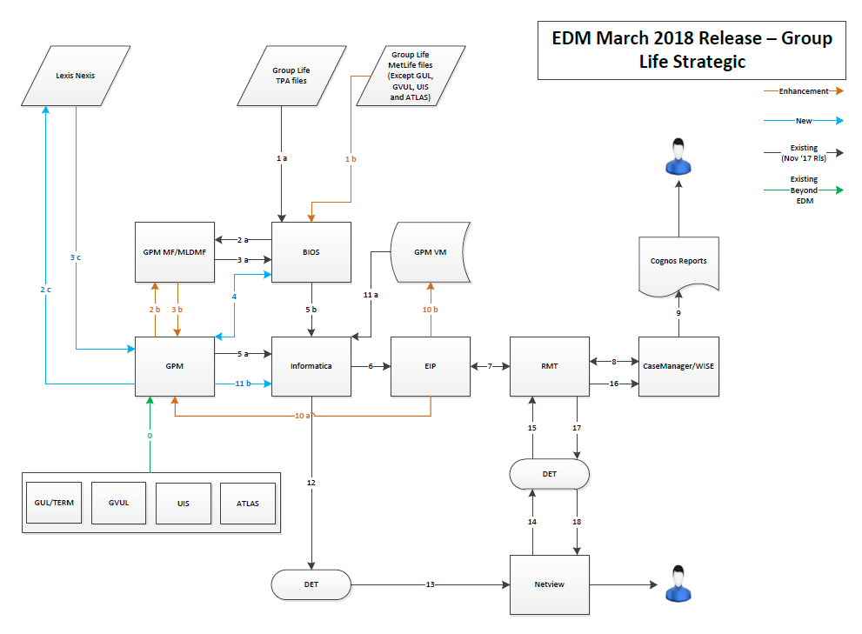

**Process description**

0 -->Daily Admin feed to GPM which is existing process and a dependency to EDM program where no change is anticipated and not scoped at this time.

1a -->BIOS consumes monthly EDM files from Group Life TPA’s.

1b -->BIOS consumes monthly EDM files from Group Life MetLife Systems (except GUL, GVUL, ATLAS and UIS*) * Assumption is UIS only includes 4 customers in the BIOS file.

2a -->BIOS sends consolidated 151 bytes EDM file to GPM Mainframe for EDM Contingency process.

2b -->GPM sends strategic Death match extract to GPM Mainframe for Strategic DM Run.

2c -->GPM sends strategic Death match extract to Lexis Nexis for Strategic DM Run.

3a -->GPM Mainframe sends back 239 bytes Result and Suspect files to BIOS.

3b -->GPM Mainframe sends back Result files to GPM MDM/ETL.

3c -->Lexis Nexis sends back DM Results back to GPM.

4 -->GPM retrieves BIOS Claim Indicator from BIOS via DET.

5a -->GPM sends MDM XML’s to Informatica Layer.

5b -->BIOS sends Group Life TPA and non-admin MetLife Group Life matches to Informatica via DET.

6 -->Informatica applies Suppression rules and sends Unsuppressed XML’s to EIP Queue.

7 -->EIP reformats XML to JSON and sends it to RMT / RMT sends back Publish case response to EIP.

8 -->RMT enriches the JSON and sends it to Case Manager via WISE Layer/ Case Manager publishes response to RMT.

9 -->Case Manager via Nightly jobs loads the Congo’s Database for Reporting.

10a -->EIP calls the existing web service to GPM MDM to update the Case Folder ID and Task ID of the GL admin cases/tasks coming back from Case Manager.

10b -->EIP calls the new web service to GPM VM to update the Case Folder ID and Task ID of the GL TPA & Non-admin cases/tasks coming back from Case Manager.

11a -->Informatica retrieves Case Folder ID and Task ID from GPM VM for Group Life TPA & Non-admin cases.

11b -->Informatica retrieves Case Folder ID and Task ID from GPM MDM DB for Group Life admin cases.

12 -->Informatica updates the Case Folder ID and Task ID in the BIOS file for the GL TPA cases and appends the group Life admin cases and sends the consolidated file to DET.

13 -->DET Transmits the file to EDM Americas Netview.

14 -->Netview sends daily status file to DET.

15 -->DET Transfers the Daily Status file to RMT.

16 -->RMT triggers update case status to Case Manager for each record in the Daily Status file.

17 -->RMT sends acknowledgement file to DET.

18 -->DET transfers the acknowledgment file to Netview.

**Glossary and Definition –**

GPM – Global Party Management. This is system that contains the party and policy level information of all MetLife admin systems and data provider for EDM Strategic process.

GPM MF – Global Party Management Mainframe. This is the system that supports the EDM Contingency Process for all the systems.

MLDMF – MetLife Death Master File. The file consisting of all Deaths from SSA and other MetLife Internal sources.

GPM VM – Global Party Management Virtual Machine. A new location outside of GPM Database which will house the TPA matches case folder and task id information from EIP.

Case Manager.EIP – Enterprise Integration Platform. A middleware system that helps in data conversion from a source system to another target system.

RMT – Retail Messaging Team – A middleware system that helps in data transmission and enrichment between Source and target system.

DET – Data Exchange Team – facilitates file transfer between two systems.

XML - Extensible Markup Language – It is a method of creating information and sharing with other systems. From EDM perspective, 1 XML corresponds to 1 Death Match Party.

JSON - JavaScript Object Notation – It is another data exchange format. Case Manager understands JSON so the GPM generated XML’s are converted to JSON’s and sent to Case Manager for creating a case. 1 JSON corresponds to 1 Death Match Case.

Informatica – The system/layer that applies all the LOB specific Suppression rules for EDM. It takes as input all Death Match results and generates the resultant Suppressed cases and Unsuppressed cases for Workflow systems.

MQ Process

EDM is using WebSphere MQ version 7.5 to send messages to EIP. It is an IBM product launched in march 1992.MQ is a messaging middleware that allows independent and potentially non concurrent applications on a distributed system to securely communicate with each other.

It facilitates the secure and reliable communications between applications, systems by sending and receiving message data via messaging queues.

For every EDM run, GPM AD team send XMLS in message queues through Informatica using below connection details. EIP, a middleware application fetches the messages from Queue and send it to Case manager via RMT to publish case for deceased parties.

Message queue details (PROD): -

**Export set IL_MQHostname=**"MQPROD01"

**Export set IL_MQChannel=**"CC.A.0075.01.GPM"

**Export set IL_MQPort=**"1463"

**Export set IL_MQQueueManager=**"PRDMQS01"

**Export set IL_MQQueueName=**"QA.0075.GPM.CM.CREATECASE.REQ"

**Export set IL_MQUsername=**"mq007501"

**Export set IL_MQPassword=**"mq007501"

# EDM Maestro Job Details

|  |  |  |
| --- | --- | --- |
| **Process** | **Maestro StreamName.JobName** | **Comments** |
| LN EDM Extract Process | BEMD_EDM_EXTRACT_LN | The LN extract process extract Party, Alt ID & Address information for eligible global parties.  Script invoked:  /work/infshared/GPM/Strategic/scripts/EDM/PHII/GPM_STRTGC_EDM_ADHOC_EXTRACT_MAIN.sh LN |
| FTP To LexisNexis | BEMD_EDM_FTP_LN_MFT | The split files will be Ftp’d to MFT team for sending to Lexis Nexis.  Script invoked:  ksh /work/infshared/GPM/Strategic/scripts/EDM/PHII/FTP_ADHOC_EXTRACT_SCRIPT_LN.sh |
| Extract Trigger | BEMD_EDM_REMV_TRIGR_EXTRCT | This process removes landing trigger file and updates last entry of landing load in T_PROC_CTRL with MDM_EXEC_CMPLT_DATE as null. It also makes a new entry in T_PROC_CTRL as ‘EDM_EXTRACT_IN_PROGRESS’.  Script invoked:  /work/infshared/GPM/Strategic/scripts/EDM/PHII/EDM_REMV_TRIGR_EXTRCT_IN_PROGRSS.sh |
| ML EDM ETL Extract | BEMD_EDM_EXTR.BEMD_EDM_EXTRACT | The extract process extract FIRST NAME, LAST NAME, SSN, DOB and RM_ID for eligible global parties’. The information will be segregated into a number of files depending on the data volume.  Script invoked:  /work/infshared/GPM/Strategic/scripts/EDM/PHII/GPM_STRTGC_EDM_ADHOC_EXTRACT_MAIN.sh ML |
| EDM ETL FTP to Mainframe | BEMD_EDM_FTP.BEMD_EDM_FTP_MF | The split files will be Ftp’d to contingency team for death match processing.  Script invoked:  ksh /work/infshared/GPM/Strategic/scripts/EDM/PHII/FTP_ADHOC_EXTRACT_SCRIPT.sh |
| Response Load - MLDMF | BEMD_EDM_RSPN.BEMD_EDM_ETL_RESPONSE_ML | The response process loads the response file send by contingency to C_L_EDM_RESULT table of PRELANDING DB.  Script invoked:  /work/infshared/GPM/Strategic/scripts/EDM/PHII/GPM_STRTGC_EDM_RESPONSE_ML.sh |
| Response Load - LN | BEMD_EDM_RSPN.BEMD_EDM_ETL_RESPONSE_LN | The response process loads the response file send by Lexisnexis to C_L_EDM_RESULT table of PRELANDING DB.  Script invoked:  /work/infshared/GPM/Strategic/scripts/EDM/PHII/GPM_STRTGC_EDM_RESPONSE_LN.sh |
| Response Landing Load | BEMD_EDM_RSPN.BEMD_EDM_ETL_RESPONSE_LAND | Loads C_L_EDM_RESULT table of PRELANDING DB and to LANDING DB.  Script Invoked:  /work/infshared/GPM/Strategic/scripts/EDM/PHII/GPM_STRTGC_EDM_RESPONSE_LANDING_LOAD.sh |
| EDM ETL PIT | BEMD_EDM_ETL_PIT.BEMD_EDM_ETL_PIT_LOAD | The process loads point-in-time snapshots of those global parties for which Match results are returned.  Script Invoked:  /work/infshared/GPM/Strategic/scripts/EDM/Phase2/EDM_PH_II_PIT_LOAD.sh |
| EDM ETL PRE MONTHLY XML Generation | BEMD_EDM_ETL_PIT.BEMD_EDM_PRE_MNTHLY_XML_GNRT | Stage table load and flat file generation for XML process  Script Invoked:  /work/infshared/GPM/Strategic/scripts/EDM/Phase2/EDM_PHASE_II_PRE_MNTHLY_XML_GNRT.sh |
| EDM ETL MDM XML generation | BEMD_EDM_MDM_XML.BEMD_EDM_MDM_XML_GNRT | This Process generates a XML file which contains all matched global parties information.  Script Invoked: /work/infshared/GPM/Strategic/scripts/EDM/Phase2/EDM_PHASE_II_MONTHLY_IO_EXTRACT.sh |
| BIOS Indicator FTP process | BEMD_EDM_MDM_FTP.BEMD_EDM_BIOS_FTP | BIOS extract will be generated and FTP to BIOS Team for fetching Suppression Indicators.  Script Invoked:  /work/infshared/GPM/Strategic/scripts/EDM/Phase2/EDM_PHASE_II_MONTHLY_IO_BIOS_EXTRACT_FTP.sh |
| EDM ETL Informatica Layer Business suppression Rule | BEMD_EDM_INFALYR.BEMD_EDM_INFA_LAYER_XML_GNRT | Generation of Unsuppressed & Suppressed XMLs.  Script Invoked:  /work/infshared/GPM/Strategic/scripts/INFA_LAYER/INFA_LAYER_MAIN.sh |
| FTP XMLs to Grid1 | BEMD_EDM_INFALYR.BEMD_EDM_FTP_GRID1 | Unsuppressed XMLs will be ftp’d to Grid1 Server.  Script Invoked:  /work/infshared/GPM/Strategic/scripts/INFA_LAYER/FTP_UNSUPPRESSED_XML_GRID1.sh |
| CR 7 | BEMD_EDM_INFALYR.BEMD_EDM_FTP_CR7 | Unsuppressed XMLs will be ftp’d to a particular target location as a part of CR 7.  Script Invoked:  /work/infshared/GPM/Strategic/scripts/INFA_LAYER/CR7_FTP.sh |
| EDM ETL Informatica Layer XML sending process to EIP | BEMD_EDM_INFALYR.BEMD_EDM_INFA_MQ | To send Unsuppressed XMLs to EIP.  Script Invoked:  /work/infshared/GPM/Strategic/scripts/INFA_LAYER/MQ_PRIMARY.sh |
| Suppression Ind updation | BEMD_EDM_AUD_UPD.BEMD_EDM_AUDT_SUP_IND_UPD | Updating suppression indicator for records which have been suppressed/unsuppressed in T_EDM_AUDT table  Script Invoked:  /work/infshared/GPM/Strategic/scripts/INFA_LAYER/AUDT_UPD_SUP_IND_MAIN.sh |
| Tactical BIOS Enriched File Genration | BEMD_EDM_NV_TACT.BEMD_EDM_BIOS_XML_GNRT | Generating XML's for Tactical BIOS file and sending to Case Manager.  Script Invoked:  . /work/infshared/GPM/Strategic/scripts/EDM/GROUP_LIFE/EDM_GRPLIFE_XML_GENERATION_MAIN.sh |
| BEMD_EDM_NV_TACT.  BEMD_EDM_ENRICH_BIOS_GNRT | Generating BIOS enriched file with Case and Task ID  Script Invoked:  /work/infshared/GPM/Strategic/scripts/EDM/GROUP_LIFE/EDM_GRPLIFE_NETVIEW_MAIN.sh |
| Netview Strategic | BEMD_EDM_NV_STGC.BEMD_EDM_NETVIEW_MERGE. | Generating Strategic Netview file and merging with Tactical enriched file.  Script Invoked:  /work/infshared/GPM/Strategic/scripts/EDM/GROUP_LIFE/EDM_NETVIEW_MERGE_MAIN.sh |
| BEMD_EDM_NV_STGC.BEMD_EDM_FTP_NETVIEW | Sending of Merged enriched file to Netview  Script Invoked:  /work/infshared/GPM/Strategic/scripts/EDM/GROUP_LIFE/FTP_NETVIEW.sh |
| UDA Process | BEMD_EDM_UDA.BEMD_EDM_UDA_XML_GNRT_MQ | UDA process receives RESULTS file from GPM mainframe after completion of death match process. Informatica EAD applies filter/suppression rules on the received death match results and converts non suppressed death matches into XML format. The unsuppressed death matches are then sent to Case Manager via EIP.  Script Invoked:  /work/infshared/GPM/Strategic/scripts/EDM/Phase2/EDM_UDA_XML_GNRTN.sh |
| TPA Process | BEMD_EDM_TPA.BEMD_EDM_TPA_XML_GNRT_MQ | TPA process receives RESULTS file from GPM mainframe after completion of death match process. Informatica EAD applies filter/suppression rules on the received death match results and converts non suppressed death matches into XML format. The unsuppressed death matches are then sent to Case Manager via EIP.  Script Invoked:  /work/infshared/GPM/Strategic/scripts/EDM/TPA/EDM_TPA_XML_GNRTN.sh |

# Appendix

**Informatica power center server details**

|  |  |  |  |  |  |
| --- | --- | --- | --- | --- | --- |
| **Repository** | **Domain** | **Hostname** | **Port** | **Repository Name** | **Integration Service** |
| **DEV** | DMN_GRID_B2B_DEV | LXRSBINOFT008 | 7005 | PC_SVC_GRID | INT_SVC_PC |
| **QA** | DMN_GRID_B2B_QA | LXRSBINOFT014 | 7005 | PC_SVC_GRID | INT_SVC_PC |
| **PROD** | DMN_GRID_B2B_PROD | LXRSBINOFP011 | 7005 | PC_SVC_GRID | INT_SVC_PC |

**MDM database details**

|  |  |  |  |
| --- | --- | --- | --- |
| **Environment** | **Database name** | **User** | **Hostname** |
| **DEV** | ETDMDM1D | at953001 | lxschudbt001 |
| **PROD** | ETDMDM1P | ap953001 | lxrshudbp002 |
| **QA** | ETDMDM1Q | aq953001 | lxrshudbt003 |

|  |  |  |
| --- | --- | --- |
| Serial No. | Release Date | File Name |
| 1. | July,2016 Release |  |
| 2. | September,2016 Release |  |
| 3. | November,2016 Release |  |
| 4. | March,2017 Release |  |
| 5. | July,2017 Release |  |
| 6. | November,2017 Release |  |
| 7. | July,2018 Release |  |
| 8. | March,2018 Release |  |
| 9. | November,2018 Release |  |
| 10. | March,2019 Release |  |
| 11. | April,2019 Release |  |