5 WHY

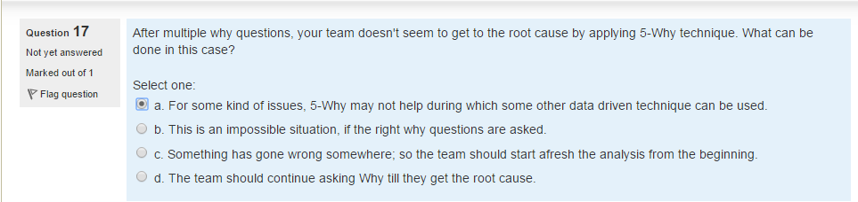

Confirmed

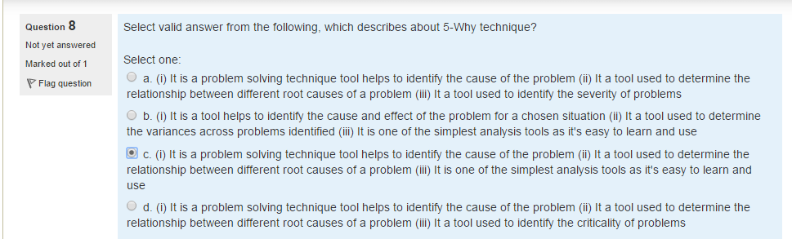

Confirmed

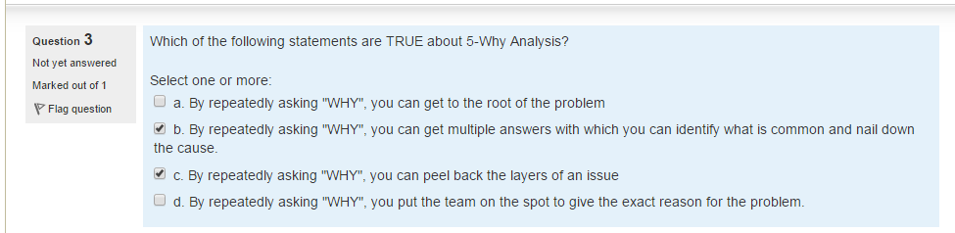

A,C confirm

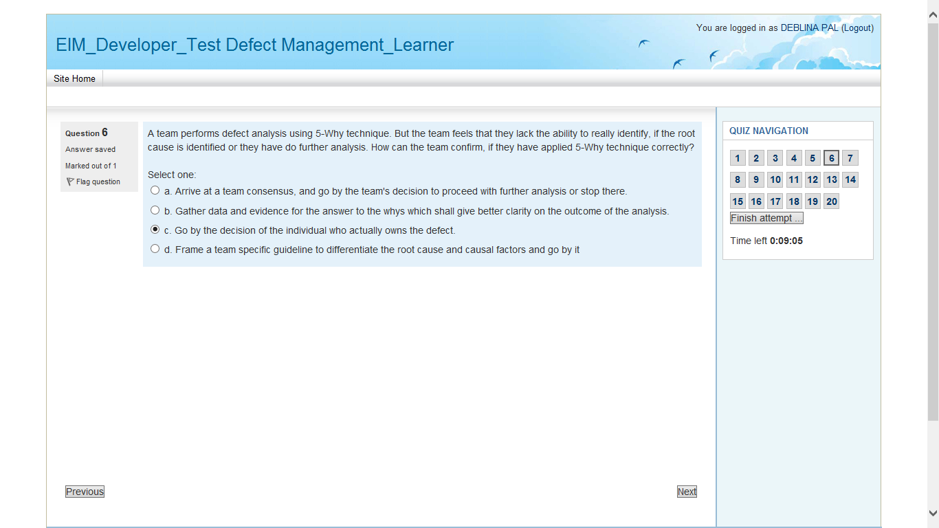

Option B confirmed

**Pareto chart**

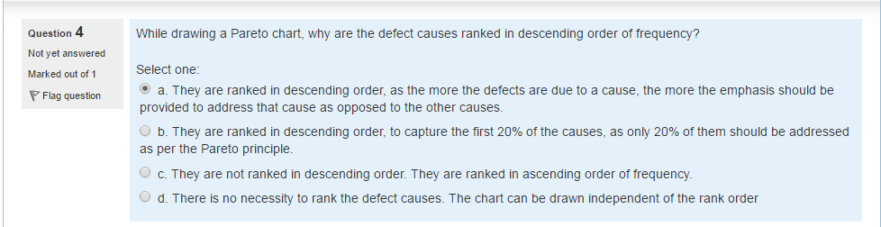

Confirmed

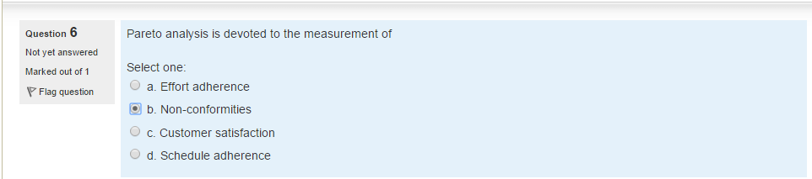

Confirmed

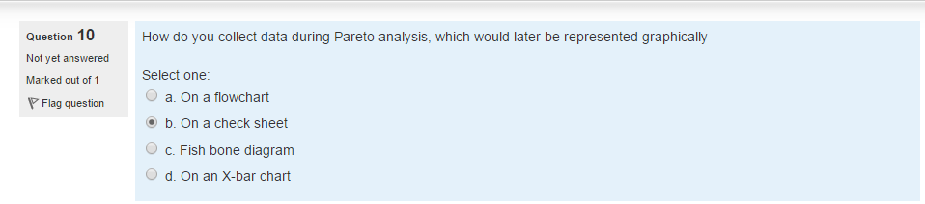

Confirmed

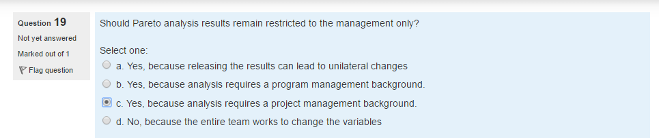

D (Confirmed)

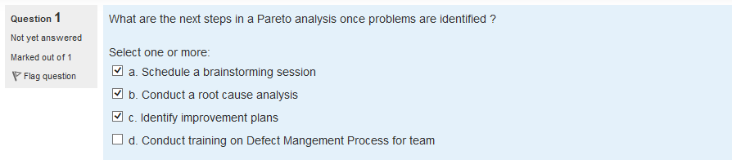

Confirmed

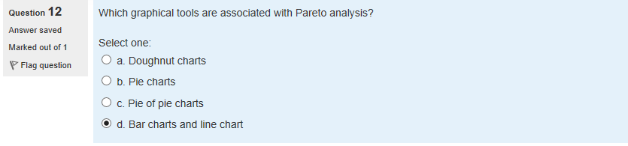

D confirmed

**Fishbone**

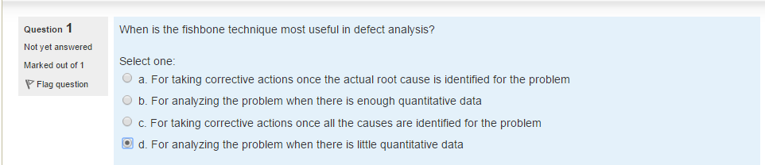

Confirmed

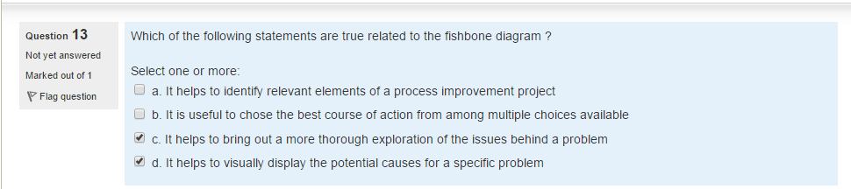

Confirmed

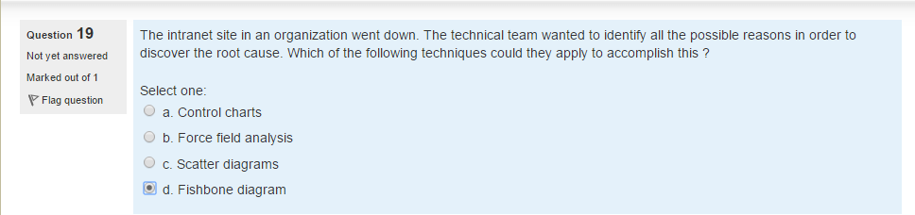

Confirmed

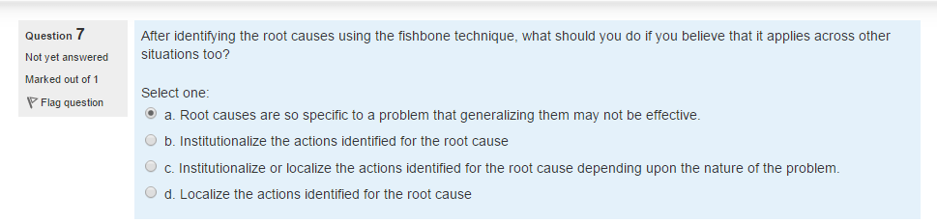

B confirmed

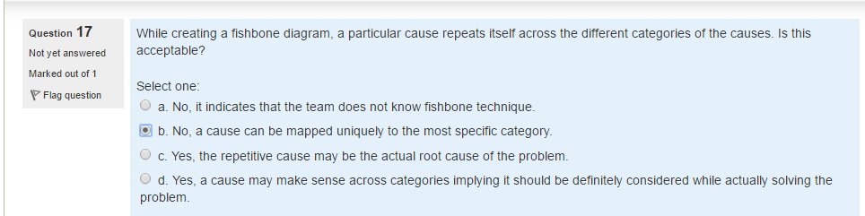

~~Don’t go with B and A try other option (go by D)~~

Go with A and check

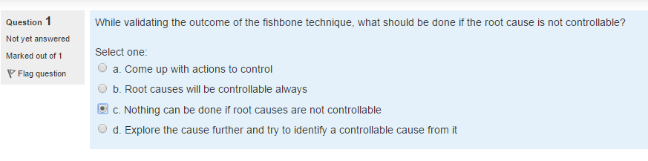

Don’t go with option B, go with D

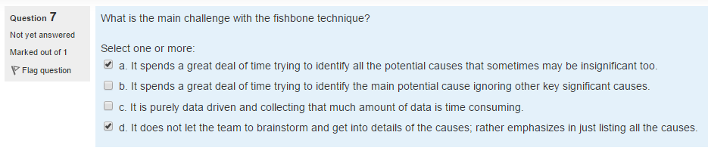

Go with option A, C and D (not sure)

**Others**

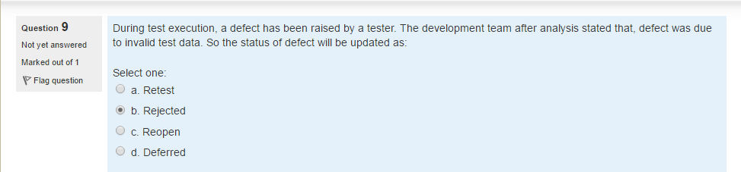

A Confirmed

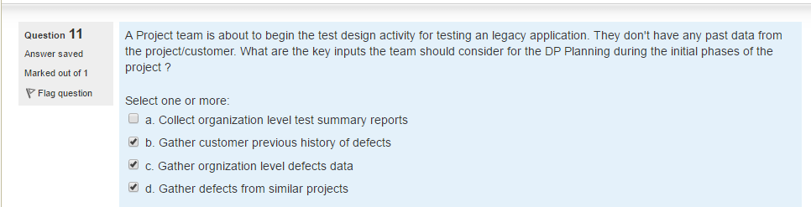

Go with B C and D (Confirm)

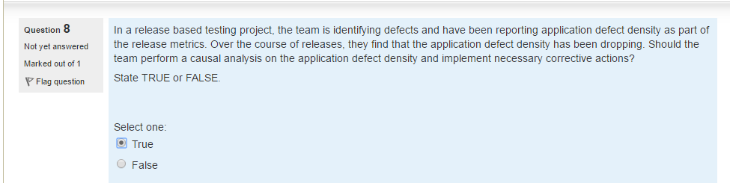

False

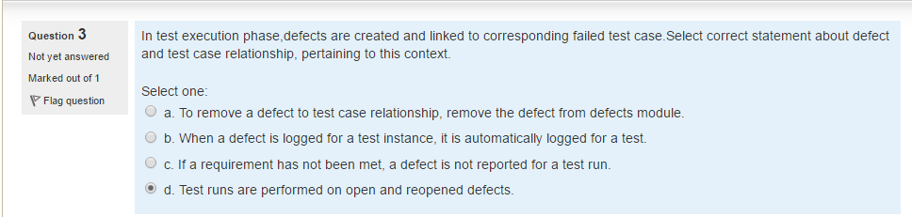

Go with A and check Defect prevention marks

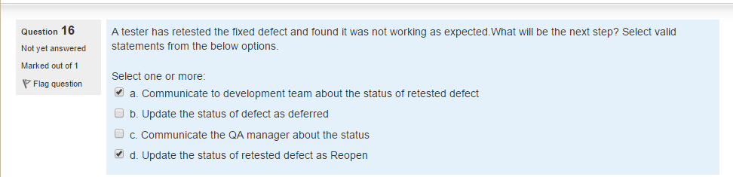

A and D and check QCD marks

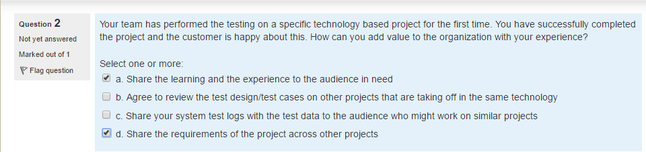

A,b and d (not sure)

`

**Test data preparation (2 qs check 100% or not)**

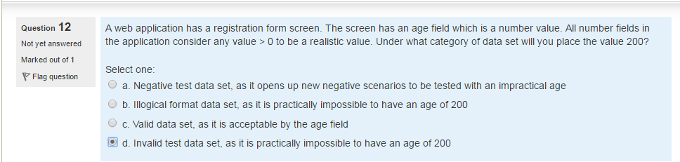

C Confirmed

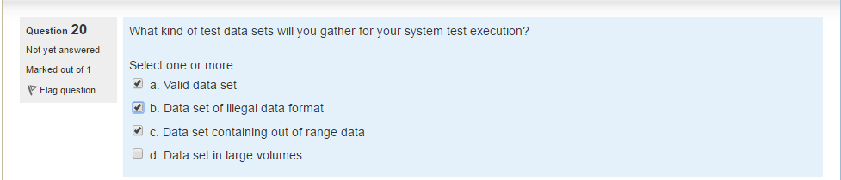

Go with A,B and C Confirmed

**Test Scenario identification (1 QS Check 100% or not)**

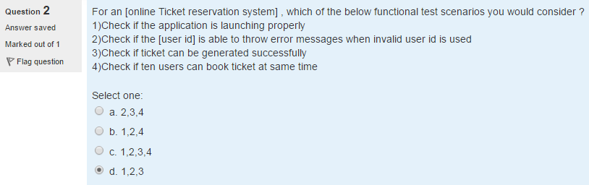

Confirmed

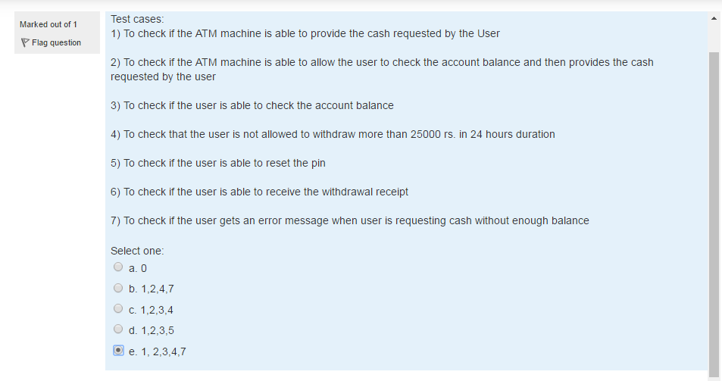

B confirmed

**Defect Analysis ( 1 Qs check 100% or not)**

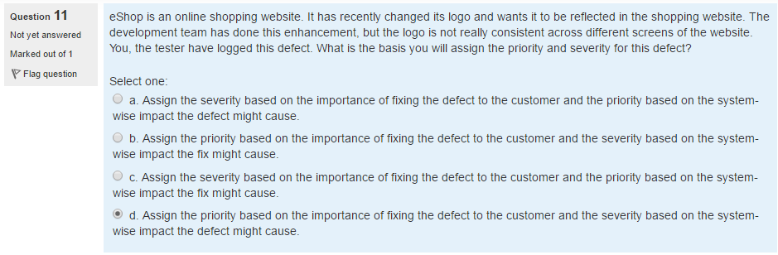

Go with D

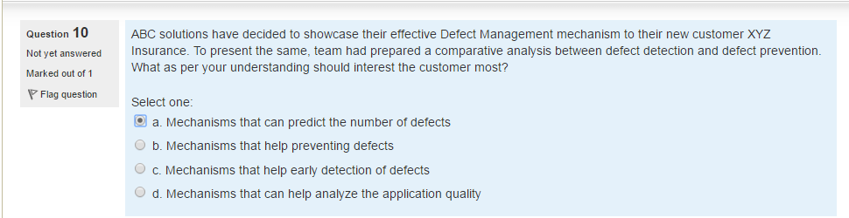

Option B

**Test Process and process package ( 1 Qs check 100% or not)**

