**#Assignment10.1**

**Que.1)** **Write a program to implement word count using Pig. Share the screenshots of the commands used with its associated output.**

To countthe repetition of the words in the file present on the local system we wrote word count code in pig, the steps as follows:

1. **Load file from local System and slice into words-**

I created a file named **‘mytest.txt’** on local system and later moved to platform of pig.

First let’s show the content of the file.

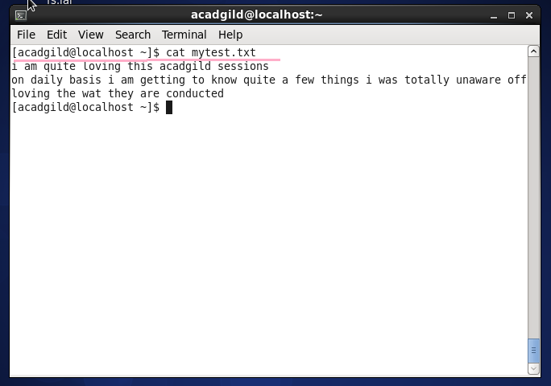

And now move this file from local to pig as **count_1,**

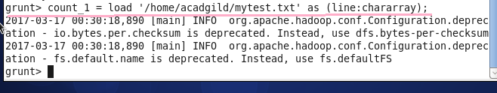

1. **Tokenize and group words –**

The file loaded will now be tokenized when ‘ ’ (Space) is present. Each token will be saved as word_1into count_row.

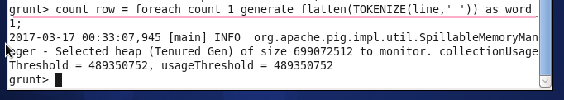

Then later these words are grouped together and when the word is repeated it will increase the count of that word.

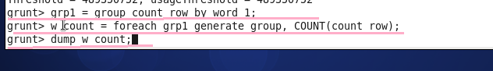

Then we will dump that file to see the result on console.

1. **Result on console-**

Now the console will show each word and its count present in the file.

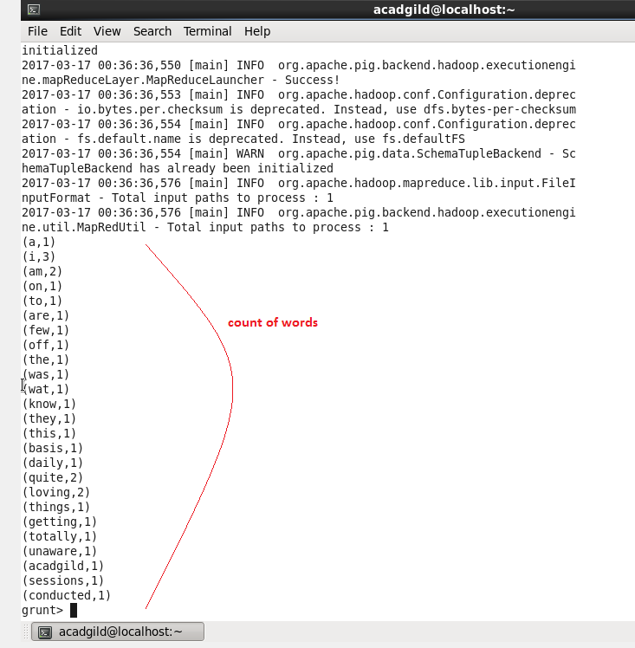

Here we can see Words like I, quite, loving, am are repeated several times and are clearly seen on console.