**#Assignment 10.2**

**Que) Create a sample dataset and implement the below Pig commands on the same dataset.**

We have created a database on local system with name of **‘employee_database.txt’**

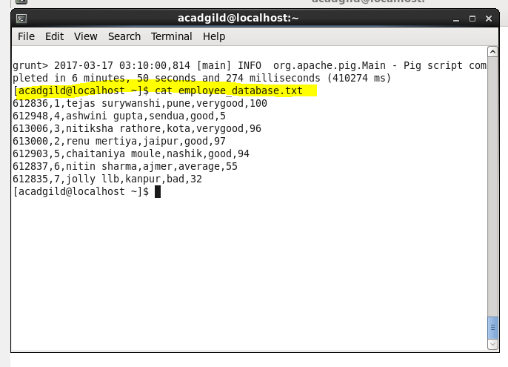

Execution of different commands as well:

**1) Concat**

We loaded the file from local and performed concat of first_name and last_name.

Program:-

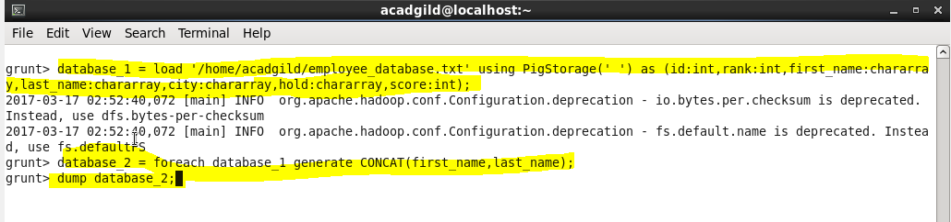

Result:-



**2) Tokenize**

**Program:-**

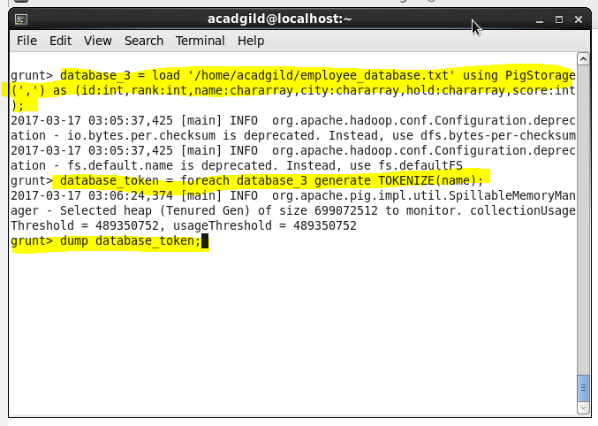

Result:-

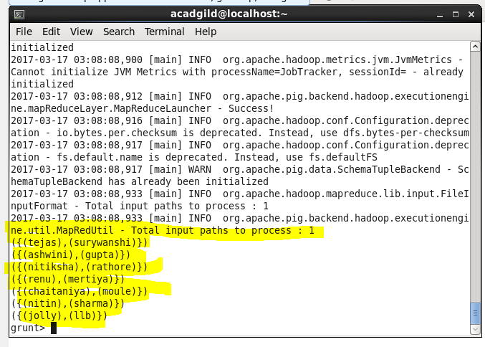

**3) Sum**

**Program:-**

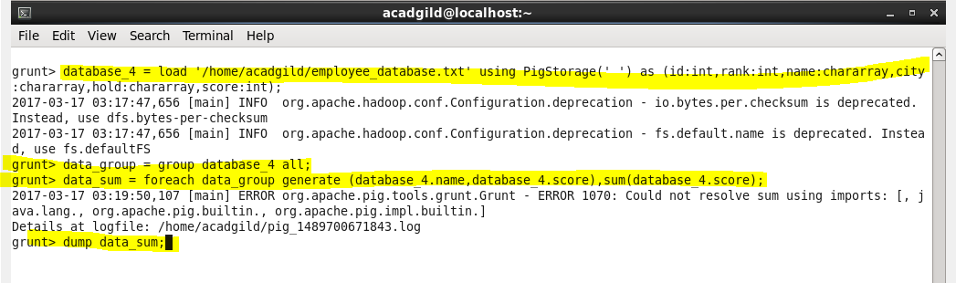

Result:-

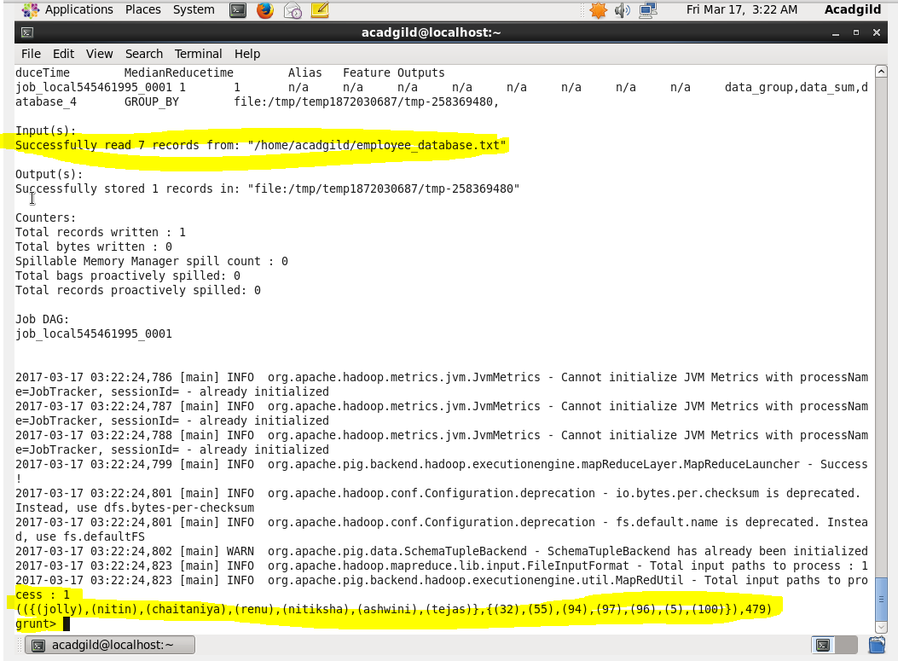

**4) Min**

**Program:-**

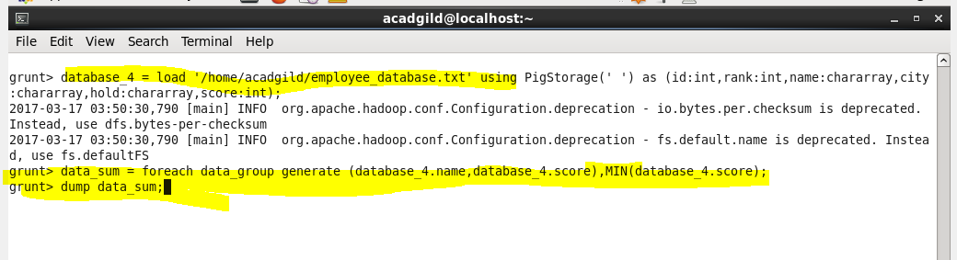

Result:-

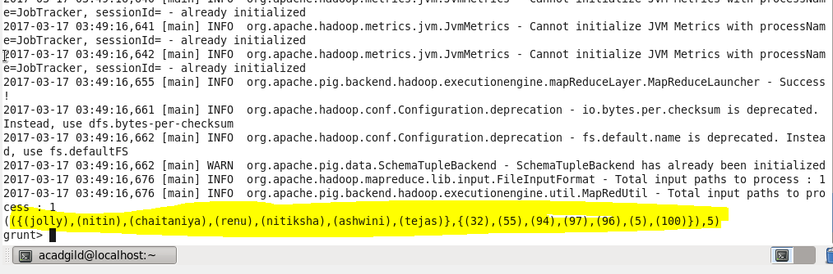

**5) Max**

**Program:-**

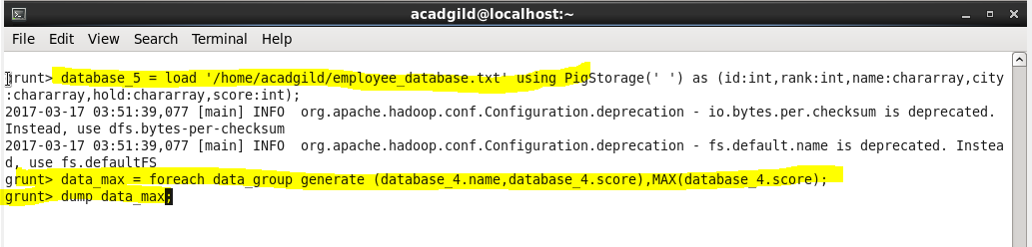

Result:-

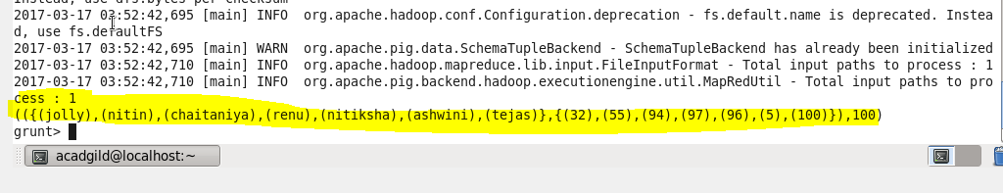

**6) Limit**

**Program:-**

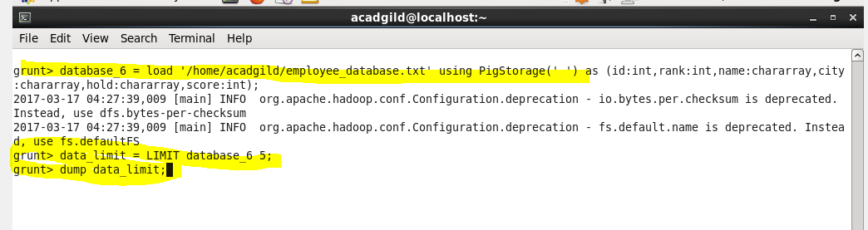

Result:-

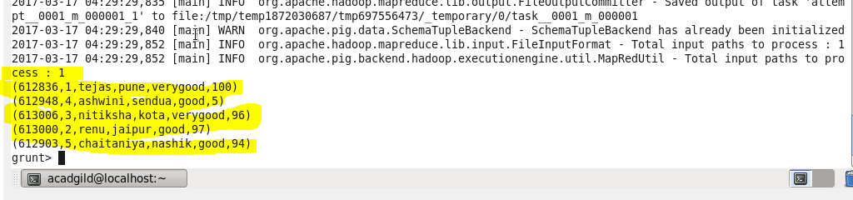

**7) Store**

**Program:-**

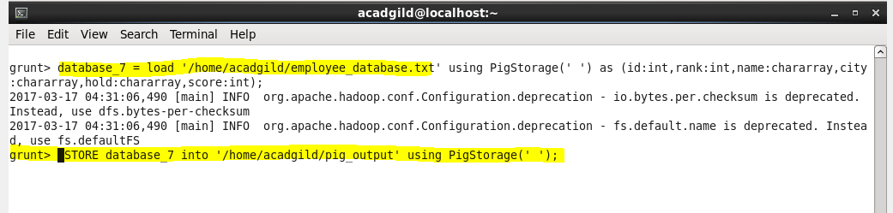

Result:-

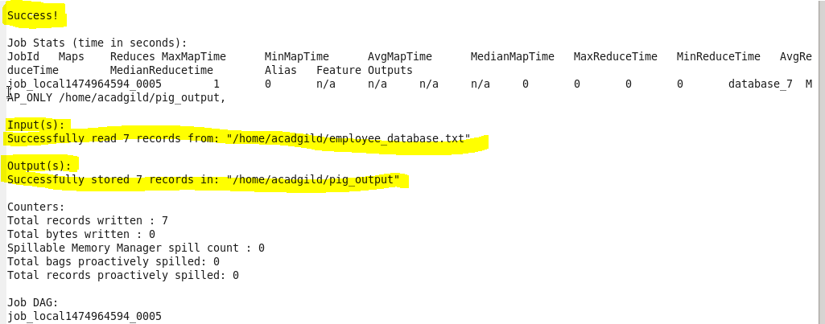

**8) Distinct**

**Program:-**

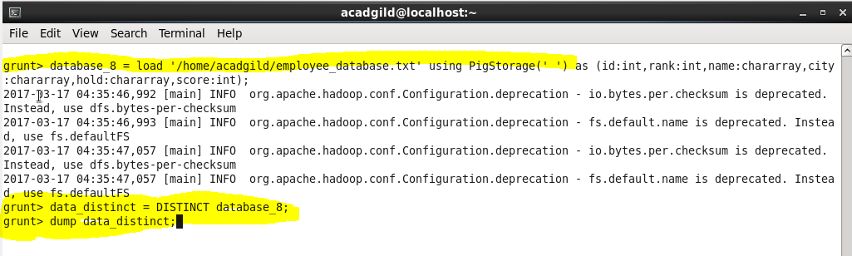

Result:-

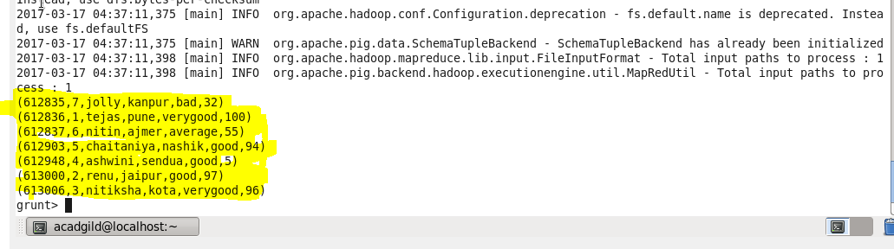

**9) Flatten**

**Program:-**

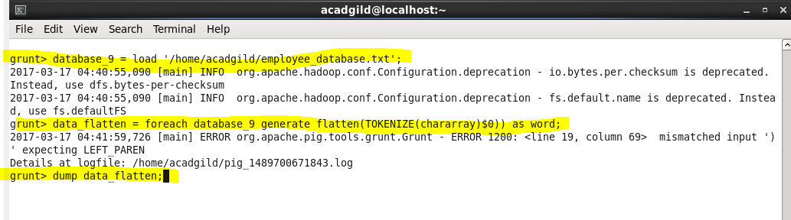

Result:-

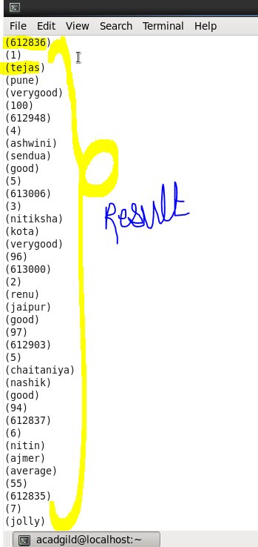

**10) IsEmpty**

**Program:-**

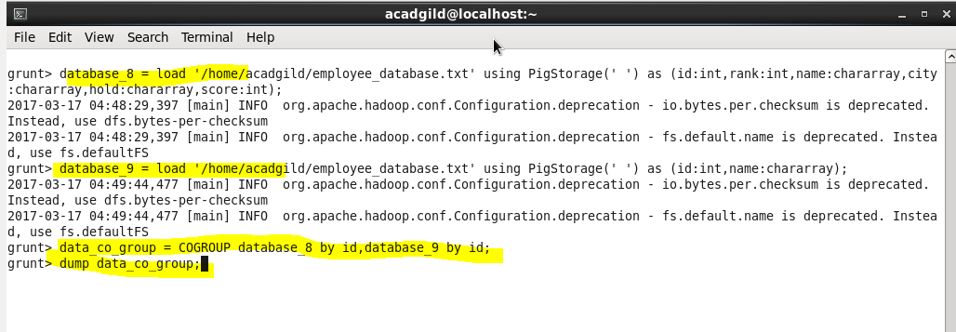



Result:-

