**#Assignment10.4**

**In this assignment you need to write the pig scripts for the given problem statements**

**Dataset:**

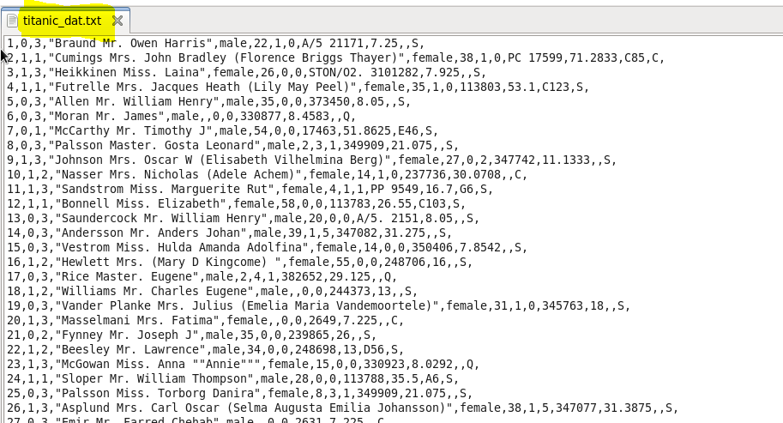

**Q1- Write a pig script to find the average age of male and female persons died in the titanic tragedy.**

**Program:**

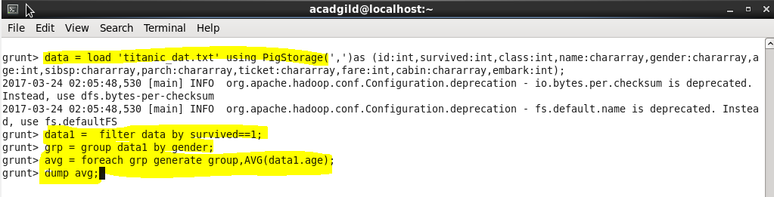

**Result:**

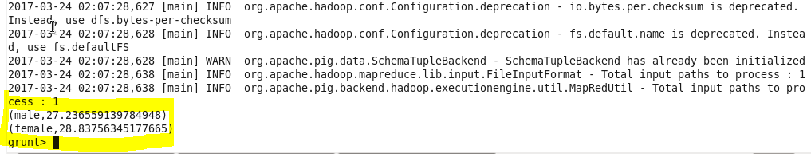

**Q2.Write a pig script to find the number of people died and survived in each class**

**Program:**

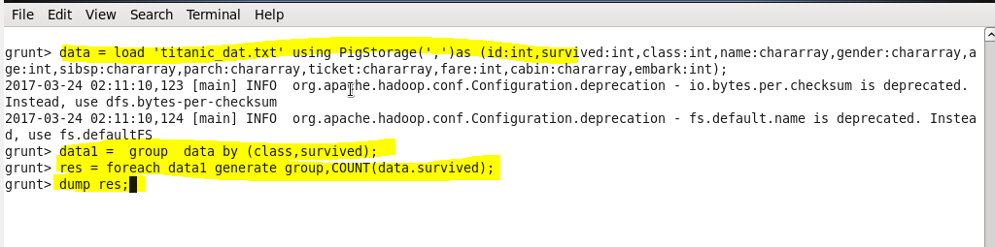

**Result:**

