**#aSSIGN_10.5**

**problem statement:**

1. **Write a pig script to find the top 20 destination people travel the most: Based on the given data**

To conclude the query above we included data set **“travel_data”** from the resource provided.

Thus,

Program:

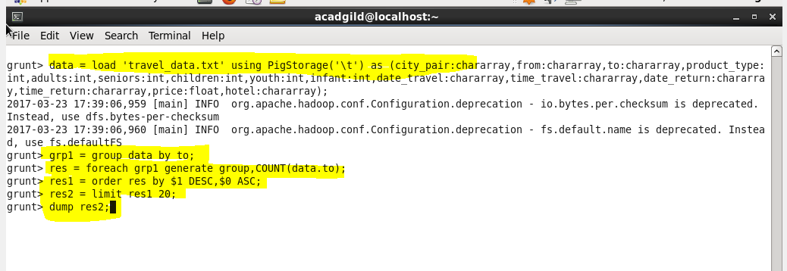

Result:

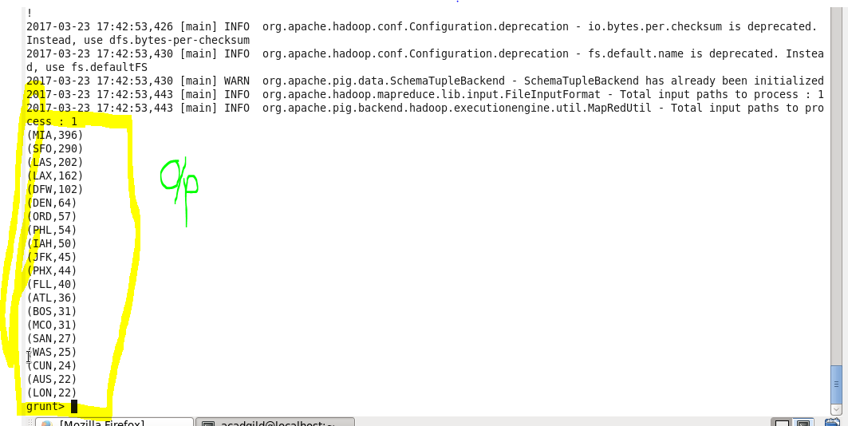

1. **Write a pig script to find the top 20 locations from where people travel the most**

Program:

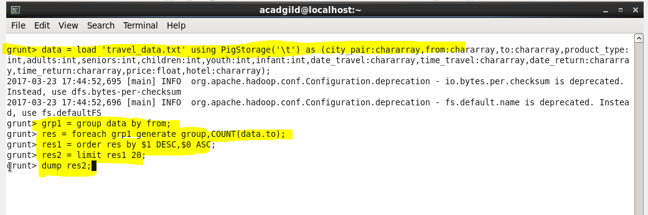

Result:

