**#ASSIGNMENT_11.2**

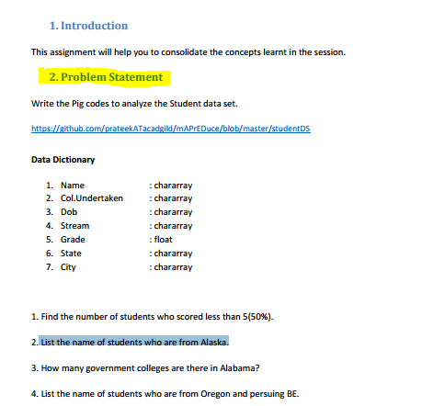

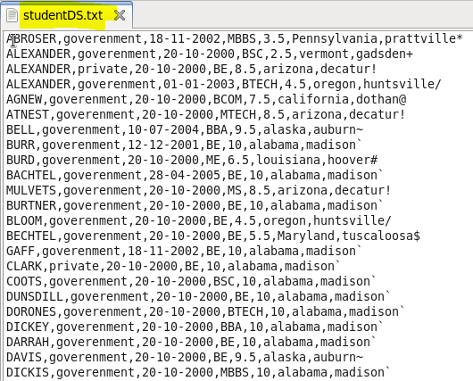

**Que.1)** **Find the number of students who scored less than 5(50%).**

First we will load studentDS.txt from local storage using PigStorage comma (,) separator and will define column name and its data type.

Later we will filter out the rows by limiting them to a condition having grade less or than equal to 5.0

We will group them by all to avoid repetition of entries and later count entries present using aggregate function COUNT.

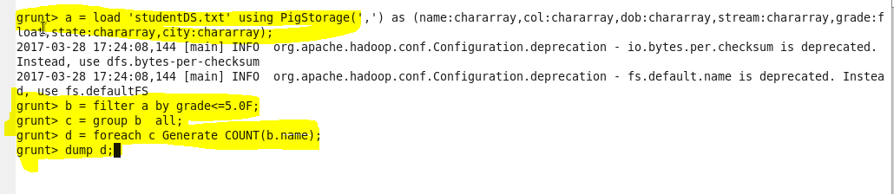

Result:

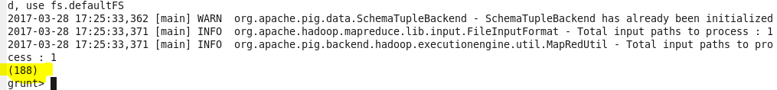

We can see there are 188 entries that satisfies the limiting condition.

**Que.2)** **List the name of students who are from Alaska.**

First we will load studentDS.txt from local storage using PigStorage comma (,) separator and will define column name and its data type.

We will filter the file loaded by limiting it to, the only entries having state as Alaska, later will select name of such entries to result.

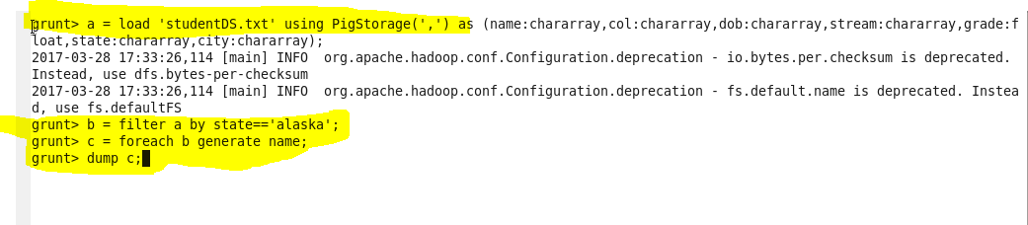

In result below we can see name of the students who are from Alaska.

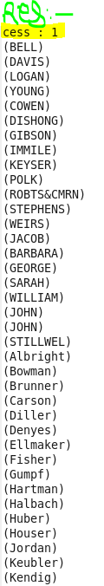

**Que.3)** **how many government colleges are there in Alabama?**

First we will load studentDS.txt from local storage using PigStorage comma (,) separator and will define column name and its data type.

We will filter the file loaded by limiting it to, the only entries having state as Alabama and col as government, later will select count of such entries to result.

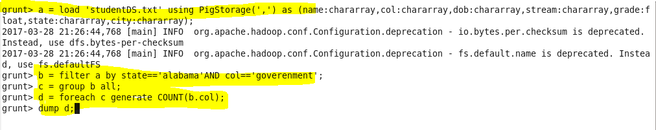

Result:-

In result we can see total count of students satisfying both the conditions.

C:\Users\612836\Desktop\ACADGILD\11.2.3op.PNG

**Que.4)** **how many government colleges are there in Alabama?**

First we will load studentDS.txt from local storage using PigStorage comma (,) separator and will define column name and its data type.

We will filter the file loaded by limiting it to, the only entries having state as Oregon and stream as BE, later will select name of such entries to result.

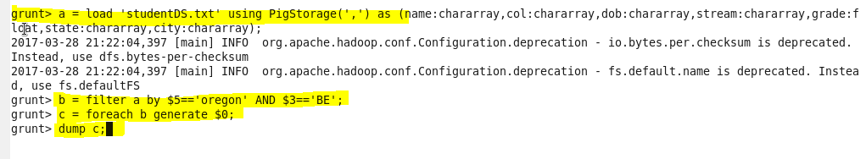

Result:-

Here we can see the names of students satisfying limiting condition.

