**PROBLEM STATEMENT:**

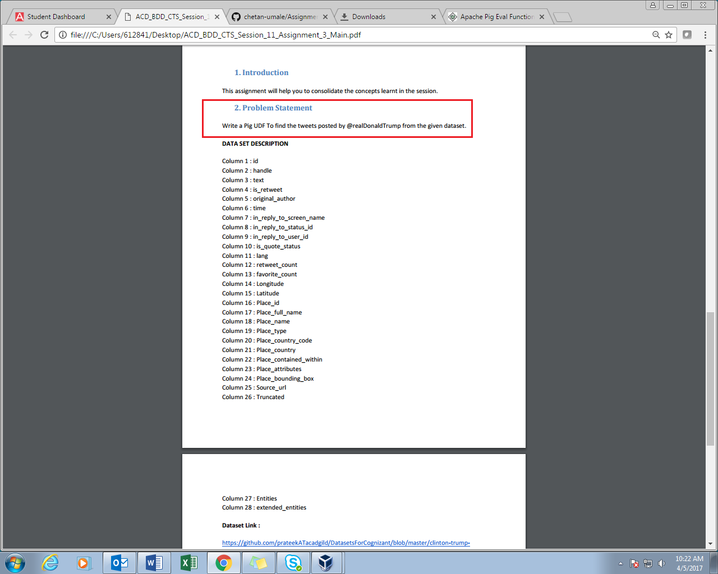

**Dataset: ’TWEETS.CSV’**

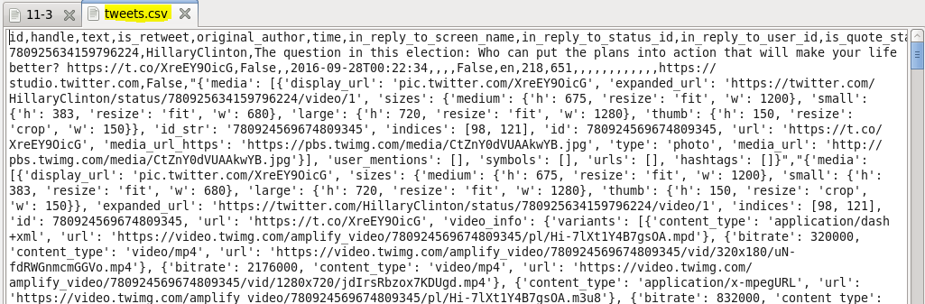

**PROGRAM:**

**UDF (JAVA CODE):**

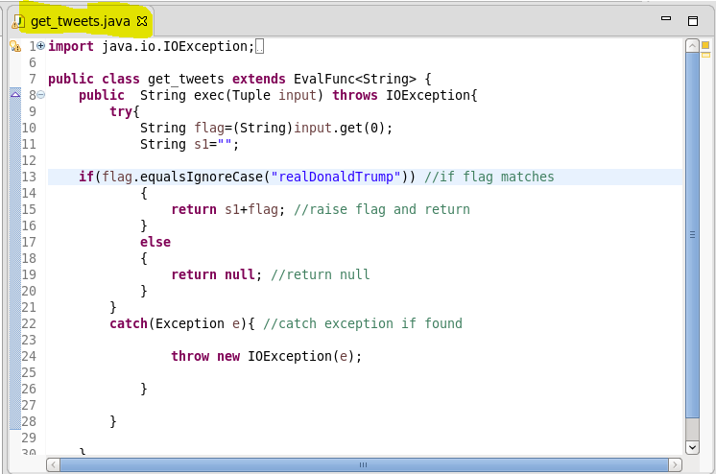

In code above we need to count the tweets made by handle name ‘realDonaldTrump’.

**PIG SCRIPT:**

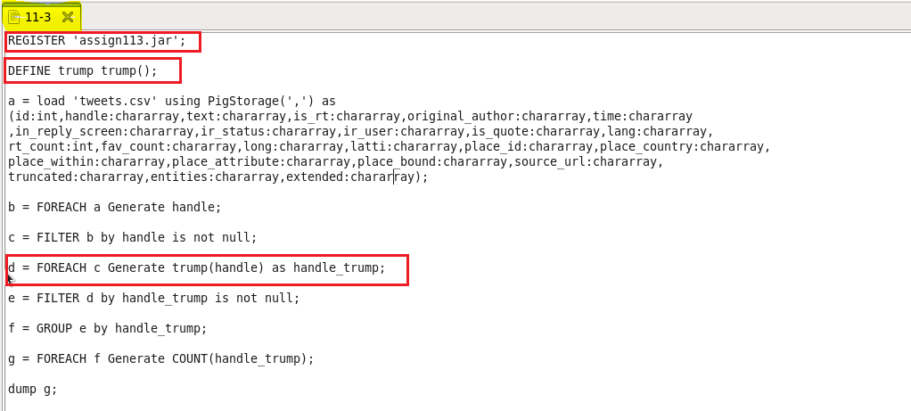

**OUTPUT:**

Count of tweets made by **‘realDonaldTrump’.**

