**#ASSIGNMENT_11.6**

**PROBLEM STATEMENT:**

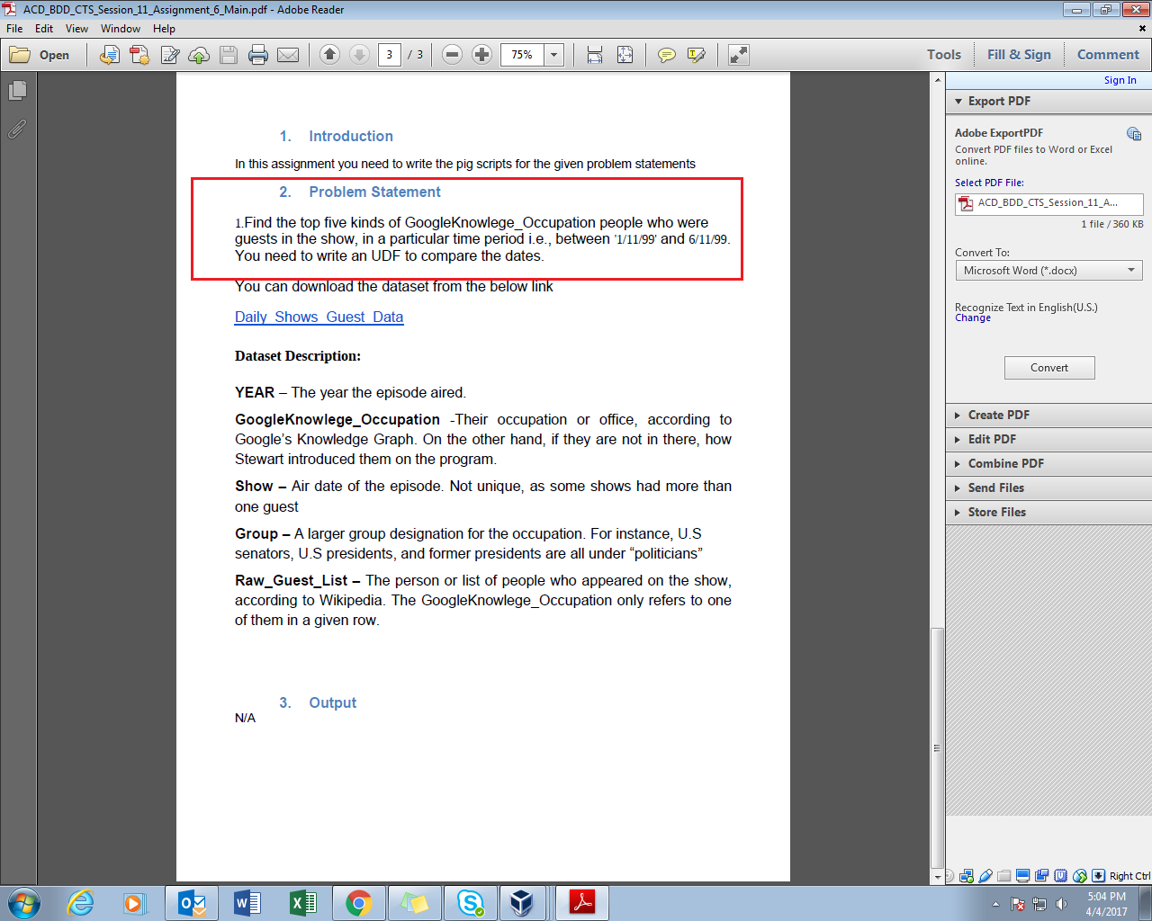

**Dataset- ‘Daily_show_guest.txt’**

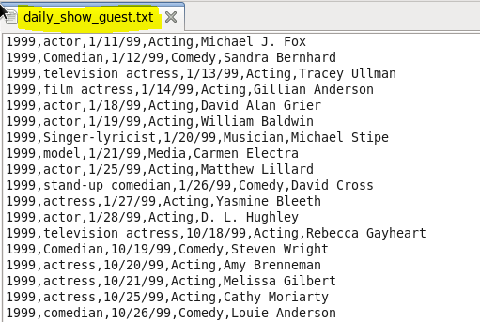

**PROGRAM:**

**UDF (java code)**

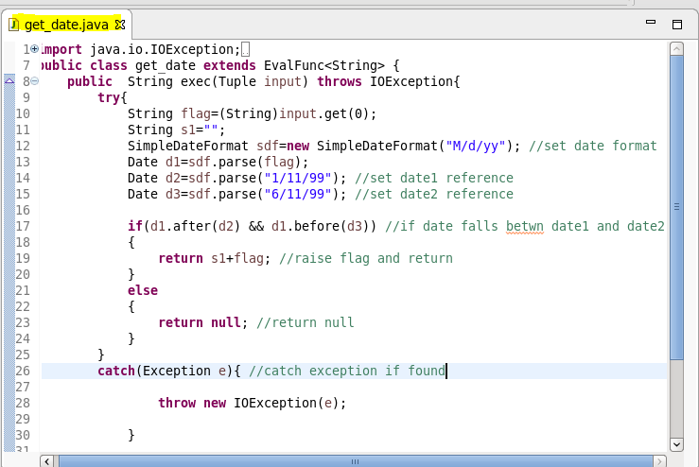

The get_date class extends the eval function and it overrides the method of exec (). The execution logic is written into the exec method. This UDF is later exported as a jar file in pig.

**PIG SCRIPT:**

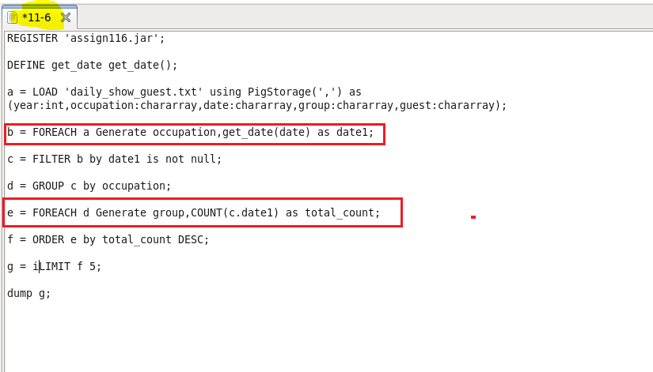

UDF is written to operate function on dataset. Date tuple is passed as parameter to udf get_date.

If the date is between date 1 and date 2 as passed into UDF else will return null value. The result is later filtered to remove null values and limit the expected result to 5.

**OUTPUT:**

**Loading gedit file 11-6**

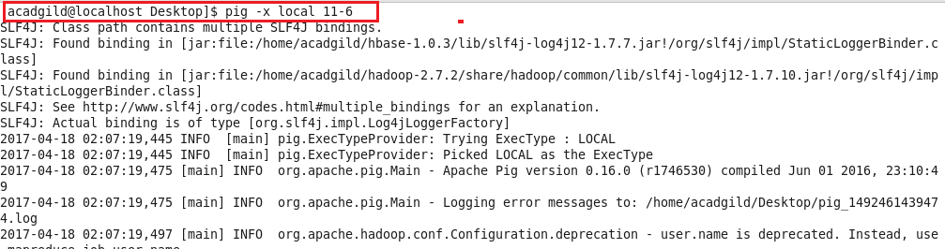

**Display result on console**

