**#ASSIGNMENT15.4**

Build and Deploy hadoop word count program using Maven

* WordCount.java which contains Driver , Mapper & Reducer class.

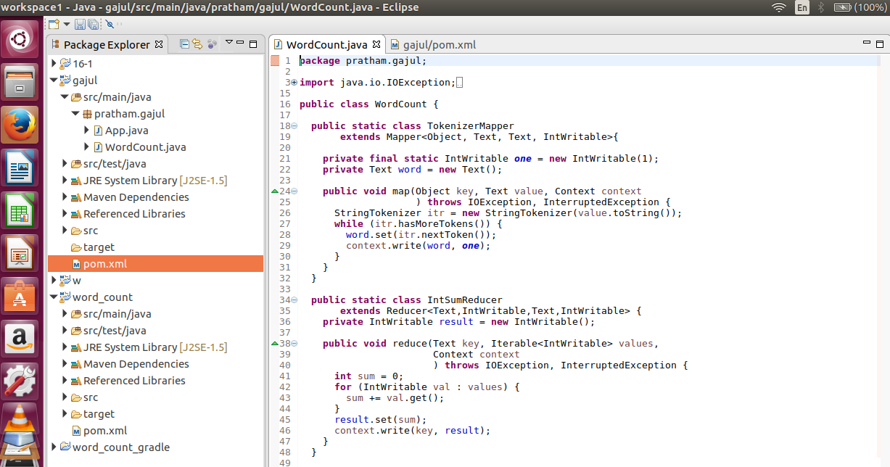

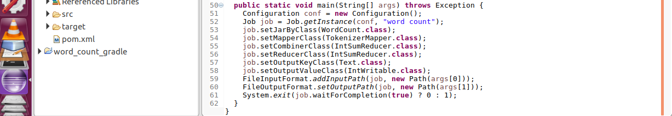

* Pom.xml file

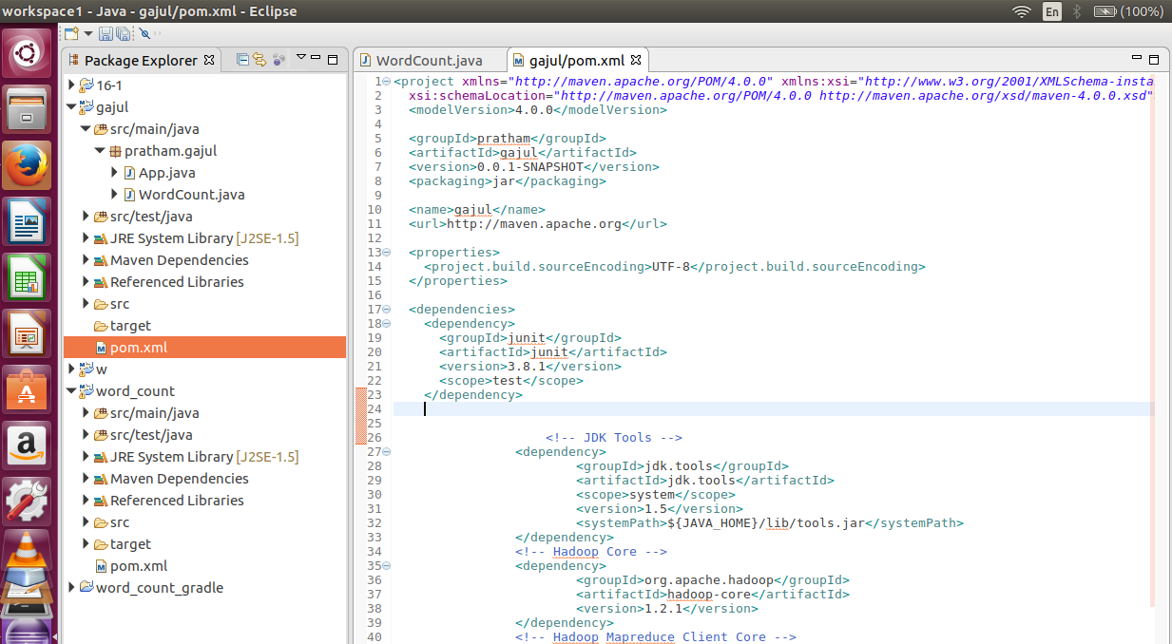



* Building jar using mvn clean install

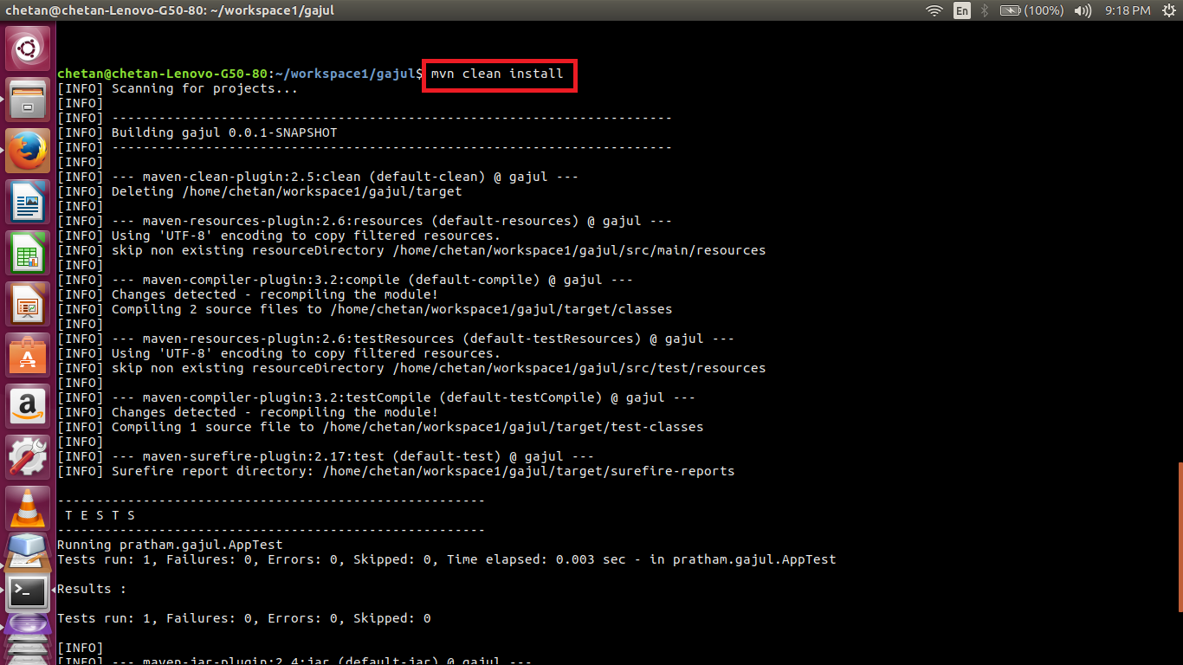

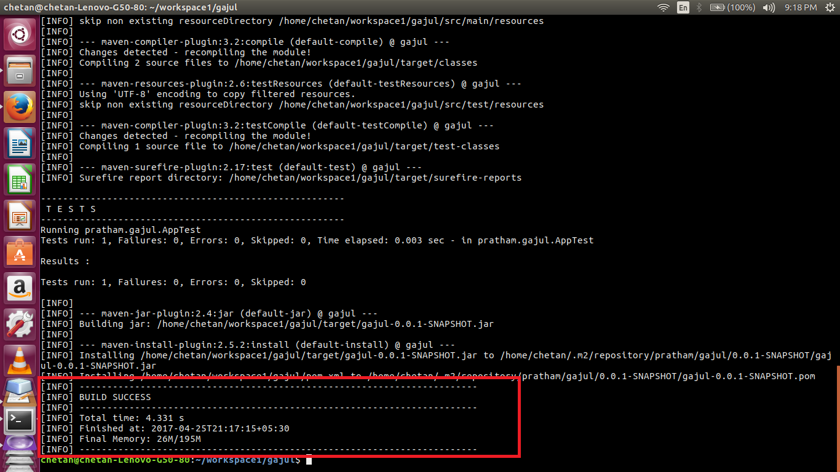

* jar file created

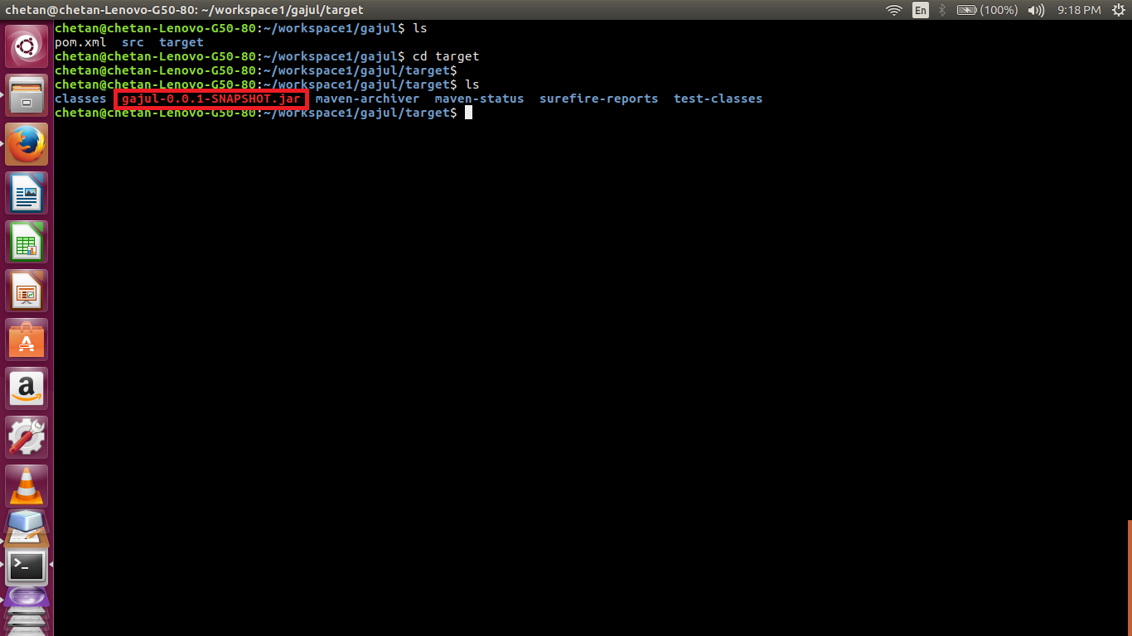

* Running the jar file

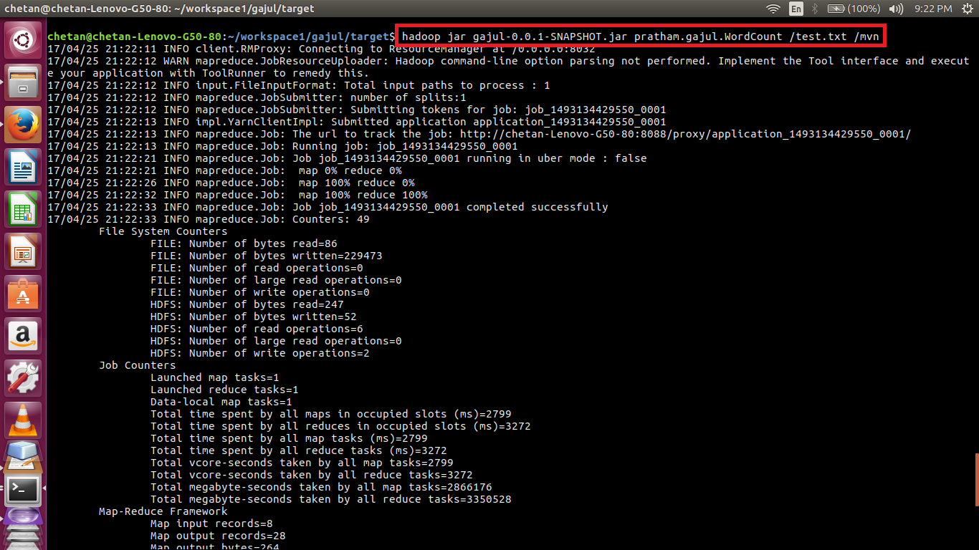

* Dataset



* Output

