**ASSIGNMENT16.1**

**Using Distributed cache join the two datasets and find out the number of temperature variations in each country using mapreduce.**

**Driver**

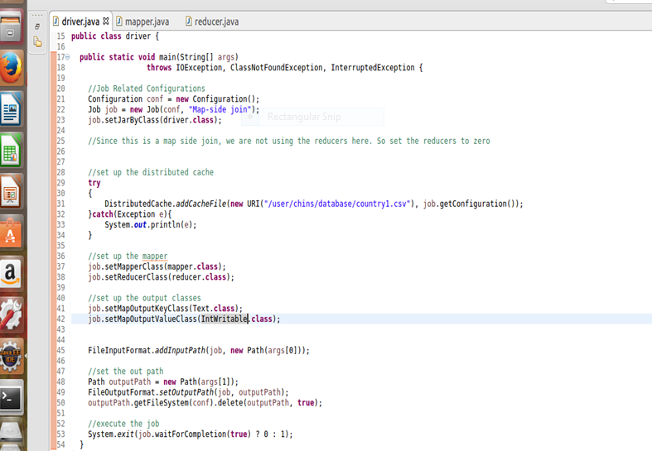

**Mapper**

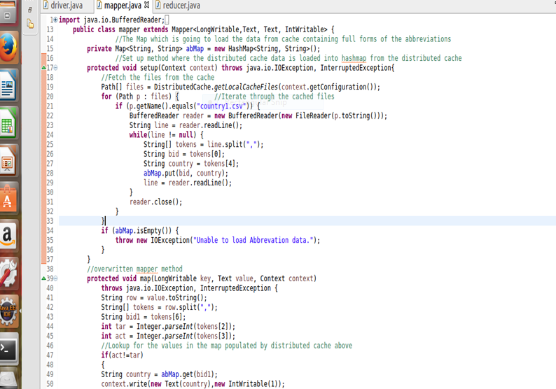

**Reducer**

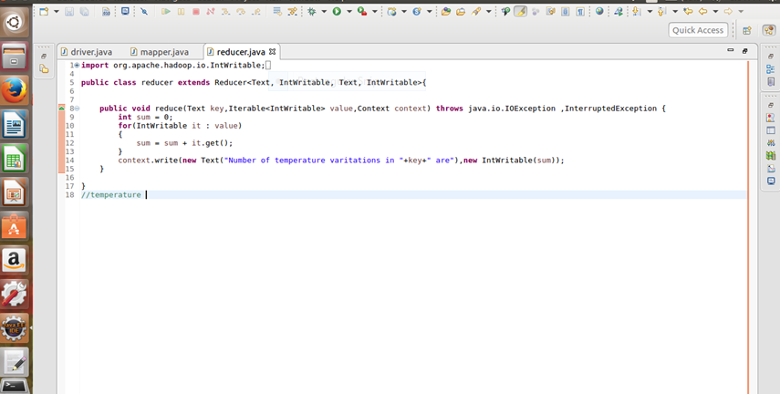

**Output**

