**ASSIGNMENT16.3**

**Use reduce side join to join the two datasets and find What kind of problems are prevalent, and in which state?**

**Driver**

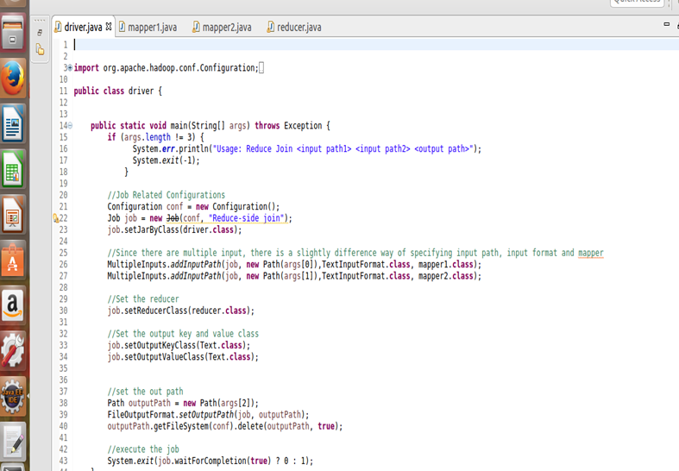

**Mapper 1**

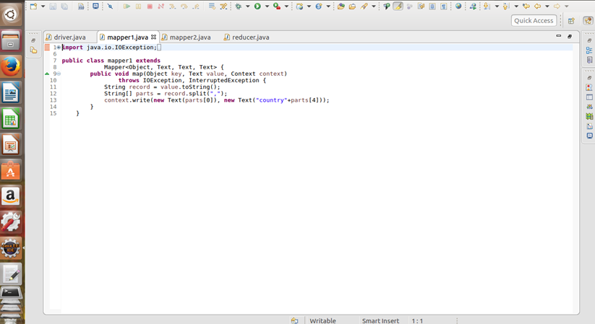

**Mapper 2**

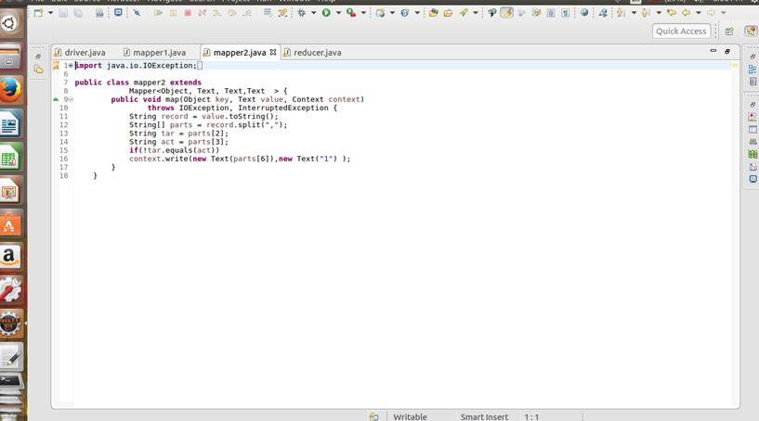

**Reducer**

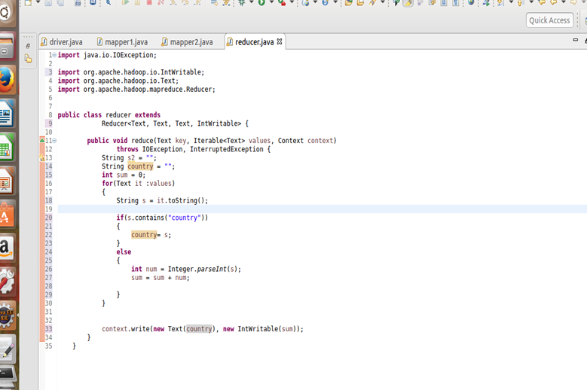

**Output**

