**Input file data set**

Hadoop is good subject

Hadoop is good subject

Hadoop is good subject

Hadoop is good subject for me

**Run a map only job on the word count program using static configurations.**

**Driver**

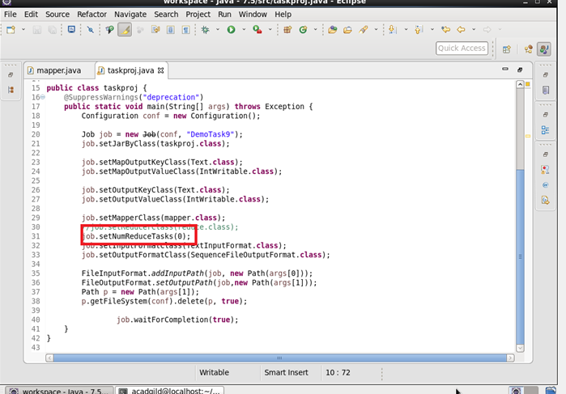

**Mapper**

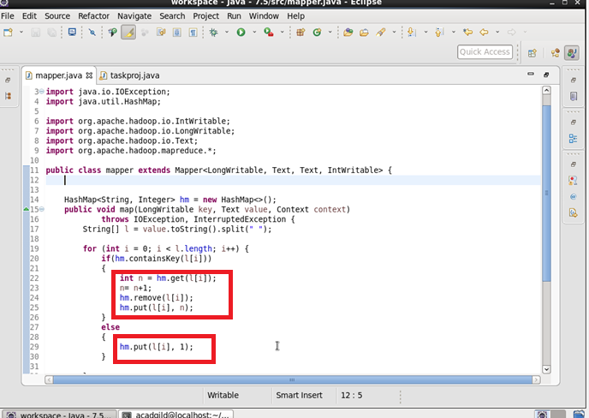

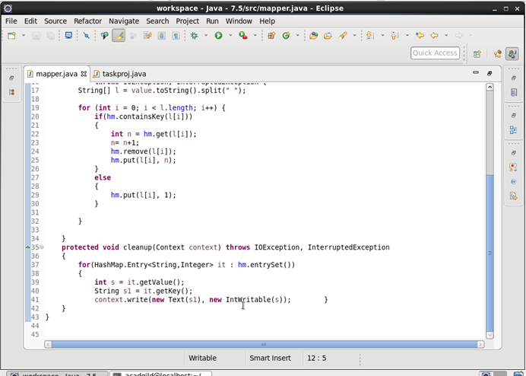

**Output**

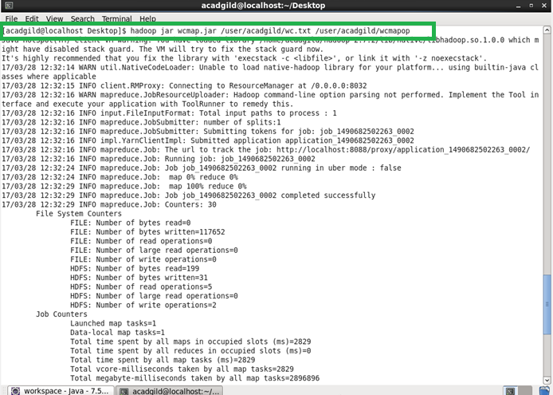

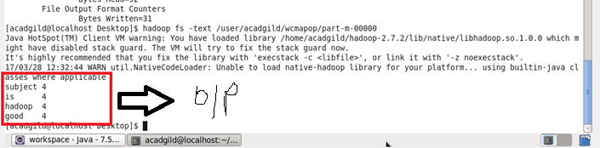

**Run the mapreduce word count program and set the number of reducers to 2 using static configurations.**

**Driver**

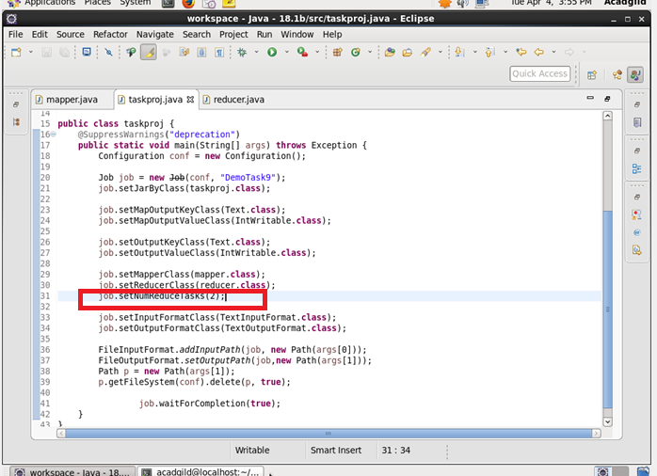

**Mapper**

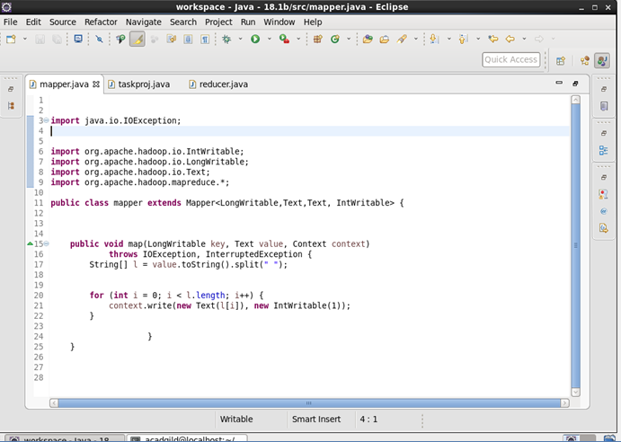

**Reducer**

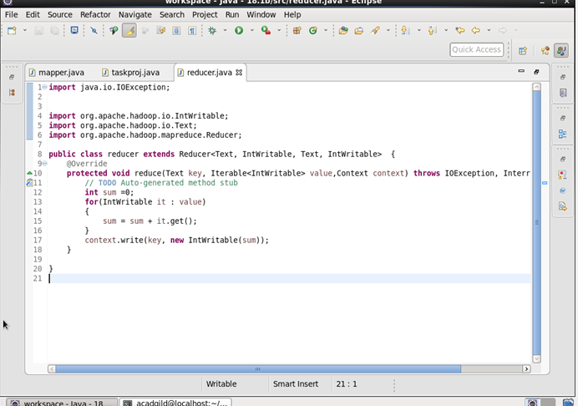

**Output**

