ASSIGNMENT18.3

Merge the small files in hadoop by following the below blog.

Here we have created a folder and the files which are to be merged are copied in the folder on hdfs. Then using the command -getmerge the files in the folder are merged.

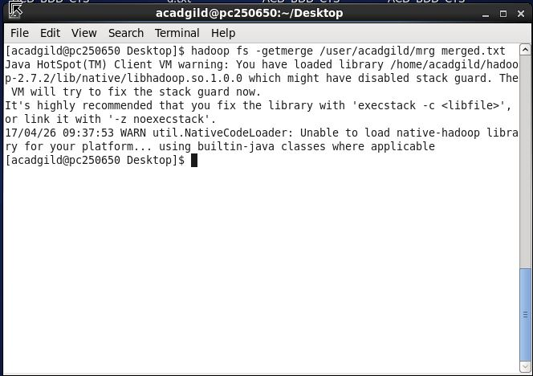

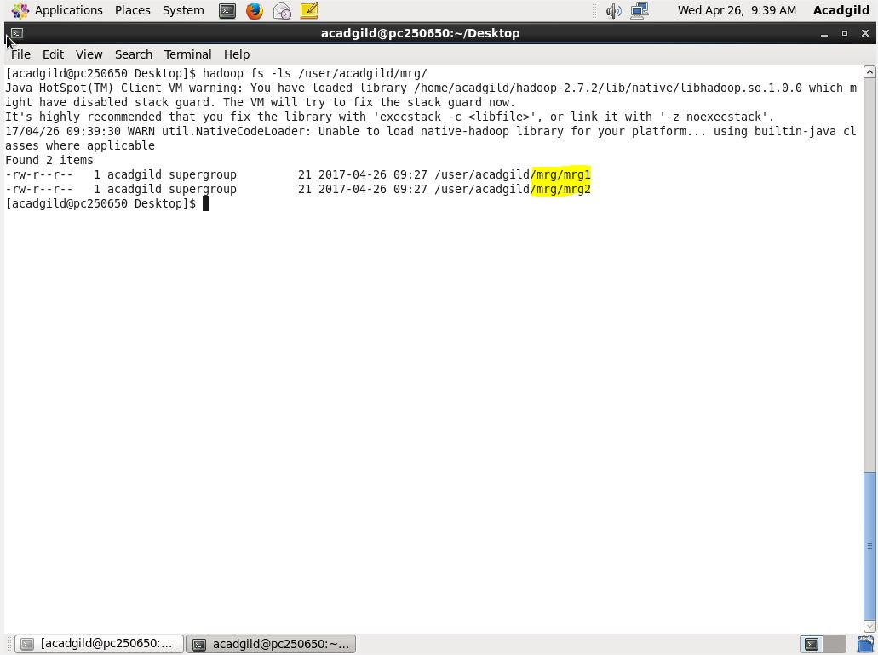

The files that are going to be merged are mrg1 and mrg2.

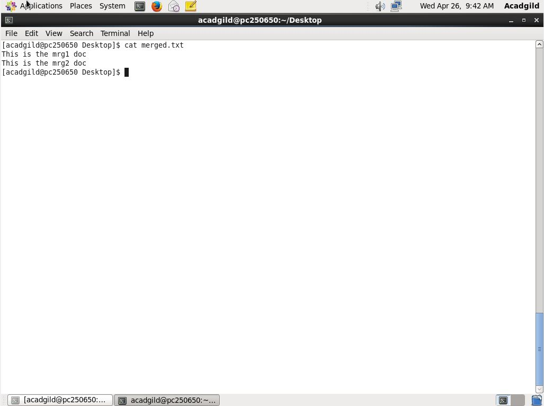

The cat command is performed on the merged.txt that we created to get the merged files mrg1 and mrg2. And the output is as above.