**ASSIGNMENT 26.4**

**PROBLEM STATEMENT:**

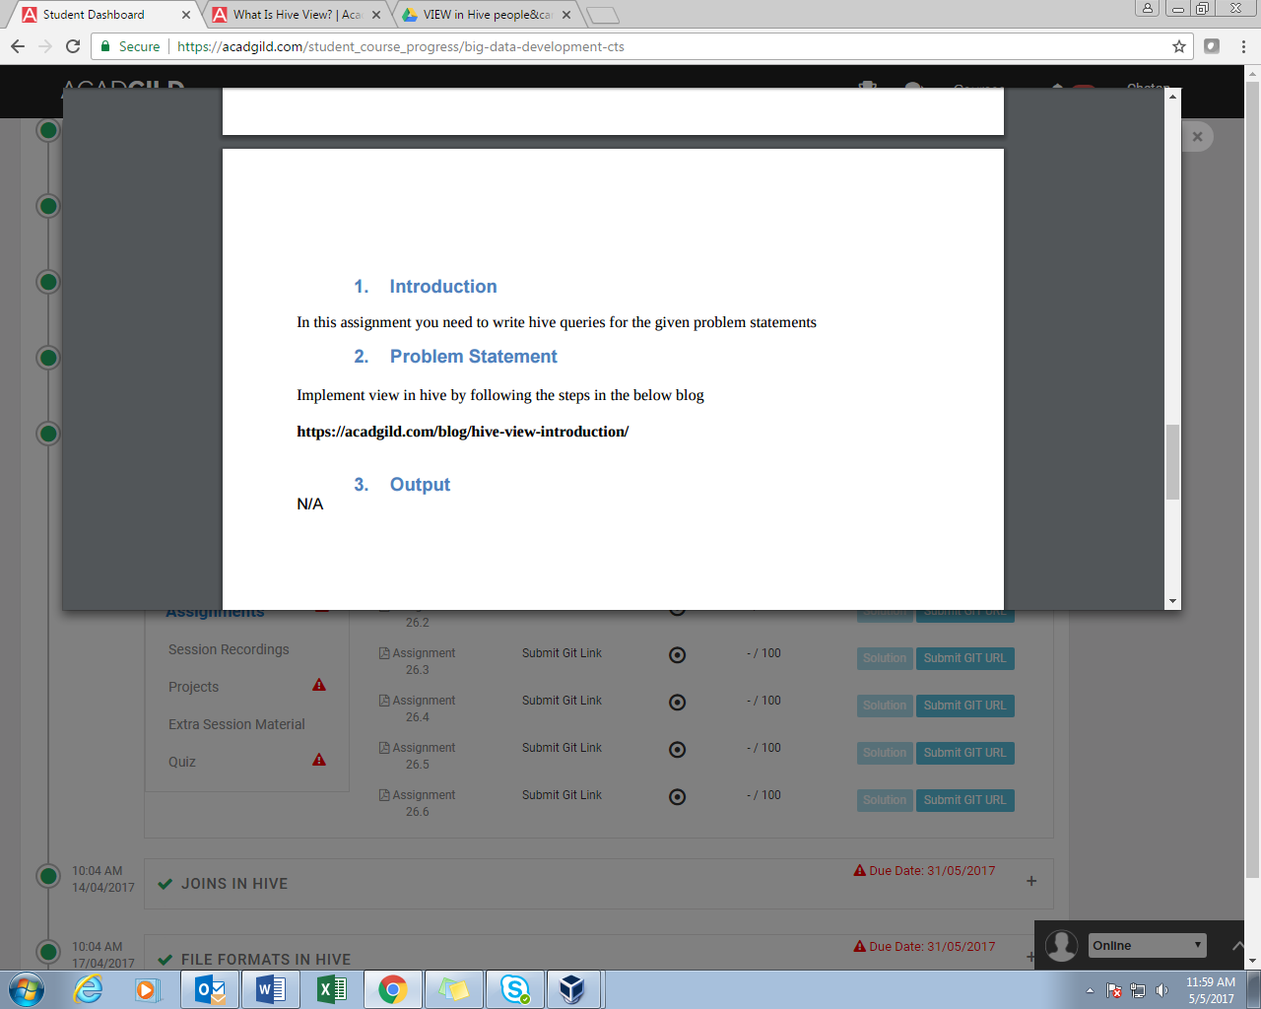

**SOLUTION:**

