ASSIGNMENT33.1

Write Java client API to perform following operations:

● Create the method name get record and use get class to retrieve one record at a time

record from company table.

Here we have implemented the method getrecord() and the program will display the record of the row id given as the input. So only the record of the desired row id is being displayed.

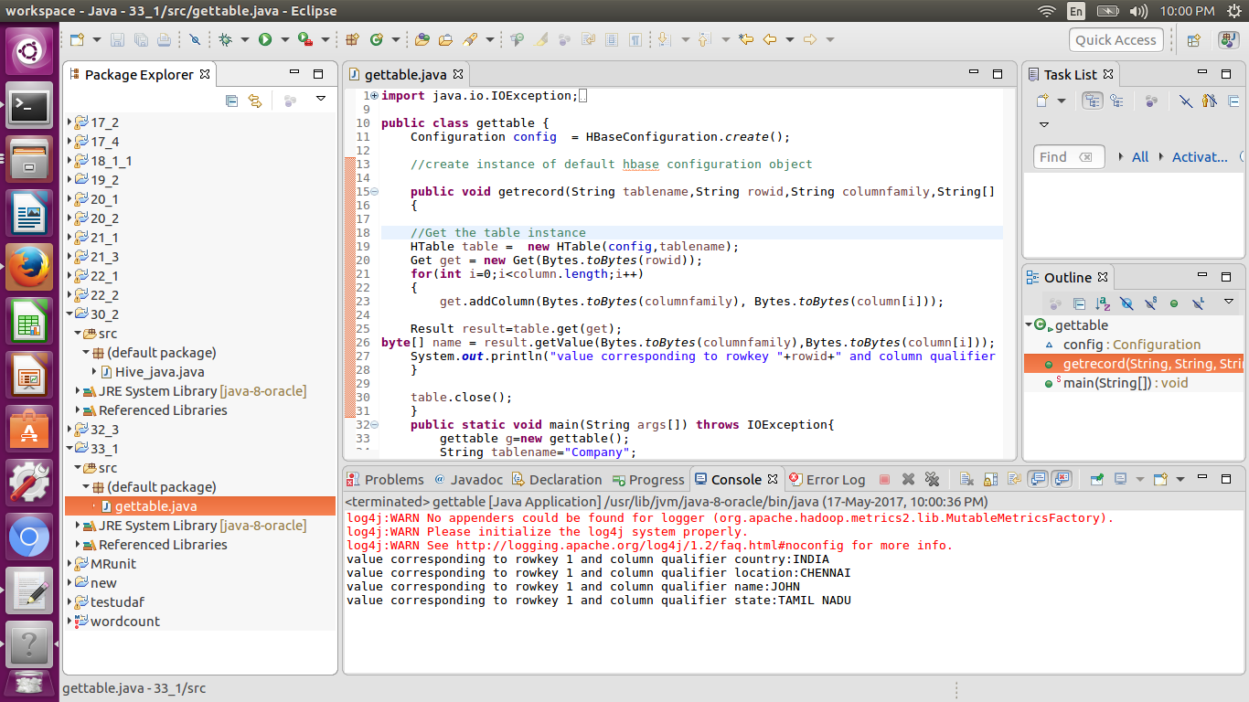

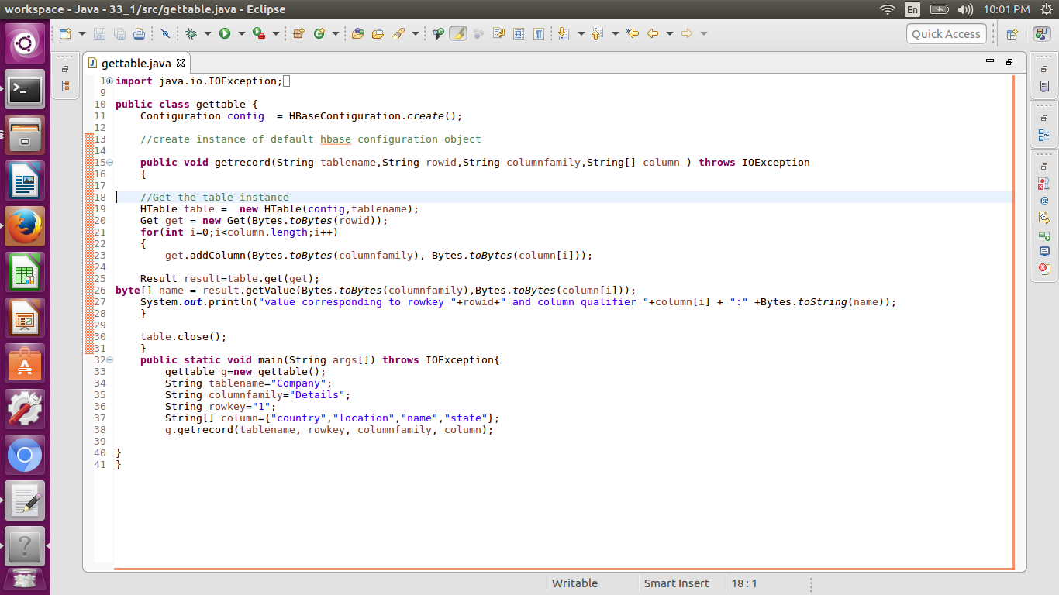

● Create the method name display and use scan class to display all records from company

Table

Here we have implemented the scan table where all the data in the table is scanned and the output is show in the console.

The below screen shot shows the program and the output.

