ASSIGNMENT33.3

● Integrate Hbase with Pig

● Load Data (Bulk Load) from HDFS to Hbase Table using Pig.

● Explain the procedures and code implemented with screenshots.

Here we have uploaded the data custs.txt into the hdfs and then we used the pig script to write the data into the hbase table using pig commands.

The file uploaded into the hdfs is as follows:

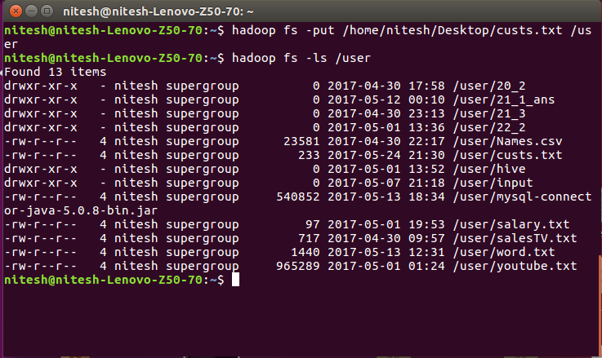

We created the cust table into the hbase so that the data could be written into it.

