**Titanic Data Analysis**

Write a mapreduce program to find the total number of people travelled in titanic Download the Titanic data set from the below link Titanic_Dataset

DATA SET DESCRIPTION

Column 1: PassengerId

Column 2: Survived (survived=0 & died=1)

Column 3: Pclass

Column 4: Name

Column 5: Sex

Column 6: Age

Column 7: SibSp

Column 8: Parch

Column 9: Ticket

Column 10: Fare

Column 11: Cabin

Column 12: Embarked

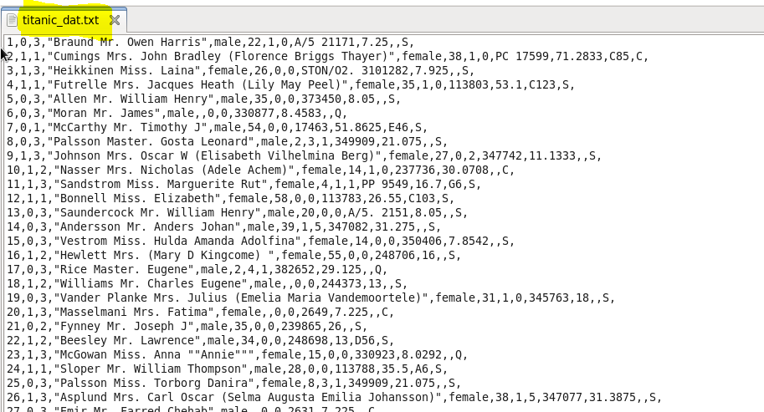

**Program:**

**Driver-**

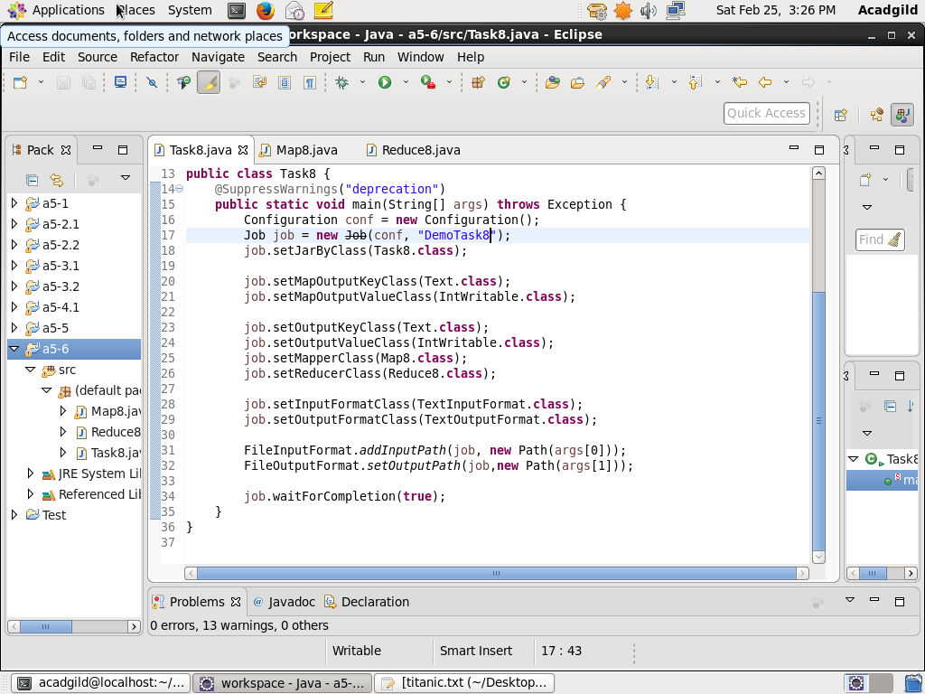

**Mapper**

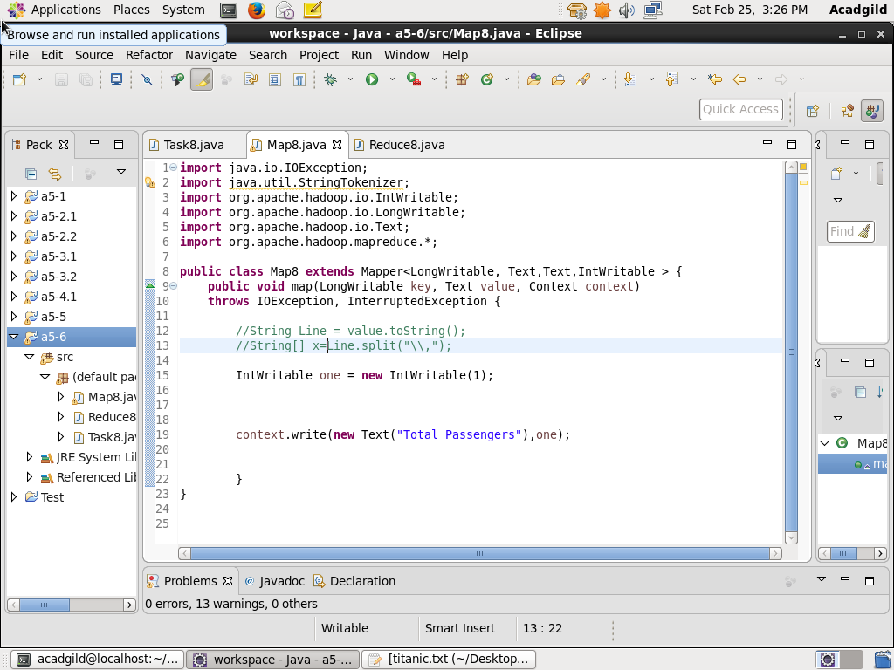

**Reducer**

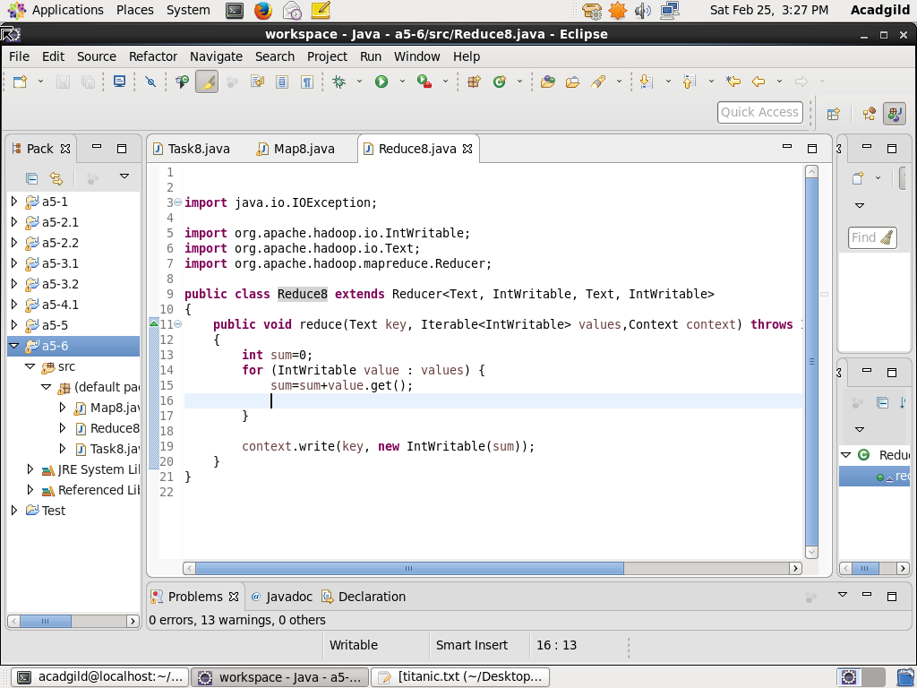

**Result:**

