**#ASSIGNMENT6.2**

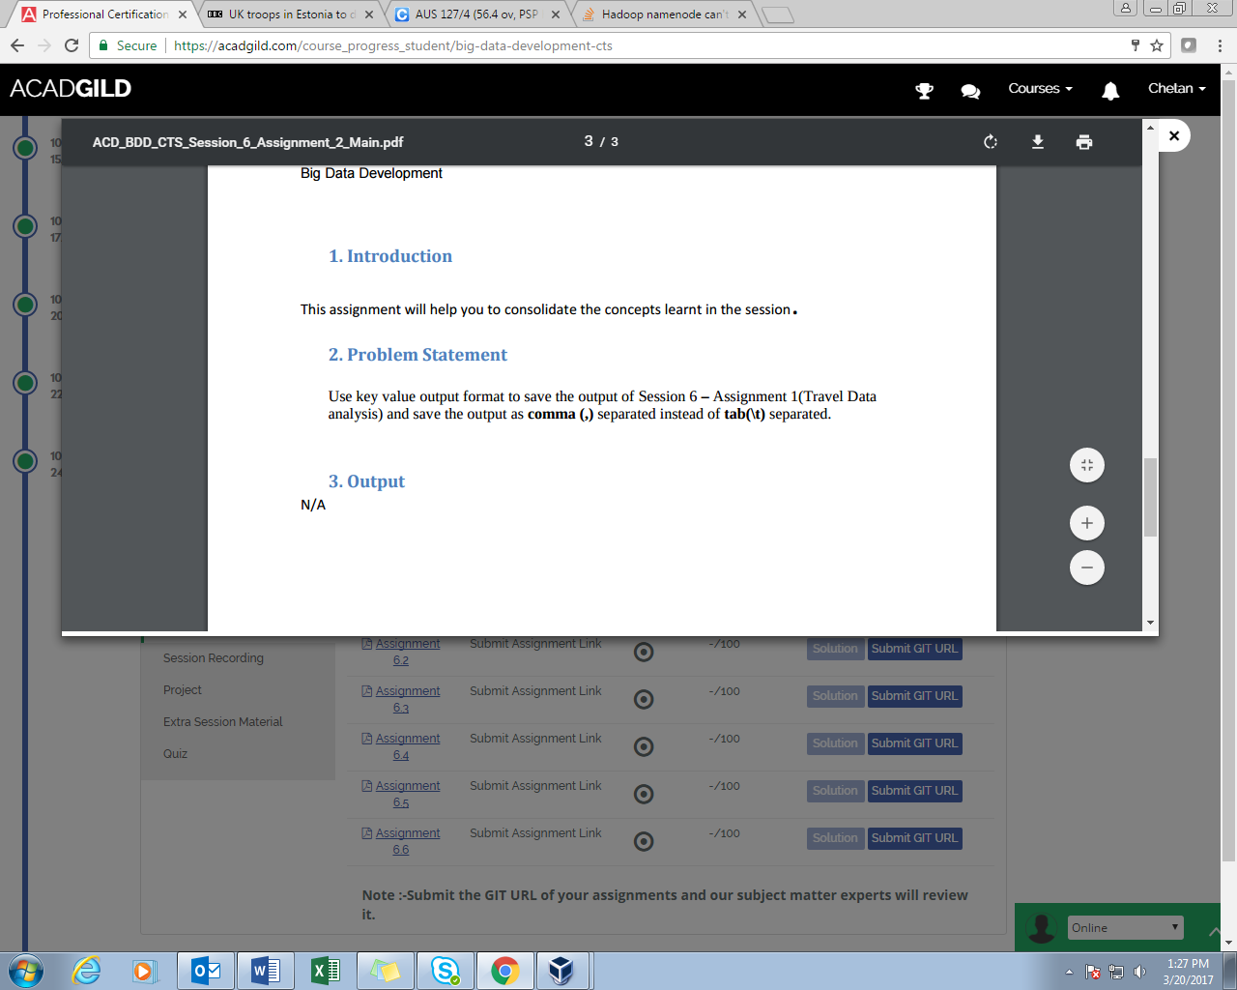

**Data_Set:-**

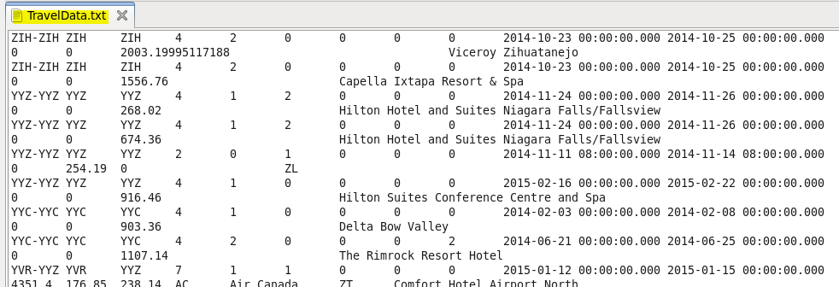

**Problem statement 1: JOB1**

**Find out how many people has chosen their destination as MIA and MCO**

**Problem statement 2: JOB2**

**Find out the number of people undertaken the trips from the places MIA and HOU**

**Problem statement 3: JOB3**

**Find out how many people has chosen airline mode of travel for the places LAS and LAX**

**SOLUTION:**

Rather than writing different codes for each problem statement, we assigned three different job and mapper do one. So the project includes three mapper classes and one reducer to function. Three different jobs are assigned.

**PROGRAM:**

**DRIVER**

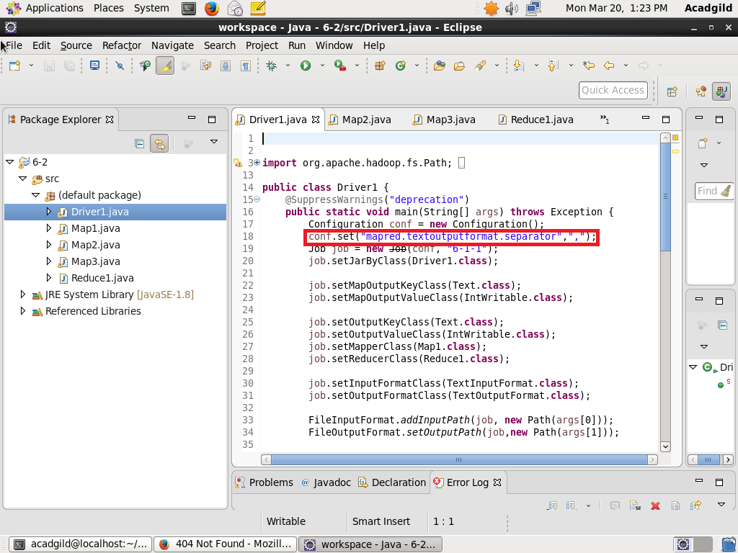

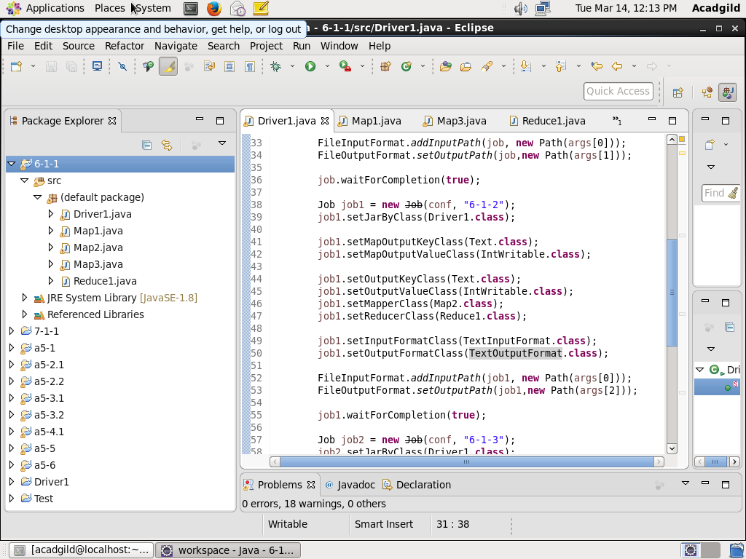

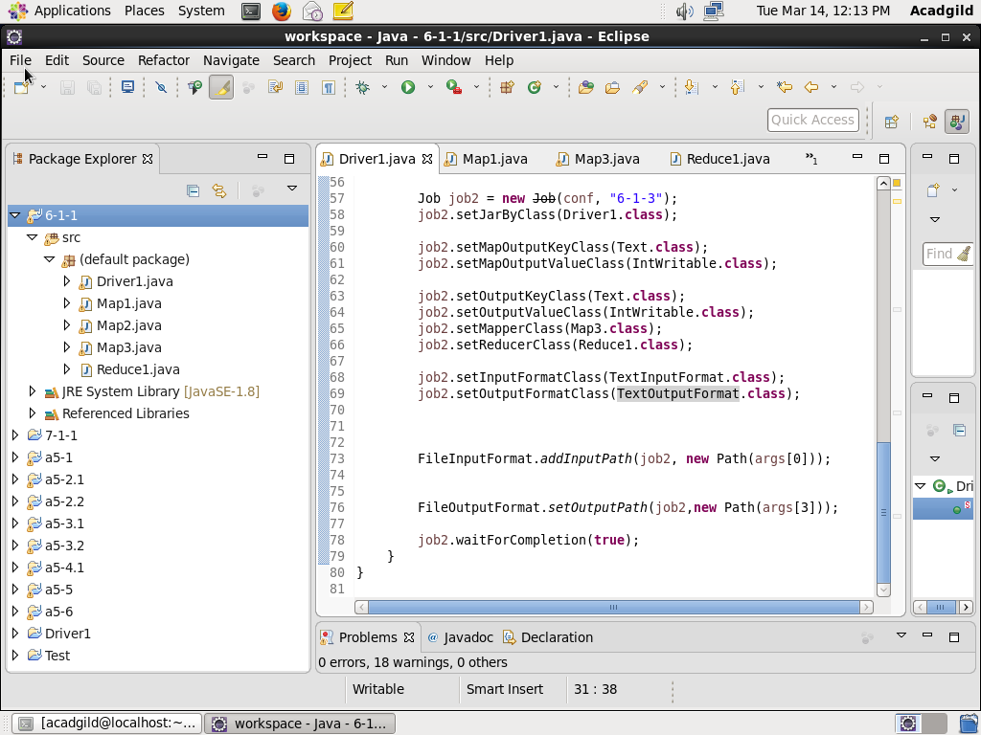

In driver class above all three jobs naming jab1, job2 and job3 are set to perform particular task.

**Map1 for job1:**

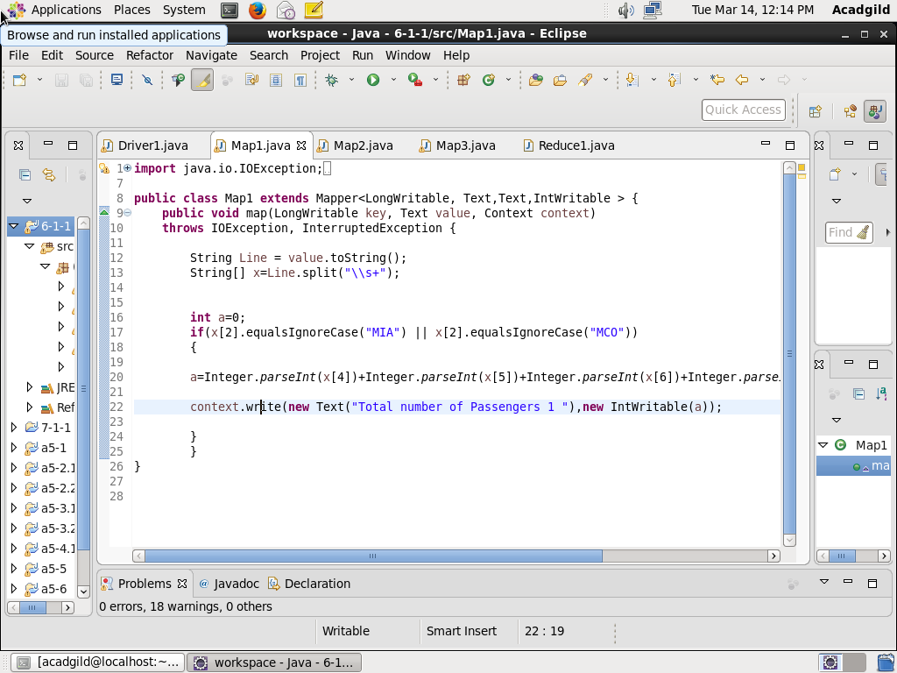

**Map2 for job2:**

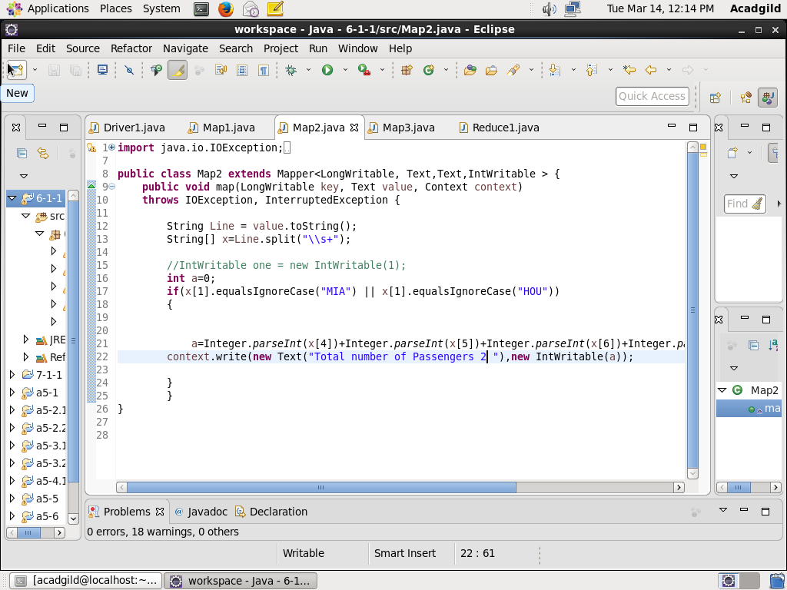

**Map3 for job3:**

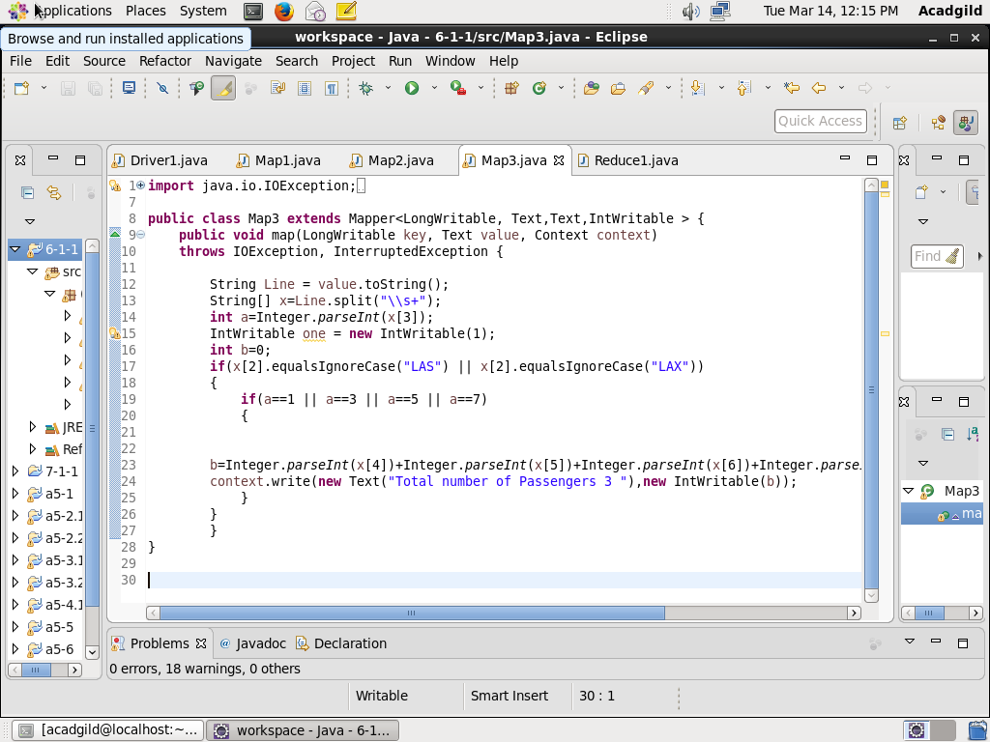

**Reducer:**

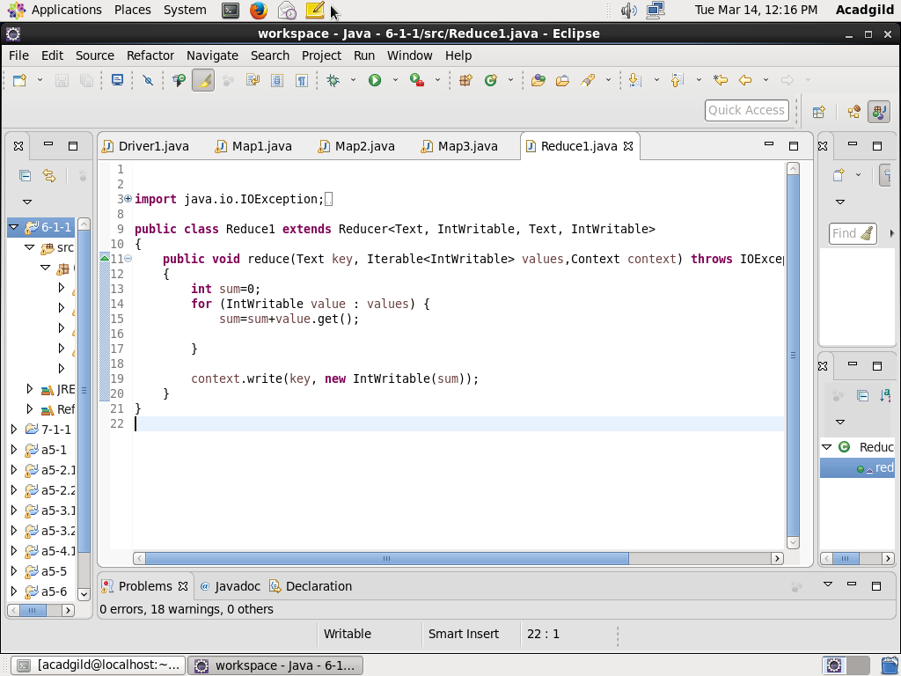

**Result:**

Jar file is loaded with four arguments, first includes the path of input file while other three are output directories for mappers assigned to perform 3 different jobs.

