**#ASSIGNMENT 6.3**

**PROBLEM STATEMENT:**

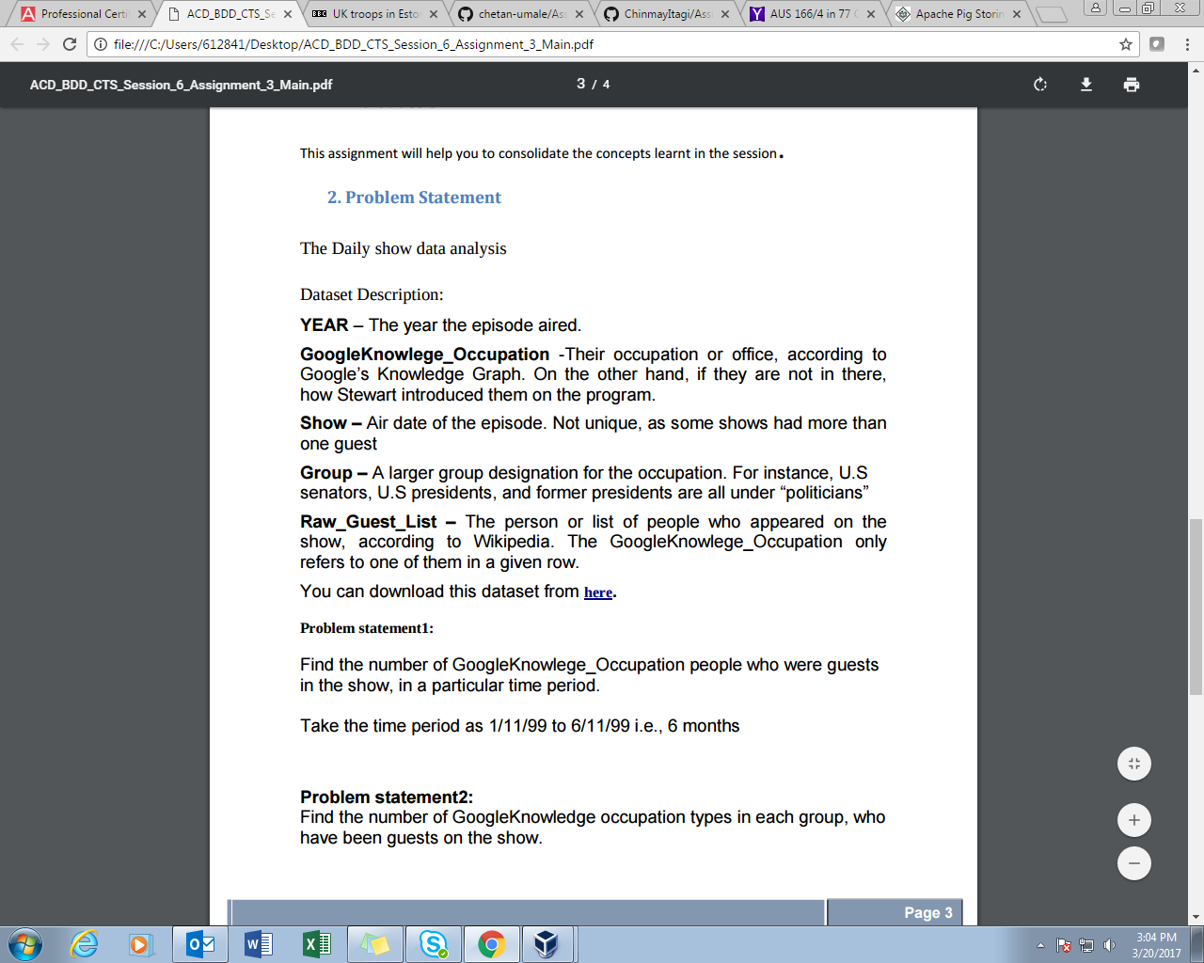

**SOLUTION:**

Instead of creating new project for every problem statement which require same data set, we have set different mappers and reducers for each particular problem statement. In driver class two different jobs are set.

Like in JOB1, mapper1 we passed two different dates as we need to calculate the count of guest present in show, followed by reducer to sum it up.

In job2, we need count occupation type wise hence mapper2 is written and reducer2 to do particular task.

**DRIVER CLASS**

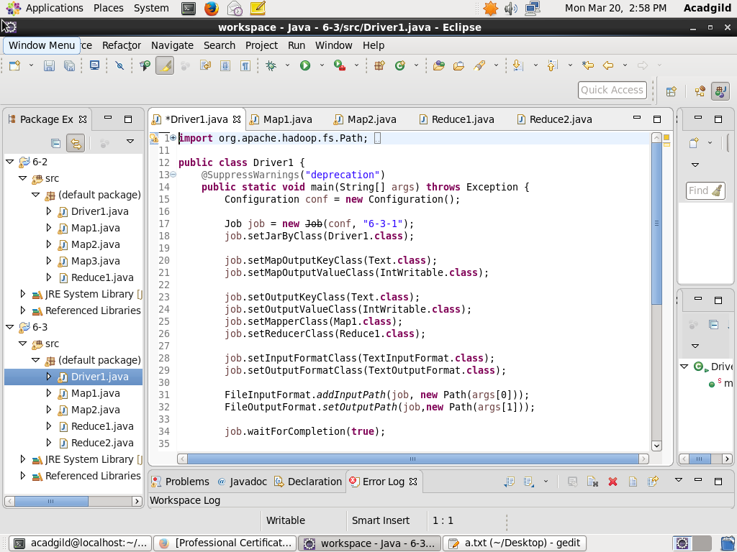

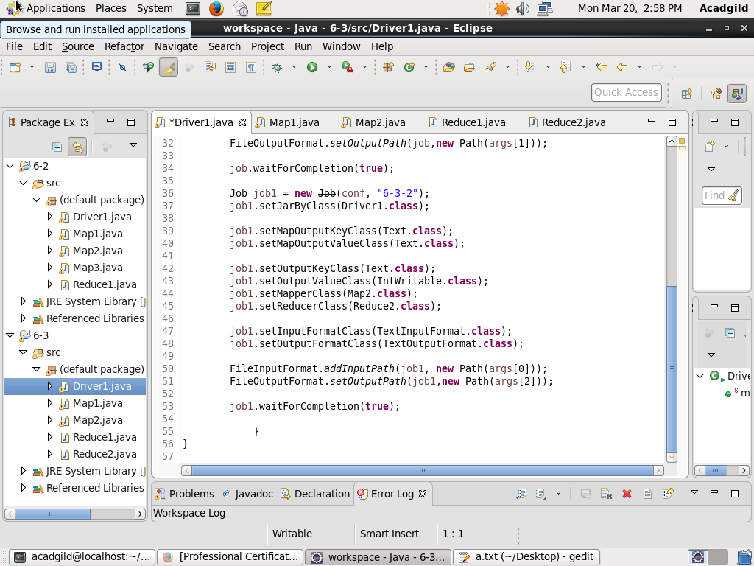

**MAPPER-1**

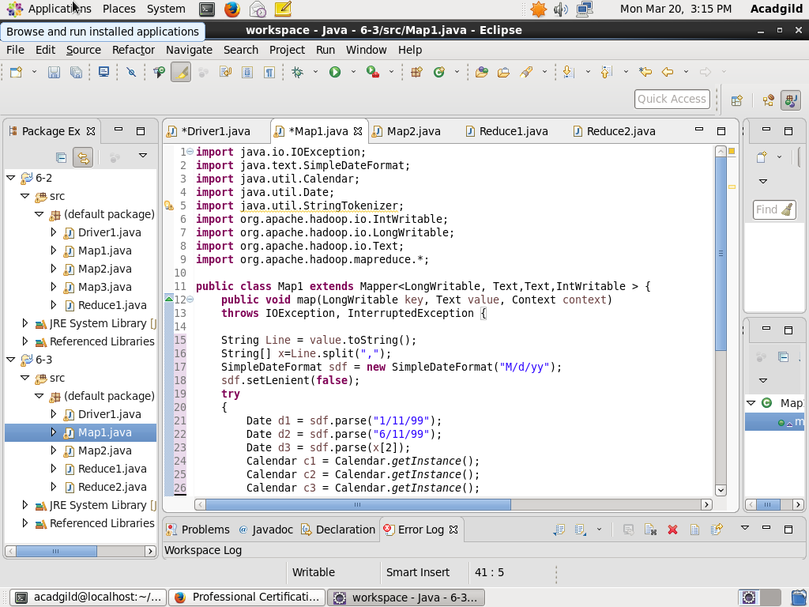

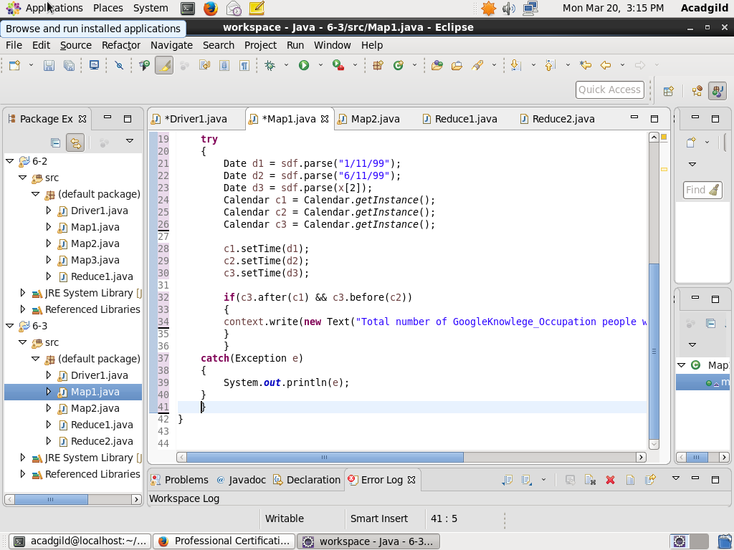

**REDUCER-1**

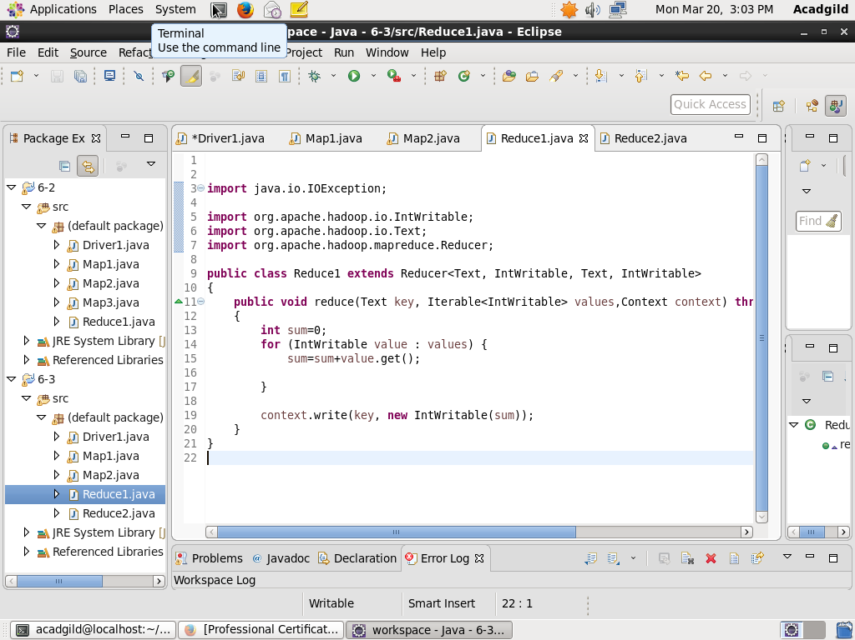

**MAPPER-2**

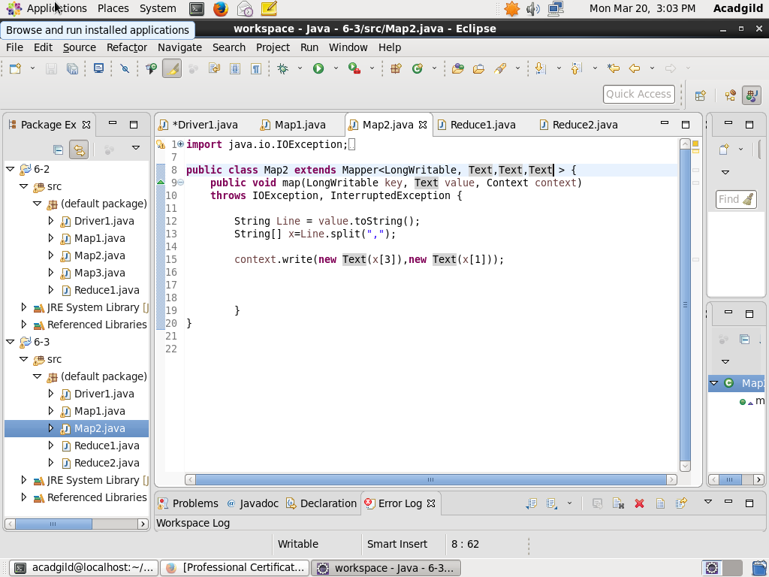

**REDUCER-2**

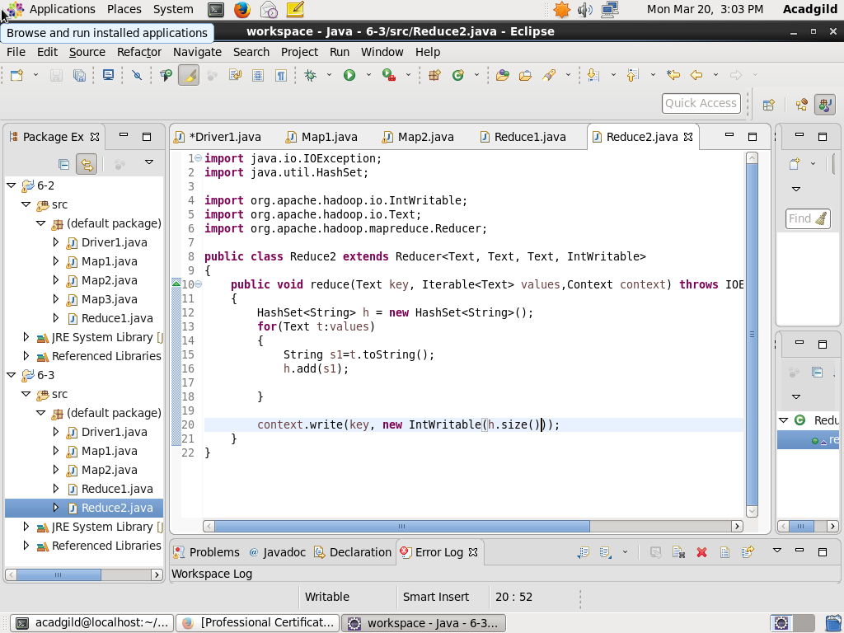

**RESULT:-**

**Loading Jar file**

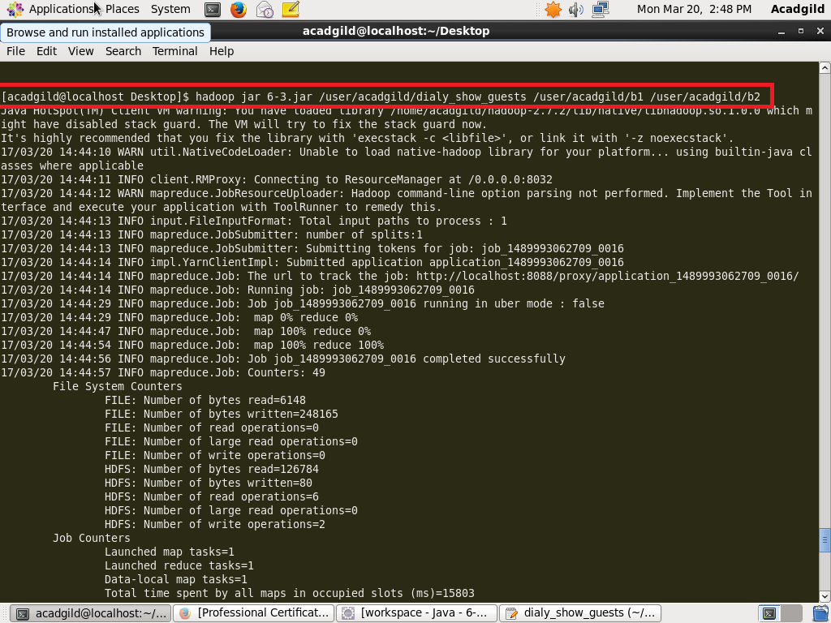

As written in code above we have two different reducers, hence for que1 job1 will work and similarly job2 for que2, both have different output directories b1 and b2 respectively**.**

**Displaying Results:-**

