**#Assignment_6.4**

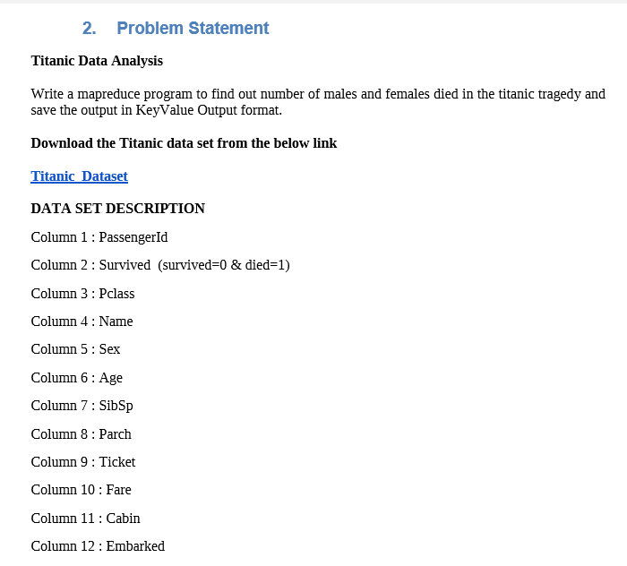

**Program:**

In a problem statement above, we will first check whether person is died or not from column 2, if is died then only we will count. In column 5 we will have two keys female and male and in reducer we will count or sum the values corresponding to key.

**Driver class-**

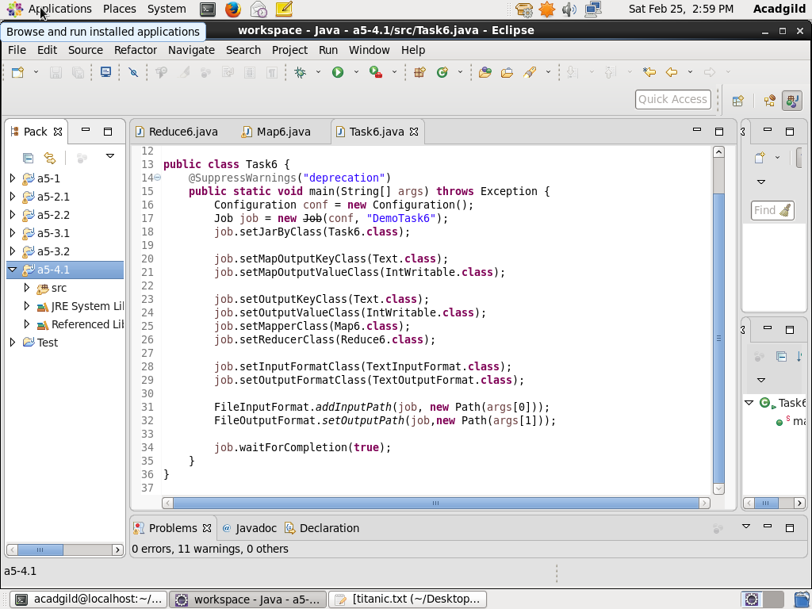

**Mapper class-**

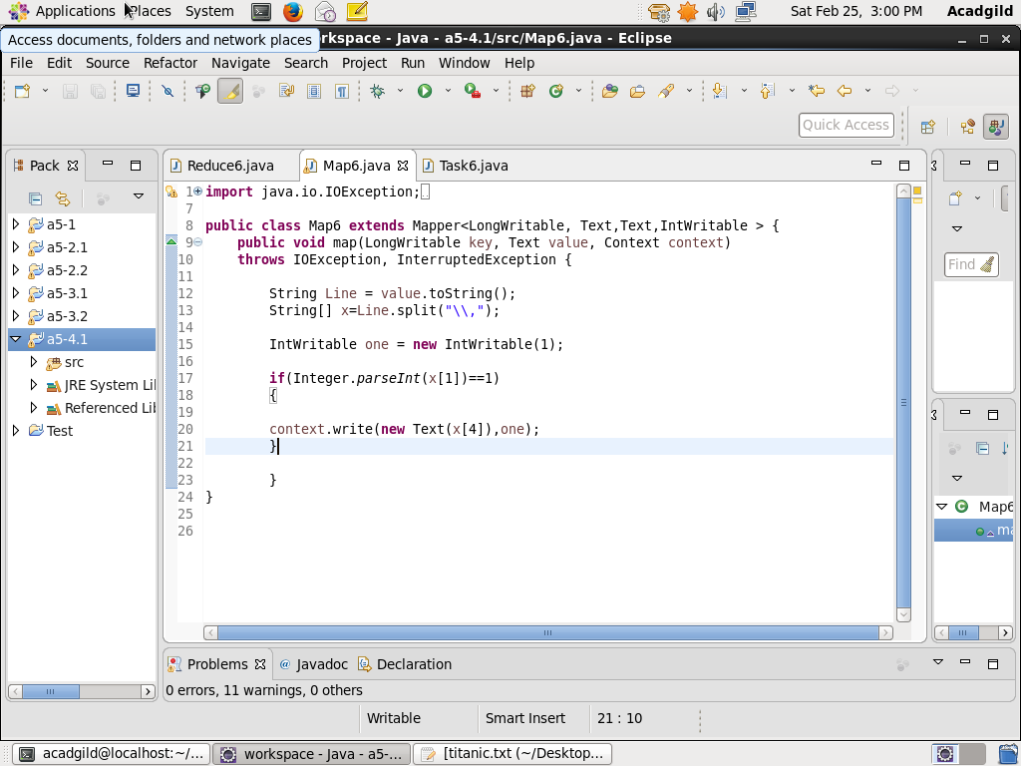

**Reducer class-**

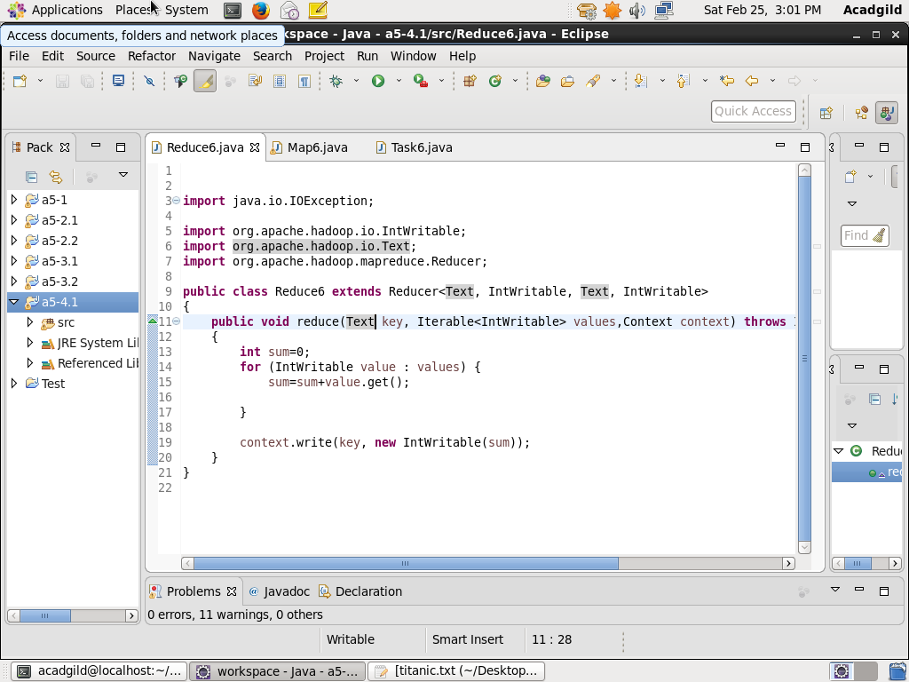

**Result-**

**Loading jar file-**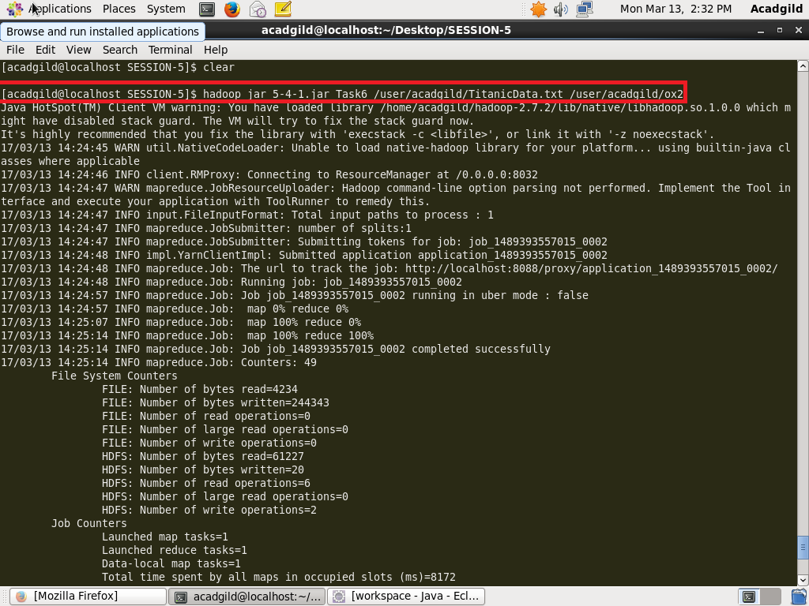

**Display result on console -**

