**#Assignment 6.5**

**PROBLEM STATEMENT:**

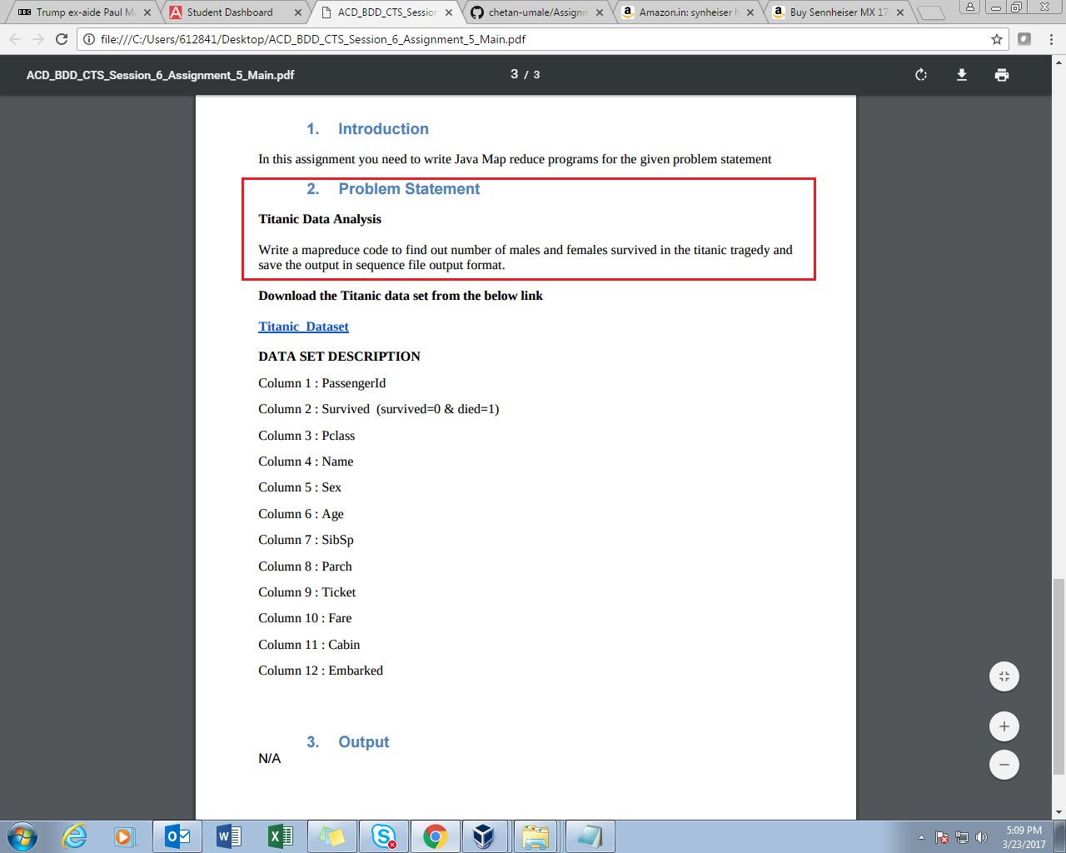

In the problem statement we are expected to set output file format as sequence file format. Once jar is loaded and output directory is given we see a reducer file, then we use cat to see contains of the file but it won’t show here as format is not text, so as to see contains we have to use text command to see them.

**PROGRAM:**

**DRIVER**

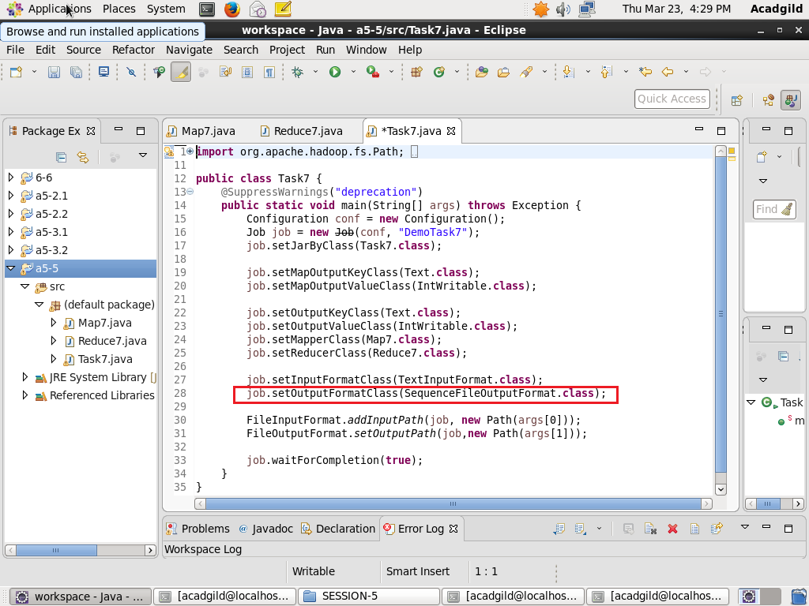

**MAPPER**

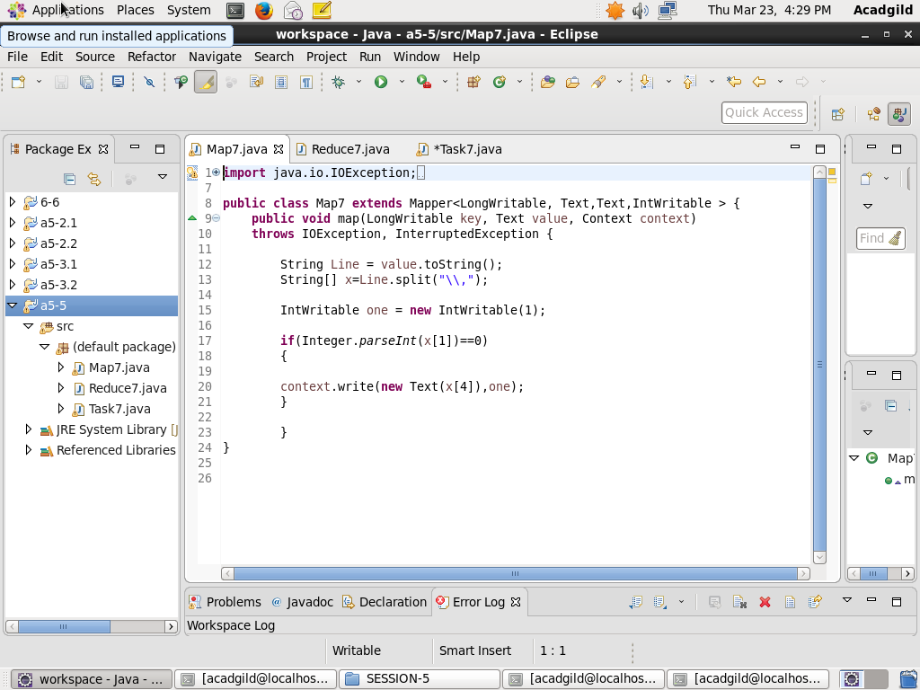

**REDUCER**

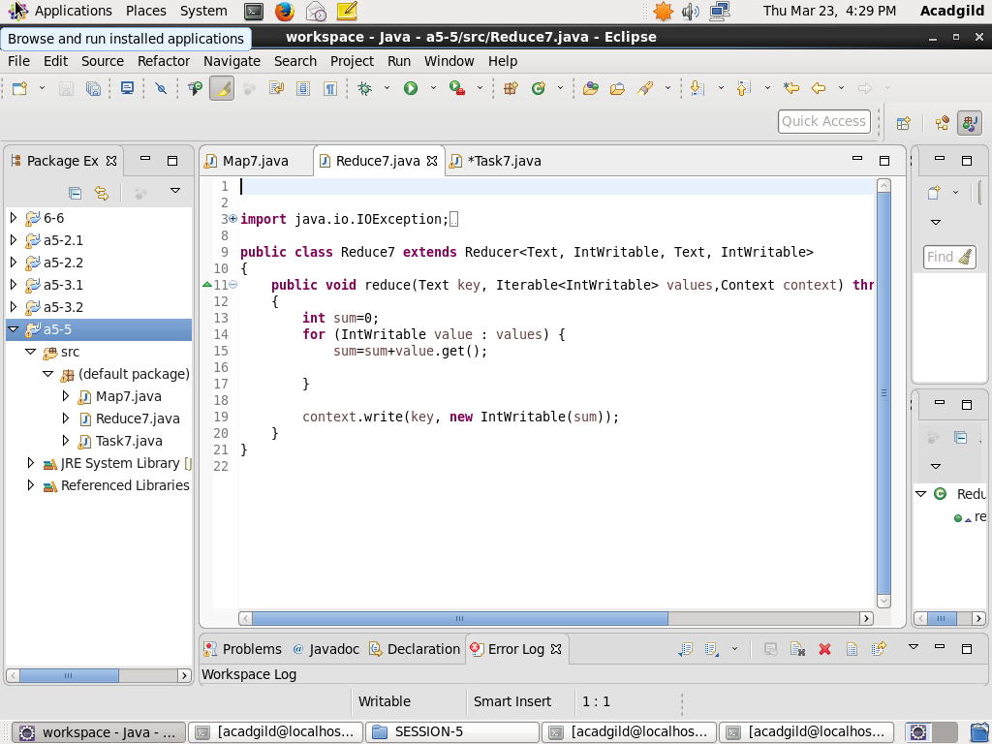

**Result:-**

**Loading jar file and output directory defined**

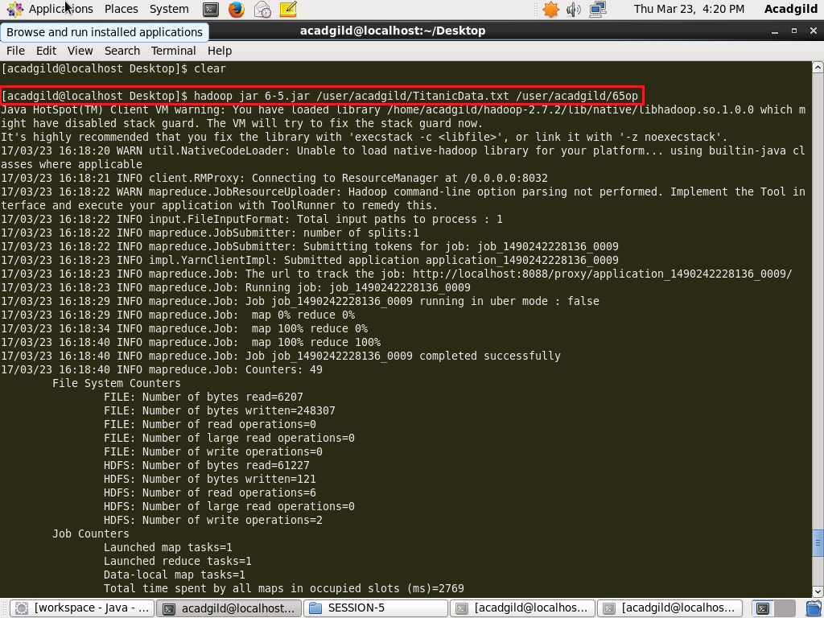

As the output format is not text, but sequence file format hence cat won’t work , use text instead of cat to see contains.

