**Assignment 6.6**

**PROBLEM STATEMENT:**

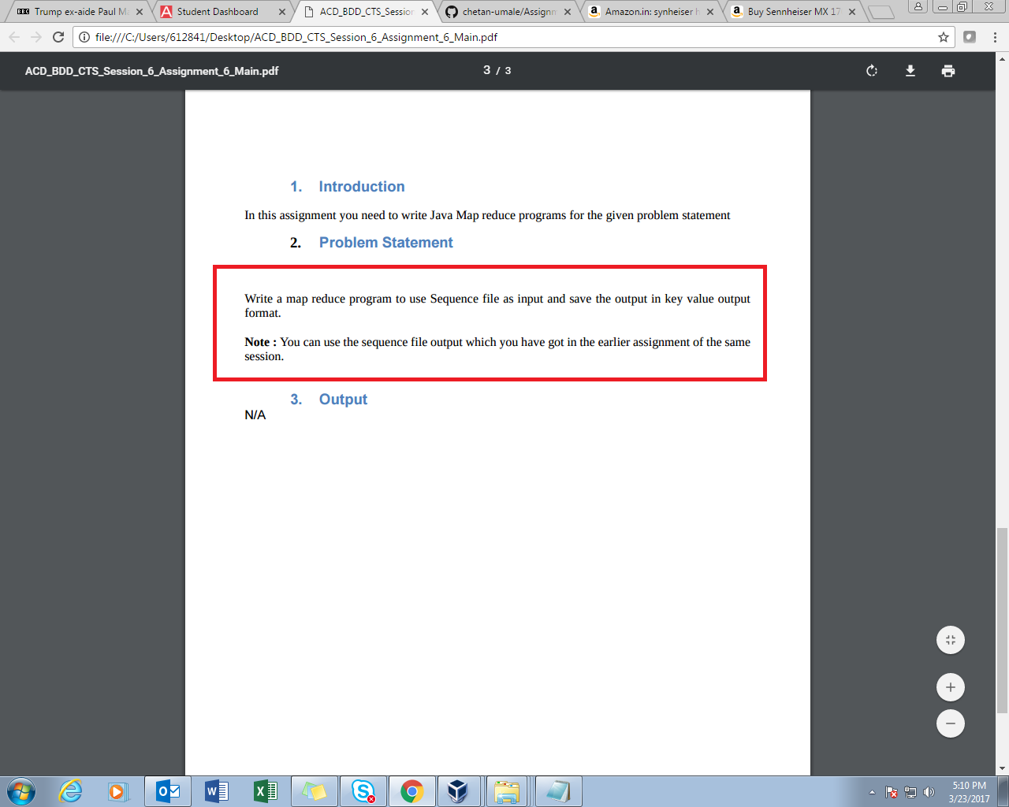

In a problem statement above, we are expected to set the input file format as sequence file format in driver .

**PROGRAM:**

**DRIVER:**

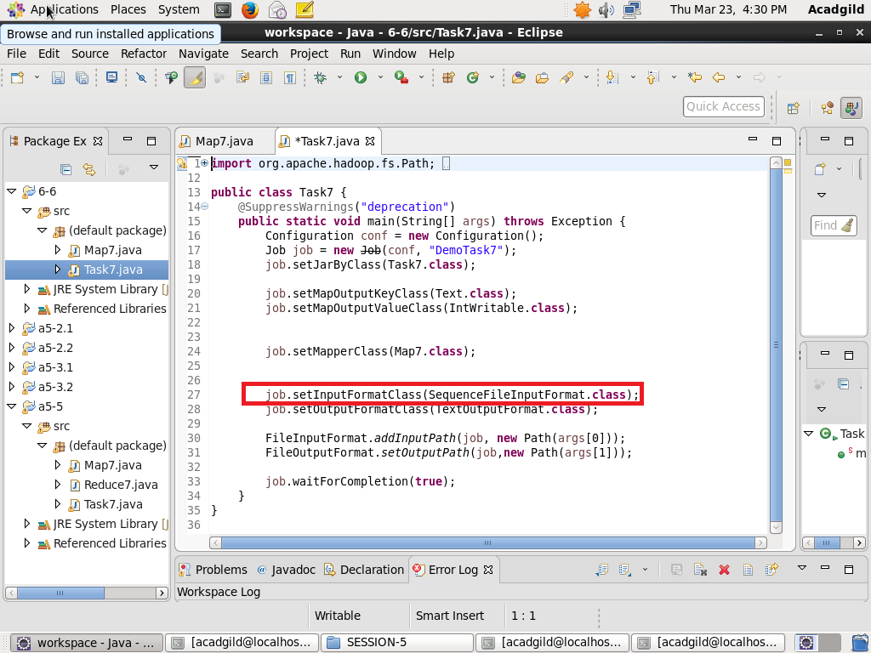

**MAPPER:-**

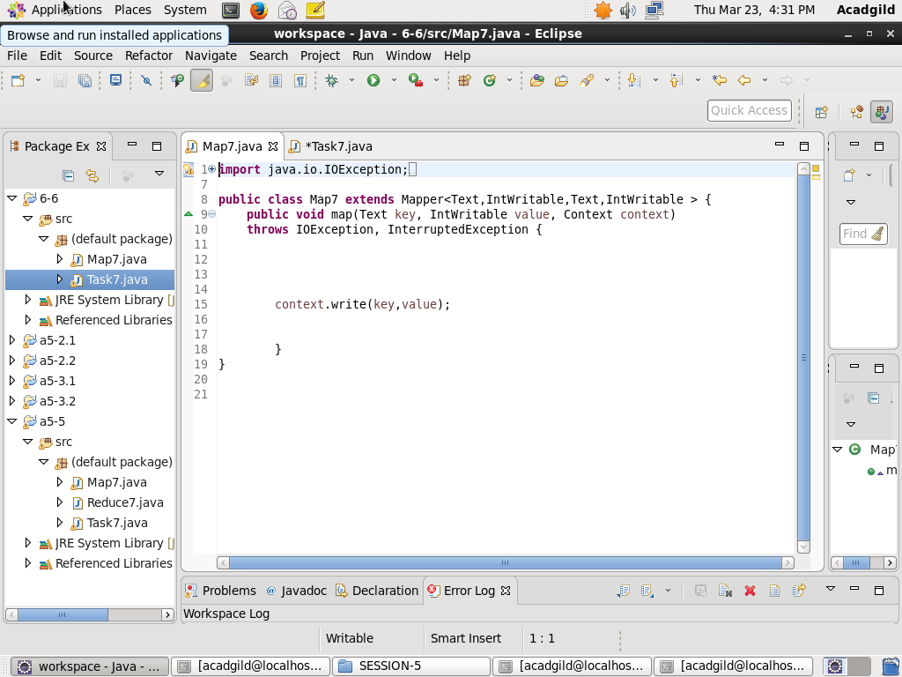

**OUTPUT:**

**Loading jar file**

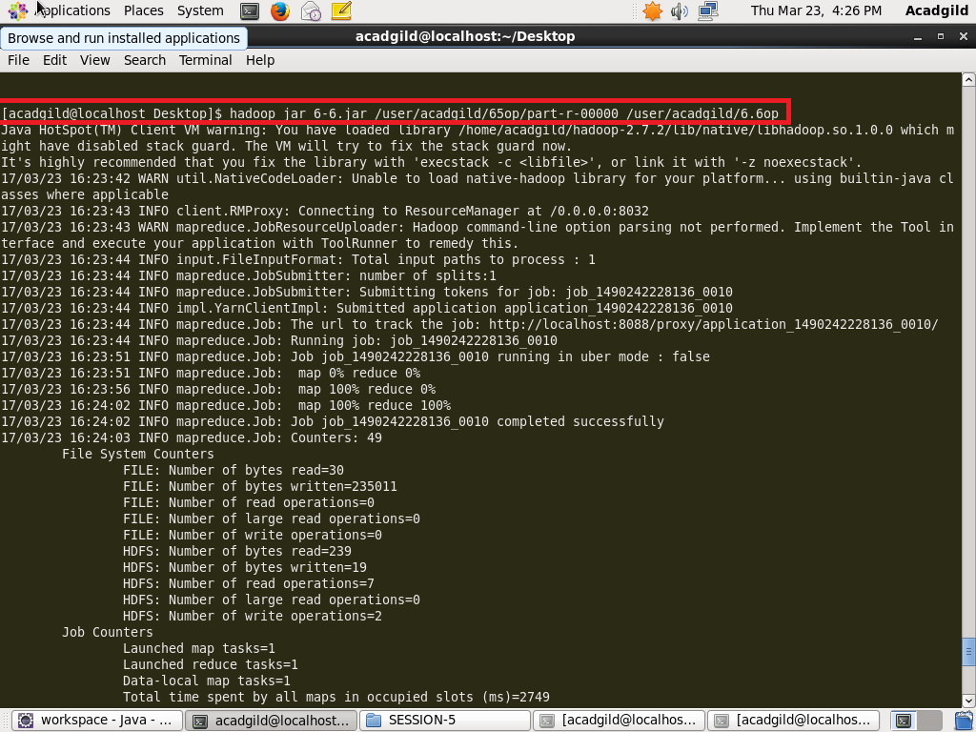

**Display result -**

