**#Assignment_7.1**

**PROBLEM STATEMENT:**

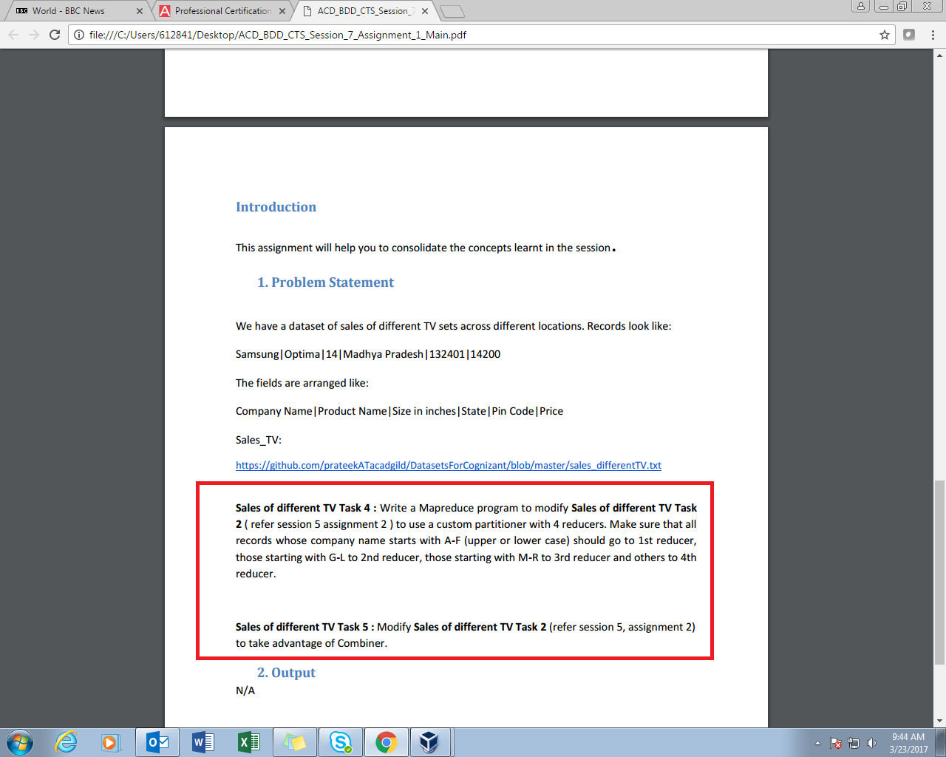

**SOLUTION-1:**

For problem statement 1, we are expected to use partition method class which segregate the data into different parts depending upon the condition. Here the condition is that Company name initials of particular kind should go to particular reducer. In driver class we have 4 reducers and in reducer class we have returned certain values respective of the condition. The satisfying condition will go to respective reducer. Like initial G-L will go to reducer 2.

**PROGRAM:**

**DRIVER CLASS**

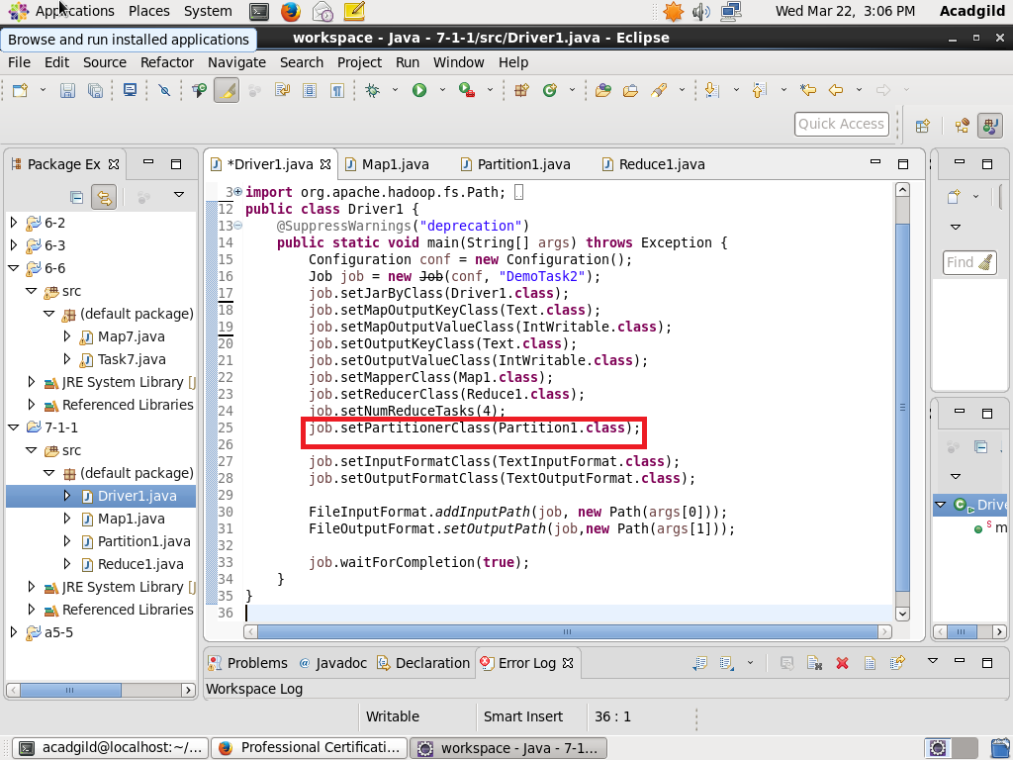

**MAPPER CLASS-**

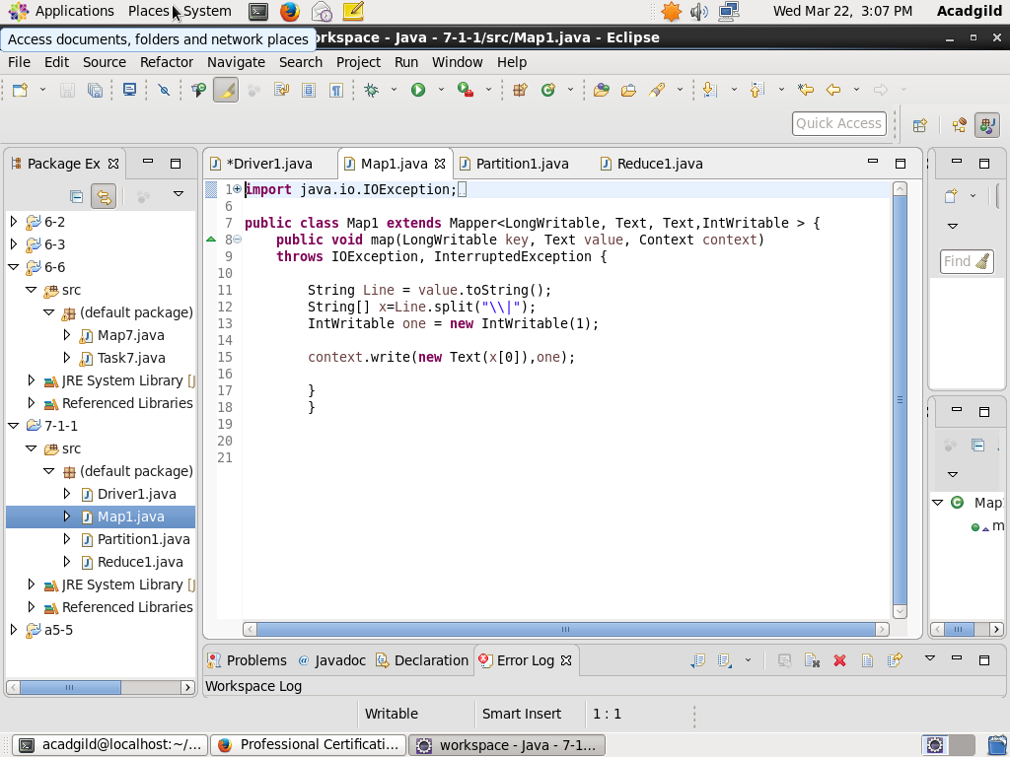

**PARTITIONER CLASS**

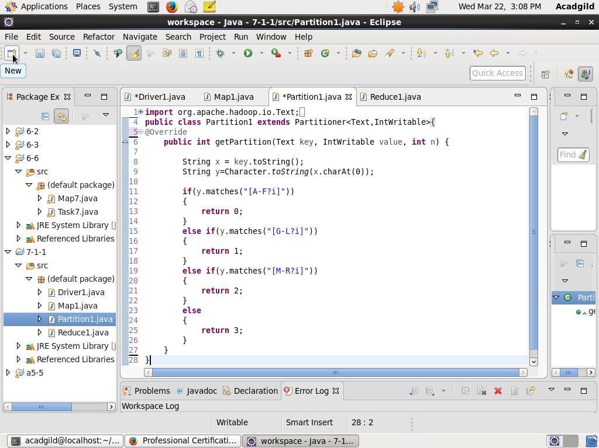

**REDUCER CLASS**

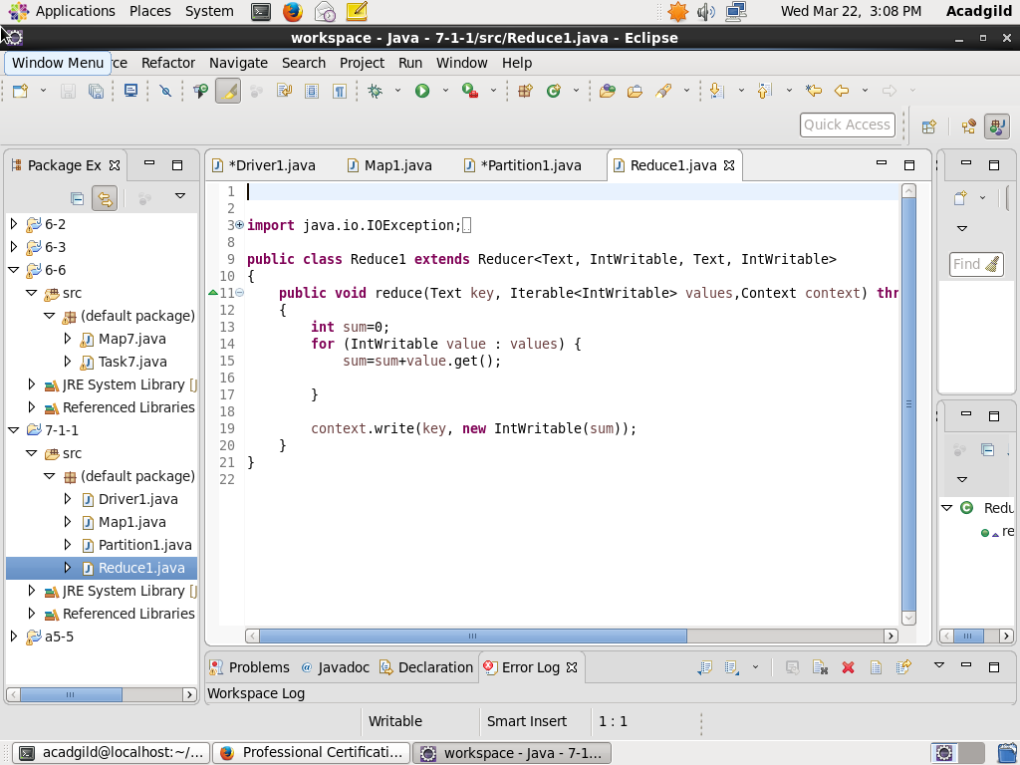

**Result-**

**Loading jar file**

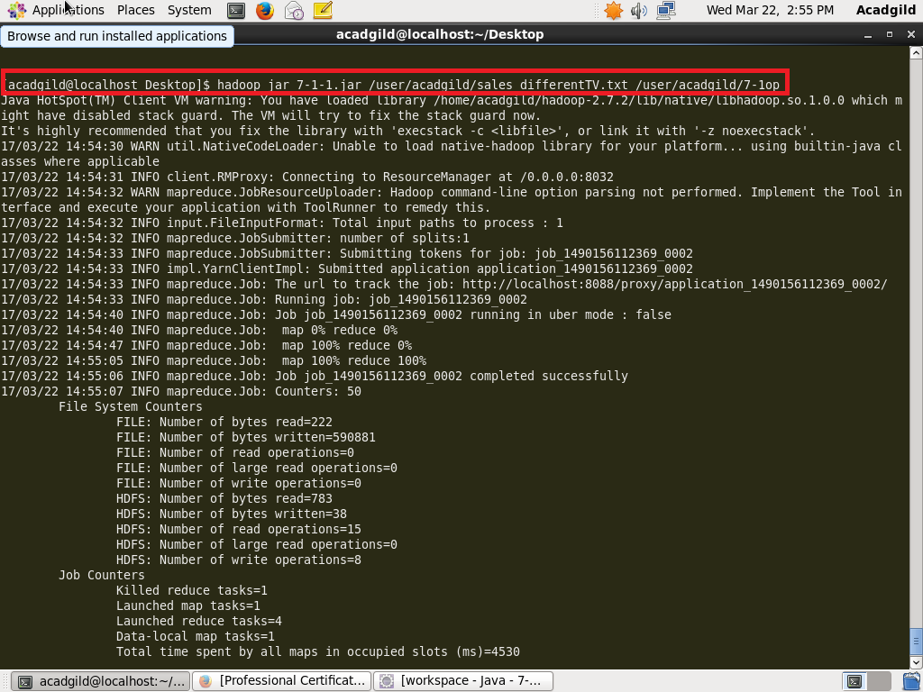

**Display Result on console-**

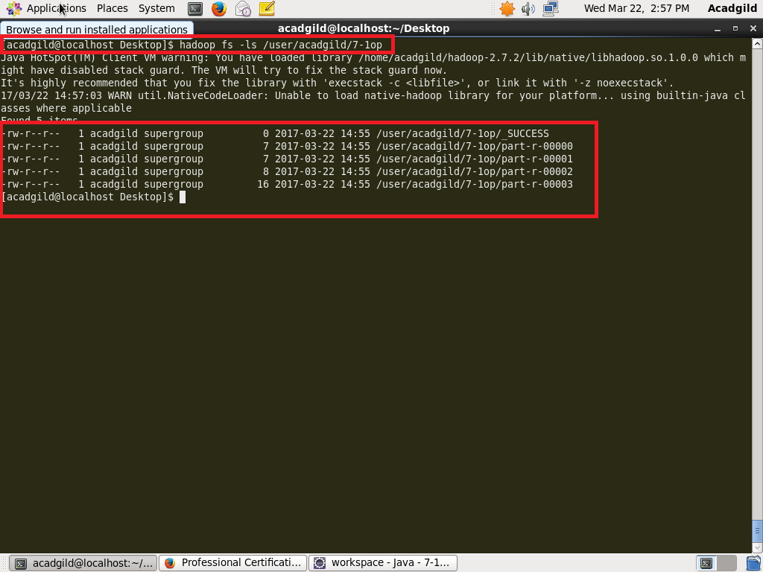

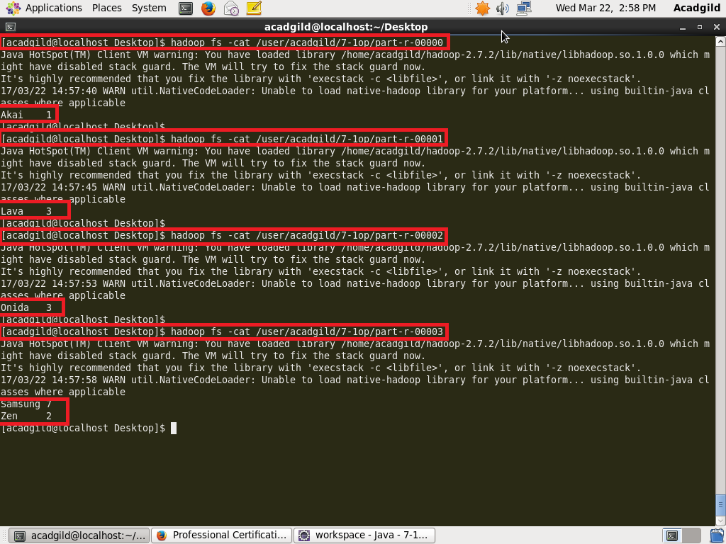

In a result above we can see that 4 different reducers are running and partition class has done his job, hence we can see different reducers having different data satisfying corresponding condition.

Like reducer 1 has data of company whose name start with A-F, reducer 2 has G-L, reducer 3 has M-R and rest in reducer 4.

**SOLUTION-2:**

**DRIVER CLASS**

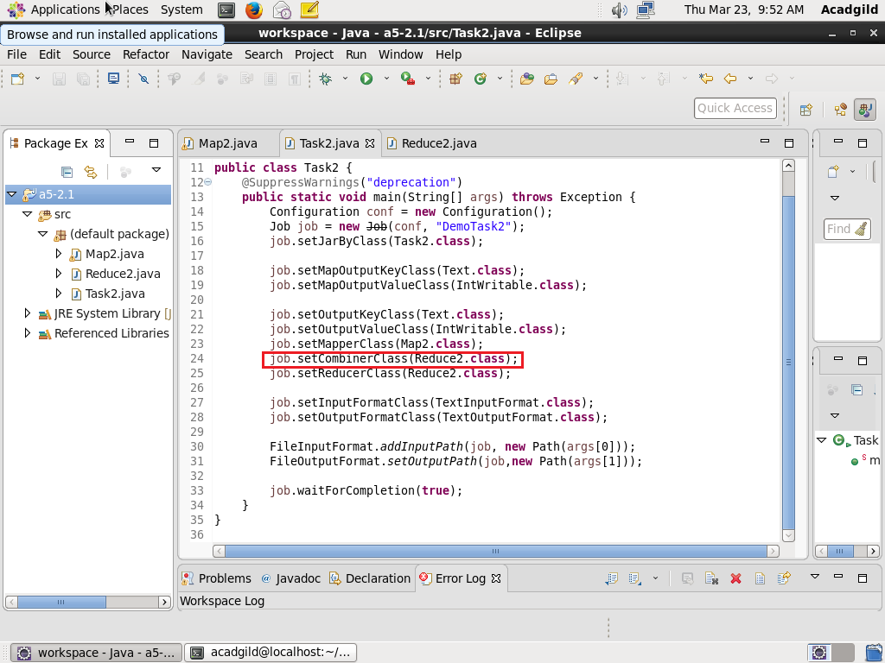

**MAPPER CLASS**

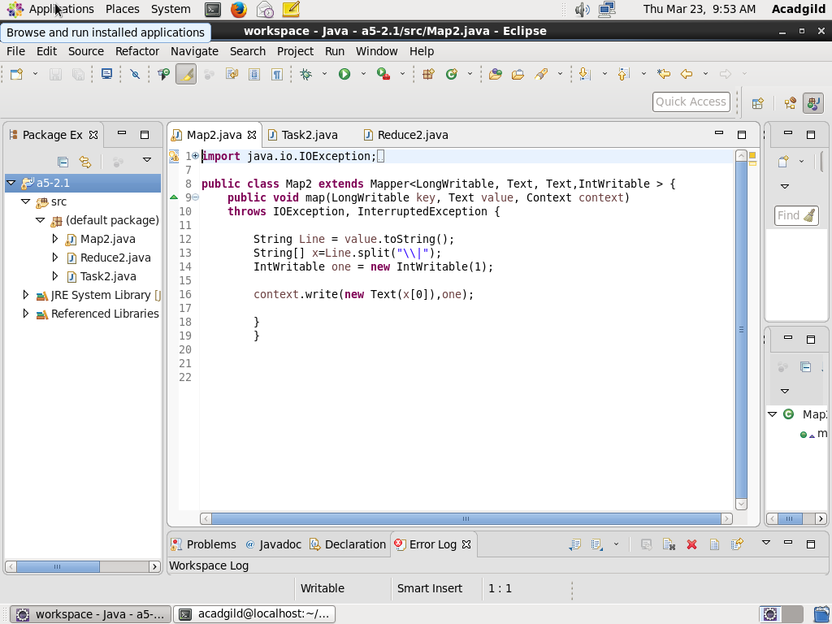

**REDUCER CLASS**

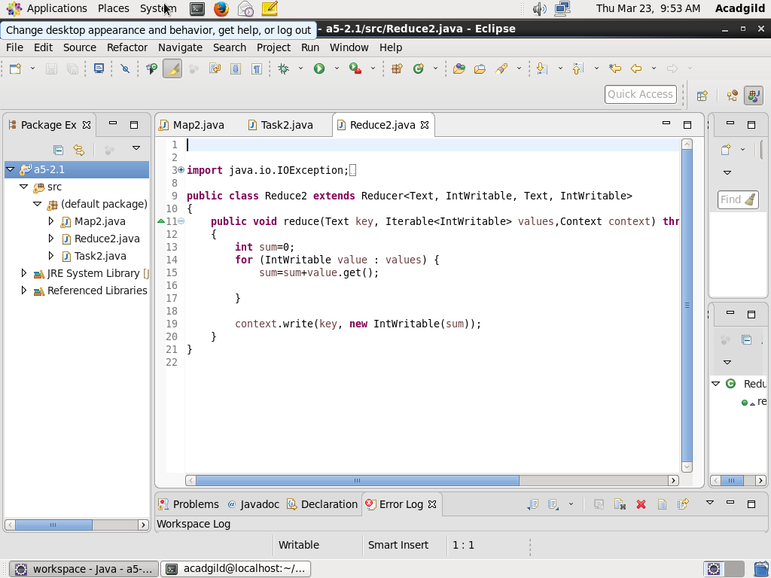

**Result-**

