PROBLEM STATEMENT:

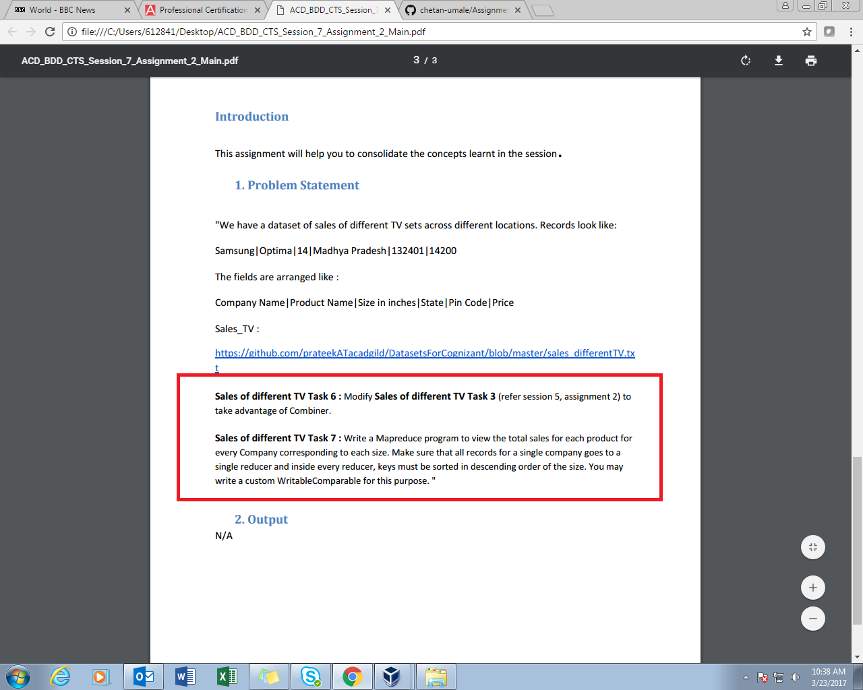

**SOLUTION-1:**

We need to find state that has max. Sale of Onida Company.

**PROGRAM:**

**DRIVER CLASS**

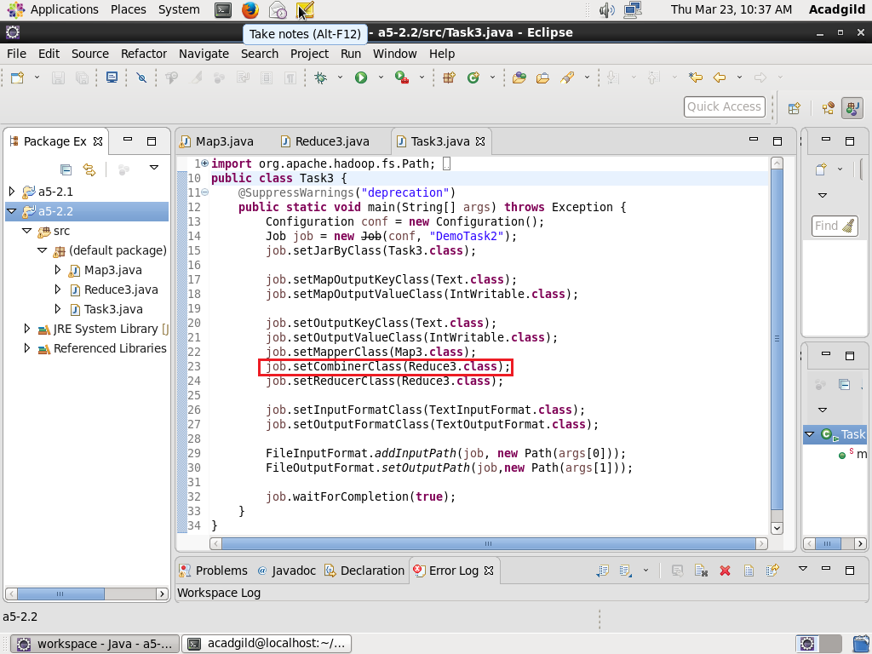

**MAPPER CLASS**

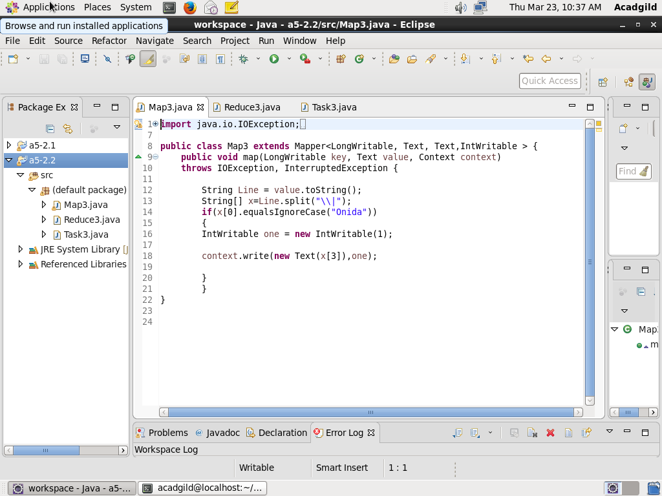

**REDUCER CLASS**

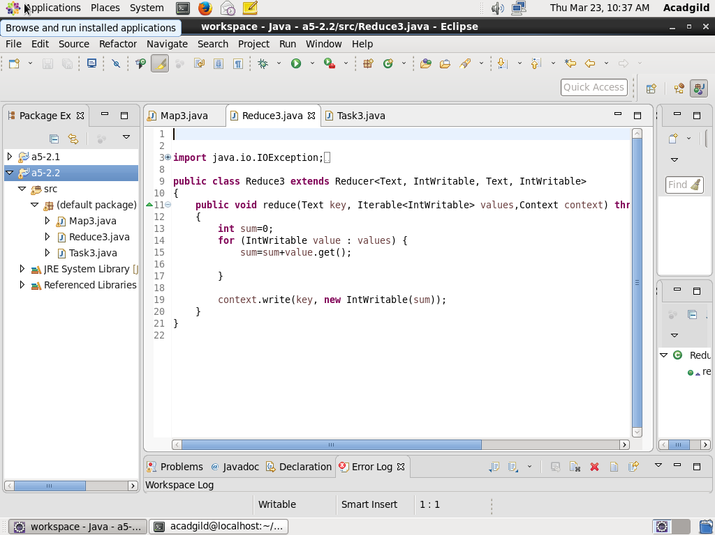

**Result:**

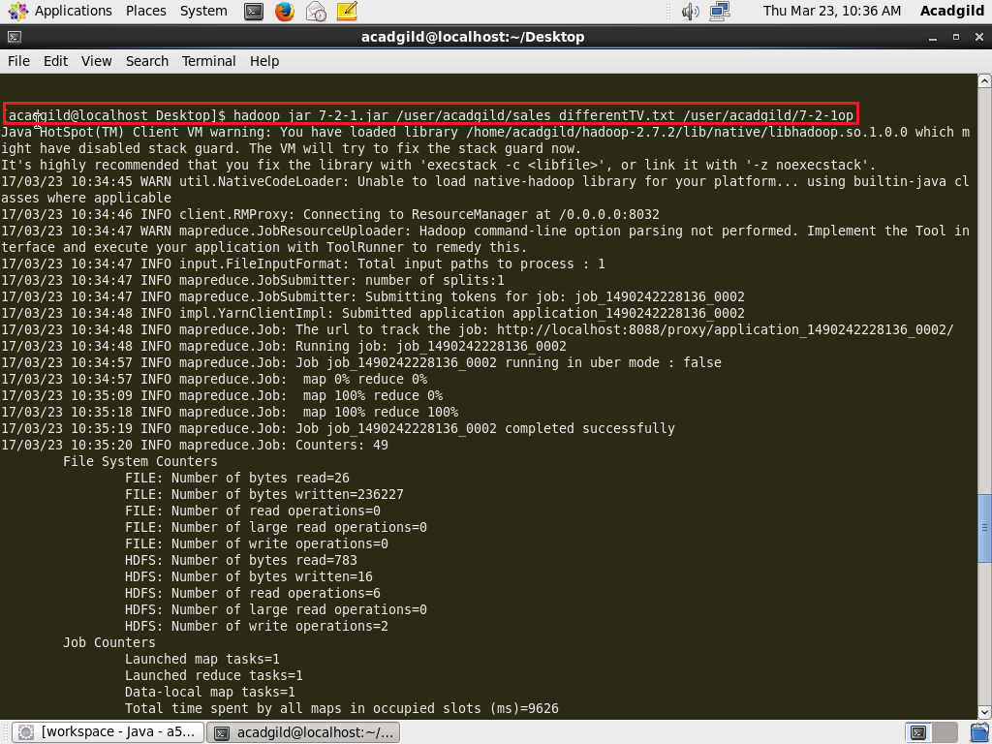

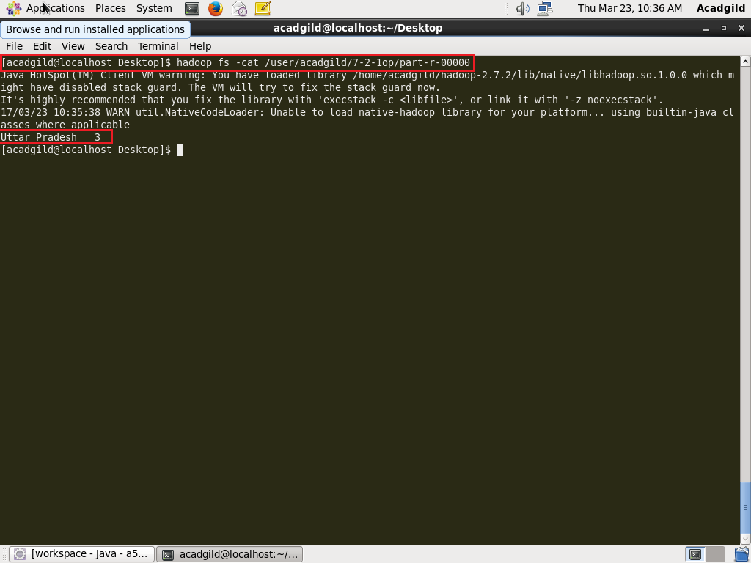

**SOLUTION-2:**

The need to find each product size and no.of products from each company.

It can be done using customized key which uses Writable Comparable method.

**PROGRAM:**

**DRIVER CLASS**

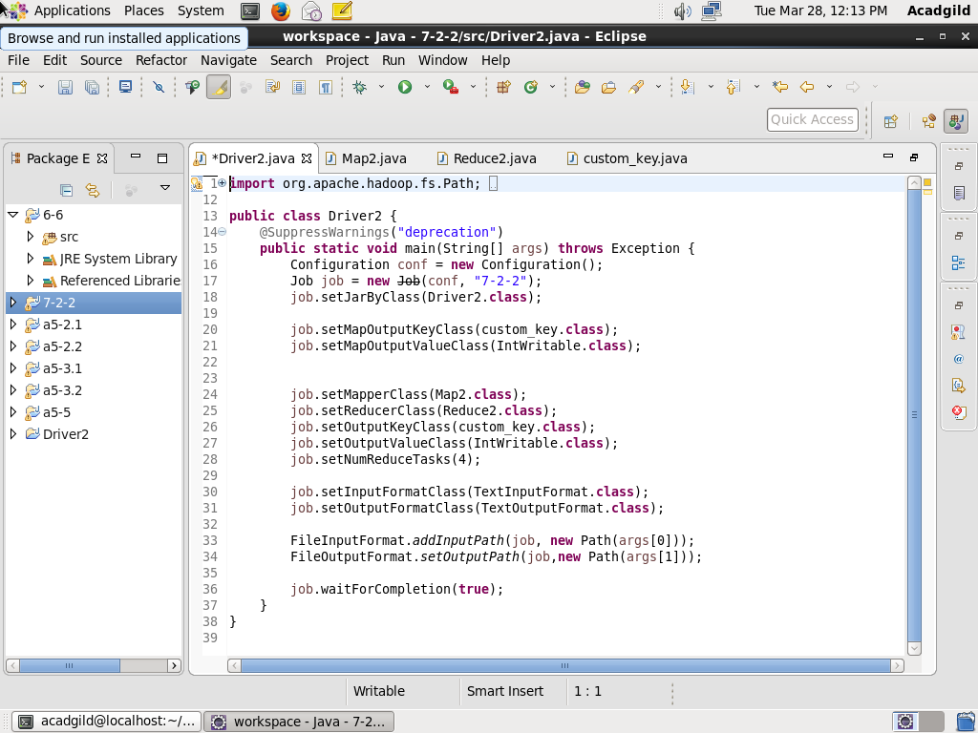

**MAPPER CLASS**

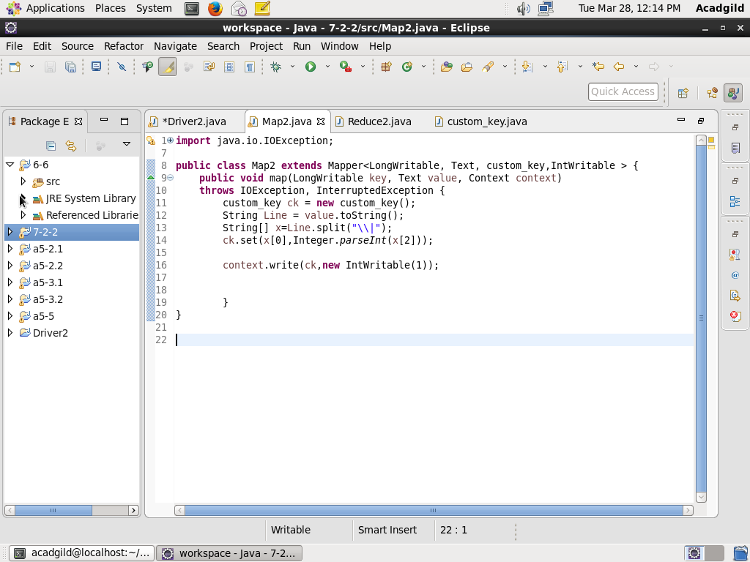

**REDUCER CLASS**

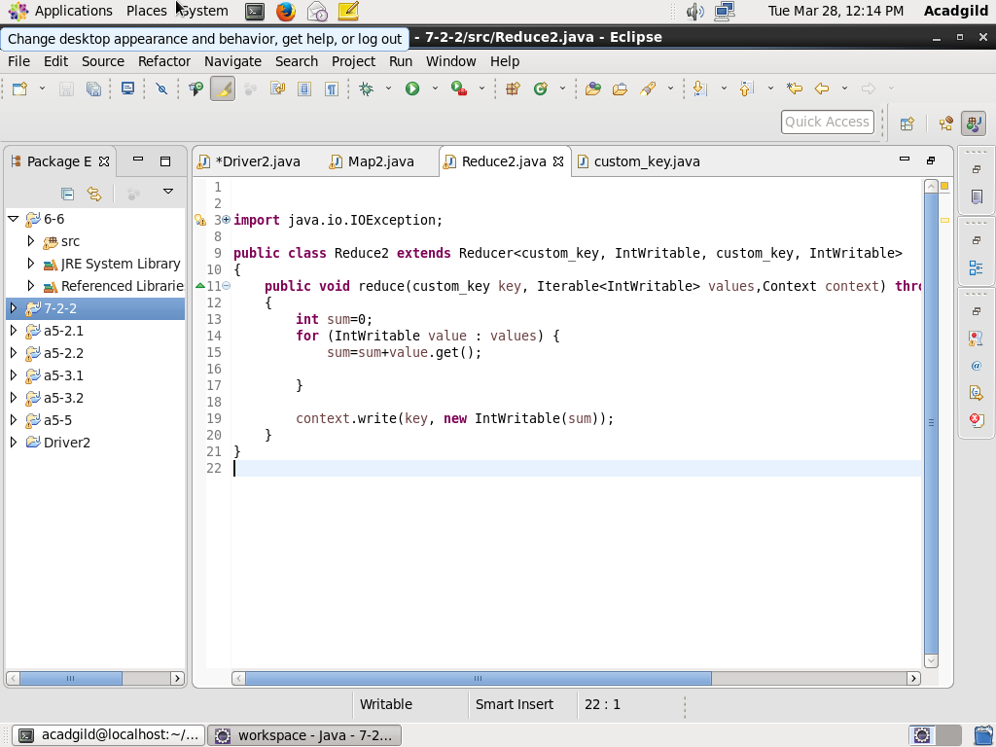

**CUSTOM_KEY CLASS**

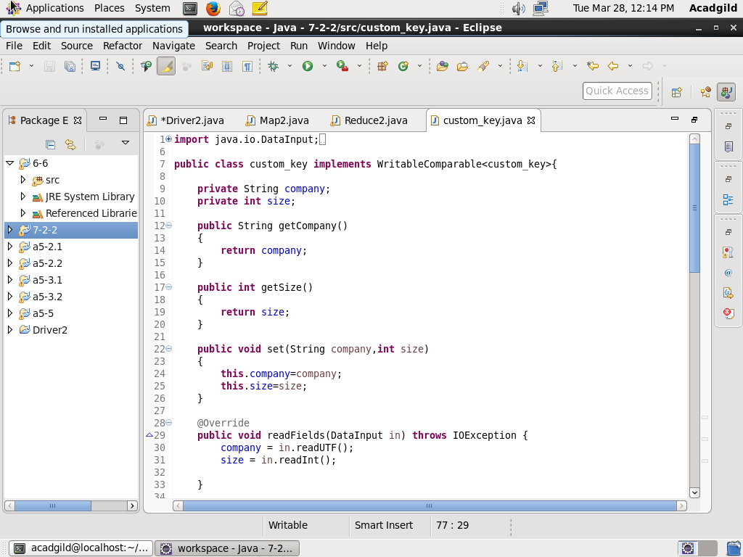

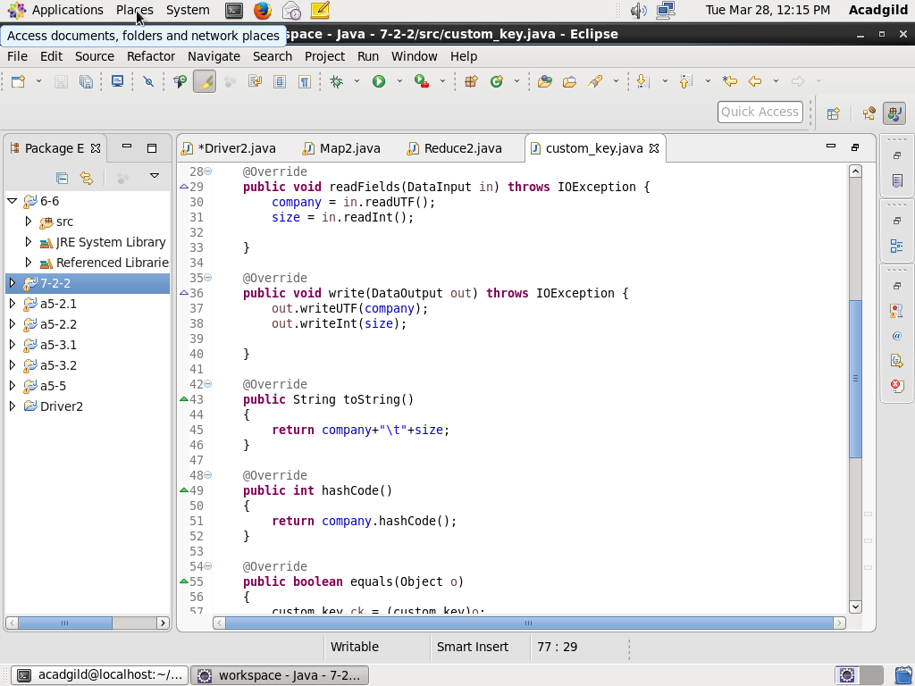

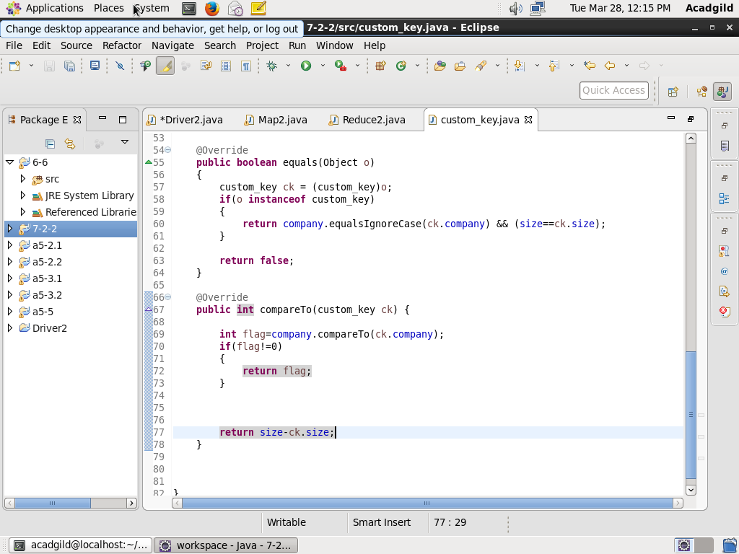

**Result:**

**Loading jar file**

