**#Assignment_7.3**

**PROBLEM STATEMENT:**

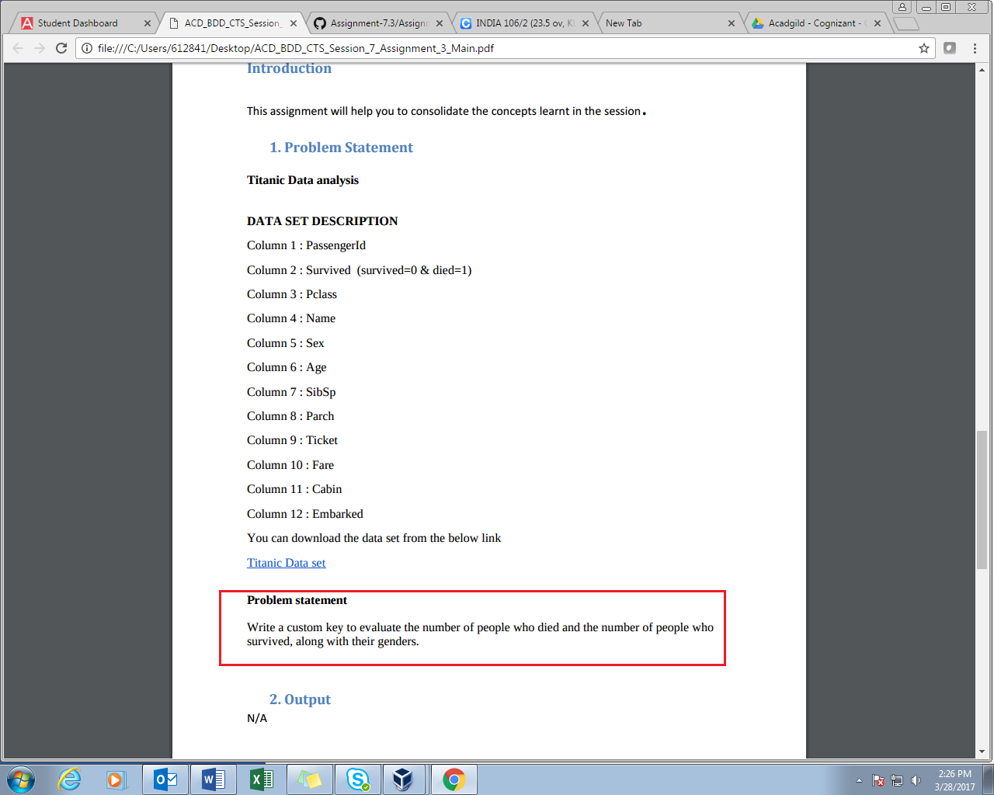

Here we are using writable Comparable method as we need count of both dead and alive male and females in titanic tragedy database. This method allow us to implement compareTo method.

**PROGRAM:**

**DRIVER CLASS**

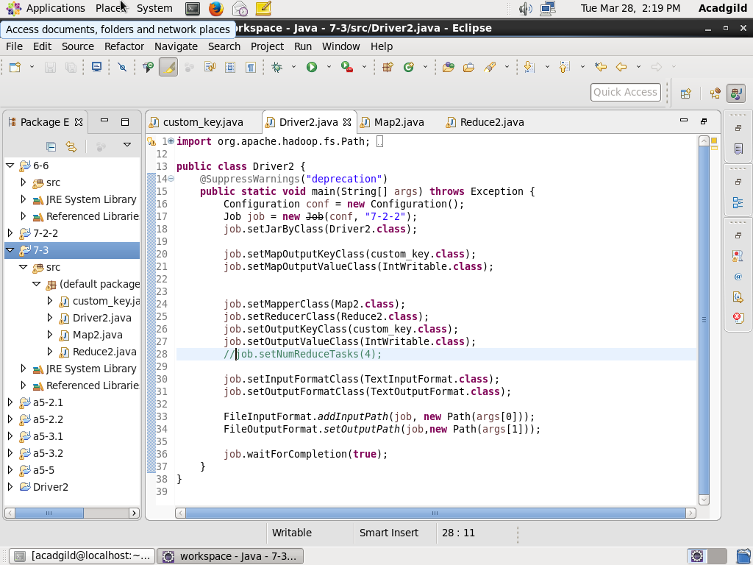

**MAPPER CLASS**

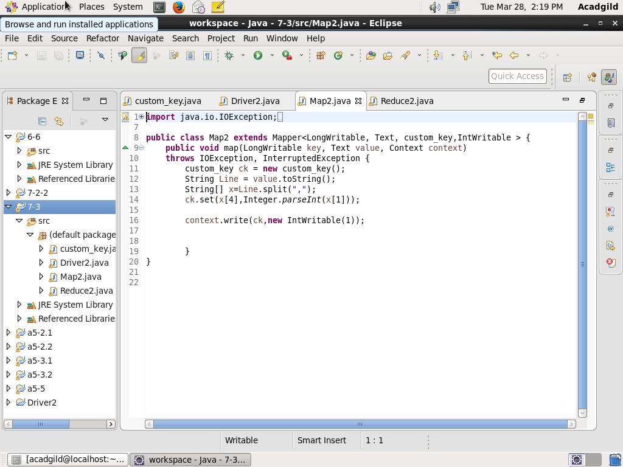

**REDUCER CLASS**

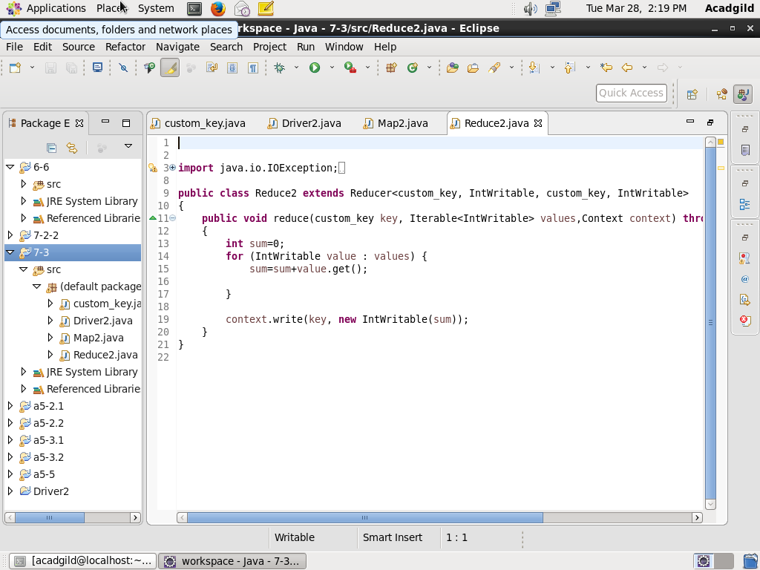

**CUSTOM_KEY CLASS (Writable comparable)**

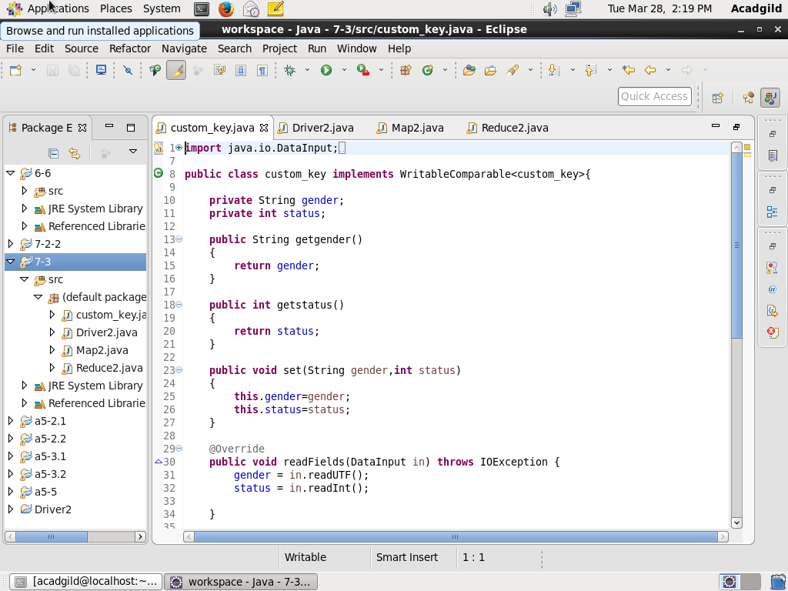

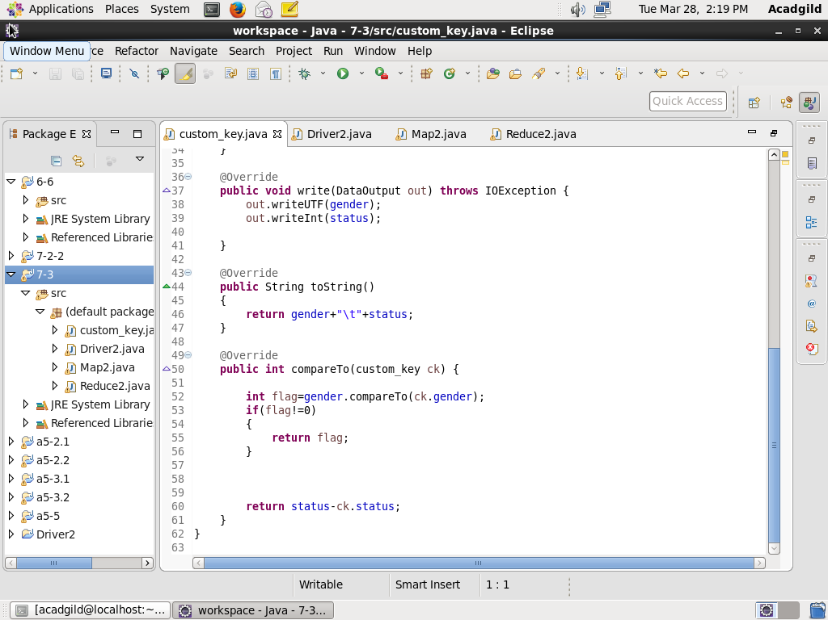

**Result-**

**Loading jar file**

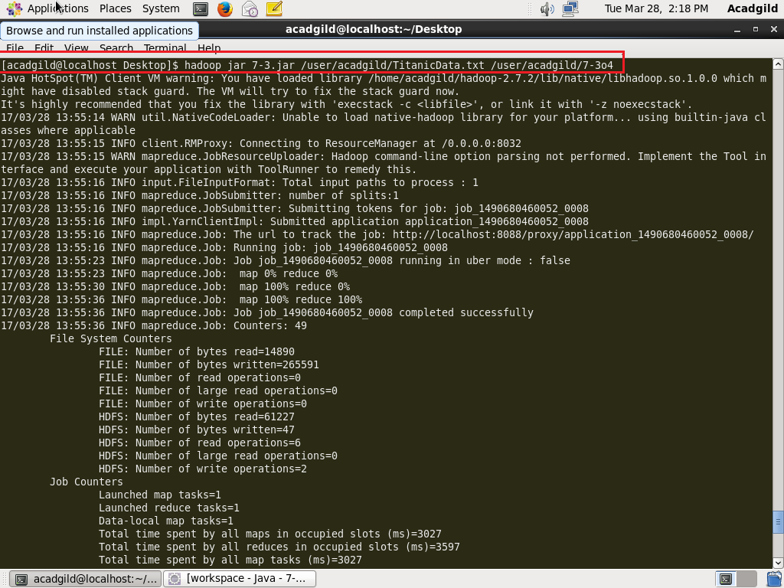

**Display result-**

Dead=1

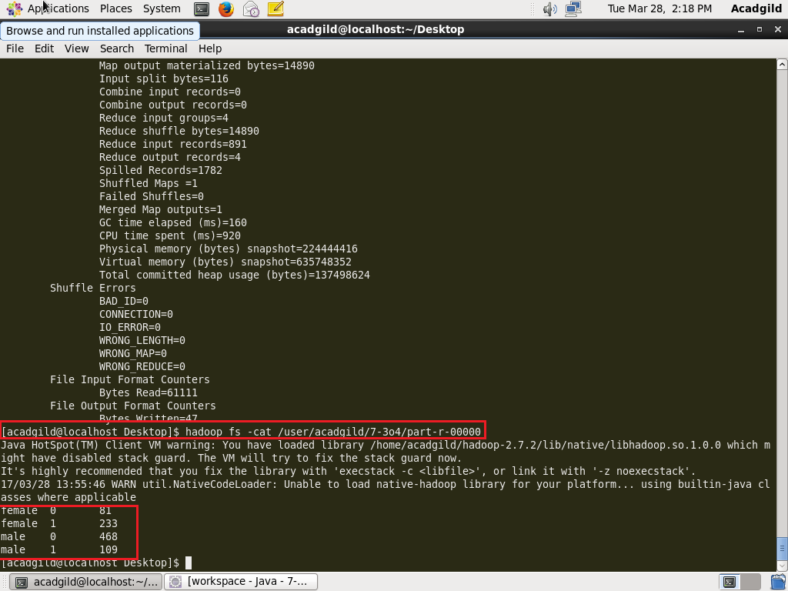Alive=0

The result shows male, females alive and dead count in titanic tragedy.