**#ASSIGNMENT_7.4**

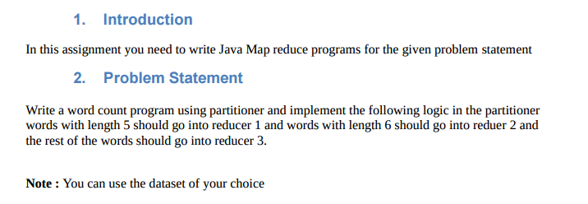

**DATA SET**

Sample_data.txt

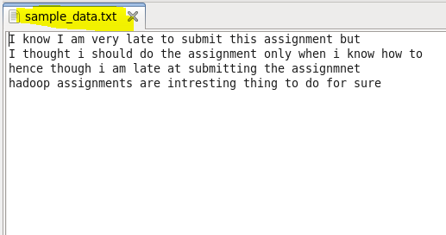

**Solution-**

**Driver class:-**

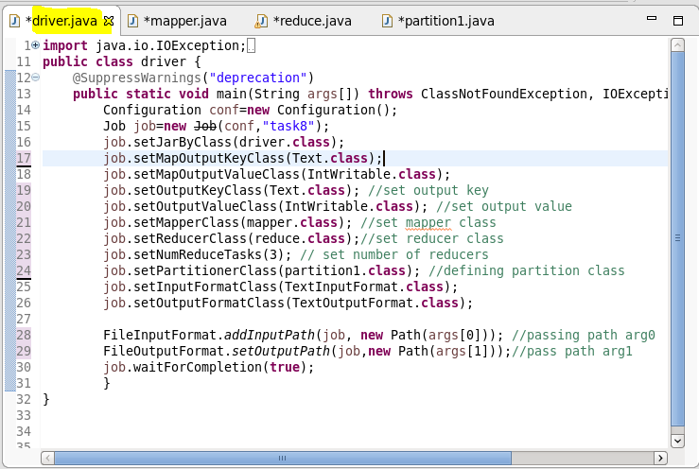

**Mapper Class:-**

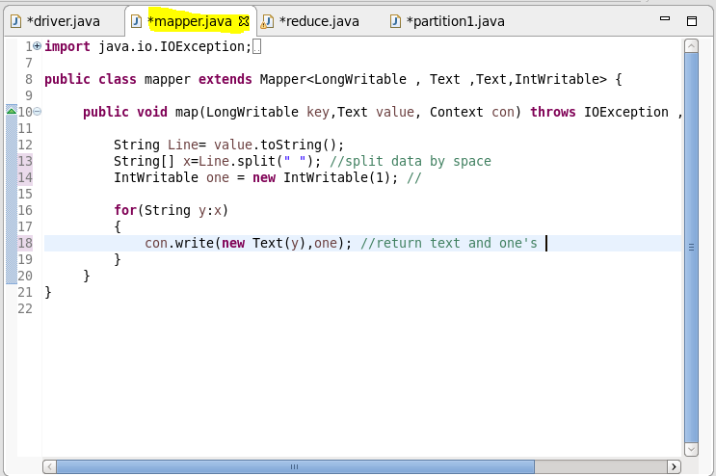

**Reducer class:-**

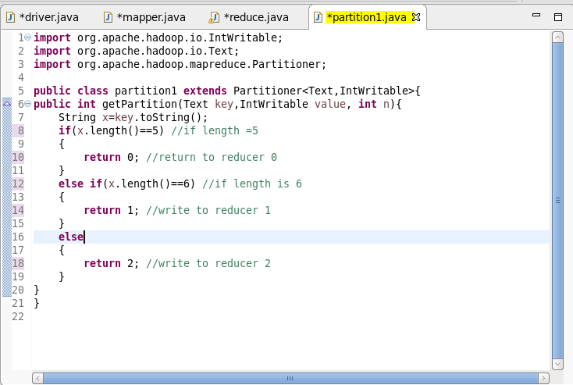

**Partition class:-**

PARTITON OF DATA INTO DIFERENT REDUCERS.

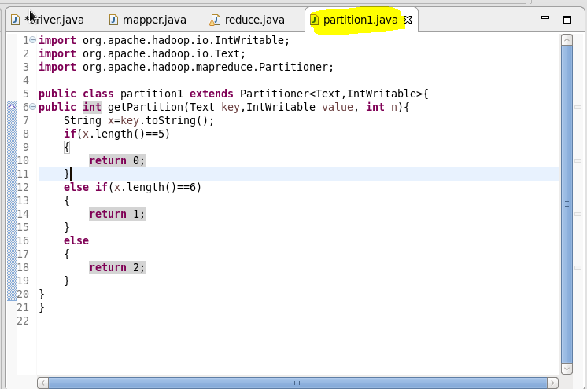

**Result:-**

Loading jar-

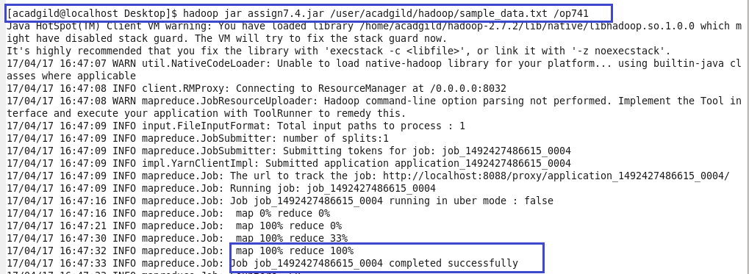

**Display result on console**

The partition of reducers is done into 3.

Reducer 1 will have values having length=5

Reducer 2 will have values having length=6

Everything else is in reducer 3

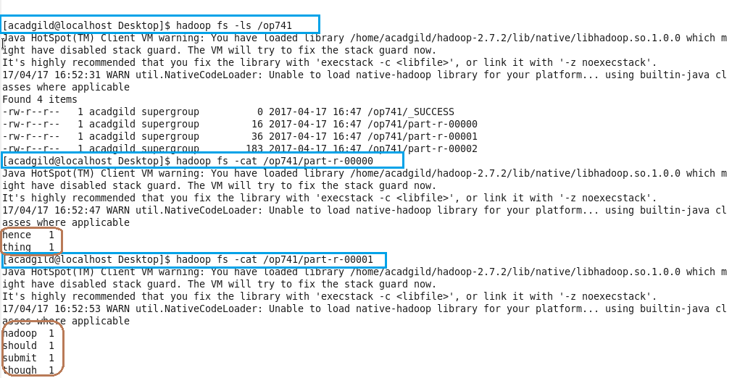

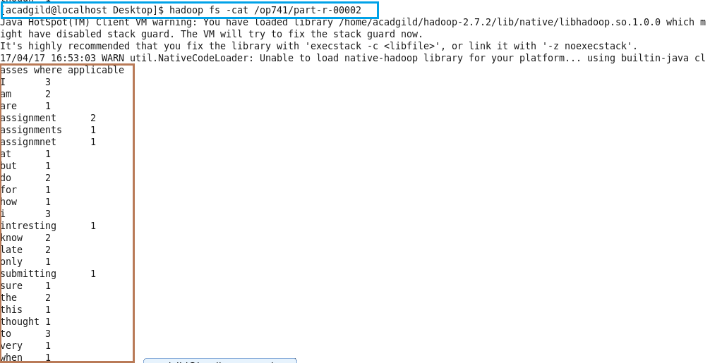

Data set is verified with the result and it is accurate.