**#Assignment_7.5**

**PROBLEM STATEMENT:**

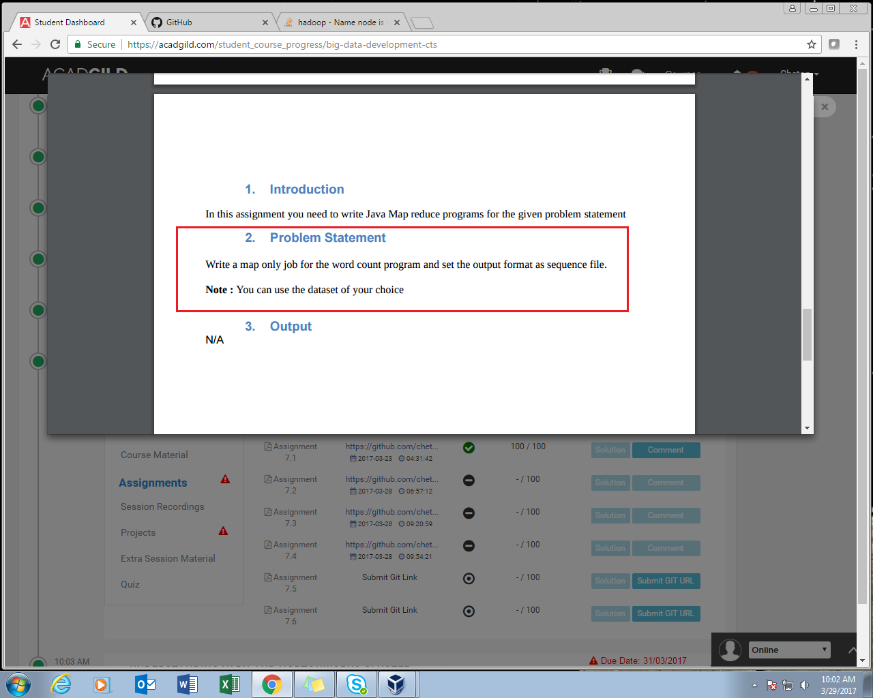

**PROGRAM:**

**DRIVER CLASS**

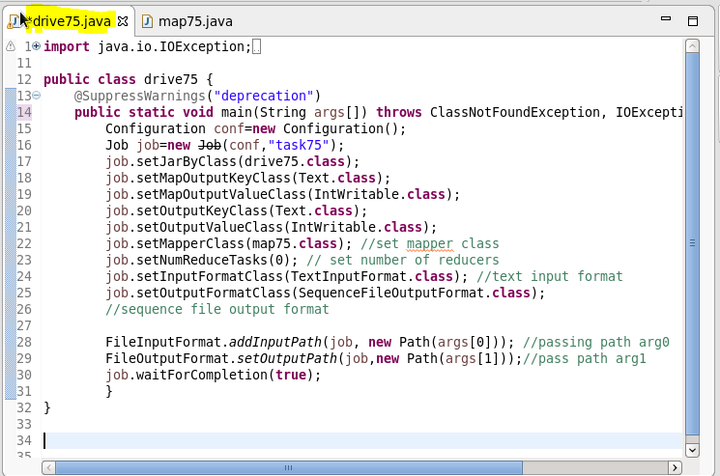

**MAPPER CLASS-**

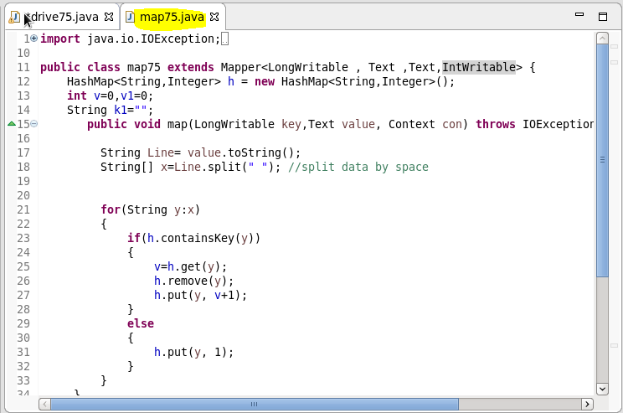

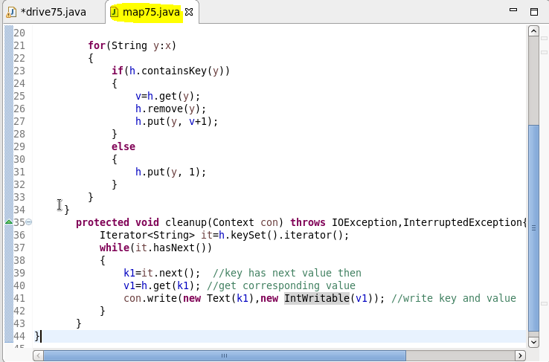

**Result:-**

**Loading Jar file**

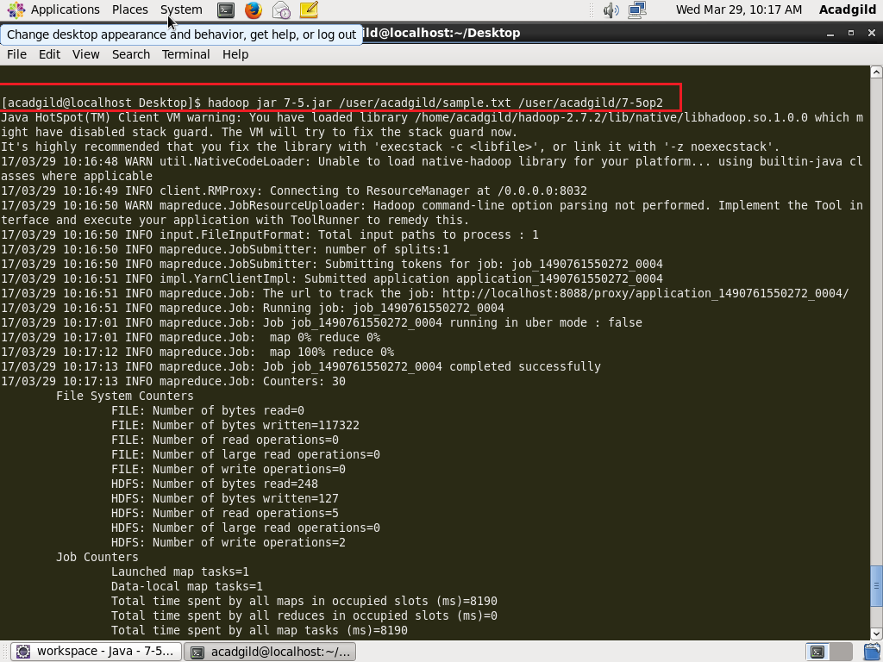

**‘Sample.txt’**

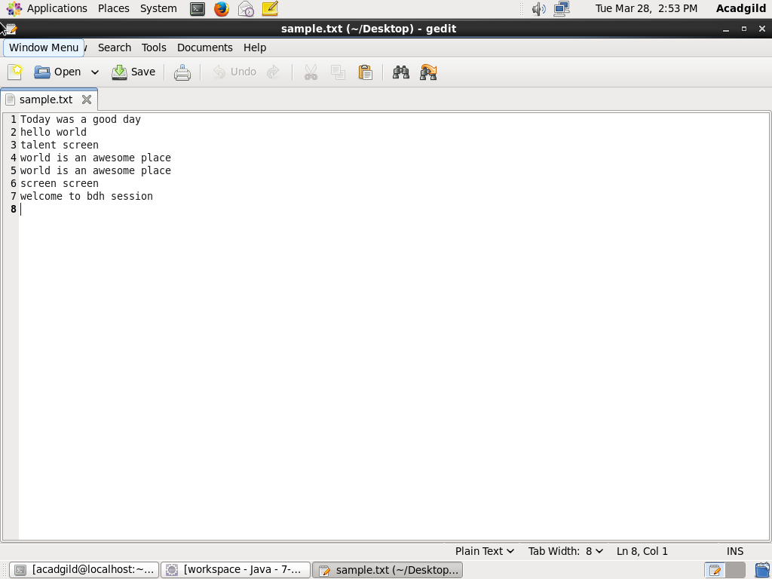

**Display on result on console-**

