**#Assignment_7.6**

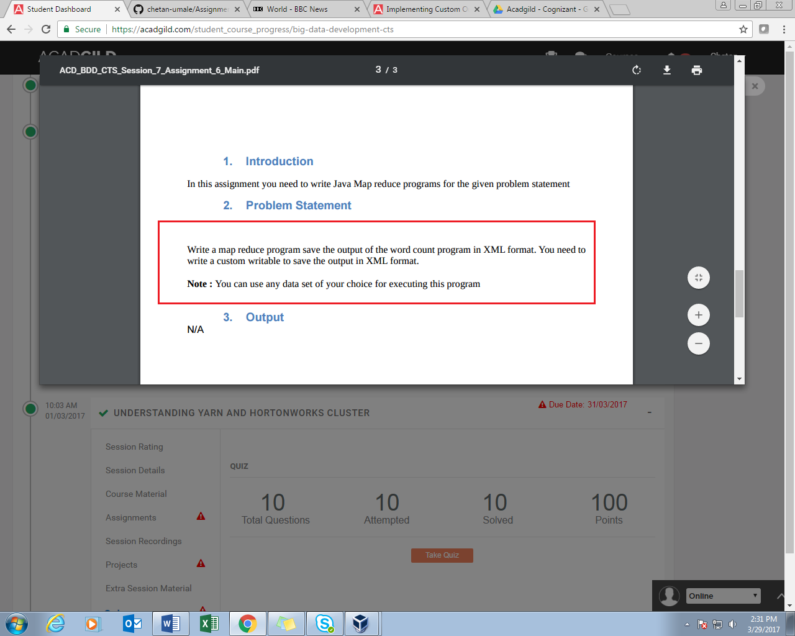

**XML** output format class is used for streaming file data. These files are delimited by <xml> </xml> at the beginning and end. The mapper outputs a tuple with the **title** string as key and a shortened version of the **text** string as value, while reducer is an identity function.

**PROGRAM:**

**DRIVER CLASS**

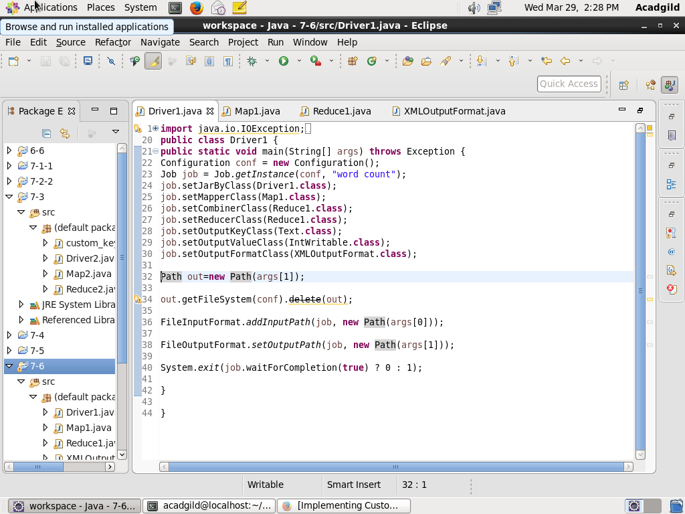

**MAPPER CLASS**

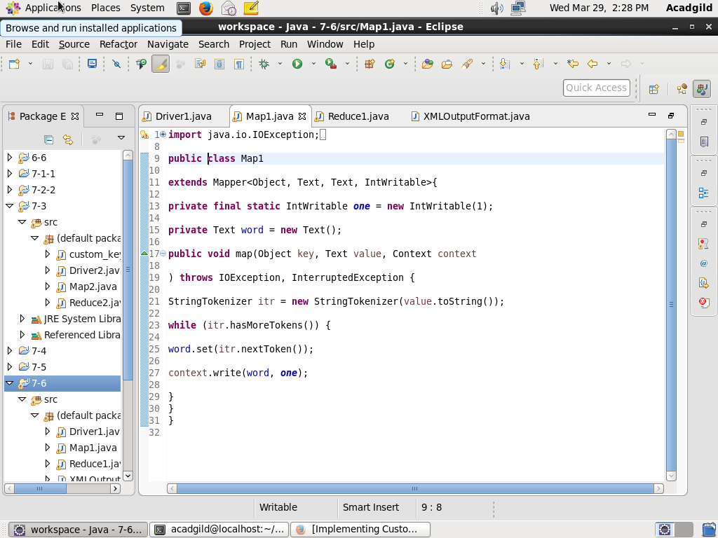

**REDUCER CLASS**

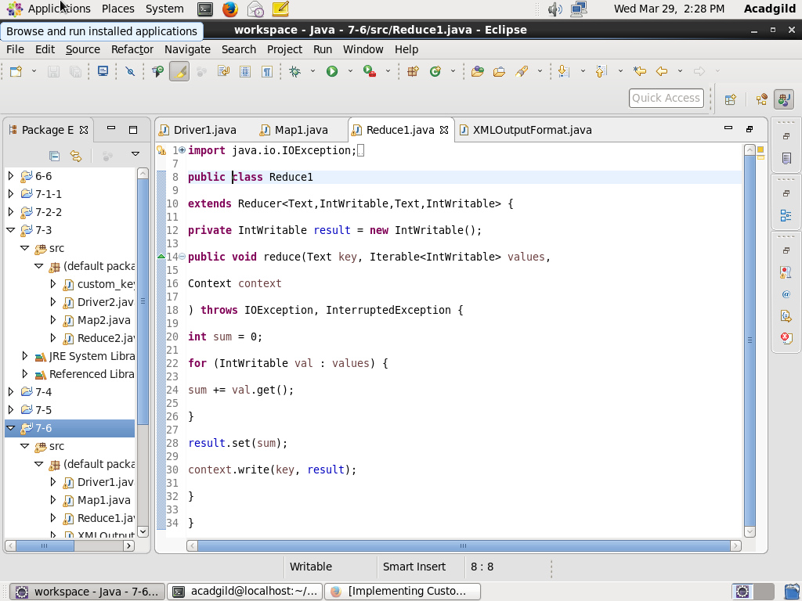

**XMLOUTPUTFORMAT CLASS**

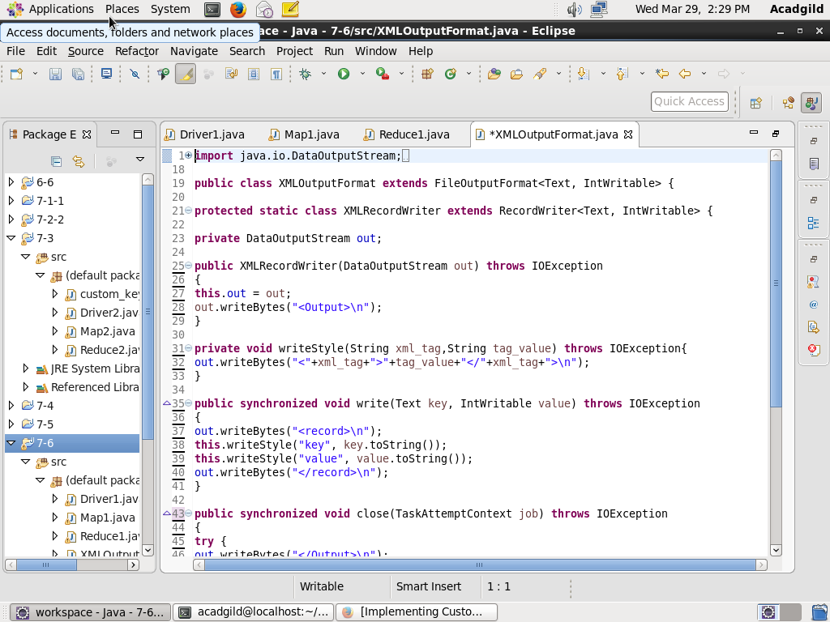

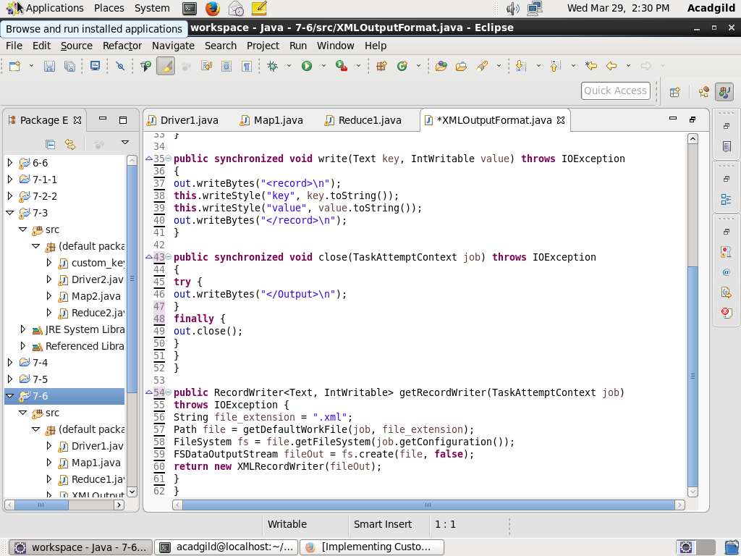

**OUTPUT:**

**Loading jar file**

**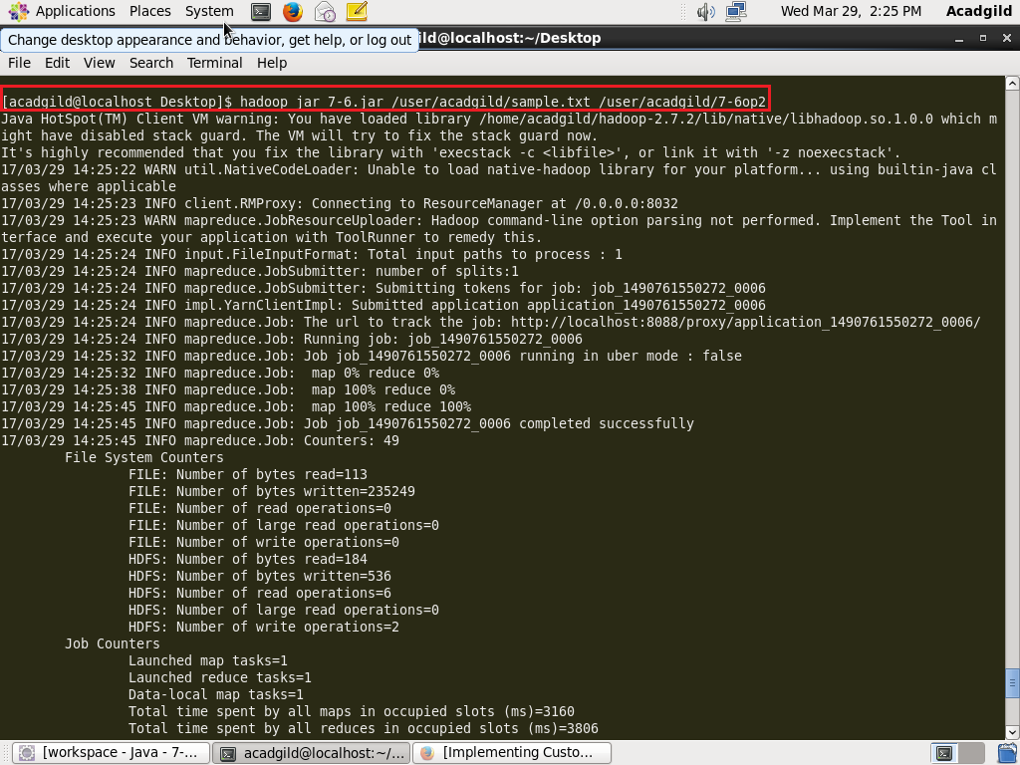  
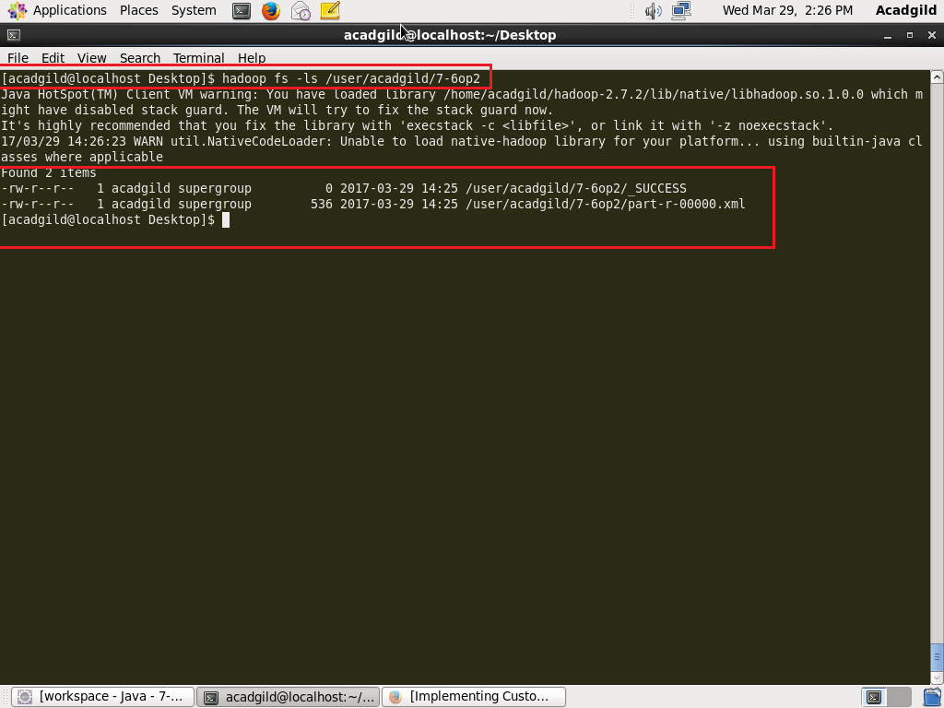**

**Display of result on console-**

