**#ASSIGNMENT_8.1**

**Problem Statements**

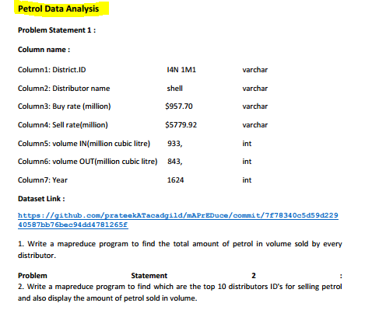

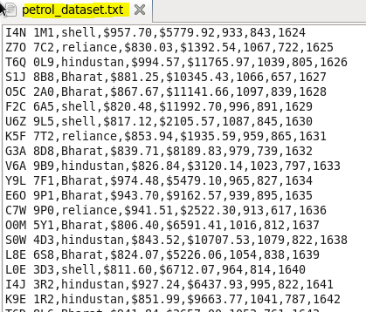

**Que1)** Write a mapreduce program to find the total amount of petrol in volume sold by every distributor

**Driver**

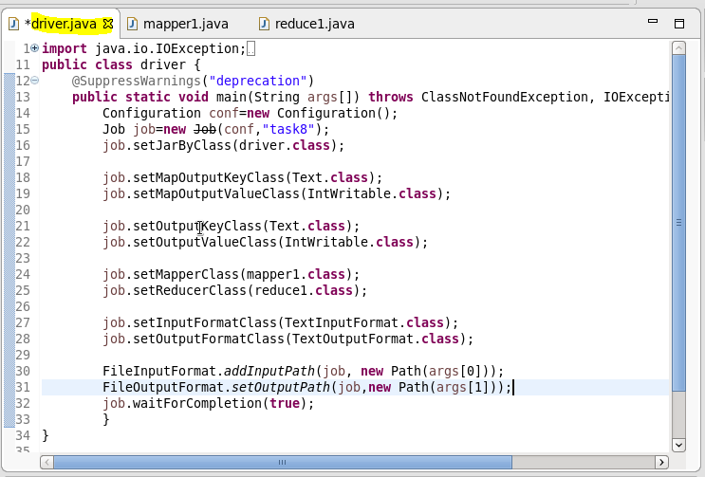

**Mapper**

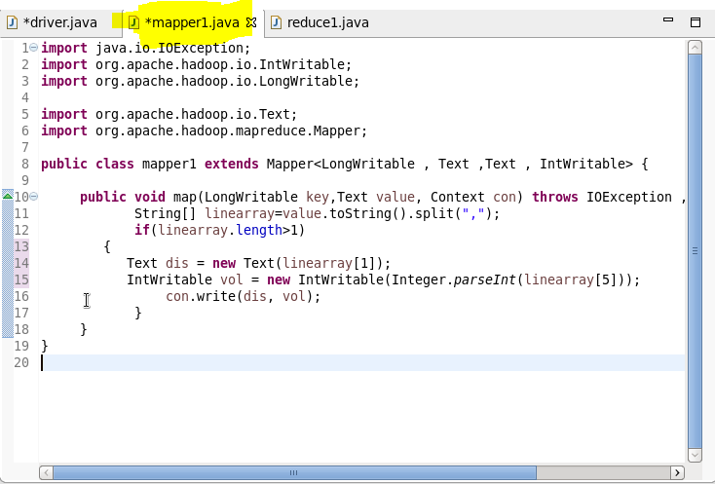

**Reducer**

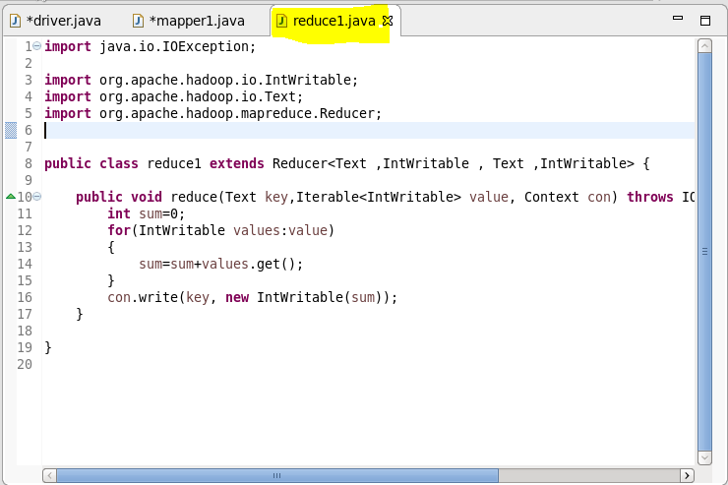

**Result:**

**Loading a Jar file**

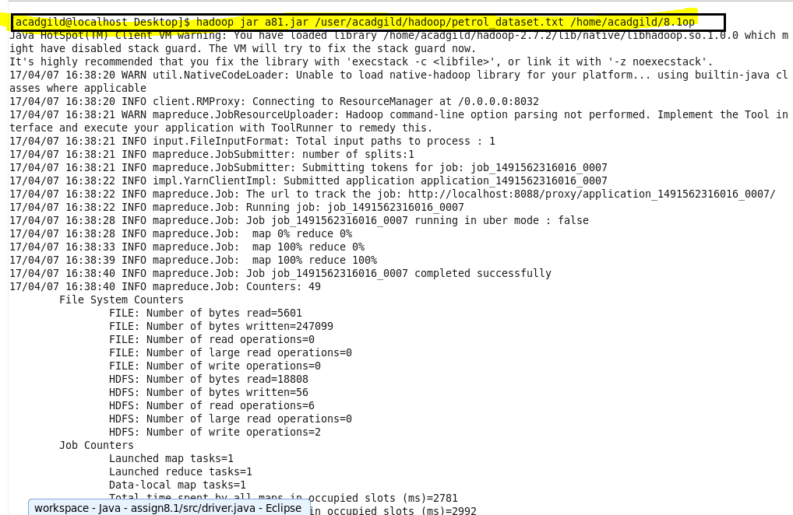

**Display result on console**

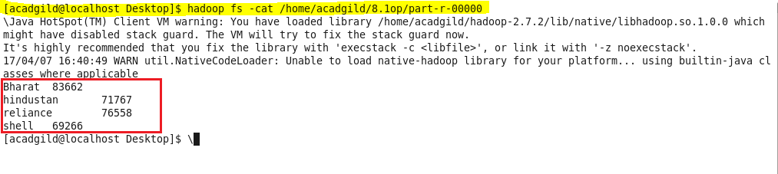

**Que2)** Write a mapreduce program to find which are the top 10 distributors ID's for selling petrol and also display the amount of petrol sold in volume.

**Driver**

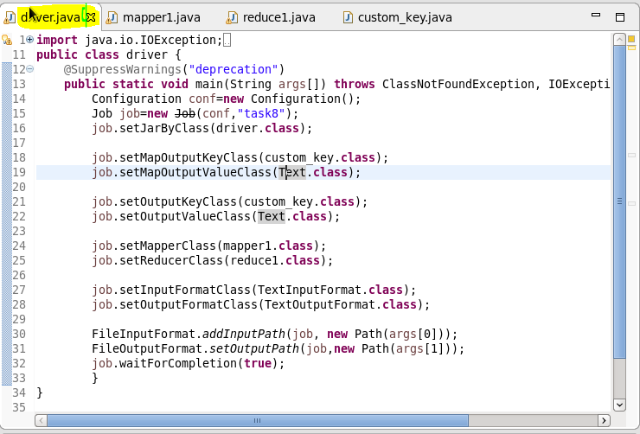

**Mapper**

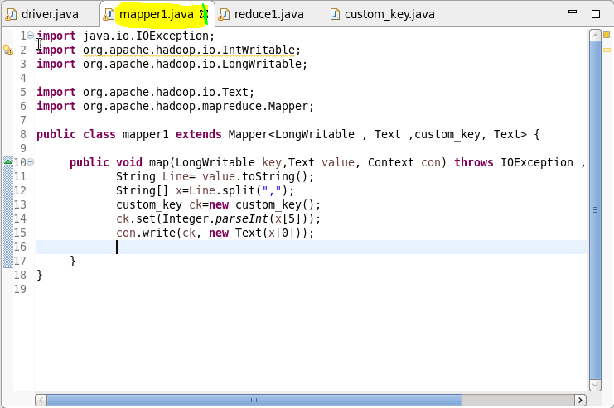

**Reducer**

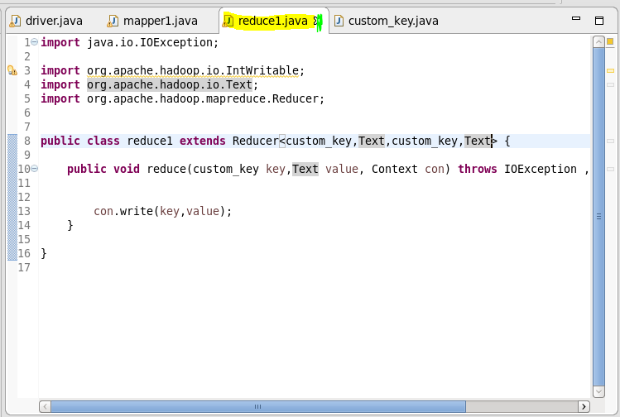

**Custom Writable**

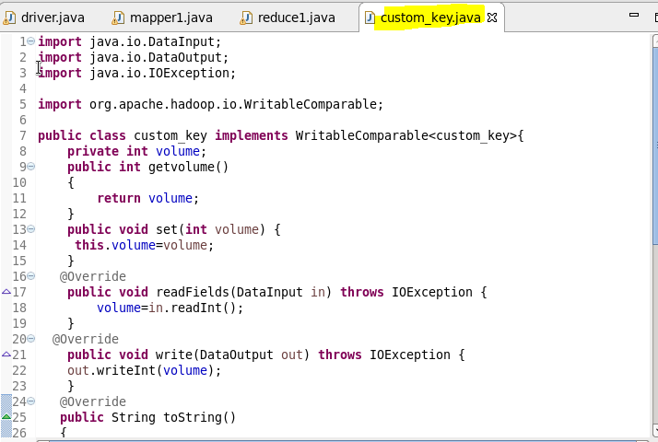

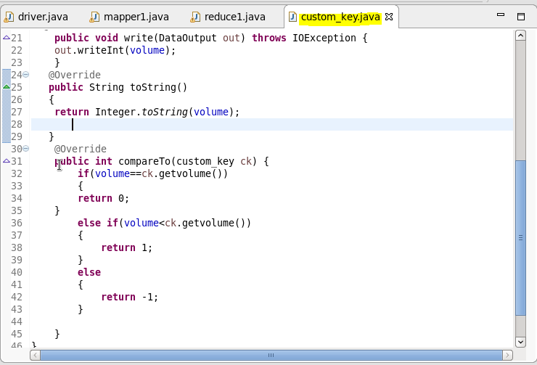

**Result:**

**Loading Jar**

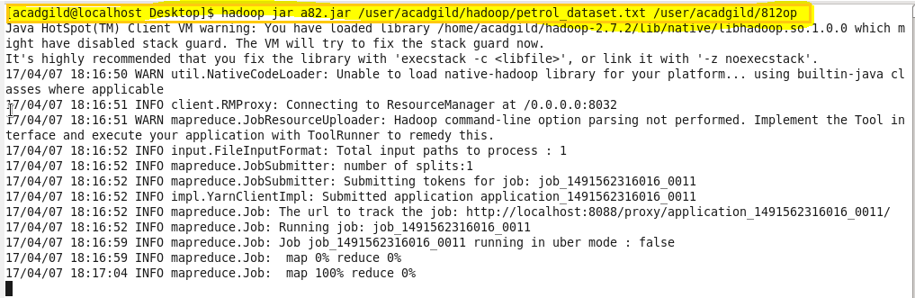

**Display Result on console**

