**#ASSIGNMENT9.3**

**QUE1) Create two databases of file type text where columns are delimited by tab (‘ ’) and use these datasets to perform join operations:-**

**Self-Join, Inner Join, Right Outer Join, Left Outer Join, Full Outer Join**

**Solution-**

**Input File:-**

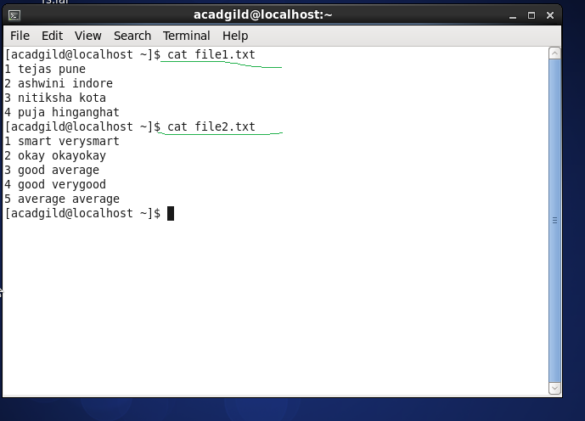

**Self-Join**

**Command**

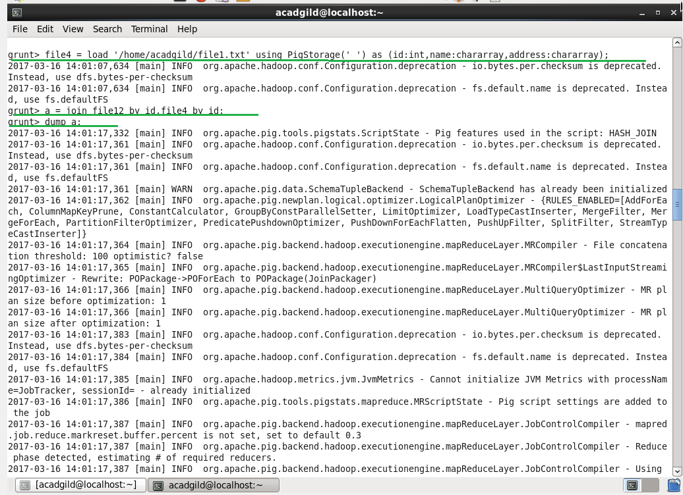

**Output**

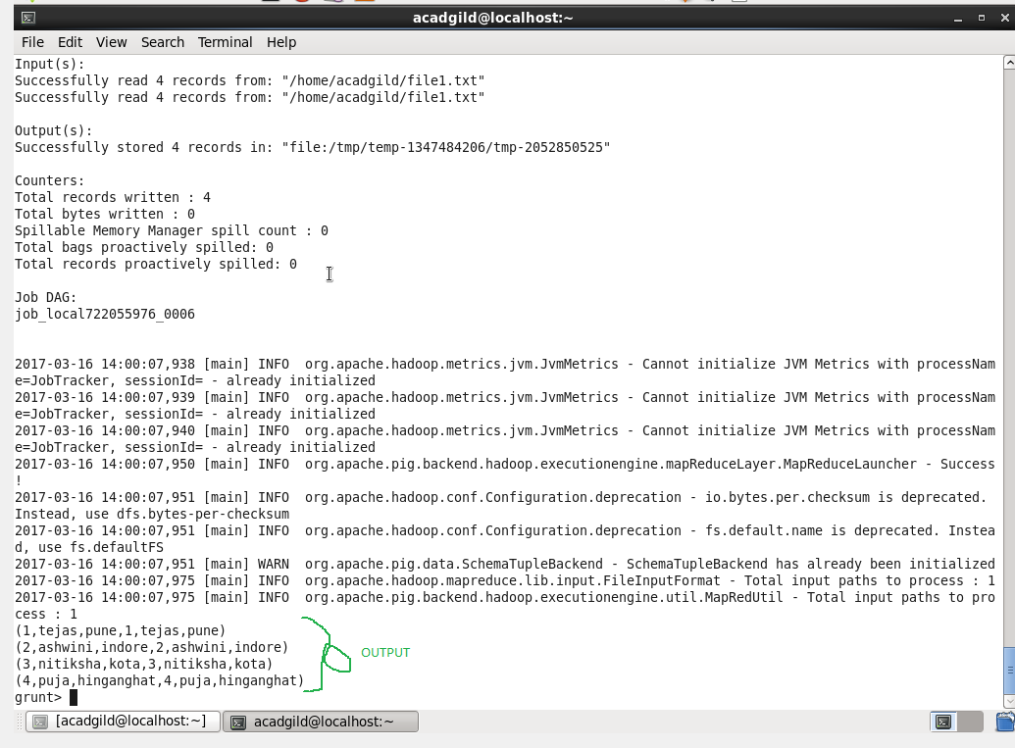

**Inner Join**

**Command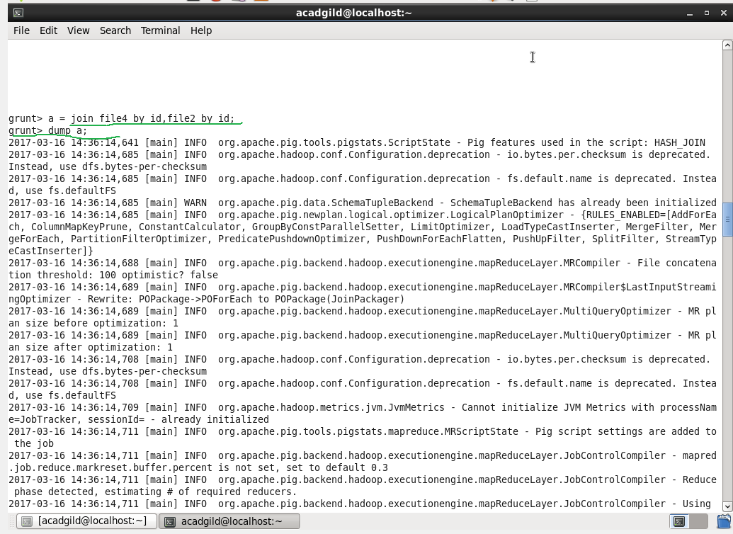Output**

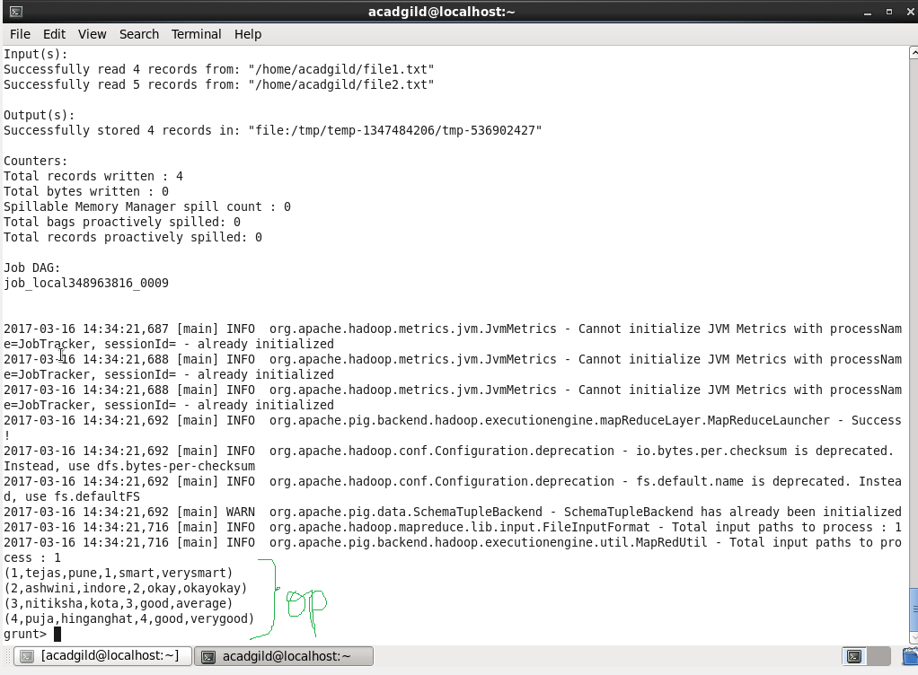

**Right Outer Join**

**Command**

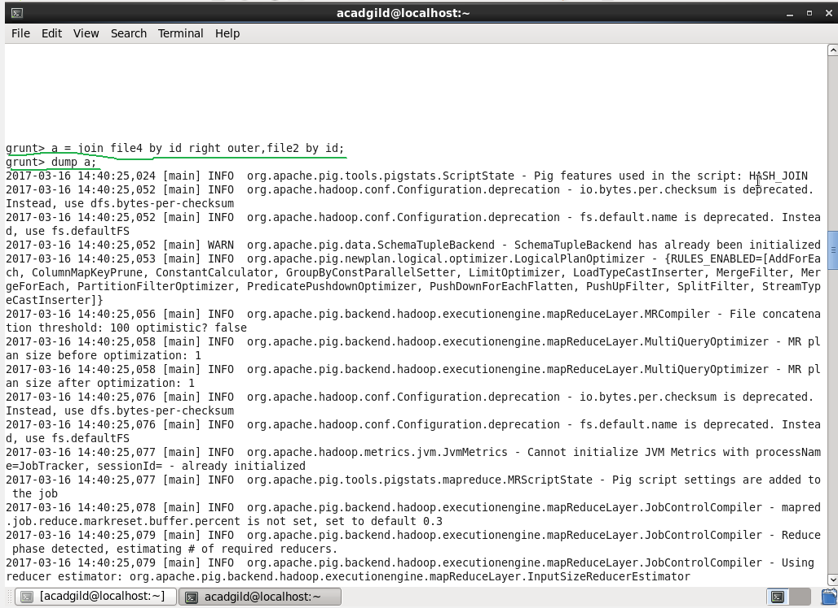

**Output**

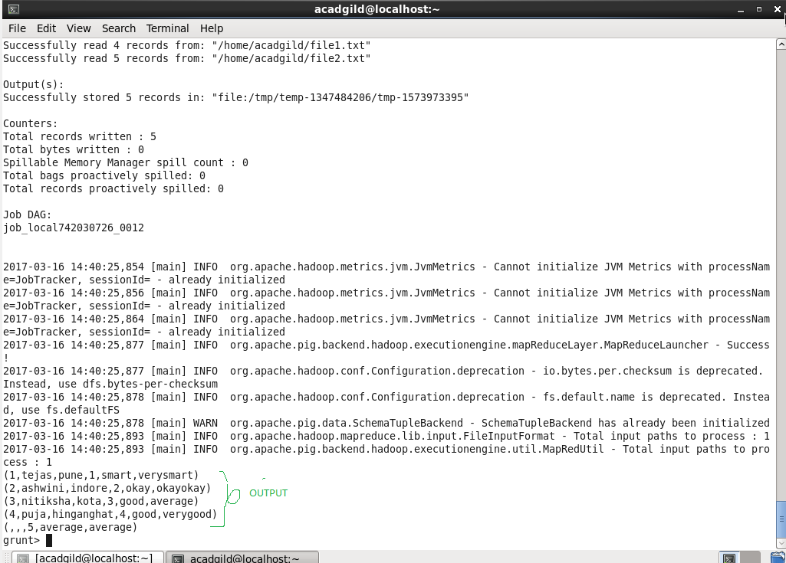

**Left Outer Join**

**Command**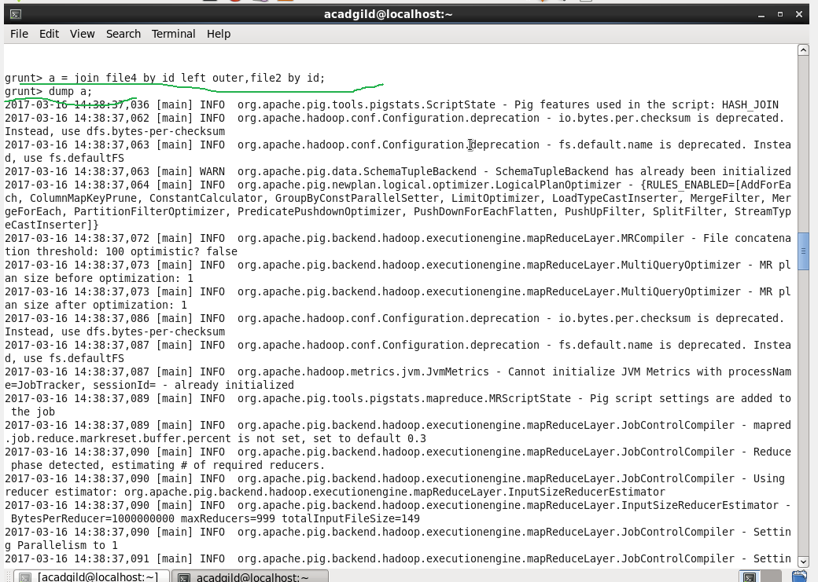

**Output**

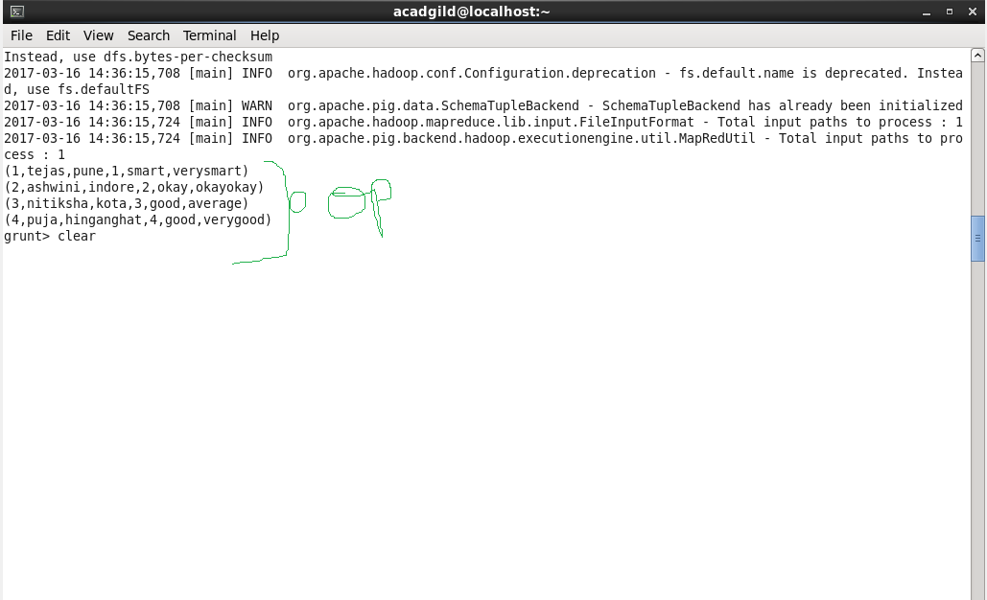

**Full Outer Join**

**Command**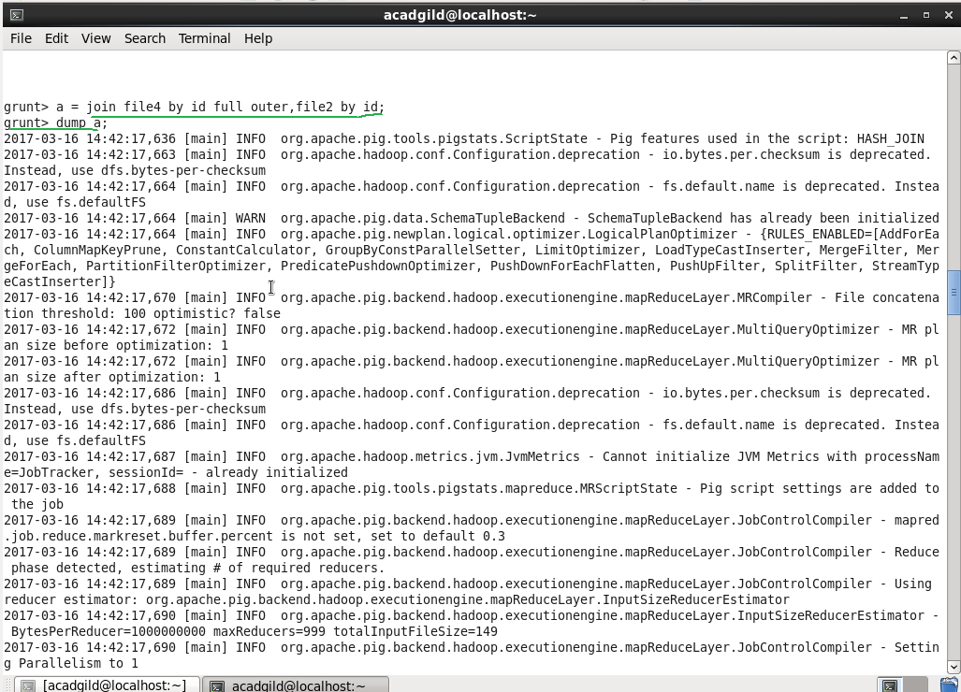

**Output**

