**#Assignment9.4**

**QUE) Practice the relational operators in pig by following the steps in the ACADGILD blog.**

Solution:-

**Input File**

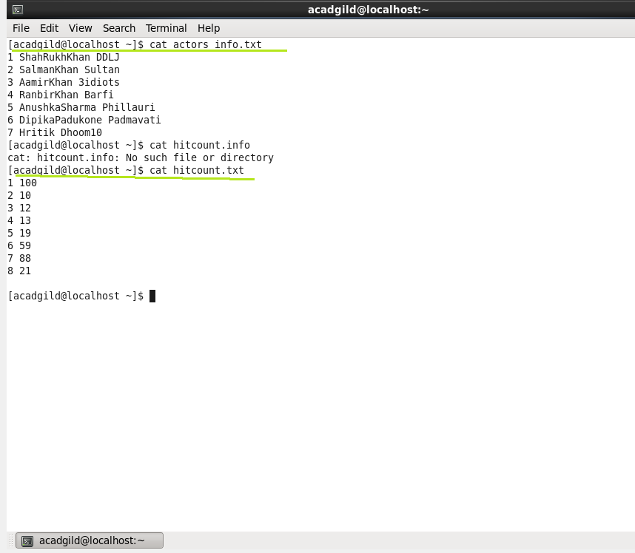

**LOAD**

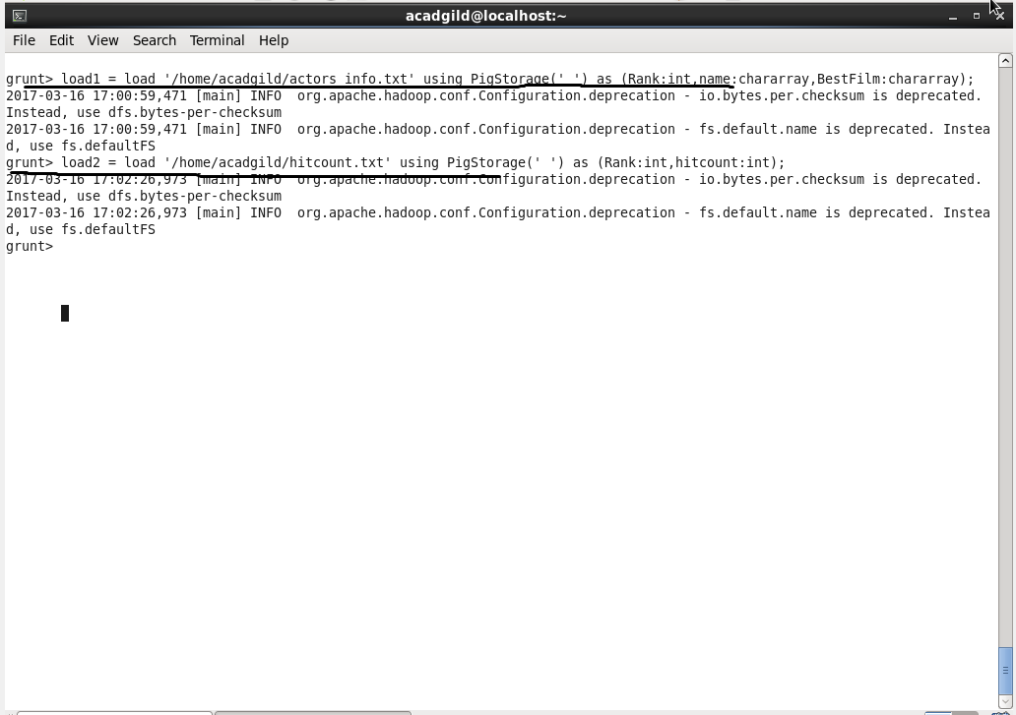

**Limit**

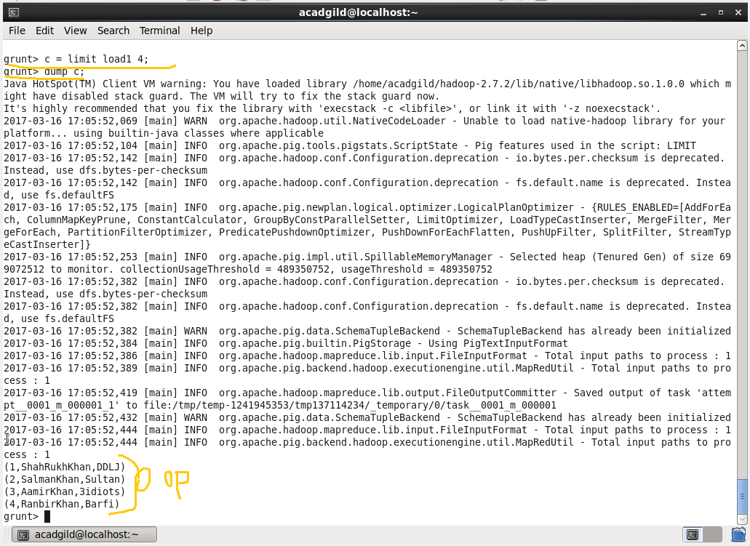

**ORDER BY**

**Command**

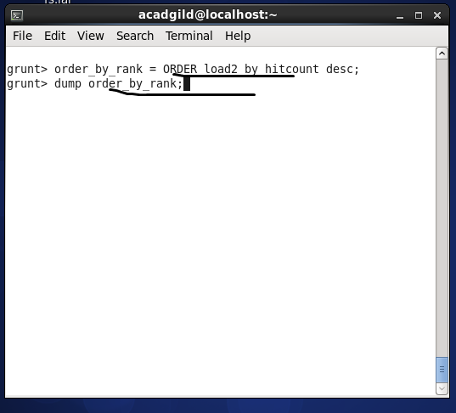

**Output**

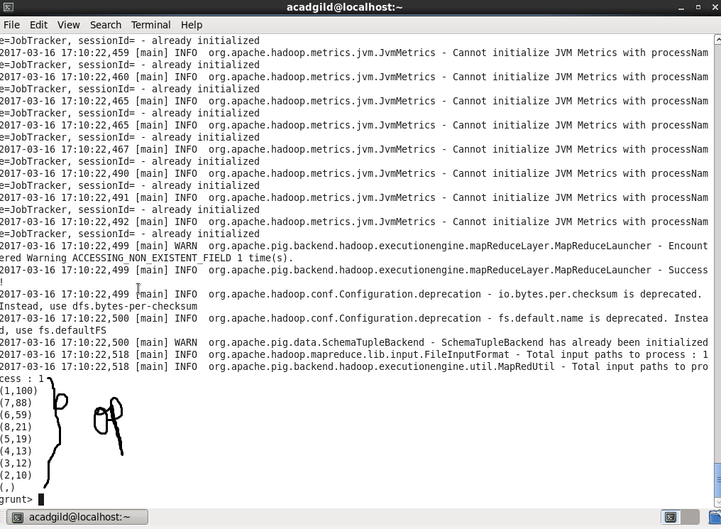

**GROUP BY**

**Command**

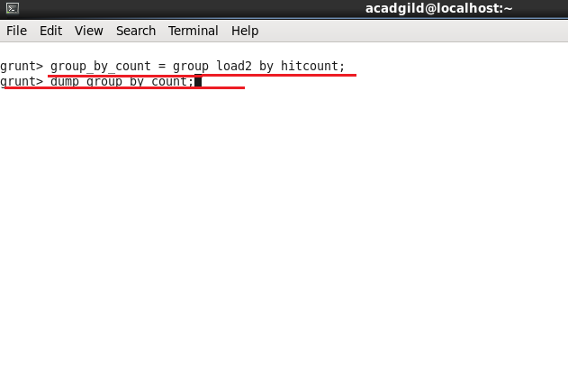

**Output**

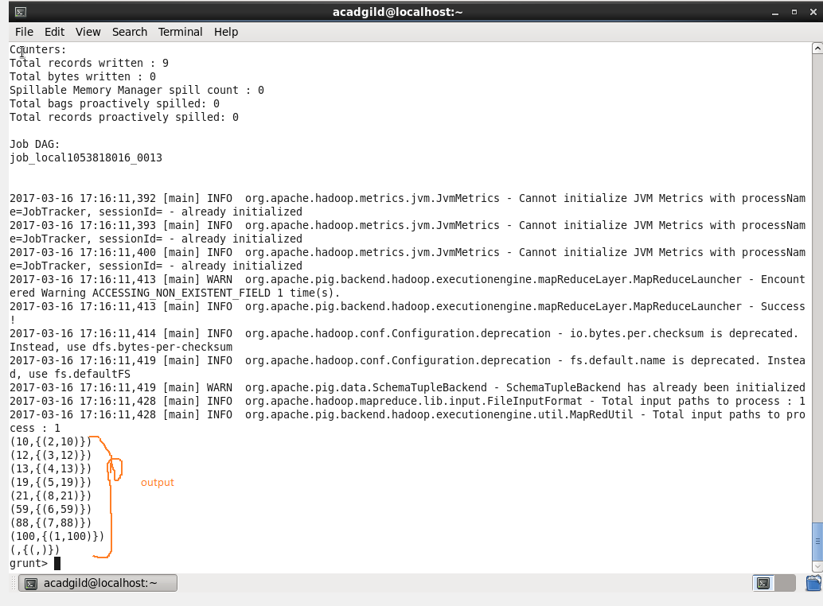

**FILTER**

**Command**

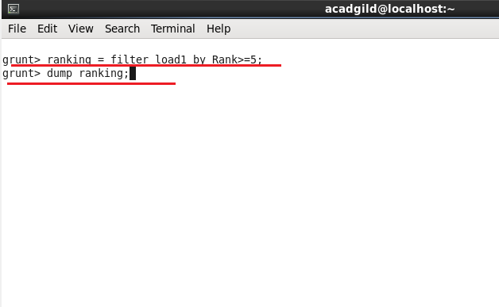

**Output**

