**#ASSIGNMENT_23.1**

**PROBLEM STATEMENT:**

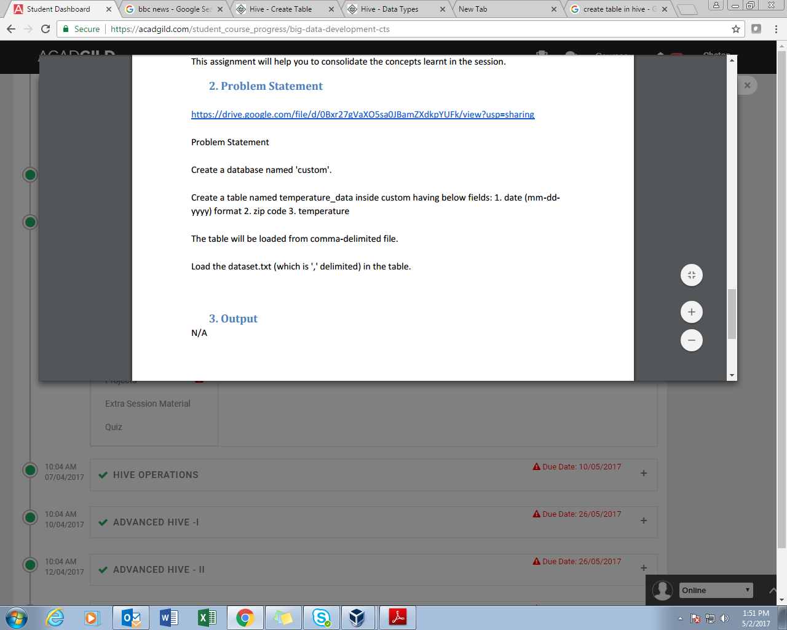

**SOLUTION:**

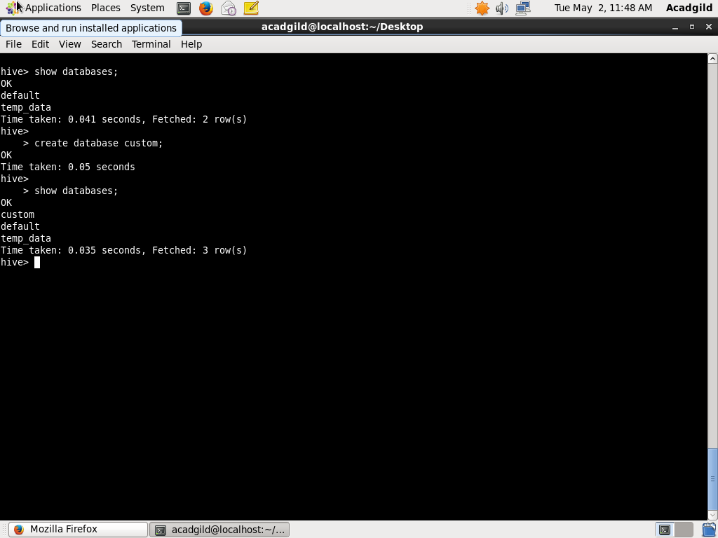

Thus we have created a database named custom, and can be seen in the databases available.

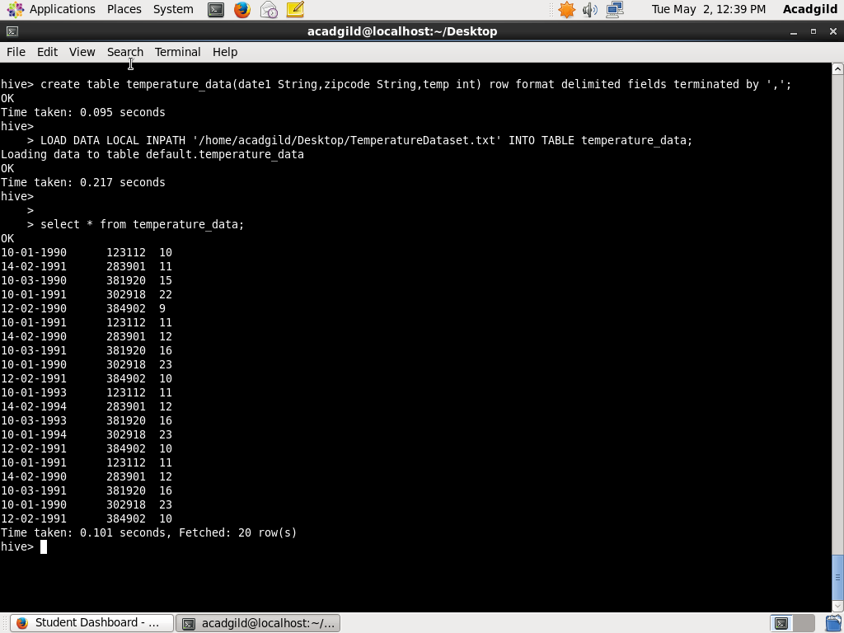

Here we have created a table named temperature_data within the database custom having columns as date, zip code, and temp where row format is delimited by coma.

Now load the data from the file to the table created.

In results we can see the data fetched.