**ASSIGNMENT 26.5**

**Q-How many kinds of tables are present in hive and explain the difference between them with a demo.**

There are two types of tables in Hive:

1. Managed table:

If a managed table is dropped, the data as well as the metadata are deleted.

2. External table.

If an external table is dropped, only metadata is deleted.

**DEMO:**

//creating managed table

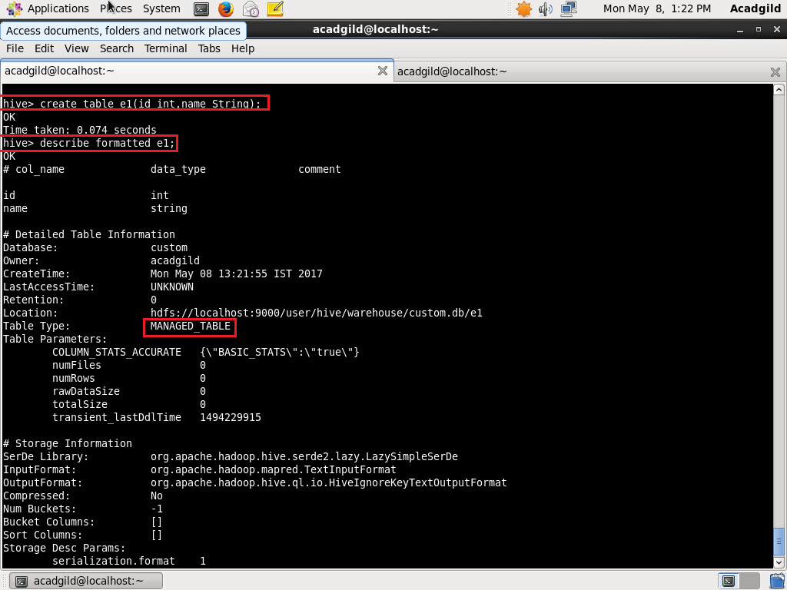

//creating external table

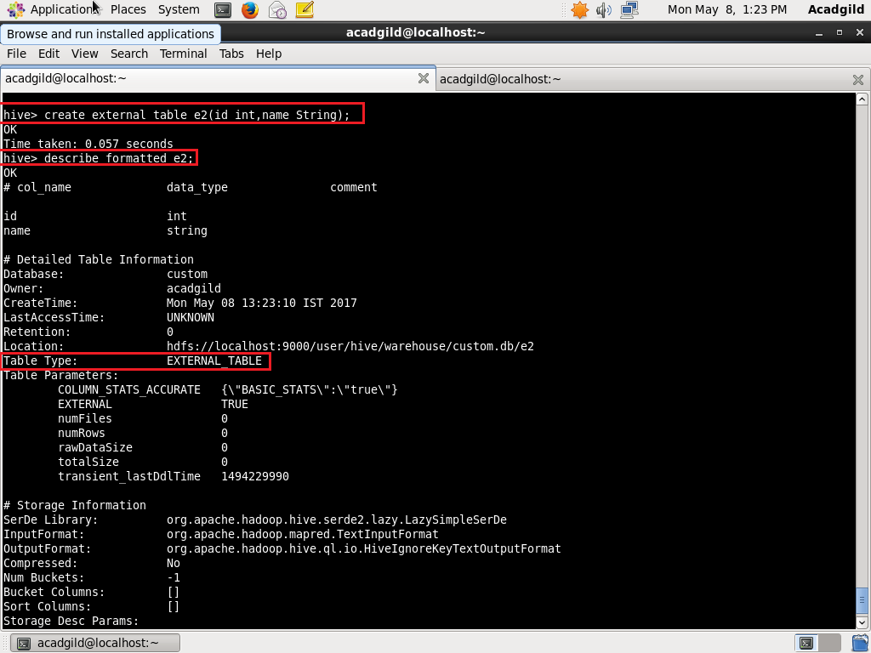

//dropping managed table

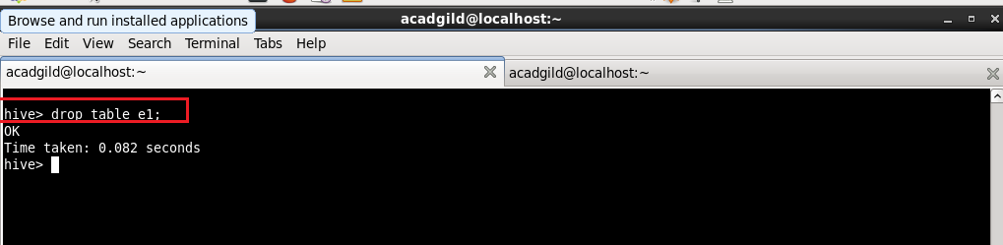

//dropping external table

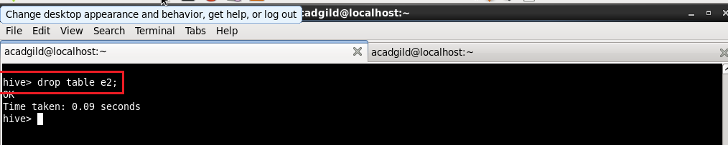

//displaying directories

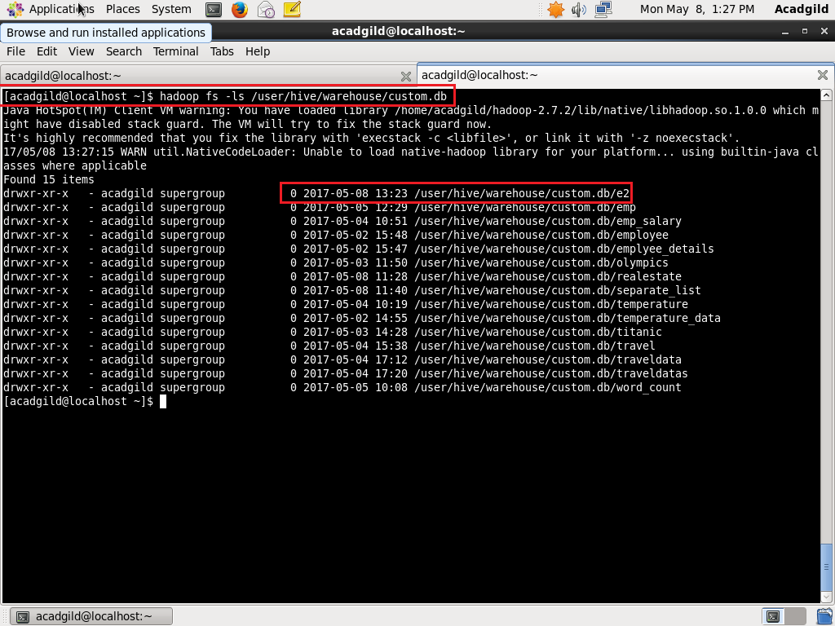

Directory e1 does not exist while directory e2 still exists after dropping both the tables.