**ITG US Business IT**

**Applications Development**



LOST AND MISSING

**Approach Document**

Version: 1.0

Date: 09/15/2017

**Management:** **Project Manager:**

Brian Ozaki Denise Murray

**NOTICE**

**THIS DOCUMENT IS PROPRIETARY AND CONFIDENTIAL**

This document is the property of, and is proprietary to, MetLife, and it is protected under the copyright, trade secret and confidentiality laws of the United States and under international treaties. Please be aware that no part of this document may be reproduced in any form or by any means, electronic or mechanical, whether now known or later invented, including, without limitation by photocopying and recording, for any purpose without the express written consent of MetLife. In addition, due to the proprietary nature of MetLife methodologies and other information contained herein, this document and any derivative content may not be shown or otherwise disclosed to any third-party without the prior written consent of MetLife.

**© 2016 MetLife®**

All Rights Reserved**.**

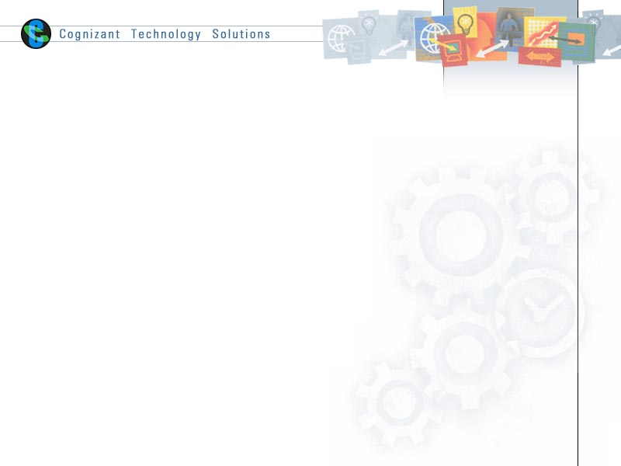

**Role Details:**

|  |  |  |  |
| --- | --- | --- | --- |
|  | **Prepared By** | **Reviewed by** | **Approved By** |
| **Name** | Aritra Mukherjee | Rakesh Chatterjee |  |
| **Role** | Application Developer | Sr. Developer |  |
| **Signature** | AD | RC |  |
| **Date** | 09/15/2017 |  |  |

**Document History:**

|  |  |  |
| --- | --- | --- |
| **Version** | **Amendment Date** | **Amendment Description** |
| v1.0 | 09/15/2017 | Initial Version |

**Requirements Sign-Off:**

I am in agreement and support of this project

|  |  |  |
| --- | --- | --- |
| **Stakeholder** | **Name** | **Date** |
| IT PM |  |  |
| Lead Developer or Architect |  |  |
| Lead QA |  |  |

TABLE OF CONTENTS

Document History: 2

Requirements Sign-Off: 2

1. Objective 4

2. Approach 1 4

3. Approach 2 7

4. XML files for Notification 9

5. Notification Attributes uploaded to web service: 9

6. Definition and Acronyms 10

# Business Objective

RIS Lost and Missing Annuitant Program seeks to enhance the process of locating, corresponding and tracking with annuitants as well as appropriately reserving for benefits that remain due.

The program’s strategic objective is multi phased. For the first phase, the following development efforts were identified to support RIS’s efforts to enhance customer outreach efforts and drive efficiencies in its operational model.

1. Campaign Management solution to create a streamlined and automated process for Annuitant outreach and track contact and response activity across RIS’s operational processes that can be used to inform future outreach efforts as well as downstream operational processes.
2. System of Record enhancements to consume best available annuitant address.
3. System of Record enhancements to capture Campaign Management contact and response activities on annuitant outreach in order to trigger operational processes for Reserve Valuations and Abandoned Property.

# Objective of the document

This document provides high level approach for 2 different options that is proposed for LOST & MISSING best address requirement mentioned in point #2 from Business Objective.

# Approach 1

To build a separate process which will use the CDC source file (C_B_ADDR_CDC.txt and C_B_PARTY_ADDR_CDC.txt) of notification process and generate the required file containing BEST ADDRESS for PCTS.

Below are the steps:

1. We will use the file C_B_ADDR_CDC.txt and find its corresponding parties at contextual level.
2. We will use the file C_B_PARTY_ADDR_CDC.txt and find its corresponding parties at contextual level.
3. Merge the output file of the STEP 3.1 & STEP 3.2 and filter out those global parties which have PCTS records.
4. Now find the ‘BEST ADDRESS’ against these global parties among all the addresses available.
5. Rule to find ‘BEST ADDRESS’:

Select the most recent complete address with Maintained Abilitec ID [most current time stamp and having all the following (address1, city, state, and zip)]

If there are multiple complete addresses with Maintained Abilitec ID and the same timestamp, then select:

* first the 'Acxiom best address' with Maintained Abilitec ID (unless there is more than one and they are different)
* then the ‘Acxiom enriched address’ with Maintained Abilitec ID (unless there is more than one and they are different)
* If there are no addresses with Maintained Abilitec ID at all, no address should be returned.

1. Compare the derived ‘BEST ADDRESS’ with address received from source system (PCTS ML address) and if different we will re-direct them to a file.
2. This file will be sent to SOR server using ftp.

**Advantages:**

1. SLA of notification process will not be hampered as this will be an independent process.
2. Separate target file will be generated and can be sent to desired team through FTP.

**Disadvantages:**

1. Entire new code needs to be built, no re-usability will be possible.

**FLOW DIAGRAM:**

Source C_B_ADDR_CDC.txt and find its contextuals parties

Source C_B_PARTY_ADDR_CDC.txt and find its contextual parties

Merge files and filter the PCTS records

Find BEST_ADDRESSES against global parties (STEP 5)

Generate address extract and ftp to SOR Server

Best Address found?

Compare BEST_ADDRESS with received address from source (PCTS)

No Action

Address different?

No Action & drop the record

Yes

No

Yes

No

# Approach 2

Existing Notification code will be used and the derived BEST ADDRESS for the PCTS records will be uploaded to web service along with the attributes required for notification process. Address related CDC source file (C_B_ADDR_CDC.txt and C_B_PARTY_ADDR_CDC.txt) will be used for the same.

1. Aim is to append the ‘BEST ADDRESS’ attributes for the PCTS records in the ADDR web service upload mapping.
2. We will use the files C_B_ADDR_CDC.txt & C_B_PARTY_ADDR_CDC.txt and find its corresponding parties at contextual level.
3. Merge the output files of the previous steps and filter out those global parties which have PCTS records.
4. Now find the ‘BEST ADDRESS’ against these global parties among all the addresses available.
5. Rule to find ‘BEST ADDRESS’:

Select the most recent complete address with Maintained Abilitec ID [most current time stamp and having all the following (address1, city, state, and zip)]

If there are multiple complete addresses with Maintained Abilitec ID and the same timestamp, then select:

* first the 'Acxiom best address' with Maintained Abilitec ID (unless there is more than one and they are different)
* then the ‘Acxiom enriched address’ with Maintained Abilitec ID (unless there is more than one and they are different)
* If there are no addresses with Maintained Abilitec ID at all, no address should be returned.

1. Compare the derived ‘BEST ADDRESS’ with address received from source system (PCTS ML address) and if different we will re-direct them to a file.
2. Append the above attributes with existing notification attributes in the C_B_ADDR mapping.
3. The PCTS records will have extra attributes and admin system records will have blank in these attributes and the same will be uploaded into the web service.

**Advantages:**

1. When combined with notification process, web service will be used to send the notification and best address at the same time.
2. There will be partial re-usability of the process.

**Disadvantages:**

1. Due to increase in complexity, the time taken for the entire process may increase.

**FLOW DIAGRAM:**

Source C_B_ADDR_CDC.txt and find its contextual parties

Source C_B_PARTY_ADDR_CDC.txt and find its contextual parties

Merge files and filter the PCTS records

Find BEST_ADDRESSES against global parties

Generate best address & append with ntfn. attributes

Existing Notification Data

Upload to Web service

Best Address found?

Compare BEST_ADDRESS with received address from source (PCTS)

No Action

Address different?

No Action & send blank best add. with existing ntfn. attributes

No

Yes

No

Yes

# XML files for Notification

PARTY



PHONE



ELEC_ADDR



ALT_ID



PARTY ADDR



ADDR



# Notification Attributes uploaded to web service:



# Definition and Acronyms

|  |  |
| --- | --- |
| **Acronym/Term** | **Definition** |
| GPM | Global Party Management |
| MDM | Master Data Management |
| LOB | Line of Business |
| Contextual Party Representation | A Contextual Representation reflects how the party represents themselves in a specific relationship or interaction with MetLife |
| Party | A Party is any person, organization or institution with whom MetLife U.S. Business has a vested or intended interest. |
|  |  |