**UNIT I - BASIC ELECTRICAL FUNDAMENTALS**

**ELECTRIC AND MAGNETIC CIRCUIT**

A closed path followed by electric current is known as electric circuit.

A closed path followed by magnetic field line or magnetic flux is known as magnetic circuit.

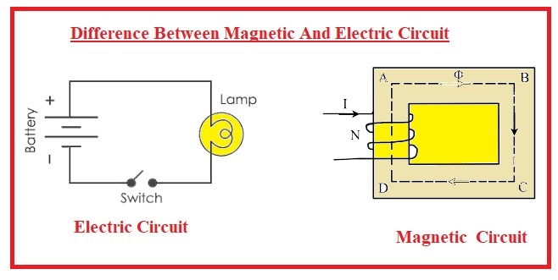

## Magnetic Circuit

A magnetic circuit is defined as a closed path followed by the magnetic flux.

A magnetic circuit consists of a core of materials having high permeability like iron, soft steel etc. It is because these materials offer very small opposition to the flow of magnetic flux.

Consider a coil of N turns wound on an iron core (see the figure). When an electric current I is passes through the coil, magnetic flux (ψ) is set up in the core. This magnetic flux follows a closed path ABCDA and hence ABCDA is the magnetic circuit.

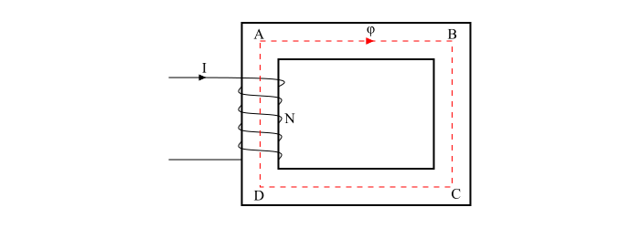

In a magnetic circuit, the amount of magnetic flux in the core depends upon the current (I) and the number of turns (N). The product NI is known as the *Magnetomotive Force (MMF)*.

MMF=NI=Ampere−TurnsMMF=NI=Ampere−Turns

The opposition offered by the magnetic circuit to the flow of magnetic flux is known as reluctance (S) of the magnetic circuit. The *reluctance* of the magnetic circuit depends upon the length of magnetic circuit, cross-sectional area of the circuit and nature of the material that makes up the magnetic circuit.

Types of Magnetic Circuit

There are two types of magnetic circuits −

* Series Magnetic Circuit
* Parallel Magnetic Circuit

## Series Magnetic Circuit

When the same magnetic flux ψ flows through each part of the magnetic circuit, then the circuit is called as series magnetic circuit.

Consider a composite series magnetic circuit (a series magnetic circuit that has parts of different dimensions and materials is called a composite series magnetic circuit) consisting of two different magnetic materials of different relative permeability. Each part of this series magnetic circuit will offer reluctance to the magnetic flux ψ. Since the different parts of the magnetic circuit are in series, the total reluctance is equal to the sum of reluctances of individual parts.

## Parallel Magnetic Circuit

A magnetic circuit which has more than one path for the magnetic flux is called as parallel magnetic circuit.

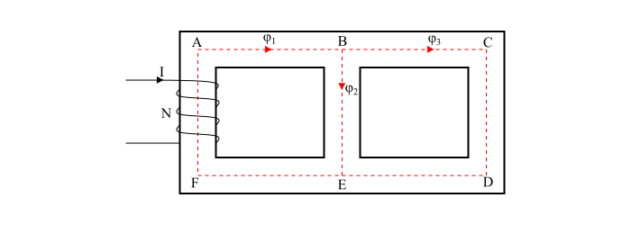

Difference between Electric Circuit and Magnetic Circuit

| **Parameter** | **Parameter** | **Parameter** |
| --- | --- | --- |
| Definition | A closed path followed by electric current is known as electric circuit. | A closed path followed by magnetic field line or magnetic flux is known as magnetic circuit. |
| Circuit quantities | In electric circuit, the major quantities associated with the circuit are EMF, voltage, current, resistance, capacitance and inductance, etc. | The fundamental quantities associated with magnetic circuits are MMF, magnetic flux, reluctance, etc. |
| Quantity flowing in the circuit | The electric current is the quantity which flows in an electric circuit. | The magnetic flux is the quantity which flows in a magnetic circuit. |
| Expression of Ohm’s law | For electric circuit, Ohm’s law is as −Current,I=EMFResistanceCurrent,�=EMFResistance | For magnetic circuit, the expression of Ohm’s law is −Magneticflux,ϕ=MMFReluctanceMagneticflux,�=MMFReluctance |
| Driving force | The EMF or electromotive force is the driving force in an electric circuit, which creates potential difference so that current can flow in the circuit. | In case of a magnetic circuit, the MMF or Magnetomotive force is the driving force, which causes the flow of magnetic flux in the core of the magnetic circuit. |
| Opposition | The resistance of the electric circuit opposes the electric current flowing in the circuit. | The reluctance of the core of magnetic circuit opposes the flow of magnetic flux in the circuit. |
| Measure of opposition | In an electric circuit, the resistance opposes the flow of current, which is given by,R=ρlaΩ�=���� | In a magnetic circuit, the reluctance produces the opposition in the flow of magnetic flux, which is given by,S=lμaAT/Wb�=���AT/Wb |
| Reciprocal of opposition | In an electric circuit, the resistance produces the opposition whose reciprocal is known as conductance and is given by,Conductance,G=1RConductance,�=1� | In a magnetic circuit, the opposition to the magnetic flux is reluctance whose reciprocal is known as permeance, and is given by,Permeance=1ReluctancePermeance=1Reluctance |
| Density | The electric current flows in an electric circuit whose density (called current density) is given by,J=IaA/m2�=��A/m2 | Magnetic flux flows in a magnetic circuit whose density, called magnetic flux density, is given by,B=ϕaWb/m2�=��Wb/m2 |
| Field intensity | In an electric circuit, electric field exists whose field intensity is given by,E=Vd�=�� | In a magnetic circuit, there is a magnetic field whose intensity isH=NIl�=��� |
| Drop | The voltage drop occurs in an electric circuit due to resistance which is given by,Voltagedrop=IRVoltagedrop=�� | MMF drop occurs in a magnetic circuit due to reluctance of the magnetic path which is given by,MMFdrop=ϕ×SMMFdrop=�×� |
| Change in the opposition | In an electric circuit, resistance is the opposition whose value remains almost constant as its value depends upon the physical properties such as area, length, resistivity, etc. of the conductor that are also constant. However, the value of resistance may change slightly due to change in temperature. | The opposition in a magnetic circuit is due to reluctance of the circuit whose value varies with change in magnetic flux density (B). |
| Insulator | A large number of perfect insulators are there for an electric circuit such as air, glass, mica, wood, etc. which do not allow electric current to flow through them. | There is no perfect insulator for the magnetic flux. The magnetic flux can also set up in a non-magnetic material like air, rubber, etc. |
| Energy required in the circuit | In an electric circuit, the energy must be expended continuously as long as the electric current flows. | In a magnetic circuit, once the magnetic flux is set up in the circuit, no energy need to be expended. |
| Circuit laws | The Ohm’s law for electric circuit, KVL and KCL are followed in an electric circuit. | The Ohm’s law for magnetic circuit, Kirchhoff’s MMF law and Kirchhoff’s flux law are followed in a magnetic circuit. |
| Direction of field lines | The direction of electric field lines is from positive terminal to the negative terminal in the electric circuit, i.e. the electric field lines starts from positive charge and ends on the negative charge. | The magnetic field lines starts from north pole and ends on the south |

# Faraday’s Laws of Electromagnetic Induction

Faraday’s law of electromagnetic induction, also known as Faraday’s law, is the basic law of electromagnetism which helps us predict how a magnetic field would interact with an electric circuit to produce an electromotive force (EMF). This phenomenon is known as electromagnetic induction.

Michael Faraday proposed the laws of electromagnetic induction in the year 1831.

Faraday’s Laws of Electromagnetic Induction consists of two laws. The first law describes the induction of emf in a conductor and the second law quantifies the emf produced in the conductor.

### Faraday’s First Law of Electromagnetic Induction

Whenever a conductor is placed in a varying magnetic field, an electromotive force is induced. If the conductor circuit is closed, a current is induced, which is called induced current.

### Changing the Magnetic Field Intensity in a Closed Loop

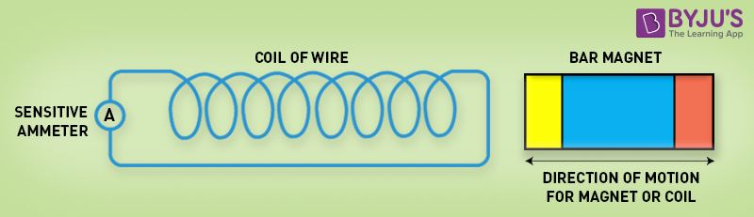

Mentioned here are a few ways to change the magnetic field intensity in a closed loop:

* By rotating the coil relative to the magnet.
* By moving the coil into or out of the magnetic field.
* By changing the area of a coil placed in the magnetic field.
* By moving a magnet towards or away from the coil.

## Faraday’s Second Law of Electromagnetic Induction

Faraday’s second law of electromagnetic induction states that

The induced emf in a coil is equal to the rate of change of flux linkage.

The flux linkage is the product of the number of turns in the coil and the flux associated with the coil. The formula of Faraday’s law is given below:

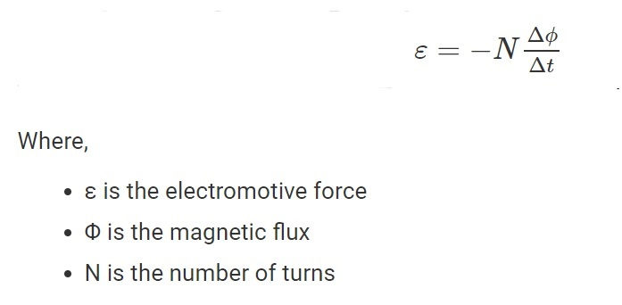

**Applications of Faraday’s Law**

Following are the fields where Faraday’s law finds applications:

1. Electrical equipment like transformers works on the basis of Faraday’s law.
2. Induction cooker works on the basis of mutual induction, which is based on the principle of Faraday’s law.
3. By inducing an electromotive force into an electromagnetic flowmeter, the velocity of the fluids is recorded.
4. Electric guitar and electric violin are musical instruments that find an application of Faraday’s law.
5. Maxwell’s equation is based on the converse of Faraday’s laws which states that a change in the magnetic field brings a change in the electric field.

**FLEMING'S RIGHT HAND RULE**

According to [Faraday’s law of electromagnetic induction](https://byjus.com/physics/faradays-law/), when a conductor moves through a magnetic field, an electric current is induced in it. Fleming’s right-hand rule is used to determine the direction of the induced current.

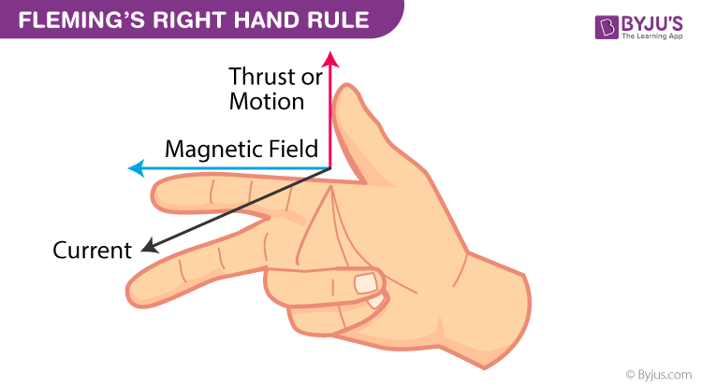

Fleming’s Right Hand Rule states that if we arrange our thumb, forefinger and middle finger of the right-hand perpendicular to each other, then the thumb points towards the direction of the motion of the conductor relative to the magnetic field, the forefinger points towards the direction of the magnetic field and the middle finger points towards the direction of the induced current.

## Fleming’s Left-Hand Rule?

When a current-carrying conductor is placed in an external magnetic field, the conductor experiences a force perpendicular to both the field and the current flow’s direction. Fleming’s left-hand rule is used to find the direction of the force acting on the current carrying conductor placed in a magnetic field.

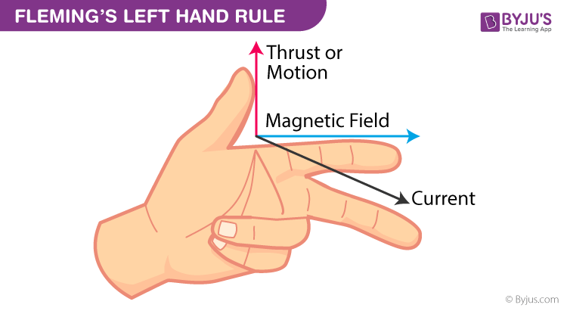

Fleming’s Left Hand Rule states that if we arrange our thumb, forefinger and middle finger of the left-hand perpendicular to each other, then the thumb points towards the direction of the force experienced by the conductor, the forefinger points towards the direction of the magnetic field and the middle finger points towards the direction of the electric current.

**LENZ LAW – Emil Lenz**

Lenz’s law depends on the principle of conservation of energy and [Newton’s third law](https://byjus.com/physics/newtons-third-law-of-motion-the-action-reaction-pair/).

The induced electromotive force with different polarities induces a current whose magnetic field opposes the change in magnetic flux through the loop in order to ensure that the original flux is maintained through the loop when current flows in it.

**Lenz’s Law Applications**

Lenz’s law applications are plenty. Some of them are listed below-

* Eddy current balances
* Metal detectors
* Eddy current dynamometers
* Braking systems on train
* AC generators
* Card readers
* Microphones

## Induced EMF

When a magnetic flux linking a conductor or coil changes, an electromotive force (EMF) is induced in the conductor or coil, is known as induced EMF. Depending upon the way of bringing the change in magnetic flux, the induced EMF is of two types −

* Statically Induced EMF
* Dynamically Induced EMF

## Statically Induced EMF

When the conductor is stationary and the magnetic field is changing, the induced EMF in such a way is known as statically induced EMF (as in a transformer). It is so called because the EMF is induced in a conductor which is stationary.

The statically induced EMF can also be classified into two categories –

* Self-Induced EMF
* Mutually Induced EMF

## Self-Induced EMF

When an EMF is induced in the coil due to the change of its own magnetic flux linked with it is known as self-induced EMF.

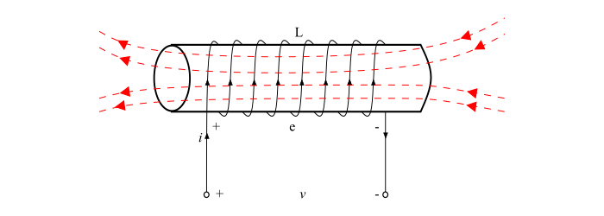

**Explanation** − When a current flows in a coil, a magnetic field produced by this current through the coil. If the current in the coil changes, then the magnetic field linking the coil also changes. Therefore, according to Faraday’s law of electromagnetic induction, an EMF being induced in the coil. The induced EMF in such a way is known as self-induced EMF.

## Mutually Induced EMF

When an EMF is induced in a coil due to changing magnetic flux of neighbouring coil is known as mutually induced EMF.

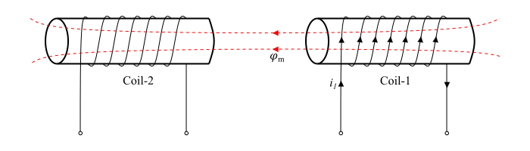

**Explanation** − Consider two coils coil-1 and coil-2 placed adjacent to each other (see the figure). A fraction of the magnetic flux produced by coil-1 links with the coil-2. This magnetic flux which is common to both the coils 1 and 2 is known as mutual flux (φm)(��). Now, if the current in coil-1 changes, the mutual flux also changes and thus EMF being induced in both the coils. The EMF induced in coil-2 is known as mutually induced EMF, since it is induced due changing in flux which is produced by coil-1.

## Dynamically Induced EMF

When the conductor is moved in a stationary magnetic field so that the magnetic flux linking with it changes in magnitude, as the conductor is subjected to a changing magnetic, therefore an EMF will be induced in it. The EMF induced in this way is known as dynamically induced EMF (as in a DC or AC generator). It is so called because EMF is induced in a conductor which is moving (dynamic).



**Differentiate Alternating Current and Direct Current**

|  |  |
| --- | --- |
| **Alternating Current** | **Direct Current** |
| AC is easy to be transferred over longer distances – even between two cities – without much energy loss. | DC cannot be transferred over a very long distance. It loses electric power. |
| The rotating magnets cause the change in direction of electric flow. | The steady magnetism makes DC flow in a single direction. |
| The frequency of AC is dependent upon the country. But, generally, the frequency is 50 Hz or 60 Hz. | DC has no frequency or zero frequency. |
| In AC the flow of current changes its direction forward and backward periodically. | It flows in a single direction steadily. |
| Electrons in AC keep changing their directions – backward and forward. | Electrons only move in one direction – forward. |

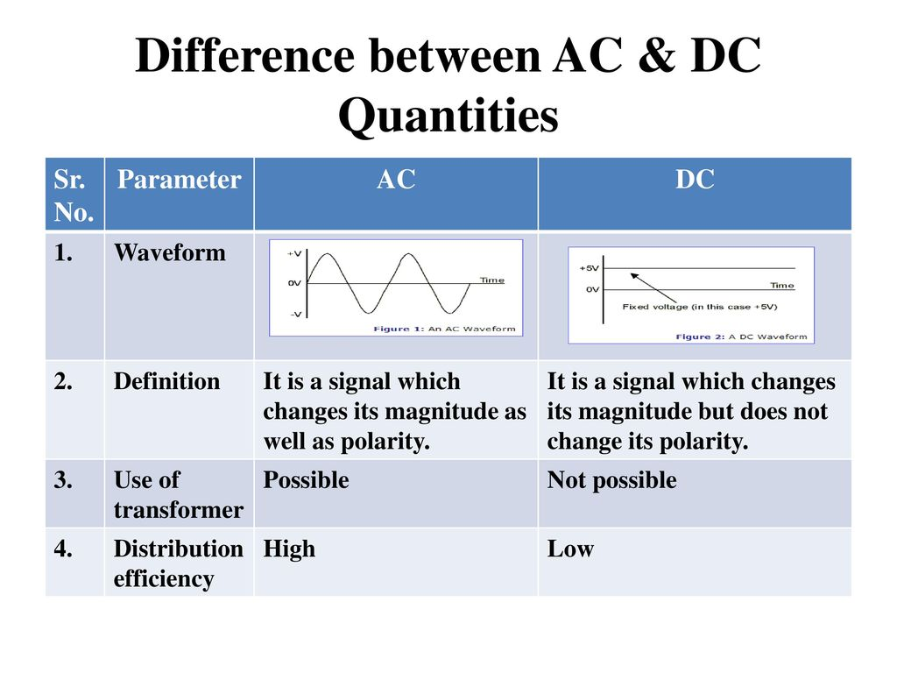

### What are the advantages of AC over DC?

Following are the advantages of alternating current over direct current:

* AC is less expensive and easy to generate than DC.
* AC can be transmitted across long distances without much energy loss, unlike DC.
* The power loss during transmission in AC is less when compared to DC.

**PARAMETERS OF SINGLE PHASE AC SINUSOIDAL WAVEFORM**