Ad Campaign Analysis (A/B Testing)
1. Project Overview
This project's objective is to determine which advertising plan is most effective in bringing in money for XYZ Company's digital product.
2. Data Summery
- Rows: 365
- Columns: 9
- Key Features:
- Advertisement Demographics ('Date', 'Facebook Ad Views', 'Facebook Ad Clicks',
'Facebook Ad Conversions', 'Facebook Ad Cost Per Day',
'Instagram Ad Views', 'Instagram Ad Clicks', 'Instagram Ad Conversions',
'Instagram Ad Cost Per Day')
3. Exploratory Data Analysis using Python
We began with data preparation and cleaning in python:
- Data Loading: Imported the data set using pandas (This data set is created by ChatGPT as per requirement).
- Initial Exploration: Used df.info() to check structure and .describe() for summary statistics.
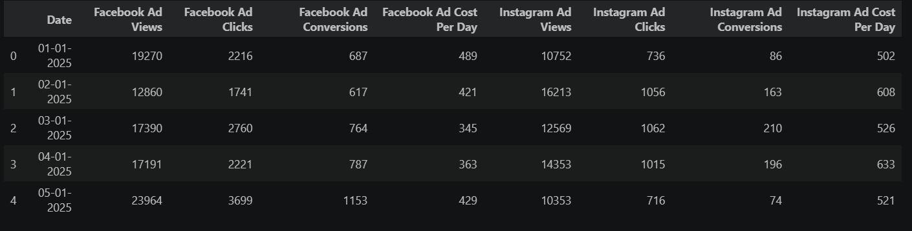
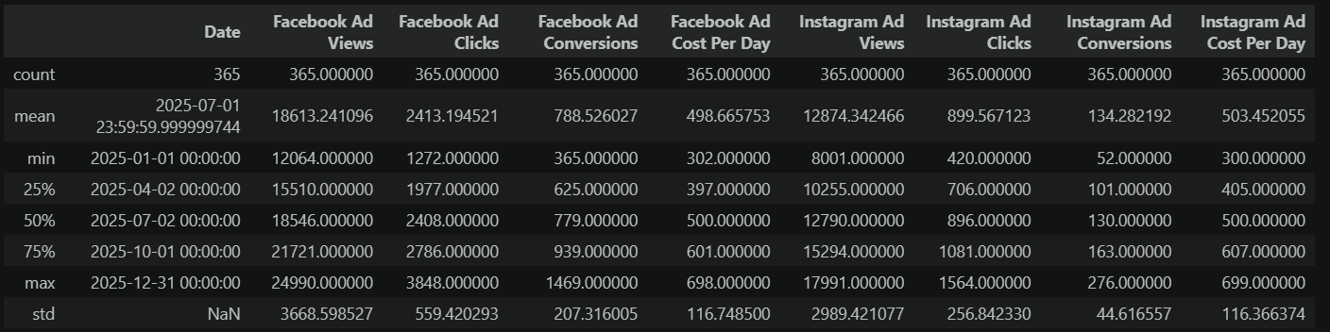
- Missing Data Handling: Checked for null values but found nothing.
- Column Standardization: Rename columns to snake case for better readability and documentation.
- Feature Engineering:
- Created 'Facebook Conversion Category' and 'Instagram Conversion Category'
Column by No of Conversions Per Day.

4. Data Analysis Done by Python

Verifying the relationship between Facebook ad clicks and conversions
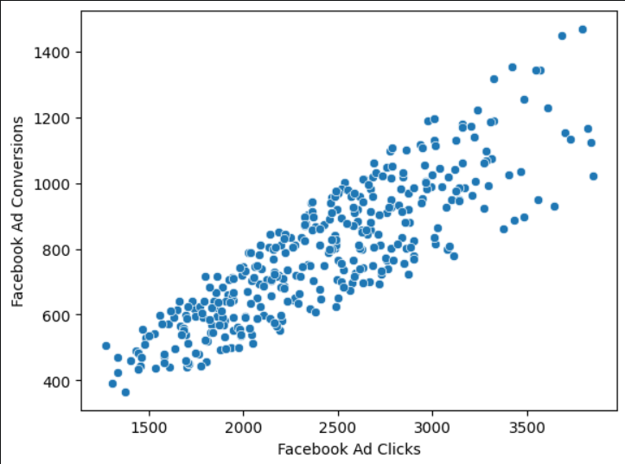
They have a positive correlation of 0.86. It is a really powerful association.

Verifying the relationship between Instagram ad clicks and conversions

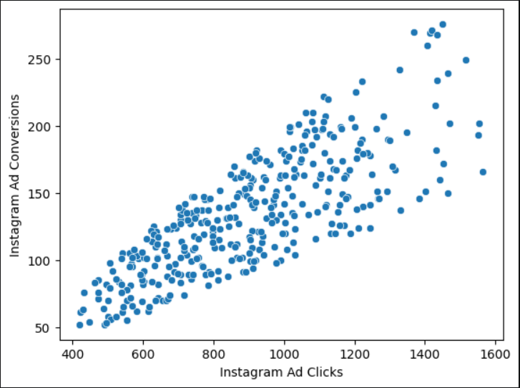
They have a positive correlation of 0.79. It is a really powerful association.
As a result, we discovered that Facebook outperforms Instagram.

To examine the distribution of clicks and conversions for both add campaigns, we are creating a histplot. To determine whether we can visually recognize certain patterns
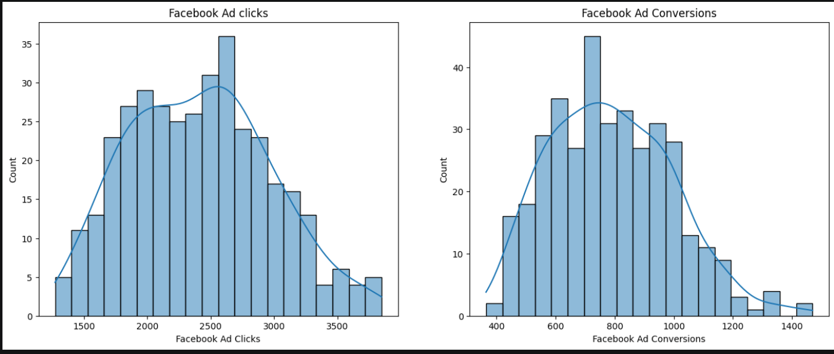

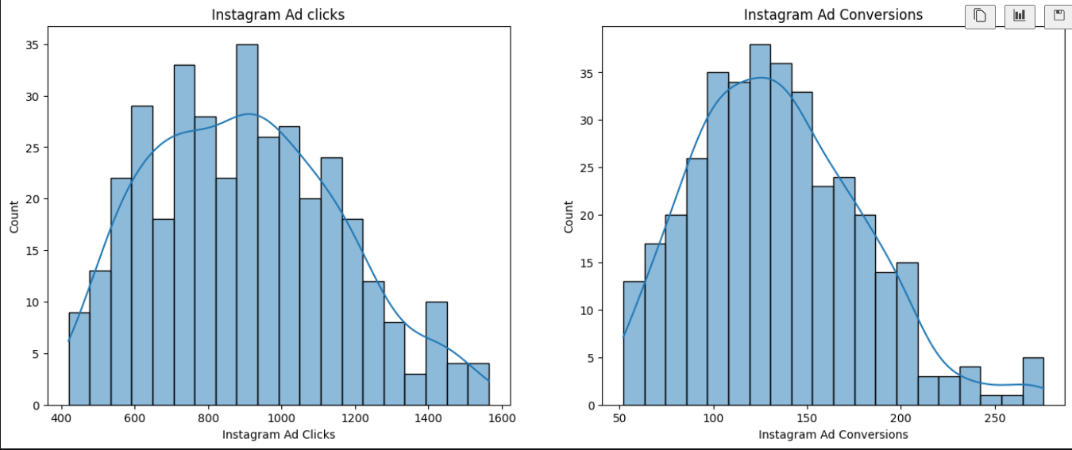
We are unable to draw a conclusion from observing their distributions.

Establishing new conversion category columns Every day, we will count the number of conversions and categorize them.
I divide them into four categories: fewer than 200, 200–400, 400–600, and more than 600.
Facebook categories have been counted.
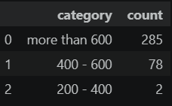
Instagram Categories count.
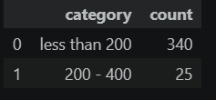
Now merging both categories
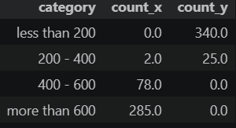
Comparing the two campaigns visually
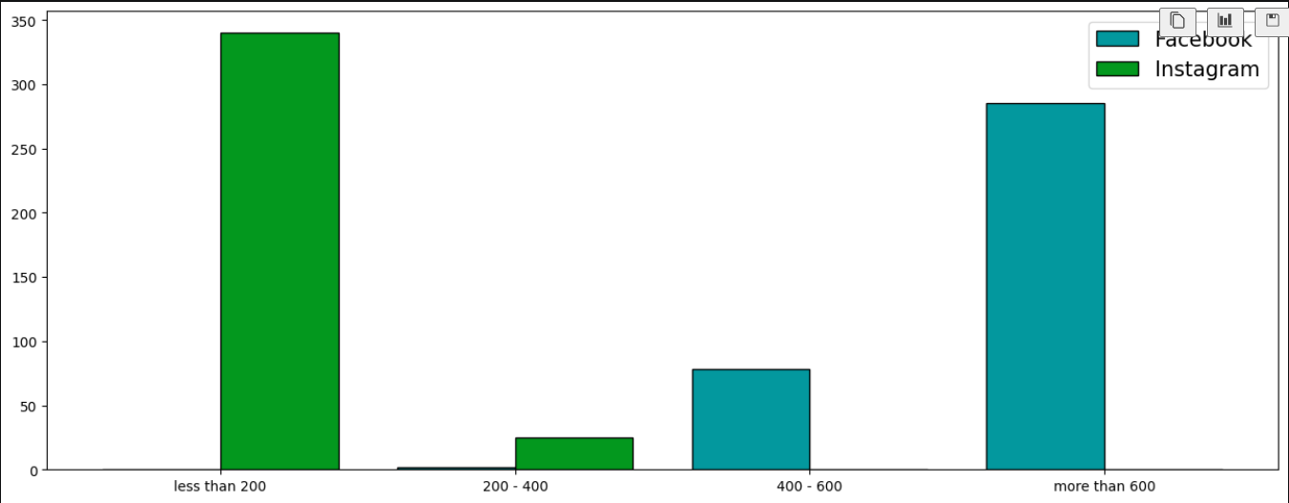
Visual comparisons allow us to determine that Facebook often generates more conversions.
Facebook hence performs better here as well.

5. Main Focus
T-test execution for deeper comprehension
Null hypothesis (H₀): The average Facebook and Instagram conversions are equal.
Alternative hypothesis (H₁): The average Facebook and Instagram conversions are different.

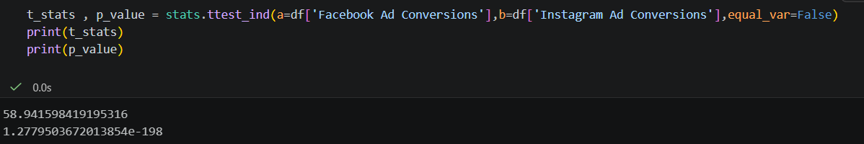

The t-statistic (58.94) is extremely large and positive, indicating that the Facebook mean is much higher than the Instagram mean.
The p-value (1.28 × 10⁻¹⁹⁸) is far smaller than the significance level of 0.05.

6 . Conclusions
The Facebook mean is significantly higher than the Instagram mean, according to the t-statistic (58.94), which is incredibly enormous and positive. Let's investigate.
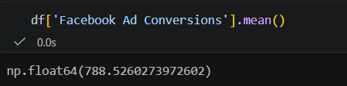

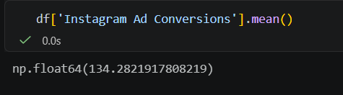

Instagram advertisements produced an average of 134.28 conversions, whereas Facebook ads produced an average of 788.53 conversions.
The null hypothesis (H₀) is rejected.
The average conversions produced by Facebook and Instagram ads differ statistically significantly.
Compared to Instagram advertisements (Mean = 134.28), Facebook ads had a far better average conversion rate (Mean = 788.53).
The Welch's t-test for independent samples yielded t = 58.94 and p = 1.28 × 10⁻¹⋅¹, indicating that the observed difference is highly improbable to have happened by chance.
According to all of the aforementioned proofs, the difference is genuine. In this sample, Facebook outperformed Instagram by a large margin.

