Day 1:

1. MVC vs MVT
2. working of request - response
   1. request -> url cheking -> views(code/business logic) -> response
3. creating project
   1. create project and open in vs code

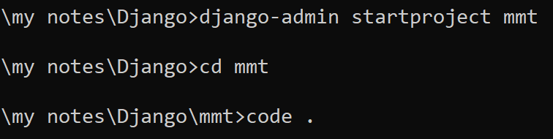

* 1. open terminal of vs code and create application(s)

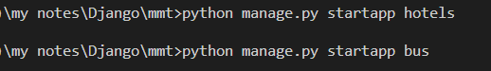

* 1. register applications in settings.py (project level)

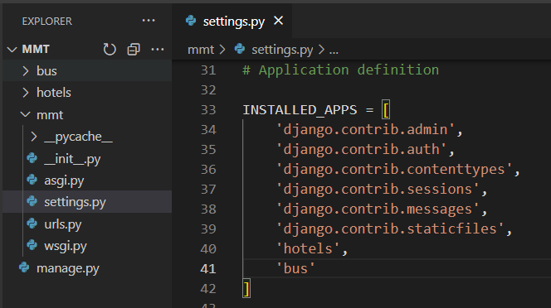

* 1. create at least one view in each application

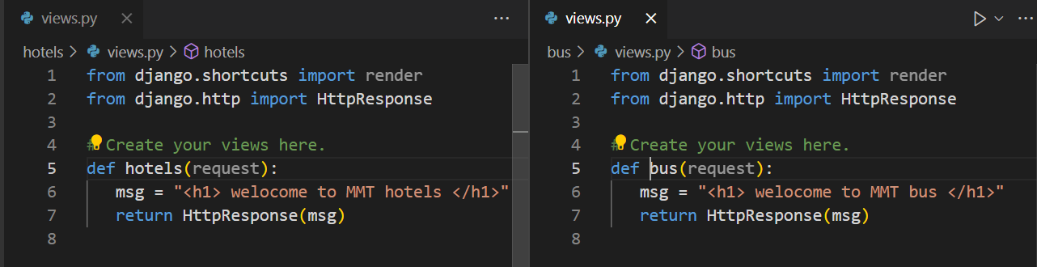

* 1. create url for views

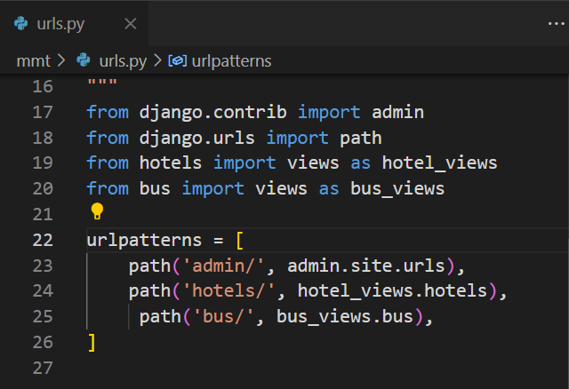

* 1. runserver
     1. python manage.py runserver

1. creating urls at application level
   1. create hotel_urls.py file in hotel and bus_urls.py file in bus application
      1. 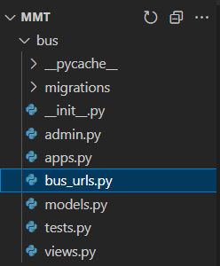 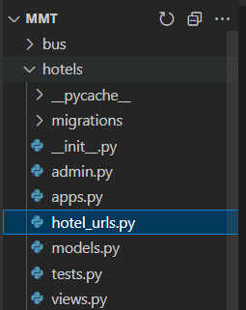
   2. Code for both file
      1. 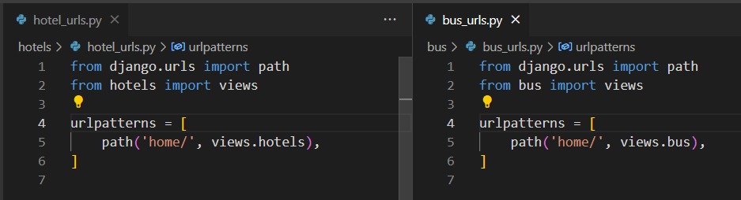
   3. Include app level urls to project level
      1. 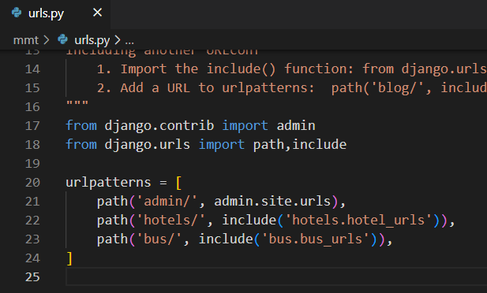
2. Creating templates
   1. Create templates folder at root level (project level)
      1. 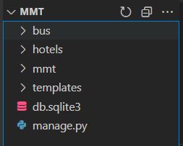
   2. Register templates folder in settings.py
      1. 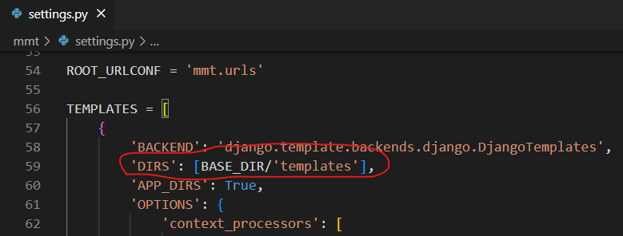
   3. Create hotels and bus folders in templates folder
      1. 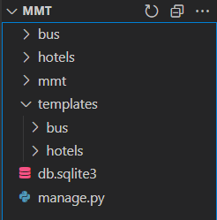
   4. Create index.html in hotels folder and index.html in bus folder
      1. 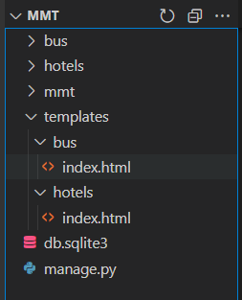
   5. Code for both index.html

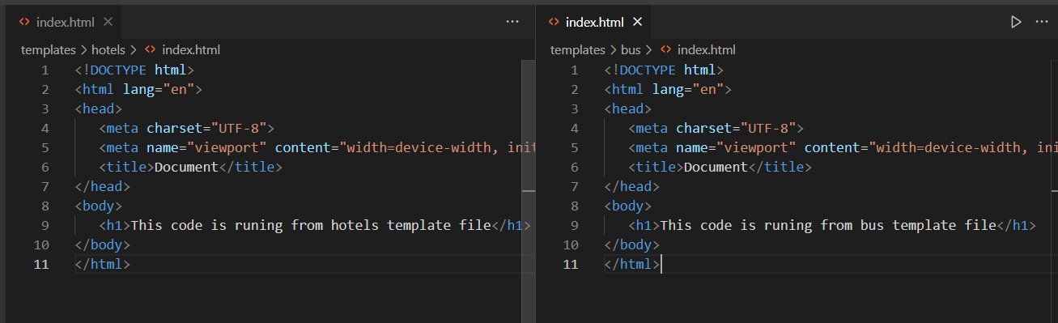

* 1. Change code for views

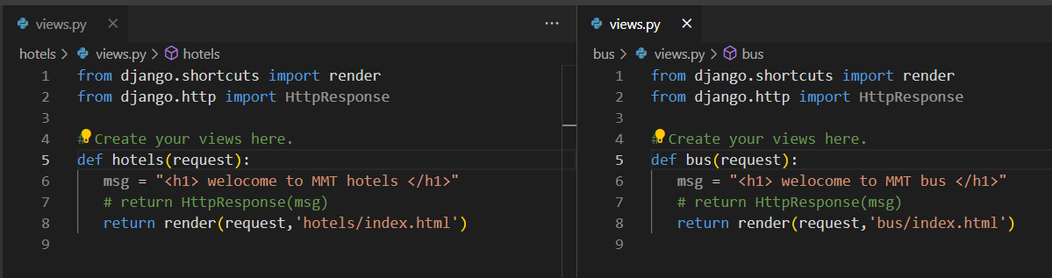

* 1. Restart server
  2. Check output

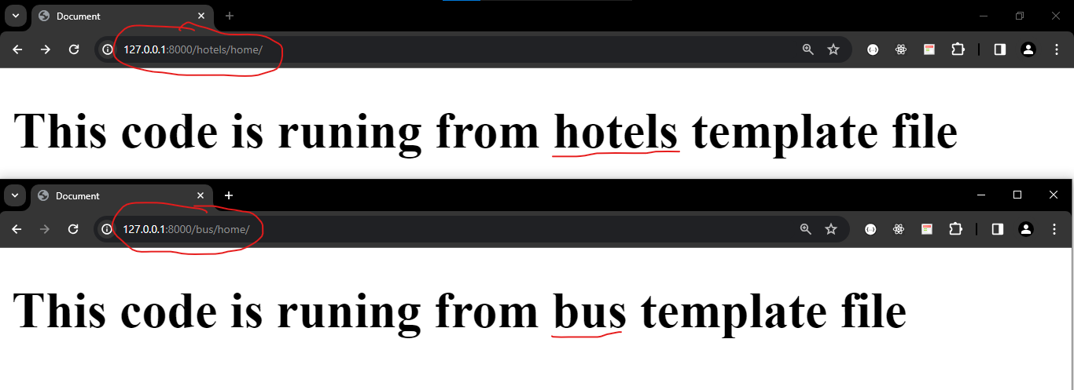

1. Working with static files
   1. Use to store images, videos, audios, css, js etc
   2. Create “static” folder at project level
      1. Create images and css folder in it. Add some image in images folder

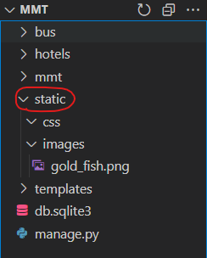

* 1. Configuring static folder in settings.py

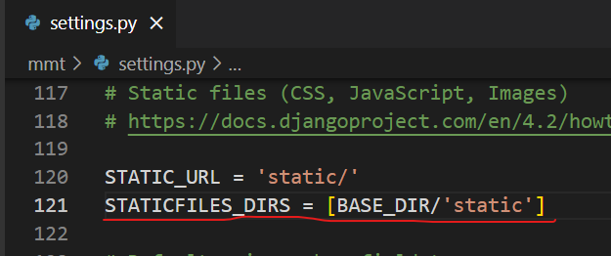

* 1. Restart server and type following url in browser

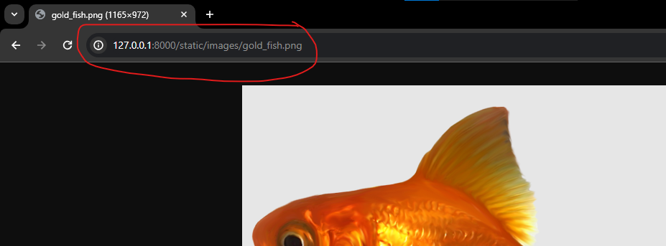

* 1. Displaying above image in index.html of hotels

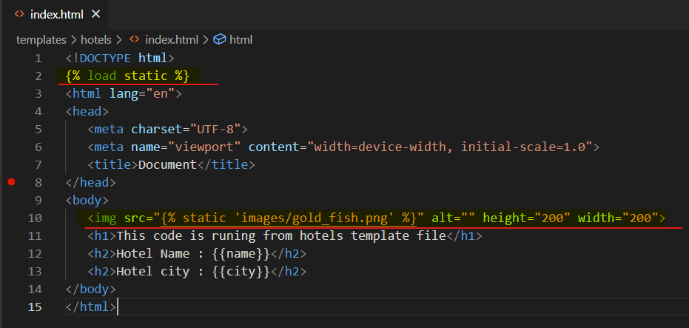

* 1. Create hotel_css.css file in css folder

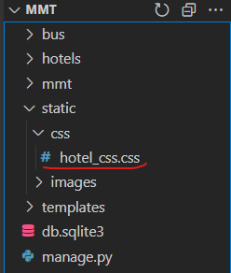

* 1. Add some code in it

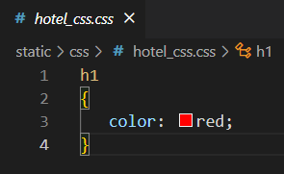

* 1. Use this css file in index.html of hotels

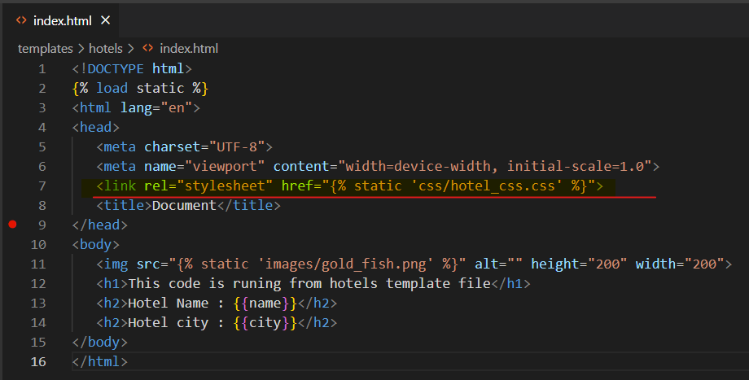

* 1. Run server and check final output

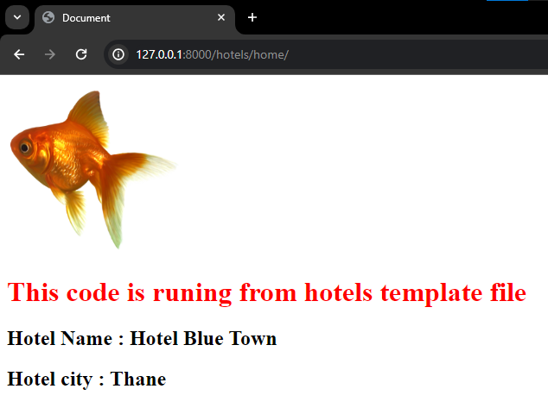

1. DONE !!!!!!!!!!!!!!
2. Sending data from view to template
   1. We have to send data in dictionary format as context
      1. In views.py of hotels

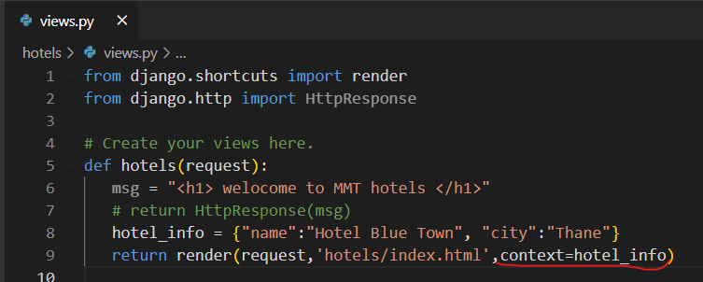

* + 1. Collect data in index.py of hotels

