1. Why there is callback function in js
2. Example of callback function

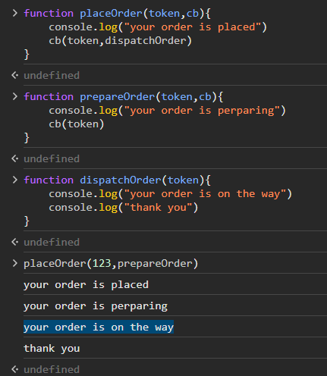

1. REPL functionality of JS

> Math.random() => Read and Evaluate

> 0.979437508321547 =>Print

> => Loop

1. Study Promises in JS
2. Install node LTS
3. Saving terminal code into files using node

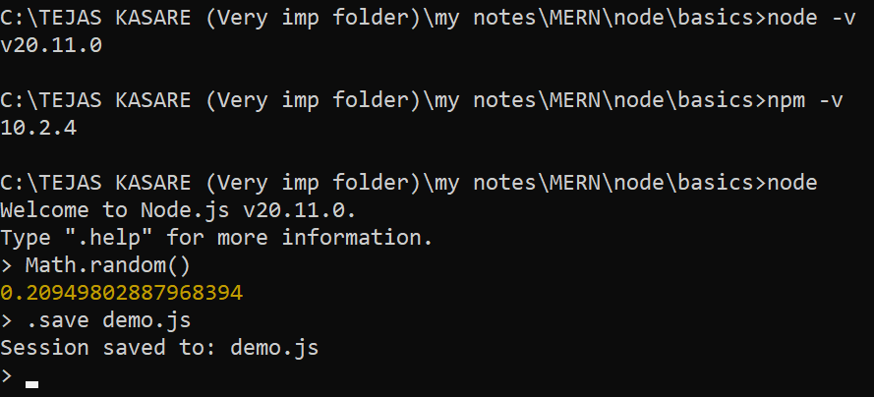

1. Lading same file

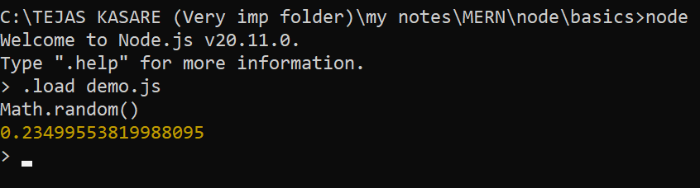

1. Creating simple js file and executing it via node

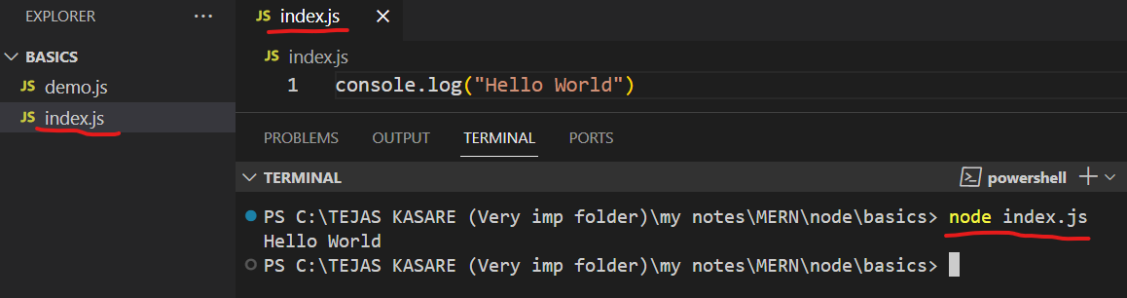

1. Creating server using node

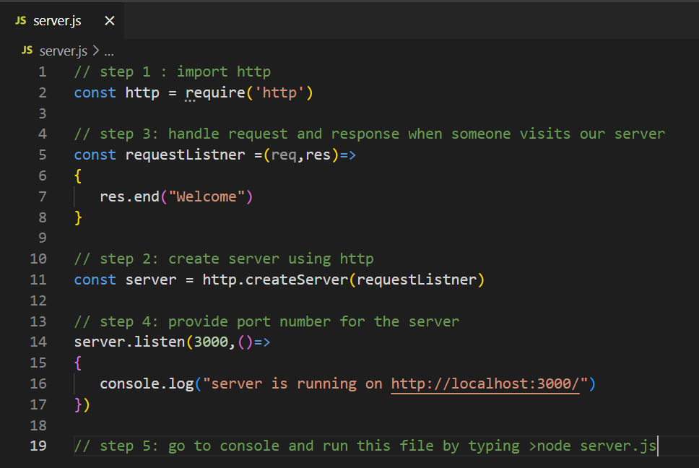

1. Storing and accesing environmental variable

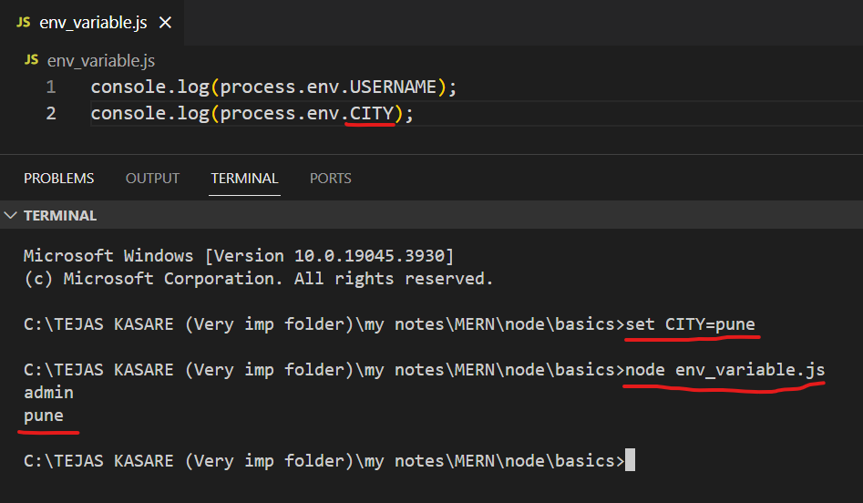

*VIMP : open cmd not powershell in VS code*

1. Setting port number dynamically from environmental variable

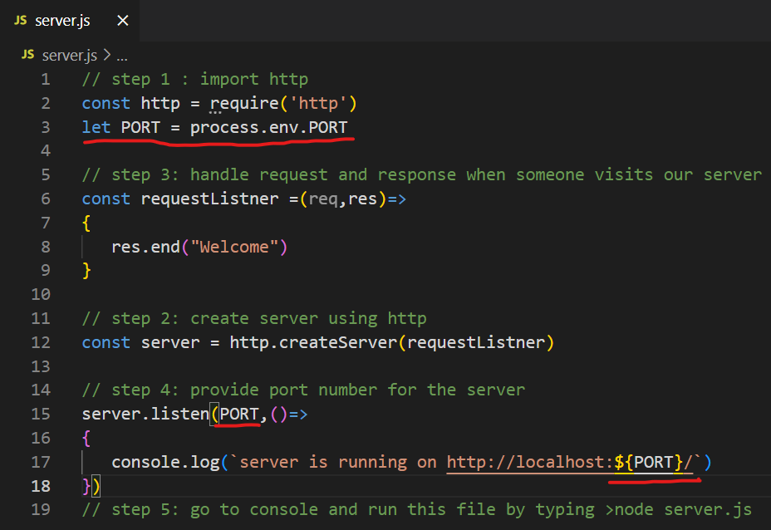

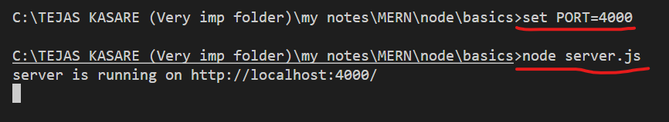

1. Checking npm version and installing packages
   1. Package : any js file or a folder that consist of js file(s) is called as package
   2. > npm –v
   3. > npm i package_name =>install package locally (only for selected application)
   4. > npm i –g package_name => install package globally
   5. > npm i –D package_name => install for development only (not for production)
2. Package.json
   1. Let we have installed express package by > npm i express

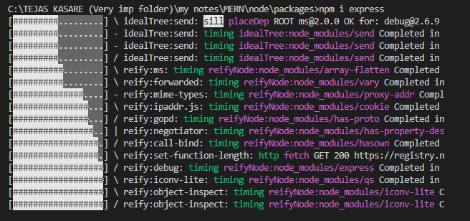

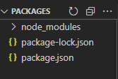

* 1. When we install any package using npm command, it will automatically generates package.json file which has registration of that package. Ex express

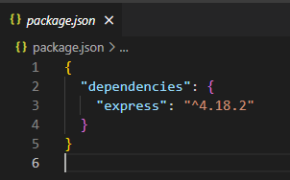

* 1. Package-lock.json => consist of sub dependencies of package installed in above command

1. Importance package.json
   1. Delete node_modules folder and go to terminal and execute
      1. > npm i
   2. By doing this, npm will go through our package.json file and install all required packages mentioned in package.json file
2. Creating package.json manually

Delete (node_modules, package.json, package-lock.json) from current folder

Open terminal and type

> npm i

After this, provide answer to all qustions

Done

If you don’t want to go through all above question, then just execute

> npm i --yes

1. Making production ready build
   1. > npm i –production
   2. By doing this, all develeopement related packages will not get added in node_modules folder
   3. develeopement related packages means the packages that we installed with

npm i –D package_name

ex : npm i –D nodemon

1. argument keyword
   1. open browser console and execute :

First :

function sum(){

console.log(arguments)

}

sum(10,20,30)

* you will get output for arguments

Later :

console.log(arguments)

* you will get error
* Conclusion : in browser, arguments keyword only work inside function.

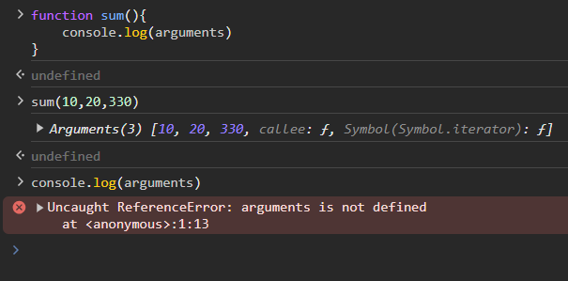

* 1. Create folder -> argu

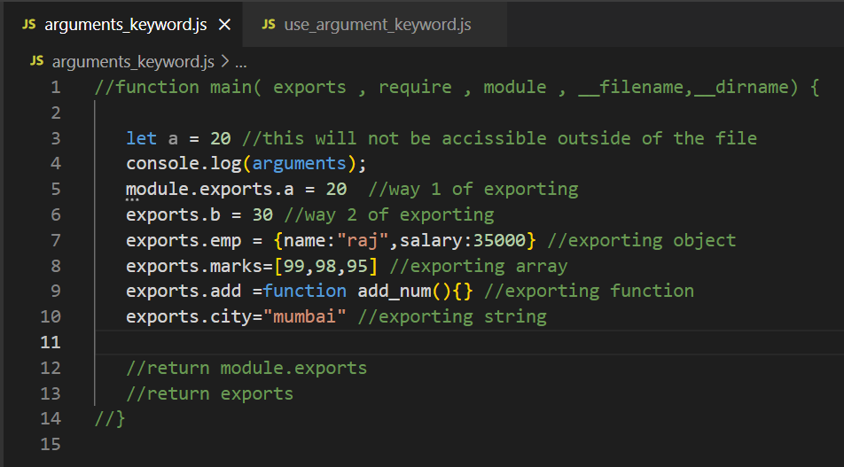

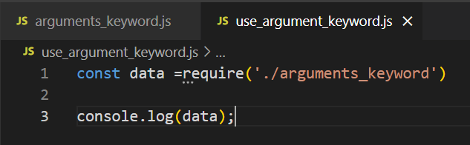

RUN :

>node arguments_keyword.js

> node use_argument_keyword.js

1. Concurrency :

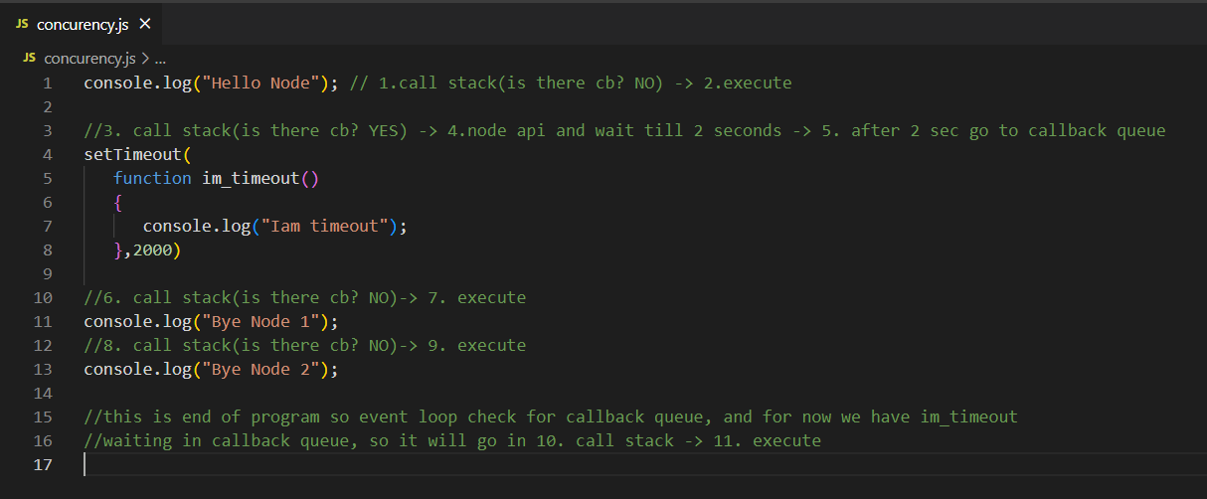

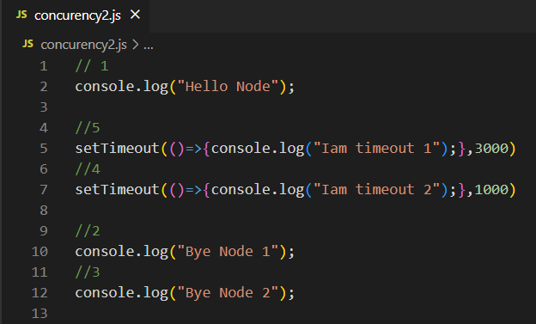

1. Exception handling
   1. Exception handling in synchronous way – using readFileSync() function
   2. Create 2 files in current folder – city.txt (add some city names) and names.txt (add some names)

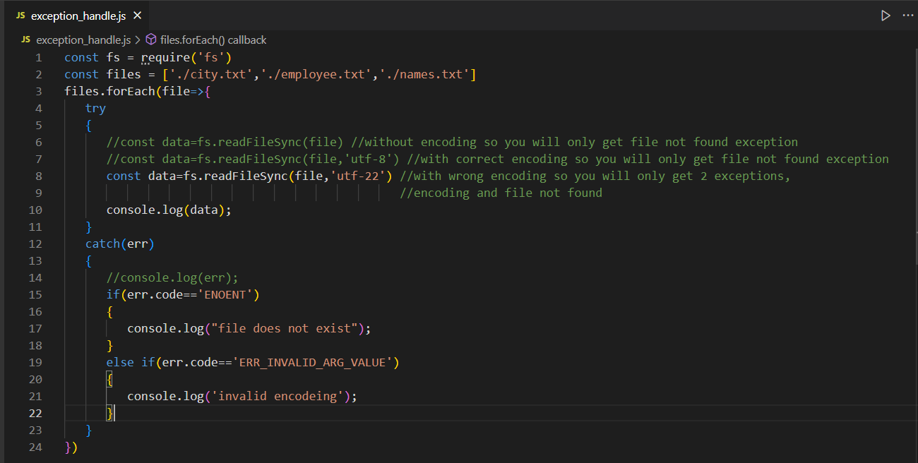

* 1. Exception handling in Async way
     1. There are 2 ways in which we can handle exception in async way – using callback function or using promise (async-await pattern)
     2. Exception handling in Async way using callback function

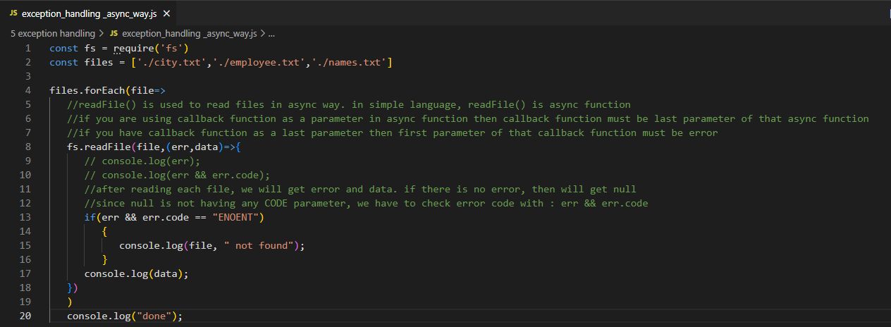

1. Exception handling in Async way using promise (async-await)

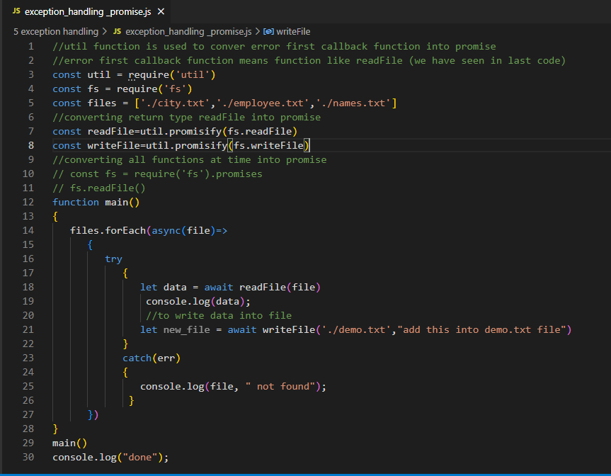

1. Event Emitter:
   1. Import events
   2. Create object of EventEmmiter class present inside events package
   3. Use this EventEmmiter class’s object and capture event (subscribe to event)
   4. Finally create event
   5. We can’t create event before capturing event (ex – throwing a ball and expecting fielders to catch the ball, if there are no fielders then who will catch (capture) the ball )
   6. Simple event capturing

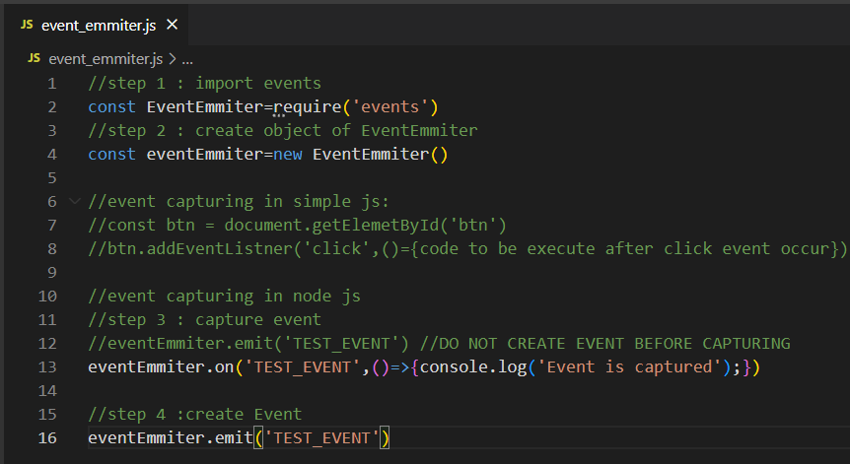

* 1. Capturing event before creating (use callback)

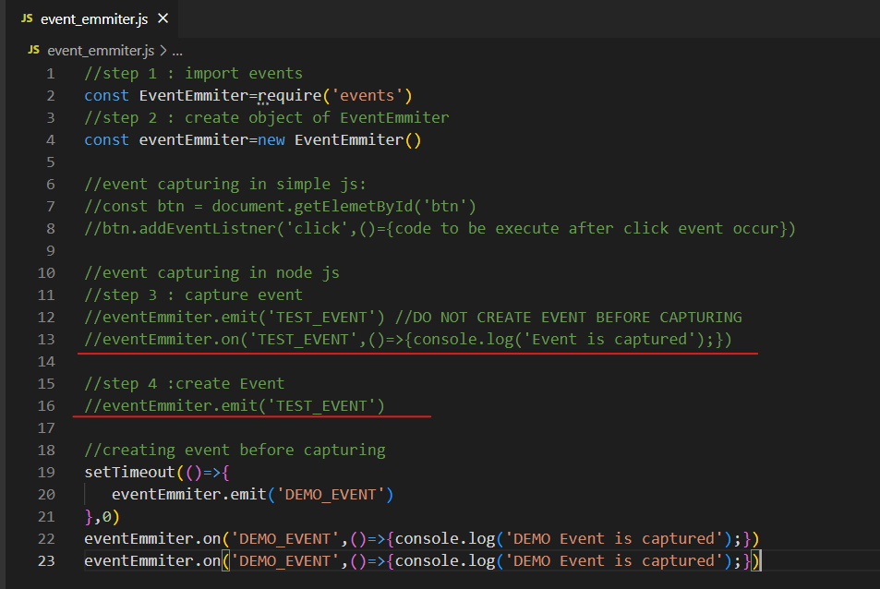

* 1. Capturing event in different file
     1. Export eventEmmiter from event_emmiter.js

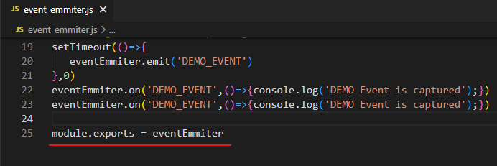

* + 1. Create new file (use_ event_emmiter.js) and import eventEmmiter exported from event_emmiter.js and Capture event in use_ event_emmiter.js

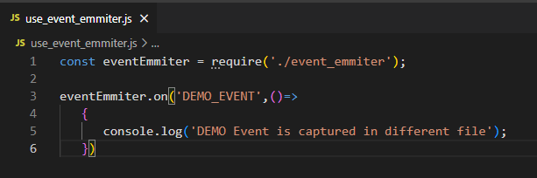

* + 1. Run use_ event_emmiter.js (>node use_ event_emmiter.js)

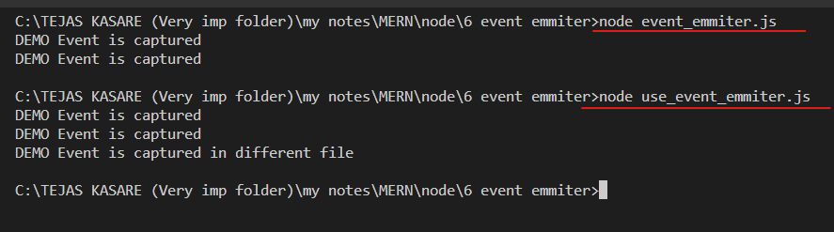

* 1. Passing data in events
     1. It is not compulsion on capturing data sent by eventEmmiter
     2. Capturing data sent by eventEmitter in same file

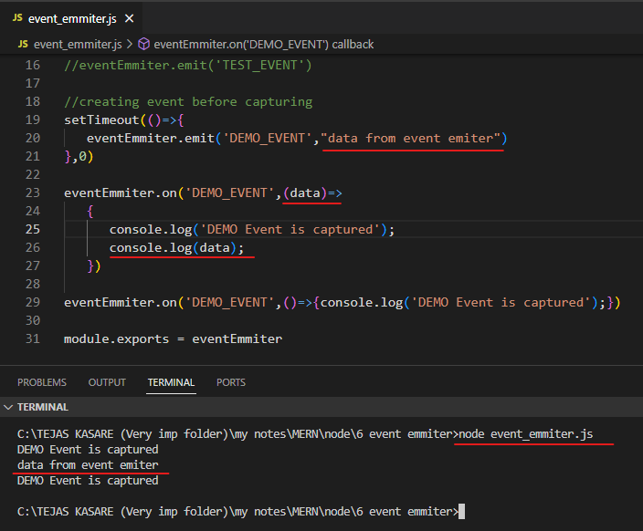

* + 1. Capturing data sent by eventeEmmiter in different file

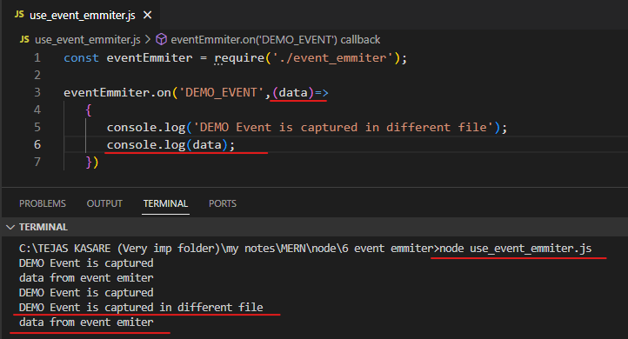

1. EXPRESS :