1. Install redux (3 packages at time)

npm i @reduxjs/toolkit react-redux redux

1. Create store.js in src and configure store in it

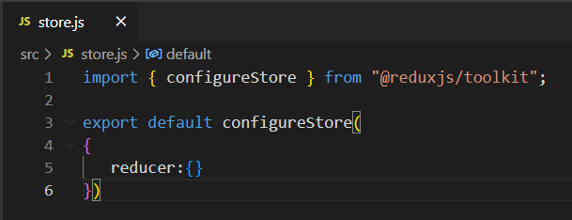

1. Wrap this store around <App>