Name: Tejas Sambhaji Kumbhar | Roll No : 205223015 | M.Tech Data Analytics

PROBLEM STATEMENT

# **OPTIMIZING ENERGY EFFICIENCY**

|  |  |
| --- | --- |
|  |  |

In recent years, energy consumption and resource utilization within our engineering college have been on the rise. This increase not only poses financial challenges but also has significant environmental implications.

It is essential to address this issue by developing a comprehensive energy efficiency management system to reduce energy consumption, minimize resource wastage, and enhance the sustainability of our institution.

**Complete Database Schema**

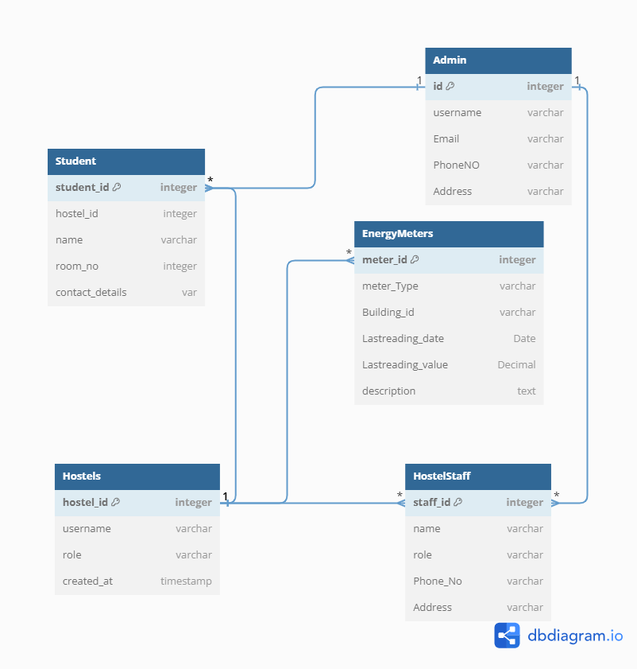

**ER Diagram**

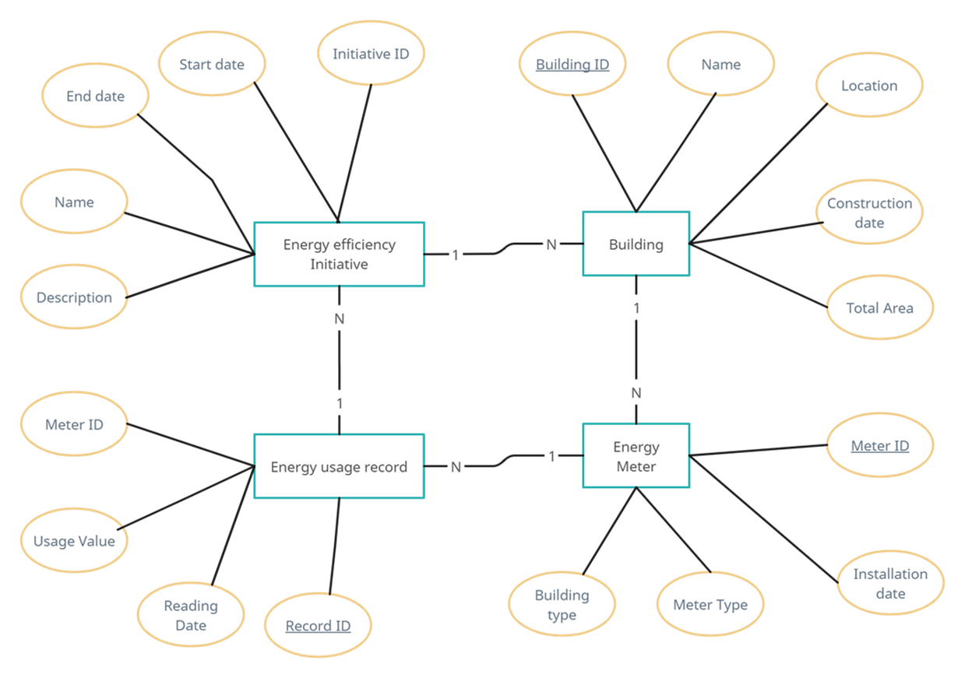

**List of Stakeholders**

* Hostel Administrator
* Hostel Staff
* Students

**Schema for Individual stakeholder and their views**

1. Administrator schema



1. Hostel Staff

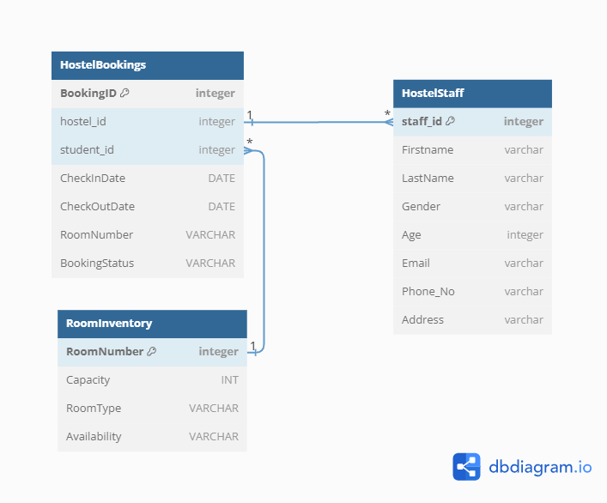

1. Student Schema

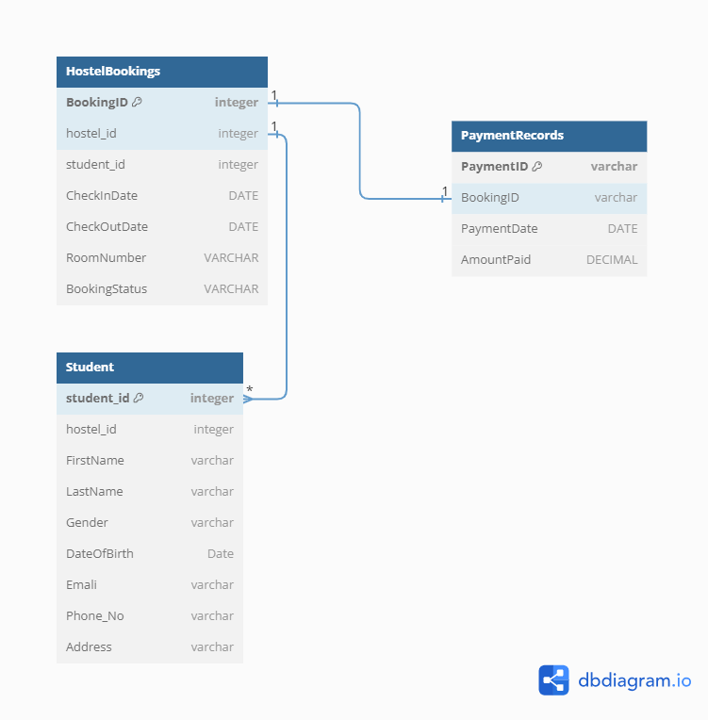

**Views Of Individual Stakeholders**

1. Student View
   * Room Booking and Reservation:
     + Students can view room options that are not only based on their preferences but also on energy efficiency ratings. Rooms with better energy ratings may be highlighted.
     + Provide information on energy-efficient practices in the hostel (e.g., turning off lights and appliances when not in use).
   * Room Assignment and Details:
     + Include energy consumption details for each room, such as average electricity and water usage per month.
     + Provide tips on how to conserve energy within the room.
   * Billing and Payments:
     + Display energy charges separately in the invoice to create awareness of individual energy consumption.
     + Offer incentives or discounts for students who maintain low energy consumption.
   * Room Information:
     + Show real-time energy usage data for the student's assigned room, encouraging responsible energy consumption.
     + Include information on sustainable practices within the hostel, such as waste recycling and water-saving measures.
   * Notifications and Updates:
     + Send periodic energy-saving tips and reminders to students.
     + Notify students about any energy-saving initiatives or competitions within the hostel.
   * Profile Management:
     + Allow students to set their energy-saving preferences, such as temperature settings for HVAC systems.
     + Provide a dashboard with energy consumption statistics for their room.
2. Administrator View

Administrators have comprehensive control over the hostel management system and oversee all aspects of its operations. Their view includes functionalities related to system management and monitoring:

* User Management:
  + Admins can assign energy efficiency roles to students and hostel staff responsible for monitoring and promoting sustainable practices.
  + Manage energy-related alerts and notifications.
* Room Allocation and Management:
  + Display energy efficiency ratings for each room to aid in room allocation decisions.
  + Monitor and analyze energy consumption trends for different rooms and buildings.
* Financial Management:
  + Generate reports on energy-related expenses and revenue.
  + Implement energy-efficient billing practices, such as tiered pricing based on consumption.
* Maintenance and Facilities:
  + Track maintenance requests related to energy-saving equipment (e.g., HVAC, lighting).
  + Schedule regular energy audits and maintenance for energy-efficient systems.
* Security and Access Control:
  + Monitor access to energy-intensive areas (e.g., utility rooms).
  + Implement access controls to limit access to energy-consuming equipment.
* Communication:
  + Communicate energy-saving initiatives and achievements to students and staff.
  + Send alerts about any anomalies or excessive energy consumption.

1. Hostel Staff View
   * Room Allocation and Check-In/Check-Out:
     + Assign rooms with energy efficiency ratings in mind.
     + Educate students during check-in about energy-saving practices within the hostel.
   * Maintenance and Housekeeping:
     + Prioritize maintenance tasks related to energy-efficient equipment.
     + Train staff to identify and report energy wastage.
   * Security and Access Control:
     + Monitor energy-related access points and ensure security.
     + Report any unauthorized or unusual energy consumption patterns.
   * Communication:
     + Communicate energy-saving procedures and guidelines to students.
     + Promptly address energy-related inquiries and concerns.

**Database type used and their view**

We can consider using a NoSQL database, i.e Document database MongoDB, a popular document-based NoSQL database, would be a suitable choice.

Student View with MongoDB:

* Room Booking and Reservation:
  + Students can search for available rooms based on preferences, including energy efficiency ratings.
  + They can view room details, including energy-saving amenities and practices within each room.

Billing and Payments:

* Energy charges are included in the invoice and displayed separately for transparency.
* Students can view their energy consumption history and costs.

Administrator View with MongoDB:

* User Management:
  + Administrators can manage user accounts and assign energy efficiency roles to students and staff.
  + They have access to energy-related alerts and notifications settings.
* Financial Management:
  + Reports on energy-related expenses and revenue are generated and stored in MongoDB.
  + Energy-efficient billing practices, such as tiered pricing based on consumption, can be implemented and tracked.
* Maintenance and Facilities:
  + Maintenance requests related to energy-saving equipment are tracked in MongoDB.
  + Energy audit reports and maintenance schedules are stored for reference.
* Security and Access Control:
  + MongoDB helps manage access to energy-intensive areas, with access controls and logs.
  + Security logs and access data are stored securely.
* Communication:
  + Energy-saving initiatives and achievements are communicated to students and staff through MongoDB.
  + Alerts about anomalies or excessive energy consumption are tracked and sent through the system

Hostel Staff View with MongoDB:

* Room Allocation and Check-In/Check-Out:
  + Staff members assign rooms with energy efficiency ratings in mind and keep records in MongoDB.
  + During check-in, staff educate students about energy-saving practices.
* Maintenance and Housekeeping:
  + Maintenance tasks related to energy-efficient equipment are tracked in MongoDB.
  + Staff members are trained to identify and report energy wastage issues within the hostel.

MongoDB's flexible document-based data model and support for complex data structures make it a suitable choice for a hostel management system with a focus on energy efficiency. It can handle various data types and structures, making it adaptable to the diverse information and requirements of such a system.

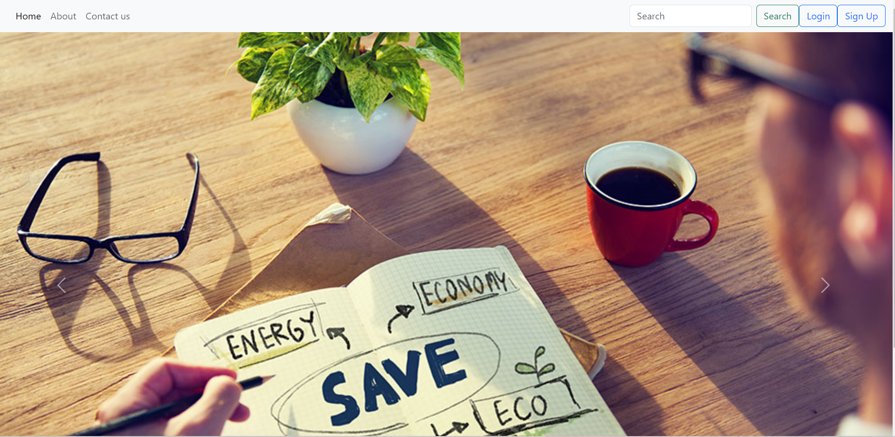**Screenshots of Frontend:**

