**Industrial Internship Report on**

**”Banking Information System”**

**Prepared by**

**Tejas Kuwar**

|  |
| --- |
| *Executive Summary* |
| This report provides details of the Industrial Internship provided by upskill Campus and The IoT Academy in collaboration with Industrial Partner UniConverge Technologies Pvt Ltd (UCT).  This internship was focused on a project/problem statement provided by UCT. We had to finish the project including the report in 6 weeks’ time.  During internship as a Core Java Developer, I developed a prototype of a **Banking Information System** to simulate key functionalities of a real-world banking system. The project provided hands-on experience with Java programming and software development principles. The primary goal of the internship was to design, implement, and test a functional prototype while adhering to industry best practices.  The Banking Information System includes essential banking operations such as user registration, account management, secure login, deposit and withdrawal, fund transfers, and transaction history. This internship enhanced my technical skills, problem-solving abilities, and software development expertise.  This internship gave me a very good opportunity to get exposure to Industrial problems and design/implement solution for that. It was an overall great experience to have this internship. |

**TABLE OF CONTENTS**

1 Preface 3

2 Introduction 4

2.1 About UniConverge Technologies Pvt Ltd 4

2.2 About upskill Campus 9

2.3 Objective 10

2.4 Reference 11

2.5 Glossary **Error! Bookmark not defined.**

3 Problem Statement 12

4 Existing and Proposed solution 13

5 Proposed Design/ Model 14

5.1 High Level Diagram (if applicable) **Error! Bookmark not defined.**

5.2 Low Level Diagram (if applicable) **Error! Bookmark not defined.**

5.3 Interfaces (if applicable) **Error! Bookmark not defined.**

6 Performance Test 14

6.1 Test Plan/ Test Cases **Error! Bookmark not defined.**

6.2 Test Procedure **Error! Bookmark not defined.**

6.3 Performance Outcome **Error! Bookmark not defined.**

7 My learnings 15

8 Future work scope 17

# Preface

This report is submitted as part of the internship program at UCT, where I worked on developing a Banking Information System prototype. The purpose of this document is to provide a comprehensive overview of the project, including its objectives, design, implementation, and outcomes. The internship offered valuable insights into practical software development processes, enhancing my technical and problem-solving skills.

I would like to extend my heartfelt thanks to UCT for providing this internship opportunity and to my mentors for their valuable guidance and support throughout the project. Their encouragement and feedback were instrumental in completing this project successfully.

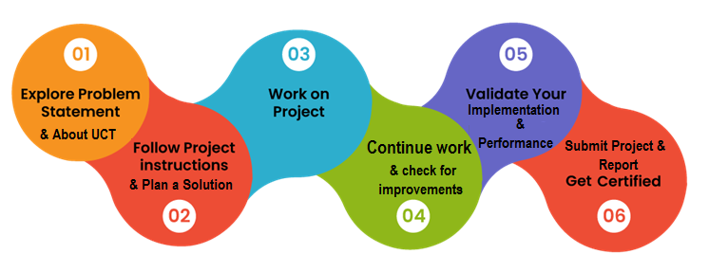

# Introduction

## About UniConverge Technologies Pvt Ltd

A company established in 2013 and working in Digital Transformation domain and providing Industrial solutions with prime focus on sustainability and RoI.

For developing its products and solutions it is leveraging various**Cutting Edge Technologies e.g. Internet of Things (IoT), Cyber Security, Cloud computing (AWS, Azure), Machine Learning, Communication Technologies (4G/5G/LoRaWAN), Java Full Stack, Python, Front end**etc.



1. UCT IoT Platform **(****)**

**UCT Insight** is an IOT platform designed for quick deployment of IOT applications on the same time providing valuable “insight” for your process/business. It has been built in Java for backend and ReactJS for Front end. It has support for MySQL and various NoSql Databases.

* It enables device connectivity via industry standard IoT protocols - MQTT, CoAP, HTTP, Modbus TCP, OPC UA
* It supports both cloud and on-premises deployments.

It has features to  
• Build Your own dashboard  
• Analytics and Reporting  
• Alert and Notification  
• Integration with third party application(Power BI, SAP, ERP)  
• Rule Engine

 

1. **Smart Factory Platform (****)**

Factory watch is a platform for smart factory needs.

It provides Users/ Factory

* with a scalable solution for their Production and asset monitoring
* OEE and predictive maintenance solution scaling up to digital twin for your assets.
* to unleased the true potential of the data that their machines are generating and helps to identify the KPIs and also improve them.
* A modular architecture that allows users to choose the service that they what to start and then can scale to more complex solutions as per their demands.

Its unique SaaS model helps users to save time, cost and money.

 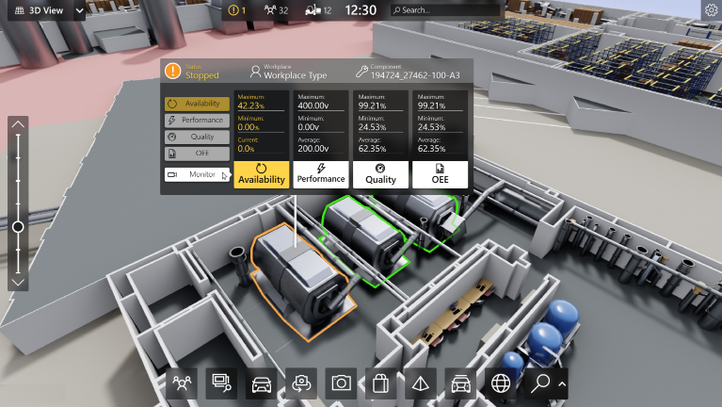

1. 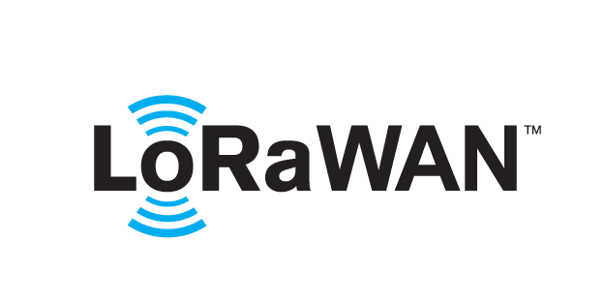 based Solution

UCT is one of the early adopters of LoRAWAN teschnology and providing solution in Agritech, Smart cities, Industrial Monitoring, Smart Street Light, Smart Water/ Gas/ Electricity metering solutions etc.

1. Predictive Maintenance

UCT is providing Industrial Machine health monitoring and Predictive maintenance solution leveraging Embedded system, Industrial IoT and Machine Learning Technologies by finding Remaining useful life time of various Machines used in production process.



## About upskill Campus (USC)

upskill Campus along with The IoT Academy and in association with Uniconverge technologies has facilitated the smooth execution of the complete internship process.

USC is a career development platform that delivers **personalized executive coaching** in a more affordable, scalable and measurable way.



Seeing need of upskilling in self paced manner along-with additional support services e.g. Internship, projects, interaction with Industry experts, Career growth Services

<https://www.upskillcampus.com/>

upSkill Campus aiming to upskill 1 million learners in next 5 year



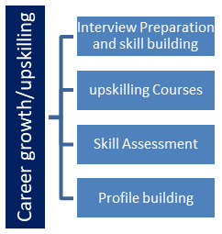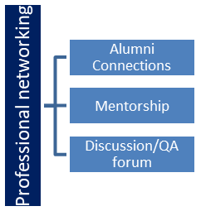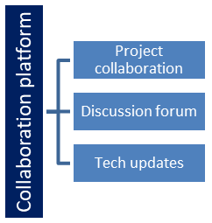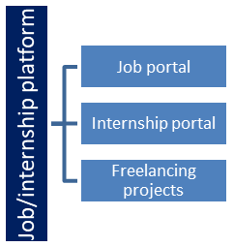

## The IoT Academy

The IoT academy is EdTech Division of UCT that is running long executive certification programs in collaboration with EICT Academy, IITK, IITR and IITG in multiple domains.

## Objectives of this Internship program

The objective for this internship program was to

 ☛ get practical experience of working in the industry.

 ☛ to solve real world problems.

 ☛ to have improved job prospects.

 ☛ to have Improved understanding of our field and its applications.

 ☛ to have Personal growth like better communication and problem solving.

## Reference

1. **BCrypt Library Documentation:** Secure password hashing techniques.
2. **Core Java Documentation:** Oracle official documentation.
3. **File Handling in Java:** TutorialsPoint and GeeksforGeeks.

# 

# Problem Statement

Develop a prototype of a Banking Information System in Core Java that provides a working preview of the key functionalities of a real banking system. The prototype should demonstrate the core features and flow of the system, showcasing its functionality and usability.

The objective of this project was to design a Banking Information System prototype in Core Java that provides the following:

* User-friendly interface for banking operations.
* Secure login using hashed passwords.
* Data persistence to store and retrieve user and transaction details.
* Validation mechanisms for error handling and data integrity.

# Existing and Proposed solution

1. Existing Solution

Traditional systems often face issues such as:

* Manual errors in transaction processing.
* Insecure handling of sensitive user data.
* Lack of real-time transaction updates.

1. Proposed Solution

The Banking Information System addresses these issues by:

1. Automating user registration, transactions, and account management.
2. Providing a secure login system with hashed passwords (BCrypt).
3. Implementing data persistence using text files (users.txt and transactions.txt).
4. Enhancing the user experience with an aesthetically improved CLI.

## Code submission (Github link) :

<https://github.com/tejaskuwar22/BankingInformationSystem.git>

## Report submission (Github link) :

## <https://github.com/tejaskuwar22/BankingInformationSystem.git>

# Proposed Design/ Model

* **High-Level Design**

The system consists of the following main components:

1. **User Registration**: Allows users to register with unique account numbers.
2. **Login System**: Ensures secure access via hashed passwords.
3. **Banking Operations:** Includes deposit, withdrawal, fund transfer, and viewing account statements.
4. **Data Persistence:** Ensures user and transaction data is stored in users.txt and transactions.txt for future access.

* **Low-Level Design**

**Directory Structure:**

src/

├── main/

│ ├── java/

│ ├── backend/

│ ├── Main.java // Entry point

│ ├── main/

│ ├── BankingSystem.java // Core logic and menu handling

│ ├── User.java // User data model

│ ├── data/

│ ├── users.txt // Stores user details

│ ├── transactions.txt // Stores transaction history

# Performance Test

The system underwent thorough testing to ensure reliability and functionality. The following test cases were executed:

|  |  |  |
| --- | --- | --- |
| **Test Case** | **Expected Result** | **Outcome** |
| Register a new user | User details stored in users.txt | Pass |
| Login with valid credentials | User authenticated successfully | Pass |
| Login with invalid credentials | Access denied | Pass |
| Deposit funds | Balance updated and transaction logged | Pass |
| Withdraw funds (sufficient) | Balance updated and transaction logged | Pass |
| Withdraw funds (insufficient) | Error message displayed | Pass |
| Transfer funds | Both accounts updated and transactions logged | Pass |
| View account statement | Displayed correct transaction history | Pass |

# My learnings

This internship provided valuable experience in:

1. Technical Skills:
   * Core Java development.
   * Implementing data persistence with file handling.
   * Secure password management using BCrypt.
2. Problem-Solving:
   * Debugging complex issues.
   * Designing algorithms for transaction validation.
3. Software Development Practices:
   * Modular design and code reusability.
   * Adhering to secure coding standards.

# Future work scope

The current prototype can be enhanced further:

1. Graphical User Interface (GUI):
   * Transition from CLI to a GUI using JavaFX for improved user experience.
2. Database Integration:
   * Replace text files with a relational database (e.g., MySQL) for better scalability.
3. Advanced Features:
   * Add features like bill payments, multi-user roles, and analytics.

# Conclusion

The Banking Information System project successfully met its objectives by implementing core banking functionalities and addressing traditional system limitations. This internship has been a significant step in gaining practical experience in software development and understanding real-world applications of Java programming.