
































Project Interim Report
On
File Compression Simulator
(Using Core Java & OOP Concepts)
RU-100-01-00012
Object Oriented Programming with Java
SESSION: 2025-26
Submitted By
Student name-Tejas Kumar Yadaw
Reg No-RU-25-11530
Bachelor of Technology in Computer Science &
Engineering with AI and ML in association with IBM
Under the Guidance of
Mr. Santanu Sasmal
IBM SME and EXPERT
SCHOOL OF COMPUTER SCIENCE AND ENGINEERING
RUNGTA INTERNATIONAL SKILLS UNIVERSITY
BHILAI, CG
(April 2026)

Abstract
The File Compression Simulator is a Java-based application developed using Core Java and Object Oriented Programming (OOP) concepts to demonstrate the fundamental principles of data compression and decompression. Data compression plays a crucial role in modern computing by reducing
the size of data, which helps in efficient storage management and faster data transmission across networks.
This project implements a basic compression technique that reduces redundancy in data and converts it into a compact form. It also includes a decompression feature that restores the compressed data back to its
original form without any loss of information. The system is designed to handle input data efficiently and perform both compression and decompression operations accurately.
The application follows key OOP principles such as encapsulation, abstraction, and modular design, ensuring better code organization, reusability, and maintainability. It provides a user-friendly, menu-driven
interface that allows users to interact with the system easily and perform operations smoothly.

Introduction
In today’s digital world, the amount of data generated and processed is increasing rapidly. From simple text files to large multimedia content, efficient storage and faster transmission of data have become essential requirements. As data size grows, it occupies more storage space and requires more time and bandwidth for transmission. To solve these problems, data compression is widely used. Data compression is a technique that reduces the size of data by removing redundancy while preserving its original meaning.
The File Compression Simulator is a Java-based application developed to demonstrate the working of basic data compression and decompression techniques. The main aim of this project is to help students understand how compression algorithm’s function and how they can be implemented using programming
concepts. It provides a simple and practical approach to learning compression without involving complex algorithms.
The system works by taking input data from the user and processing it through a compression technique
that reduces unnecessary repetition in the data. After compression, the system is also capable of performing decompression, which reconstructs the original data accurately. This ensures that the process is reliable and no information is lost during compression. Such techniques are important in real-world applications where data accuracy is critical.
This project is implemented using Core Java and follows Object-Oriented Programming (OOP) principles such as encapsulation, abstraction, and modular design. These concepts help in dividing the program into different classes and methods, making it more organized, reusable, and easy to maintain. Each part of the
system, such as input handling, processing, and output display, is managed separately to improve clarity and efficiency.
The application provides a simple menu-driven interface that allows users to interact easily with the system. Users can perform operations like entering data, compressing it, decompressing it, and viewing the results. This makes the system user-friendly and suitable for beginners who are learning programming and
basic algorithms. Data compression is widely used in many real-world applications such as file storage systems, communication networks, and internet services. It helps reduce storage requirements and improves the speed of data transfer. Although this project uses a basic compression method, it gives a clear understanding of how compression systems work in practice.

Scope
This project is mainly designed for educational purposes to understand the basic concepts of data compression and Java programming. It helps beginners learn how compression techniques work and how. Object-Oriented Programming (OOP) concepts can be applied in real-world applications. The system is
suitable for small-scale use and focuses on handling text-based data efficiently. The project provides a simple platform for experimenting with compression and decompression processes, making it useful for students studying data structures and algorithms. However, it is limited to basic functionality and does not handle large or complex file formats.
In the future, this project can be enhanced by:
Adding advanced compression algorithms such as Huffman Coding and LZW
Supporting file-based compression instead of only string data
Integrating with databases for data storage
Developing a graphical user interface (GUI) for better user experience

System Requirements
The File Compression Simulator requires basic hardware and software to run efficiently. It is designed to
work on standard systems without the need for high-end resources.
Hardware requirement
- Computer or Laptop
- Minimum 4GB RAM
- Basic processor (Intel i3 or equivalent and above)
Keyboard and Monitor
- SoftWare Requirment
- Operating System: Windows, Linux, or macOS
- Java Development Kit (JDK 8 or above)
- IDE: VS Code / Eclipse / IntelliJ IDEA
- Basic command-line interface (for running the program)

Methodology
The project follows a simple step-by- step process. First, the user enters a string through the console. The Compressor class receives the input and applies the compression logic by counting consecutive repeated characters and storing them in a compressed format. After compression, the decompression method reads the compressed string and reconstructs the original string by repeating characters according to their counts. Finally, the program displays the original, compressed, and decompressed strings and verifies that the decompressed output matches the original input.

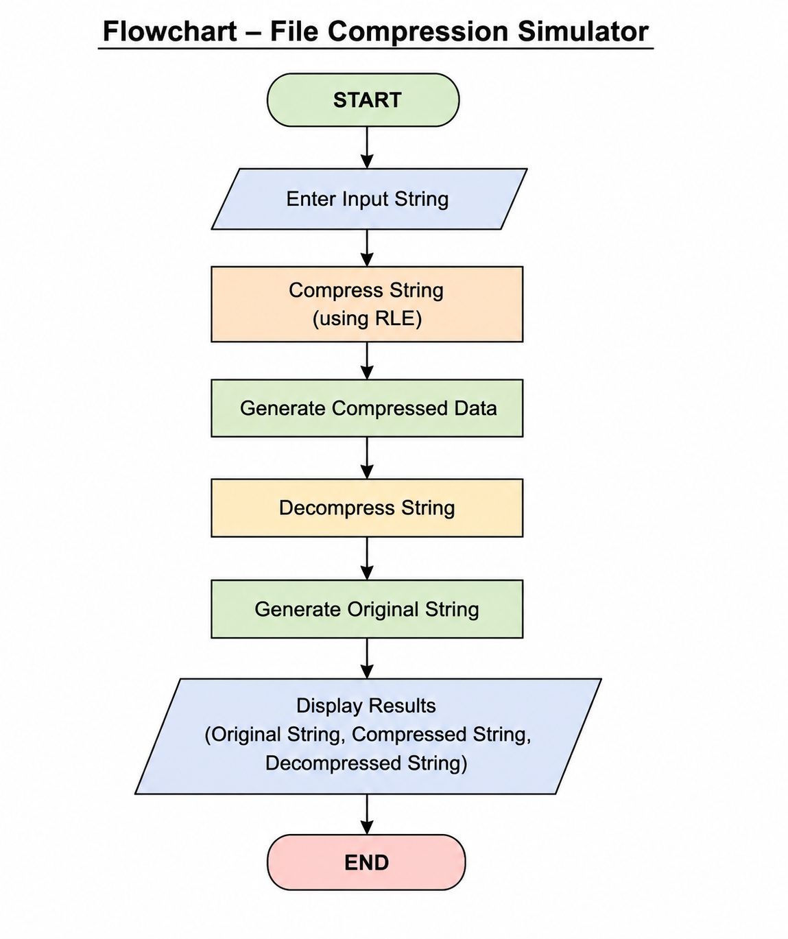
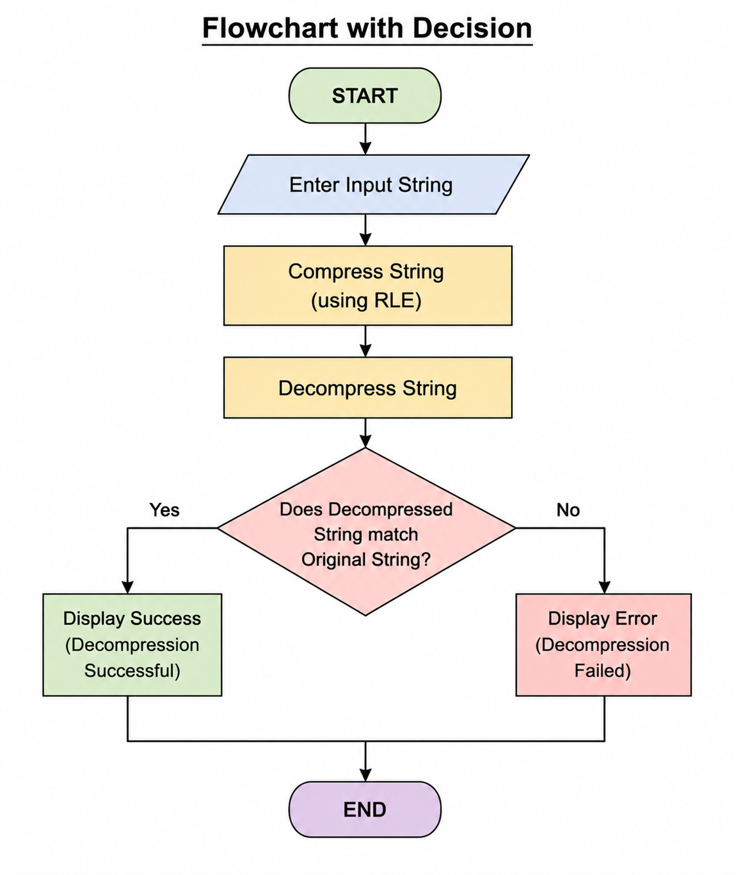

Implementation
The project mainly consists of two classes:
1. Compressor Class
- Handles compression and decompression operations.
- The compress () method converts repeated characters into a compressed format.
- The decompress () method restores the original string.
2. Compression Demo Class
- Contains the main method.
- Takes user input.
- Calls compression and decompression methods.
- Displays the results to the user.
The implementation uses loops, conditional statements, StringBuilder, and string manipulation methods such as charAt() and substring ().

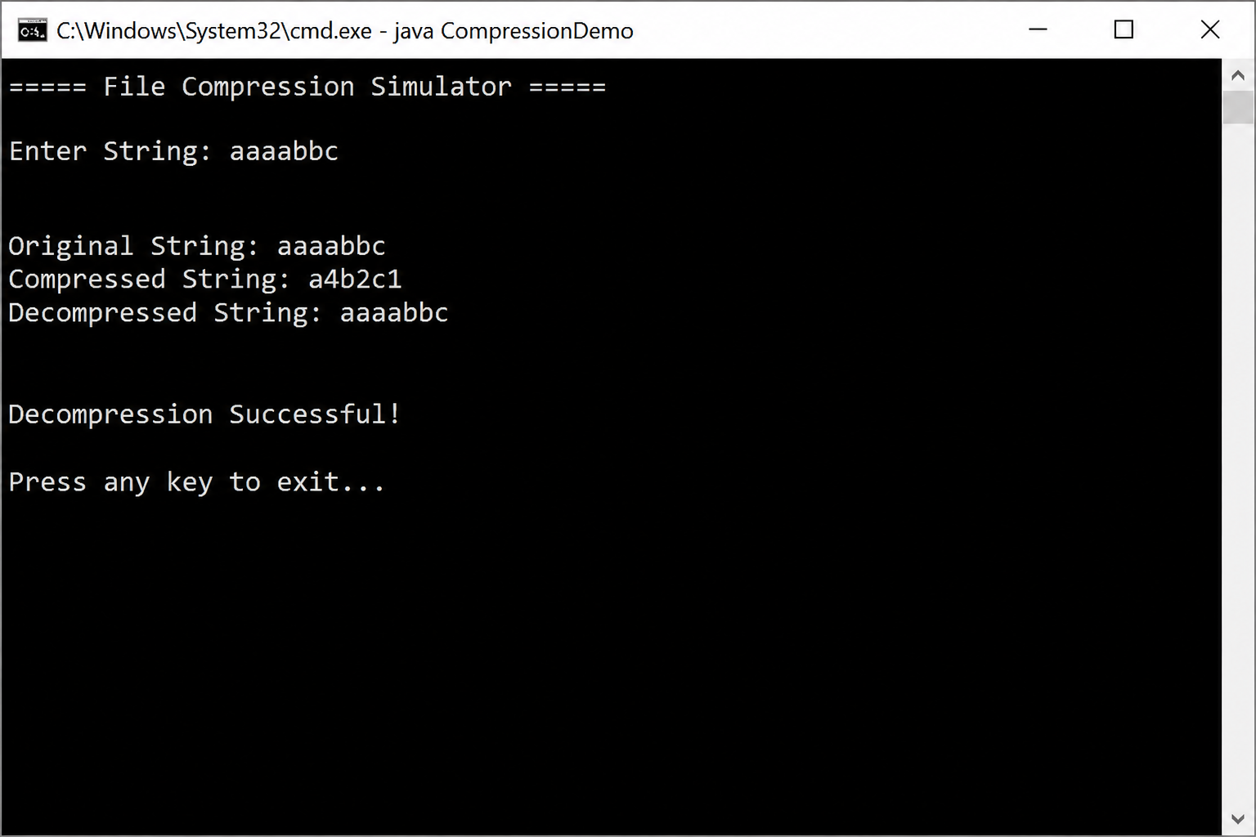

Conclusion
The File Compression Simulator successfully demonstrates the basic principles of compression and decompression using Java. The project provides practical experience with Object-Oriented Programming concepts, string manipulation, and logical problem-solving techniques. It verifies that compressed data can be restored accurately, helping students understand the importance of data compression in computer systems. The project serves as a strong foundation for learning more advanced data processing and file management techniques in the future.

References
Books
- Herbert Schildt, Java: The Complete Reference, 11th Edition, McGraw-Hill, 2018.
- E. Balagurusamy, Programming with Java, McGraw-Hill Education, 2020.
Websites
1.https://docs.oracle.com/en/java/?utm_source 2.https://www.geeksforgeeks.org/java/?utm_source

